

Summary Report

Sturry and Herne Highway Capacity Study

CO04300400/001 Revision 02

April 2016



**Document Control Sheet**

| Project Name: | Sturry and Herne Highway Capacity Study |
| --- | --- |
| Project Number: | CO04300400 |
| Report Title: | Summary Report |
| Report Number: | 001 |

| **Issue Status/Amendment** | **Prepared** | **Reviewed** | **Approved** |
| --- | --- | --- | --- |
| 00 | Name:  Gareth Elphick/Steve Whittaker | Name:  Margaret Nicholls | Name:  Steve Whittaker |
| Signature:  Date: 23/09/15 | Signature:  Date: 23/09/15 | Signature:  Date: 23/09/15 |
| 01 (minor updates – PICADY results added) | Name:  Gareth Elphick/Steve Whittaker | Name:  Margaret Nicholls | Name:  Steve Whittaker |
| Signature:  Date: 24/09/15 | Signature:  Date: 24/09/15 | Signature:  Date: 24/09/15 |
| 02 (extended commission updates) | Name:  Gareth Elphick | Name:  Margaret Nicholls | Name:  Steve Whittaker |
| Signature:  Date: 21/03/16 | Signature:  Date: 13/04/16 | Signature:  Date: 27/04/16 |
|  | Name: | Name: | Name: |
| Signature:  Date: | Signature:  Date: | Signature:  Date: |

**Contents**

**1** **Introduction 1**

1.1 Background 1

1.2 Project Scope 1

**2** **Study Area 2**

2.1 A291 and A28 Corridors 2

2.2 Network Pinch Points 3

2.3 Local Plan Context 8

**3** **Current Situation 10**

3.1 Overview 10

3.2 Traffic Flows 10

3.3 Junction Queue Lengths 11

3.4 Journey Time Data 13

3.5 Delay/Congestion 16

3.6 Highway Safety 19

**4** **Forecast Conditions 23**

4.1 Forecast Scenarios 23

4.2 Link Capacity 23

4.3 Junction Capacity / Network Assessments 26

**5** **Conclusions 30**

**Figures**

Figure 2-1: A291 and A28 Corridors 2

Figure 2-2: Herne Village 3

Figure 2-3: Sturry Level Crossing 4

Figure 2-4: Kent & Medway Level Crossings – Vehicles Per Day Comparison 5

Figure 2-5: A28/A291 Junction Arrangement 6

Figure 2-6: A28/A291 Junction Interaction with Level Crossing 6

Figure 2-7: Broad Oak Level Crossing 7

Figure 2-8: Strategic Development Sites & Highway Scheme Locations 8

Figure 2-9: Sturry Link Road 9

Figure 3-1: Junction turning counts 10

Figure 3-2: A291 Herne – Two-way Traffic Flows 11

Figure 3-3: AM peak key junction queue lengths (Vehs) 12

Figure 3-4: Journey time reliability 1 (capacity issues) 14

Figure 3-5: Journey time Reliability 2 (periodicity of level crossing) 14

Figure 3-6: Herne Village Travel Time Southbound 15

Figure 3-7: Herne Village Travel Time Northbound 15

Figure 3-8: DMRB TA 79/99 road classifications 16

Figure 3-9: Sturry level crossing – link flow vs capacity (AM peak) 18

Figure 3-10: 5 year PIC’s by section and severity 20

Figure 3-11: 5 year PIC rate by veh km 20

Figure 3-12: Section 2 – accident rate & severity by route 21

Figure 3-13: A291/Sweechgate accident cluster 21

Figure 3-14: EuroRAP A291 route designation 22

Figure 4-1: Sturry level crossing - forecast link flow vs capacity (AM peak) 24

Figure 4-2: Herne - Forecast Link Flow vs Capacity (AM peak) 25

Figure 4-3: Forecast Journey Times (AM Peak) with/without Sturry Link Rd 28

# Introduction

## Background

### Amey have been commissioned by Kent County Council (KCC) to undertake an outline route assessment of the A291/A28 corridors which approach and merge through the rural hinterlands on the north-eastern outskirts of the Canterbury urban area.

### This is an area with five key potential strategic local plan allocations, and two proposed significant highway infrastructure improvements, Herne Bypass and Sturry Link Road.

### This study is to provide consideration of the following:

* The consented development at Herne Bay Golf Club;
* The lodged planning appeal against non-determination of the planning application for the Strode Farm development site (‘Lower Herne Village’);
* A wider consideration of existing highway conditions in this area, and whether there is a limitation on any new development, particularly larger strategic sites, without the two aforementioned highway schemes;
* The broader justification of the two highway schemes, and their fit in the transport strategy.

## Project Scope

### The route assessment is comprised of the following components:

1. Junction capacity assessments at key locations:

* A291/Sweechgate priority junction;
* A28/Fordwich Rd junction(s);
* A291/School Lane, Herne.

1. Link capacity at Sturry level crossing;
2. Road safety/severance considerations
3. ‘Rat-running’ issues.

# Study Area

## A291 and A28 Corridors

### The A291 connects Canterbury with Herne Bay to the north and forms a mid-point of the A299 Thanet Way, a strategic route from M2 to Isle of Thanet.

### It passes through the village of Herne and rural areas towards Sturry. The A291 observes traffic flows of circa 9,000 vehicles per day (DfT count points 46895 & 78219). Canterbury-bound traffic on the corridor can either use an alternative rat-run through Broad Oak or join with the A28 (Thanet to Canterbury). The A28 crosses the railway at the Sturry Level Crossing.

### The A28 joins the eastern end of the Thanet Way with Canterbury. The route passes through Hersden and Sturry. Here it is joined by the A291 and heads over the Sturry level crossing. At the level crossing the traffic flow is circa 18,000 vehicles per day (Network Rail data).

### The A291 and A28 corridors are shown in Figure 2-1 below.

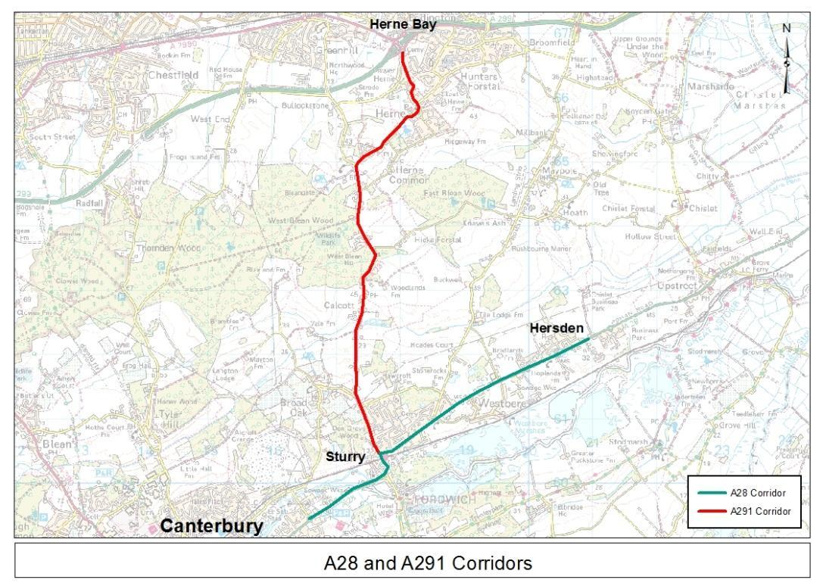

**Figure 2-1: A291 and A28 Corridors**

## Network Pinch Points

#### Eddington Roundabouts

### The A291 meets the A2990 and A299 Thanet Way at the Eddington roundabouts, a dumbbell junction over the A299 enhanced by a third roundabout. This complex has not been included in this study as it is more suited to being a wider area study also including the Thanet Way.

#### Herne Village

### The A291 through the centre of Herne Village is characterised by tight bends and slow vehicle speeds which affect the capacity of the road. The route has sections of narrow road on the approach to the mini roundabout at the junction with School Lane, pinch points caused by parked cars and a pedestrian crossing west of the junction; and bus stops to the east of the junction. Forward visibility is constrained by the tight bends and proximity of buildings to the road at the junction with School Lane.

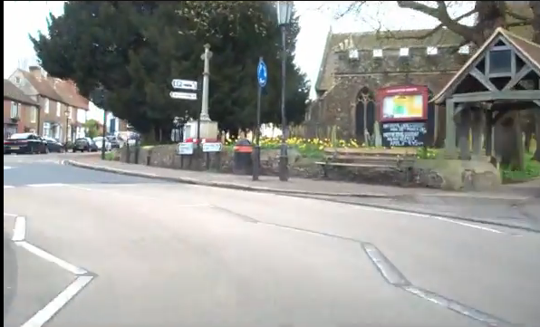

**Figure 2-2: Herne Village**

#### Sturry

### The A291 joins the A28 on a tight bend immediately to the north of the railway line. The A28 then crosses the railway line at the Sturry level crossing, before bending to the west towards Canterbury. Within this section of the route there is also a formal pedestrian crossing facility and a busy side road (High St) which provides access to local shops/services and the Junior King’s school. A high level of pedestrian demand at the crossing and significant volumes of right turning traffic into High Street cause additional delay to the mainline flow on the A28.

#### Sturry Level Crossing

### The Sturry level crossing represents a notable barrier to traffic movements along the A28 and significant queuing is observed on both the A28 and A291, particularly during peak highway periods. The crossing is on the Thanet to Ashford International line which serves Canterbury via Canterbury West. The line has both classic and High-speed (HS1) Domestic services. On average six trains pass each hour with five or six level crossing activations of approximately 2.5-3 minutes in length.

### The Sturry level crossing is shown in Figure 2-3 below.

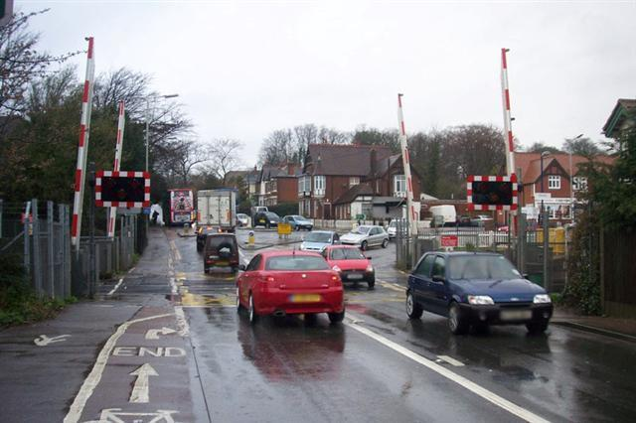

**Figure 2-3: Sturry Level Crossing**

### The level crossing at Sturry is in the top ten highest vehicle flows crossing a level crossing in the Network Rail database.This flow is noticeably higher than other crossings in Kent. In addition, of those level crossings with high vehicle flows, Sturry also has the highest frequency of trains. There are also approximately 900 pedestrian and cyclist movements per day. The graph in **Figure 2-4** below shows the volume vehicles per day at the Sturry level crossing in comparison to other level crossings in Kent and Medway.

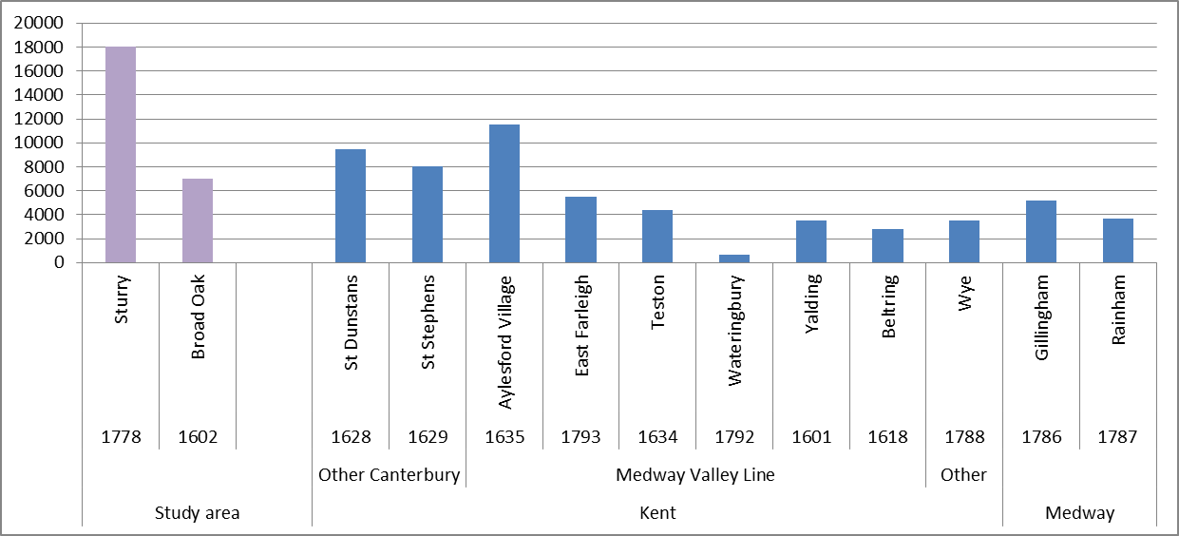

**Figure 2-4: Kent & Medway Level Crossings – Vehicles Per Day Comparison**

### In addition to the obvious capacity restriction of the level crossing itself, the proximity of the level crossing to various junctions is noted, particularly the A291/A28 priority junction on the northern side. On the southern side there is a combination of Sturry High St, a pedestrian crossing on the A28, and the priority junction with the road to Fordwich.

### There are also bus stops present in the area which serve Stagecoach’s ‘Triangle’ via the A291 to Herne Bay and the ‘Breeze’ via the A28 to Thanet. In addition, there are in and out movements to Sturry station just north of the level crossing opposite the A291/A28 junction.

#### A291/A28 Junction

### Traffic from the A291 gives way to the A28 at a priority junction opposite Sturry railway station. The dominant ‘give-way’ movement from the A291 is the right turn towards Canterbury. The junction has in irregular arrangement whereby a right turn facility created by the bend in the road provides stacking capacity for right turning traffic exiting the A291 as well as right turning traffic entering the minor arm.

### The right turn storage facility allows traffic to cross the A28 eastbound traffic and wait for a gap in the westbound traffic. Whilst it only has space for one vehicle, it is often occupied by two vehicles squeezing alongside each other. It can just accommodate a turning bus or Heavy Goods Vehicle (HGV).

### The tight turn arrangement is shown in Figure 2-5 below:

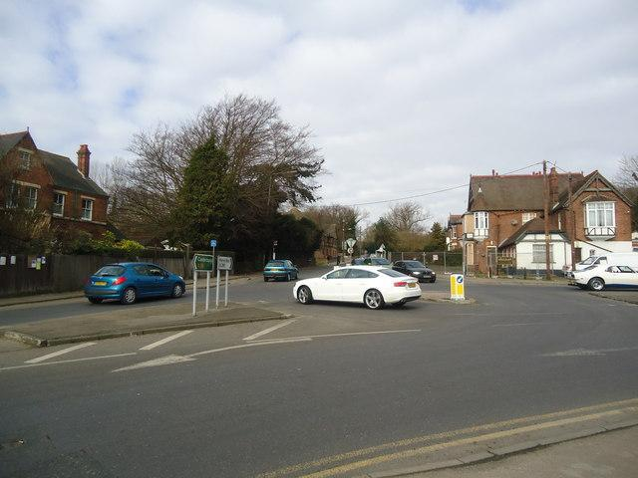

**Figure 2-5: A28/A291 Junction Arrangement**

### The operation of the junction interacts significantly with the level crossing in close proximity to the south. When the level crossing is in operation the A28 eastbound traffic is held which removes this opposing flow for traffic exiting the A291. However, the A28 westbound traffic queues back preventing right turning traffic from the A291 from exiting the junction. It does provide opportunity for these movements to ‘nudge out’ into the queueing traffic once traffic at the level crossing is released.

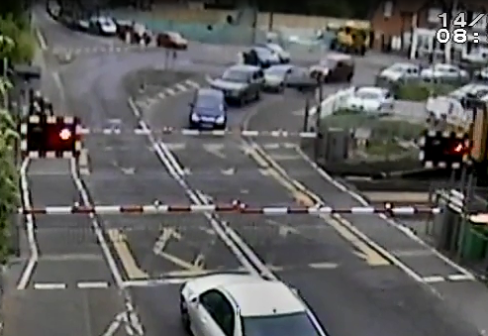

**Figure 2-6: A28/A291 Junction Interaction with Level Crossing**

#### Broad Oak ‘Rat-run’

### An alternative route towards Canterbury city centre is available to southbound traffic on the A291 via a non-classified route through the village of Broad Oak. The route is accessed by turning right from the A291 into Sweechgate before turning left onto Shalloak Rd. The route then continues to the south before crossing the railway line at another level crossing and then merging into Broad Oak Rd which provides an alternative route to the town centre other than the A28. This is also an alternative route for some Sturry traffic.

Traffic flows at the level crossing on Shalloak Rd total approximately 7,000 vehicles per day. The level crossing is shown in **Figure 2-7** below. 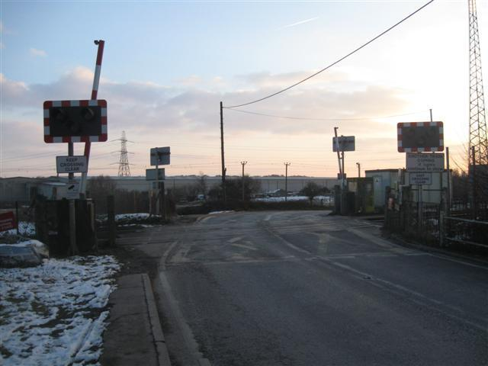

**Figure 2-7: Broad Oak Level Crossing**

#### Vauxhall Road

### Vauxhall Rd is a short link which connects the two main approaches to the city centre from the North East; the A28 and Broad Oak Rd. Vauxhall Rd also serves as the access road to an industrial estate on both sides of the road. The road meets both Broad Oak Rd to the north and the A28 Sturry Rd to the south in the form of priority roundabout junctions. It is understood that the A28/Vauxhall Rd junction, in particular, observes heavy traffic flows and suffers from congestion and delay during peak highway periods.

## Local Plan Context

### There are five key strategic development sites allocated within the emerging Local Plan for Canterbury in close proximity to the study corridors. As part of the transport strategy intended to mitigate the growth associated with future developments two major infrastructure projects are proposed in the form of the Sturry Link Rd and Herne Relief Rd. **Figure 2-8** below illustrates the locations of the strategic development sites in relation to the proposed highway schemes.

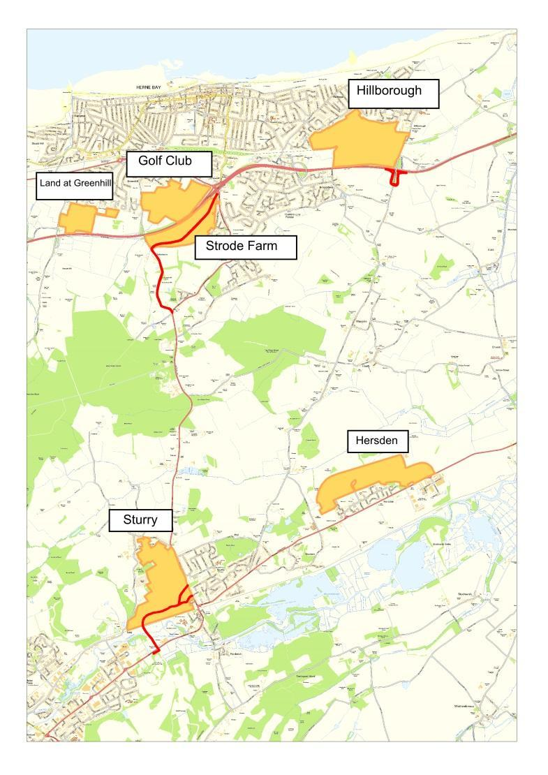

**Figure 2-8: Strategic Development Sites & Highway Scheme Locations**

### **Table 1** provides a summary of the strategic development sites including quantum and connection to the surrounding highway network.

| **Development** | **Target Development Size** | **Connects** |
| --- | --- | --- |
| Golf Club | 570 | Near A299/A291 |
| Strode Farm | 800 | Proposed Herne Relief Rd |
| Broad Oak / Sturry | 1000 | Proposed Sturry Link Road |
| Hersden | 800 | A28 |
| Hillborough | 1000+300 | North of Thanet Way |

**Table 1: Strategic Development Sites Summary**

### The proposed Herne Relief Rd consists of the widening and improvement of Lower Herne Rd and Bullockstone Rd to a local distributor road standard to effectively provide a bypass of Herne Village. The current alignment of the A291 runs through the village which presents restrictions to capacity as discussed earlier in this chapter.

### The Sturry Link Rd will provide the access road to the Broad Oak/Sturry allocation site in addition to providing a new link to the A28 that will bypass the Sturry level crossing, which represents a major constraint and cause of delay on the network. An indicative plan of the Sturry link road is shown in **Figure 2-9** below.

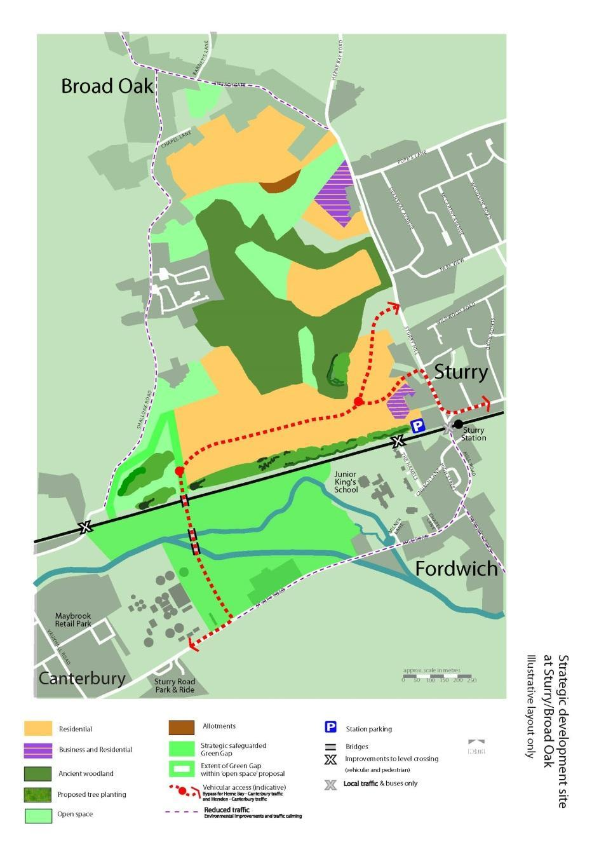

**Figure 2-9: Sturry Link Road**

### In addition to the above the transport strategy targets increased bus patronage, including Park & Ride, by incorporating priority bus routes alongside the highway schemes. The Sturry Link Rd will allow more efficient arrival at the existing Park & Ride site on the A28, to the east of the A28/Vauxhall Rd roundabout.

# Current Situation

## Overview

### A review of the existing highway conditions along the corridor has been undertaken using the following indicators:

### Traffic Flows;

* Queue lengths;
* Journey times;
* Delay and congestion.

## Traffic Flows

#### Sturry / Broad Oak

### The A291 and A28 corridors currently observe high levels of traffic demand, particularly on the A28 to the west of the junction where the two routes meet in Sturry. At this location the level of traffic is 18,000 vehicles per day (vpd). In addition there are the traffic movements on the alternative (non-classified) route through Broad Oak towards Canterbury. As mentioned this route has a flow of around 7,000 vpd.

### AM peak hour turning counts are available at the junctions of the A291/Sweechgate and the A291/A28 as shown in **Figure 3-1** below.

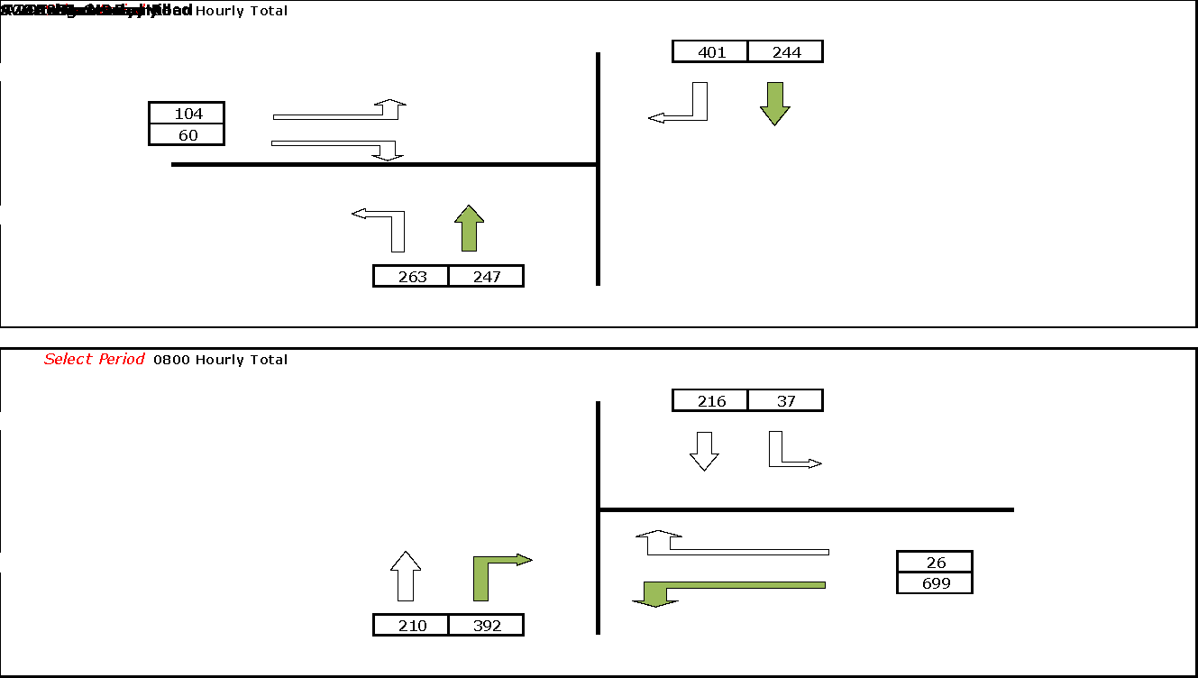

**Figure 3-1: Junction turning counts**

### The turning counts indicate a significant proportion of vehicles use the alternative route to Canterbury via Broad Oak with a high number of vehicles turning right from the A291 into Sweechgate. There is also a high left turn from the A291 in Sturry suggesting Sturry residents also make use of the route.

### This suggests that there is a latent demand of Canterbury-bound traffic which currently chooses to use the alternative route via Broad Oak as opposed to the A291 and A28 corridor due to perceived delay at the level crossing in Sturry.

#### Herne Village

### The A291 through Herne village carries an average daily flow of 11,100 vehicles and during the peaks the two way flows are between 940 and 1040 vehicles per hour. School Lane, which links to the neighbouring village of Broomfield, joins the A291 at a mini roundabout in the centre of Herne village and carries a two way peak flow of around 500 vehicles per hour (**Figure 3-2**).

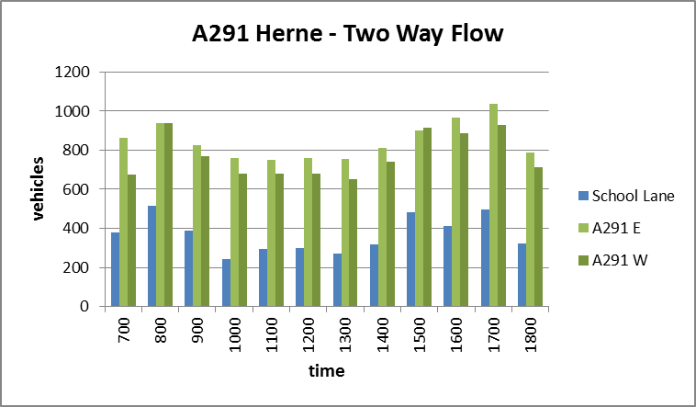

**Figure 3-2: A291 Herne – Two-way Traffic Flows**

## Junction Queue Lengths

### In order to gain an indication of the current level of congestion and delay at key junctions within the study corridor, queue length data has been analysed. Queue length surveys were undertaken on Tuesday 23rd June 2015 at the following junction locations:

1. A28/A291
2. A28/Sweechgate
3. A28/Fordwich Rd & Water Lane

### An additional survey was carried out at the junction of the A291 and School Lane in Herne village on Wednesday 9th March 2016. The results of this survey are discussed separately later in this section.

#### Sturry / Sweechgate / Fordwich

### The observed AM peak queue lengths are shown in **Figure 3-3** below for the minor arms of each of the junctions in addition to the A28 westbound arm approaching the level crossing. It should be noted that the survey only recorded to a maximum queue length of 25 vehicles (approx. 150 metres). Where queues were observed to exceed this threshold they were simply recorded as ‘25+’ and therefore the full extent of the queue is not known.

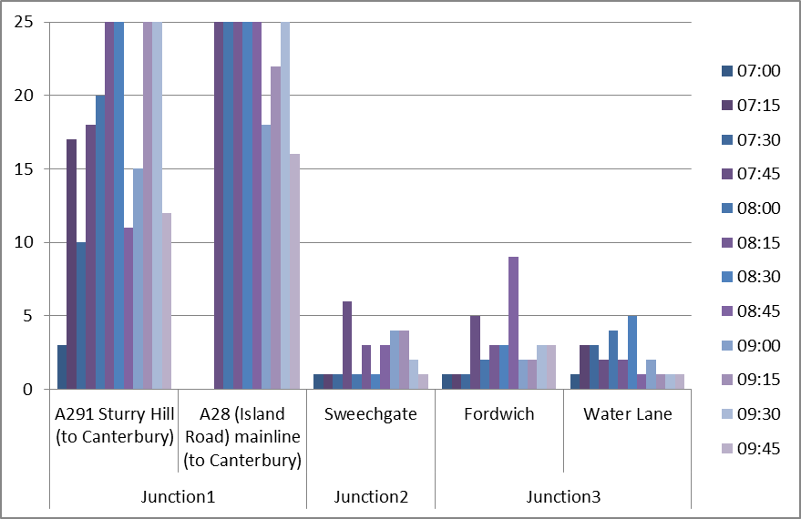

**Figure 3-3: AM peak key junction queue lengths (Vehs)**

### The graph indicates that the A28/A291 junction observes a sustained queue, often exceeding 150 metres in length, on both arms during the AM peak hour. It is important to note that due to its proximity to the junction, the operation of the level crossing in Sturry has a significant impact on the operation of the junction.

### The observed queues at A291/Sweechgate and the Fordwich Rd & Water Lane junctions with the A28 are shown to be minimal with the exception of the occasional spike.

### Although not shown it should be noted that the PM has less queuing issues when compared with the AM peak.

#### Herne Village

### A queue survey was recorded at the mini-roundabout in Herne. This shows some evidence of static queueing, although relatively minimal and sporadic with current flows. It is important to note that a mini-roundabout will likely show less resilience than standard roundabouts with increasing flows; and that all three arms in Herne are prone to queues and likely to worsen. Although the static queues are comparatively small, the slow moving traffic stream through Herne will provide a constant feed to the queues which form at the mini roundabout.

## Journey Time Data

#### Sturry

### Travel times through Sturry on the A28 and A291 were extracted from ANPR data. There was one limitation as the camera on Island Rd was close to the A28/A291 junction and therefore did not capture the full queuing time. The data both shows relatively high times to cross the small network and unreliability in the journeys. This unreliability is from both capacity limitations and the periodicity of the level crossing (**Figure 3-4** and **Figure 3-5**).

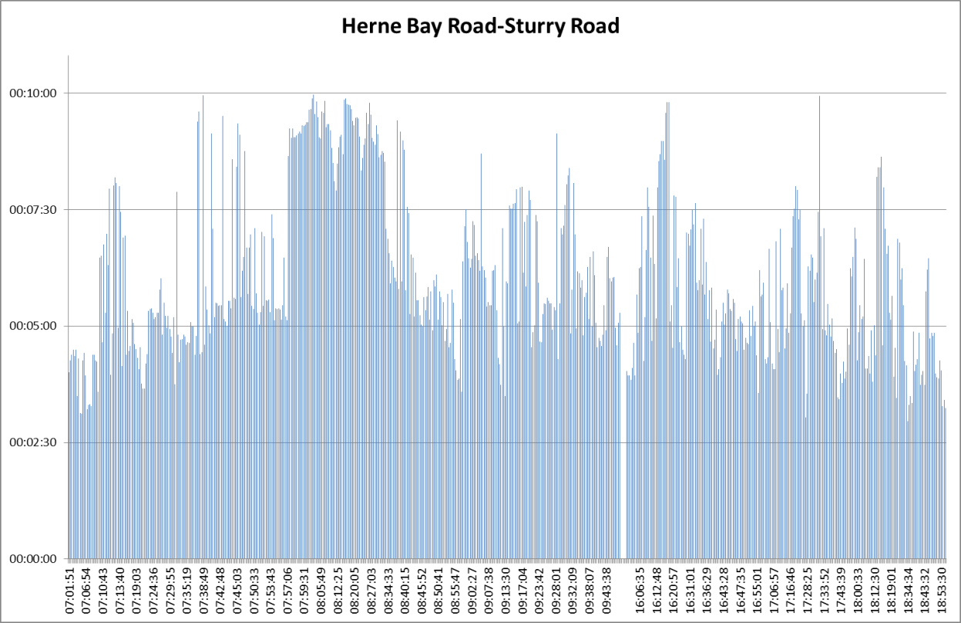

**Figure 3-4: Journey time reliability 1 (capacity issues)**

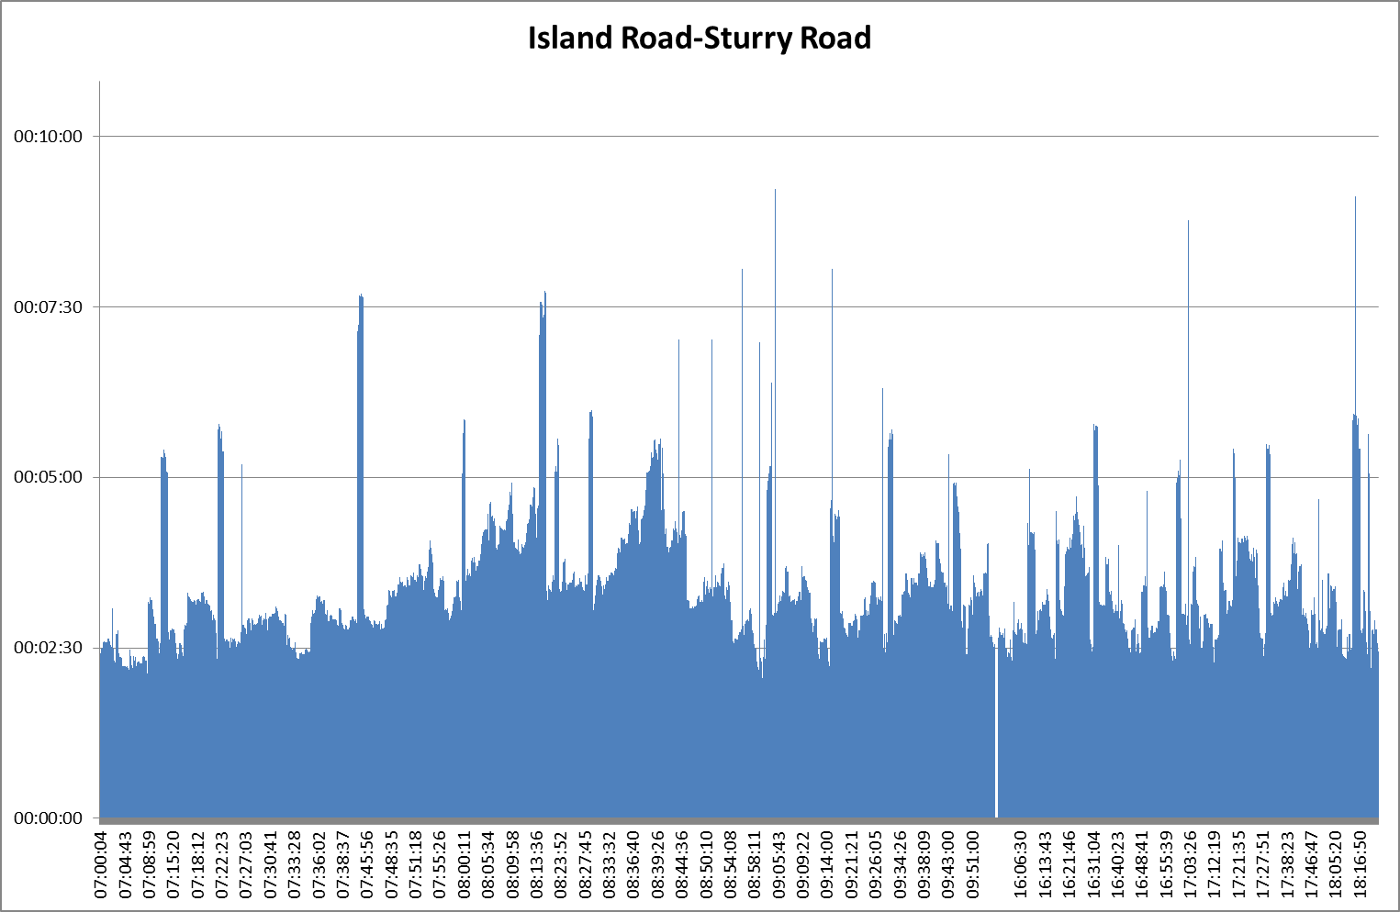

**Figure 3-5: Journey time Reliability 2 (periodicity of level crossing)**

#### Herne Village

### Average journey times through the village have been derived using TrafficMaster GPS data. The TrafficMaster database holds data collected from in-vehicle GPS tracking devices and provides real-time traffic data. An analysis has been carried out using this data source to demonstrate the average journey times through Herne Village for three consecutive years. The section of the A291 Canterbury Road between Lower Herne Road and Curtis Wood Park Road was identified as being representative.

* + 1. Data was extracted for weekdays in September 2012, 2013 and 2014 and with the first week excluded to allow post-holiday travel patterns to resume. The figures below show the average travel times through the village throughout the day, southbound and northbound (**Figure 3-6** and **Figure 3-7**).

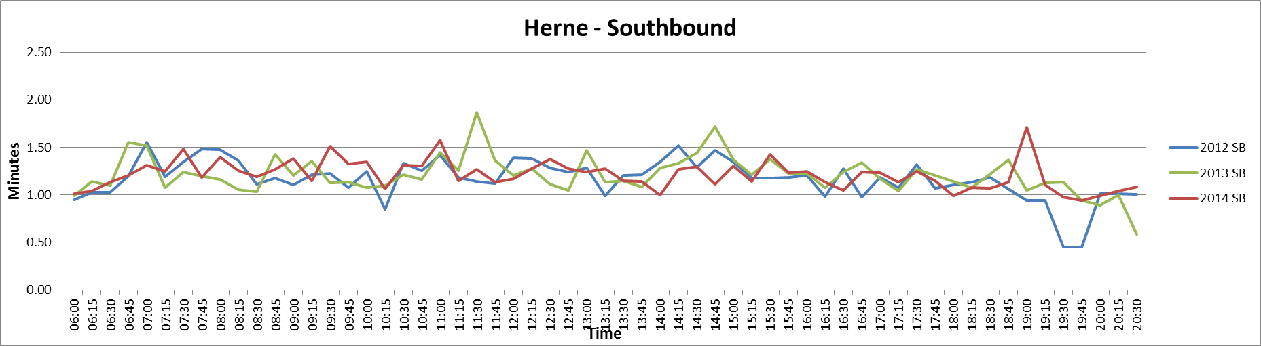

**Figure 3-6: Herne Village Travel Time Southbound**

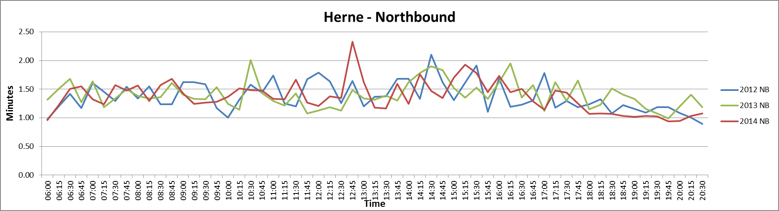

**Figure 3-7: Herne Village Travel Time Northbound**

* + 1. The average journey time profiles have remained consistent across the three year period. The range in average journey times for this section of route (07:00-19:00) across all three years is only 2 seconds southbound and only 1 second northbound which shows a high degree of consistency.
    2. The consistency in terms of both average journey time profiles throughout the day and across the three year period suggests that the section of the road through the village is currently operating at its practical capacity, which is constrained by the various pinch points along the route.

## Delay/Congestion

#### Link Flows vs Capacity (Overview)

### The roads through Herne Village and Sturry (the level crossing section of the A28) can be rated using DMRB volume 5 TA 79/99. This rating and the road width then determine a theoretical capacity to compare against flows. An extract of the relevant section of the DMRB providing a description of the different road classifications is shown in **Figure 3-8** below.

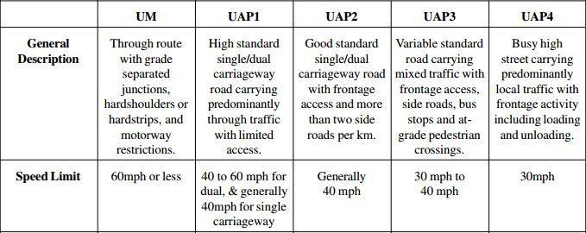

**Figure 3-8: DMRB TA 79/99 road classifications**

### The roads are considered to fall between UAP3/UAP4 with low road widths. This accounts for the various points that have been raised, such as the exit of Sturry High St and the pedestrian crossings. In addition, for Sturry, the level crossing needs to be accounted for, by reducing the initial derived capacity. As such the theoretical capacity of the routes is assumed to be between 750 and 1300 one-way hourly flow depending on the specific location.

### It should be noted, however, that the above capacity assessment is indicative only as the purpose and width of the routes, and therefore the associated link capacity, varies along the corridor. Furthermore the theoretical link capacity does not take into account the operation of junctions which represent the main cause of delay on the network.

#### Link Flows vs Capacity (Sturry Level Crossing)

### At the Sturry level crossing, recognised as a significantly constrained location, the effective link capacity has been calculated based upon site observations of the saturation flow of unconstrained vehicles and the estimated lost time due to the operation of the level crossing.

### A site visit was undertaken at the level crossing on Tuesday 15th September 2015 during the morning peak period to capture video footage of traffic behaviour at the level crossing and to record the frequency and duration of the level crossing in operation. The video footage was then analysed to determine the following:

1. The average saturation flow (per minute) for unconstrained vehicles at the level crossing;
2. The total amount of ‘lost time’ during the peak hour where the level crossing barriers were down and vehicles are effectively stopped;
3. An estimated amount of additional ‘lost time’ either side of the level crossing operation where vehicles are discharging but not at full saturation flow.

### The effective capacity of the level crossing would then be derived using the following calculation:

a x (60 mins – (b + c))

### The saturation flow observed from the video footage to range between 20-25 vehicles per minute (vpm). The average saturation flow was therefore calculated conservatively at 22.5 vpm.

### During the AM peak hour on the day of the survey the level crossing was called into operation five times for a total of 12.5 minutes.

### It has been estimated from site observations that an additional time of 1.5 minutes over the peak hour is lost where traffic is slowing down or setting off either side of the 5 level crossing operations, and therefore traffic is not travelling at saturation flow.

### Therefore, based on the formula in Section 3.5.6, the effective capacity of the Sturry level crossing can be determined as follows:

22.5 vpm x (60 mins – (12.5 mins + 1.5 mins)) = **1035 one-way vehicles per hour**

### The effective capacity of the level crossing has been compared with observed traffic flows in order to show the current level of flow (Canterbury bound) vs capacity at the level crossing. This is shown in the form of a graph as **Figure 3-9** below.

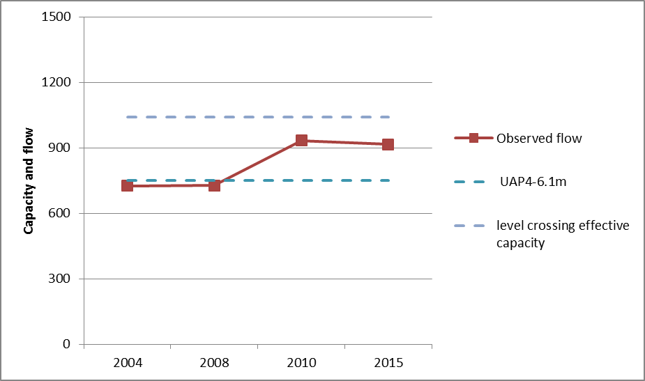

**Figure 3-9: Sturry level crossing – link flow vs capacity (AM peak)**

### The presented graph is for the AM peak hour ‘tidal flow’ (towards Canterbury). Therefore it also applies indicatively in the PM with the reverse tidality.

### Although the observed flow at the level crossing is below that of its calculated effective capacity, the length and nature of the operation of the level crossing results in significant queues being observed for certain periods within the highway peaks.

### Furthermore, the relationship between capacity and traffic demand also needs to be considered. As the Sturry level crossing is perceived as a constrained location the full traffic demand is not currently realised as alternative routes, such as the Broad Oak ‘rat-run’, are used in order to avoid peak hour delays at the level crossing. As such the capacity at the level crossing has the effect of constraining traffic demand and therefore the observed flow-to-capacity ratio is considered an underestimate.

#### Link Flows vs Capacity (Herne Village)

### The typical travel time on the A291 between Lower Herne Road and Curtis Wood Park Road, a distance of approximately 0.4miles, is 1 minute 25 seconds to 1 minute 43 seconds, giving an average speed of 14 to 18 mph through the village centre. This travel time appears to be reasonably consistent during peak and off peak traffic conditions, which indicates that it is the physical constraints and other features of the route through the village centre that effectively dictate the average speed. The constraint on the average speed effectively limits the practical capacity of this section of the A291. Assuming an average speed of 14 to 18 mph and based on average values for vehicle length and headway, the one way capacity of the route would be of the order of 970 to 1000vph.

### In addition the presence of parked cars and the location of bus stops present intermittent periods of traffic constraint where vehicles are forced to adopt one way operation periodically, alternating by direction based on driver courtesy.

### As noted above, theoretical link capacity is based on average width and road purpose and does not reflect the local character of a route such as the A291 through Herne village. It is also important to balance the relationship between flow and capacity with other issues such as environmental impacts and severance caused by traffic flows.

## Highway Safety

### 5 year personal injury crash (PIC) records were provided by KCC and have been analysed to determine whether there are any trends in the data terms of geographical clusters or common themes, such as turning movements or presence of cyclists, that would suggest prevalent highway safety concerns within the study corridor.

### It was logical to divide the area into three sections. Firstly, the northern end of the A291, around Herne, which could be bypassed by the Herne Relief Road. Secondly, there is the area around Sturry where the A28 and A291 meet. This area will be changed with the proposed Sturry Link Rd. Thirdly, the remaining middle section of the A291, near Wildwood.

### The number of crashes recorded by section and categorised by severity are shown in **Figure 3-10** below. In addition, the number of crashes within each section of the route has been converted to an accident rate per 100,000 vehicle kilometres in **Figure 3-11** below.

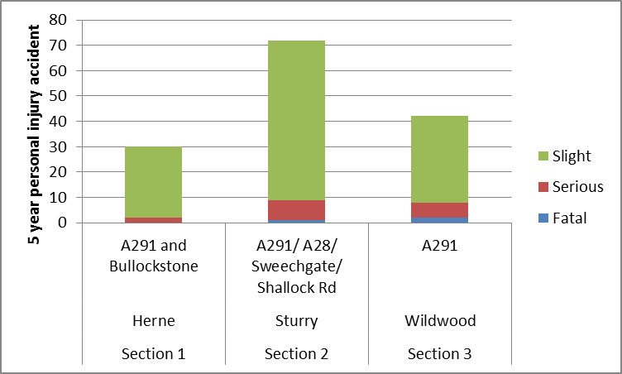

**Figure 3-10: 5 year PIC’s by section and severity**

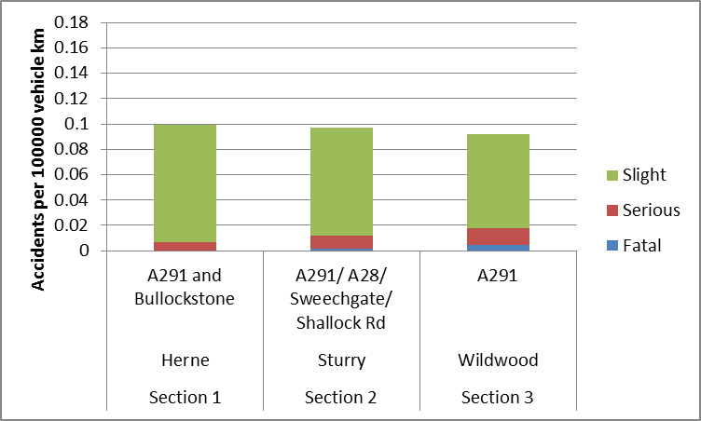

**Figure 3-11: 5 year PIC rate by veh km**

### The graphs indicate that whilst the accident rate is similar for all three sections, there are more severe accidents in Section 3. This is likely to be attributed to the higher speeds in this middle section of the study corridor.

### In addition, Section 2 of the route has been broken down further to disaggregate the three flows of traffic involved. This is shown in **Figure 3-12** below and indicates that the alternative route through Broad Oak via Shalloak Rd observes a higher accident rate and a higher rate of severe accidents than the other routes within the section. This is likely due to the high volumes of traffic using this unclassified route, which is not suitable to carry such levels of flow.

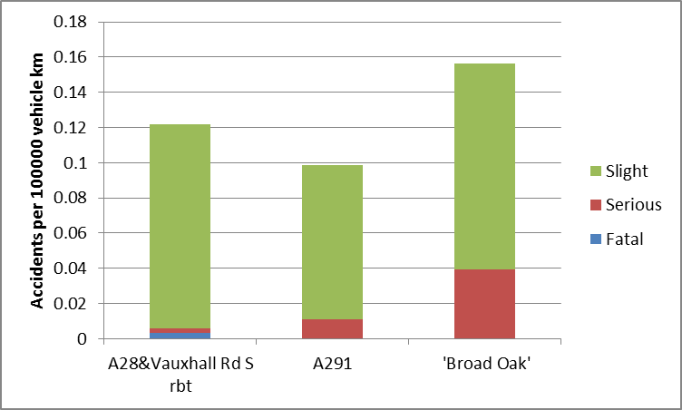

**Figure 3-12: Section 2 – accident rate & severity by route**

### Furthermore an accident cluster was noted at the A291/Sweechgate junction where 9 PIC’s have been reported during the previous 5 years as shown in **Figure 3-13** below.

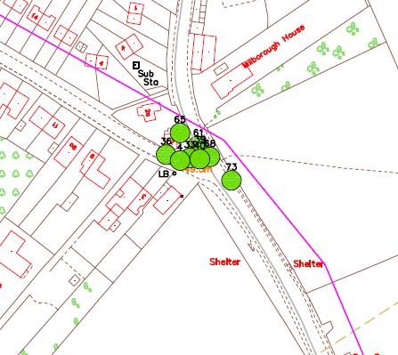

**Figure 3-13: A291/Sweechgate accident cluster**

### This is a little higher than would be expected from default accident rates (DfT COBALT), and could likely be reduced if less traffic used the ‘rat-run’ or an alternative junction arrangement was considered at this location. This conversion would be potentially superfluous if the Sturry Link Road is delivered as traffic movements would likely change as the ‘rat-run’ would be less desirable.

### In terms of road-users or themes of accidents, no particular trends are apparent; with accidents varying from involving pedestrians, cyclists, turning, stopping at shops, and parked cars.

#### EuroRap (European Road Assessment Programme)

### It should also be noted that the A291 has been assessed as a black route in EURORAP, the only wholly-Kent road designated as such (**Figure 3-14**).

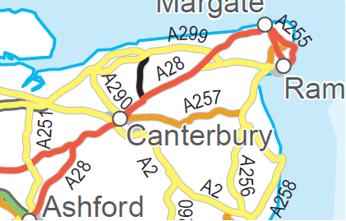

**Figure 3-14: EuroRAP A291 route designation**

### The EuroRAP programme aims to reduce death and serious injury through a programme of systematic assessment of risk, identifying the major shortcomings that can be addressed by practical road improvement measures.

### EuroRAP risk maps give an objective view of where people are being killed or seriously injured on a road network and where their crash risk is greatest. They capture the combined risk arising from the interaction of road users, vehicles and the road environment.

### Road sections are allocated into colour-coded categories from high risk to low:

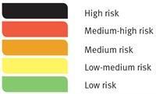

# Forecast Conditions

## Forecast Scenarios

### In order to test the traffic impact of a number of variations of the strategic development sites the following forecast scenarios have been assessed:

1. 2031 with Herne Bay Golf Club (HBGC) development only;
2. 2031 with HBGC and Strode Farm developments;
3. 2031 with all strategic development sites;

### The forecast year 2031 has been selected as it represents the end of the current Local Plan period for Canterbury.

### It should be noted that the following assessments have been undertaken independently of any background growth in the district. The reason for this is to highlight the impact of each scenario in isolation, although it is considered that all of the strategic development sites incorporated within forecast scenario 3 would account for a significant portion of expected growth in this area of the district anyway.

## Link Capacity

### The impact of the forecast scenarios has been tested in terms of forecast flow (2015 base + development) vs link capacity both in Herne and at the level crossing in Sturry. The trip generation and distribution associated with each of the forecast scenarios has been derived from specific site trip rates and distribution assumptions developed by KCC and CCC officers.

### An extract of the KCC/CCC trip generation and distribution exercise for the strategic sites is shown in **Table 2** below:

| Trip rate | Trip distribution | Development | Target development size | Trip generation |
| --- | --- | --- | --- | --- |
| 0.55 | 0.26 | Hillborough TW | 1000 | 143 |
| 0.55 | 0.26 | Hillborough AE | 300 | 43 |
| 0.55 | 0.31 | Golf Club | 570 | 97 |
| 0.55 | 0.36 | Strode Farm | 800 | 158 |
| 0.55 | 0.26 | Broad Oak/Sturry | 1000 | 143 |
| 0.55 | 0.19 | Hersden | 800 | 84 |
| Traffic generated through **Herne** | | | | **668** |
| 0.55 | 0.23 | Hillborough TW | 1000 | 127 |
| 0.55 | 0.23 | Hillborough AE | 300 | 38 |
| 0.55 | 0.27 | Golf Club | 570 | 85 |
| 0.55 | 0.30 | Strode Farm | 800 | 132 |
| 0.55 | 0.74 | Broad Oak/Sturry | 1000 | 407 |
| 0.55 | 0.67 | Hersden | 800 | 295 |
| Traffic generated through **Sturry** | | | | **1084** |

**Table 2: Strategic development sites – trip generation & distribution**

### The link capacity graph for the Sturry level crossing (**Figure 3-9**) has been extended to show the addition of the projected trips for the forecast scenarios and assuming no new infrastructure. No additional background growth has been included. The updated graph is shown in **Figure 4-1** below.

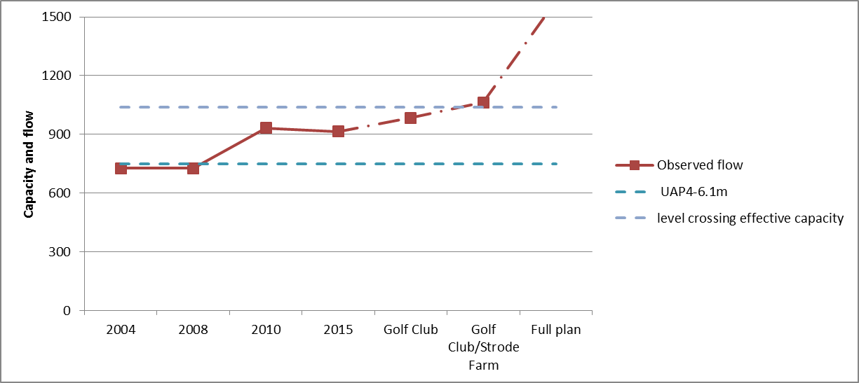

**Figure 4-1: Sturry level crossing - forecast link flow vs capacity (AM peak)**

### The above graph indicates that the addition of the projected trips from the HBGC development in isolation would increase flows at the Sturry level crossing and when added to 2015 level of flow would cause the link to approach its effective capacity.

### With the addition of HBGC and Strode Farm projected flows to 2015 baseline traffic at the level crossing, the effective capacity of the level crossing is exceeded.

### The projected increase in traffic at Sturry associated with the forecast scenario including all strategic sites would result in the capacity at the level crossing being exceeded significantly.

### In addition, a similar exercise has been undertaken for Herne as shown in **Figure 4-2** below. It should be noted, however, that the graph should be considered as indicative only as the direction of flows from the various sites would vary. Once again no additional background growth has been included.

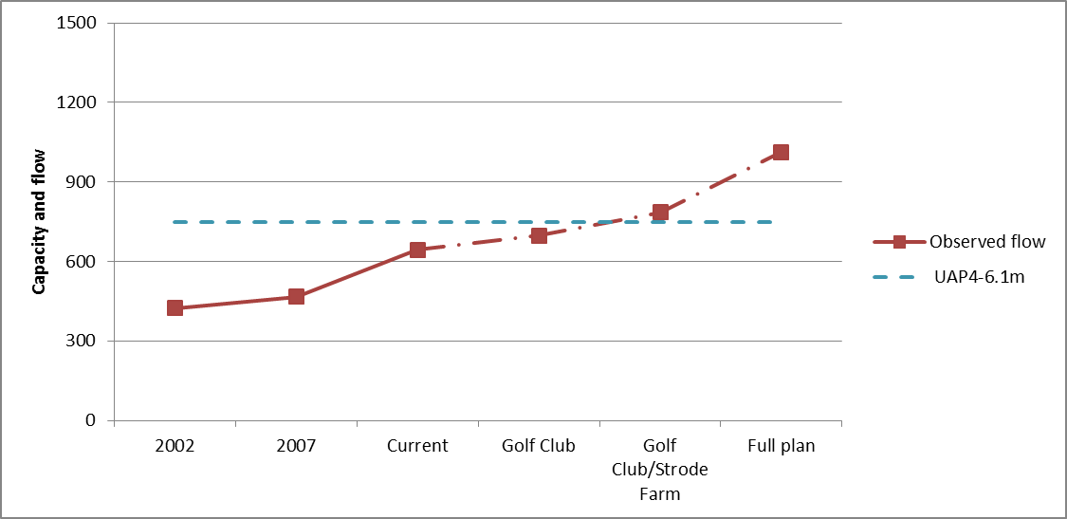

**Figure 4-2: Herne - Forecast Link Flow vs Capacity (AM peak)**

### The graph indicates that the level of flow on the A291 through Herne would still operate within theoretical capacity with the addition of HBGC flows only.

### The addition of Strode Farm and HBGC projected flows would push certain locations along the link over their theoretical capacity where the road is classified as a UAP4 road narrows to a width of 6.1 metres or less.

### The projected flows associated with the scenario with all strategic sites would result in a significant increase in flow on the A291.

## Junction Capacity / Network Assessments

### Junction capacity / network assessments have also been undertaken in both Sturry and Herne. For Sturry, due to the interconnected nature of the junctions with each other and the level crossing, the A291/A28 has not been assessed as a stand-alone junction. A wider network assessment in VISSIM has been used.

#### Sturry - A291/Sweechgate

### The A291/Sweechgate junction, located to the north of Sturry, is a priority ‘T’ junction which provides access to the alternative route to the city centre via Shalloak Road.

### **Table 3** below provides a summary of the PICADY assessments undertaken at the junction to represent the baseline and 3 forecast scenarios for both the AM and PM peak periods.

| Arm | 2015 Base | | HBGC only | | HBGC & Strode Farm only | | All Sites | |
| --- | --- | --- | --- | --- | --- | --- | --- | --- |
| **RFC** | **Max Q** | **RFC** | **Max Q** | **RFC** | **Max Q** | **RFC** | **Max Q** |
| AM Peak | | | | | | | | |
| A291(N) right turn | 0.93 | 12 | 1.03 | 30 | 1.2 | 84 | 1.51 | 255 |
| Sweechgate to A291(N) | 0.22 | 1 | 0.27 | 1 | 0.46 | 1 | 9999 | 137 |
| Sweechgate to A291(S) | 0.32 | 1 | 0.39 | 1 | 0.68 | 2 | 9999 | 53 |
| PM Peak | | | | | | | | |
| A291(N) right turn | 0.33 | 1 | 0.37 | 1 | 0.43 | 1 | 0.54 | 2 |
| Sweechgate to A291(N) | 1.07 | 21 | 1.17 | 36 | 1.35 | 70 | 1.79 | 173 |
| Sweechgate to A291(S) | 1.04 | 10 | 1.13 | 15 | 1.32 | 25 | 1.76 | 55 |

**Table 3: A291/Sweechgate Junction – Capacity Assessment Summary**

### The capacity assessments indicate that right turn from the A291(N) into Sweechgate is currently busy during the AM peak and causes some queueing and delay. Conversely the Sweechgate minor arm is over capacity and observes some queuing during the PM peak. This is due to the tidal nature of traffic using the Broad Oak alternative route to access the city centre.

### The addition of flows related to the ‘all sites’ scenario would have a severe impact on the junction with significant increases in queuing and delay. In particular, during the AM peak the assessment indicates that the junction would completely ‘lock-up’ which is represented with an RFC error value of 9999.

#### Sturry - A28/Fordwich Rd

### The A28/Fordwich Rd is a priority junction located in Sturry to the south of the railway line and provides access to the village of Fordwich.

### Table 4 below provides a summary of the PICADY assessments undertaken at the junction to represent the baseline and 3 forecast scenarios for both the AM and PM peak periods.

| Arm | 2015 Base | | HBGC only | | HBGC & Strode Farm only | | All Sites | |
| --- | --- | --- | --- | --- | --- | --- | --- | --- |
| **RFC** | **Max Q** | **RFC** | **Max Q** | **RFC** | **Max Q** | **RFC** | **Max Q** |
| AM Peak | | | | | | | | |
| A28(W) right turn | 0.01 | 0 | 0.01 | 0 | 0.01 | 0 | 0.04 | 0 |
| Fordwich Rd | 0.67 | 2 | 0.78 | 3 | 1.02 | 9 | 9999 | 205 |
| PM Peak | | | | | | | | |
| A28(W) right turn | 0 | 0 | 0 | 0 | 0 | 0 | 0.01 | 0 |
| Fordwich Rd | 0.96 | 8 | 1.08 | 15 | 1.29 | 30 | 8.14 | 228 |

**Table 4: A28/Fordwich Rd Junction – Capacity Assessment Summary**

### The addition of flows related to the ‘all sites’ scenario would have a severe impact on the junction with significant increases in queuing and delay. In particular, during the AM peak the assessment indicates that the junction would completely ‘lock-up’ which is represented with an RFC error value of 9999.

#### Sturry – Network Assessment

### An assessment of the network through Sturry has been developed by extracting information from a VISSIM model which has been used to test the value for money for the proposed Sturry Link Rd scheme. The approach used analyses journey times through the network (origin-destination) rather than, specifically, individual junction operation. Any delays at junctions form part of the overall journey time.

### The forecast capacity issues are demonstrated by showing how the introduction of the link road (Do Something (DS) scenario) would reduce the journey times compared with forecast journey times through the existing network (Do Minimum (DM) scenario). This is particularly noticeable in the forecast year, where the existing network limitations are clearly under extreme pressure (**Figure 4-3**).

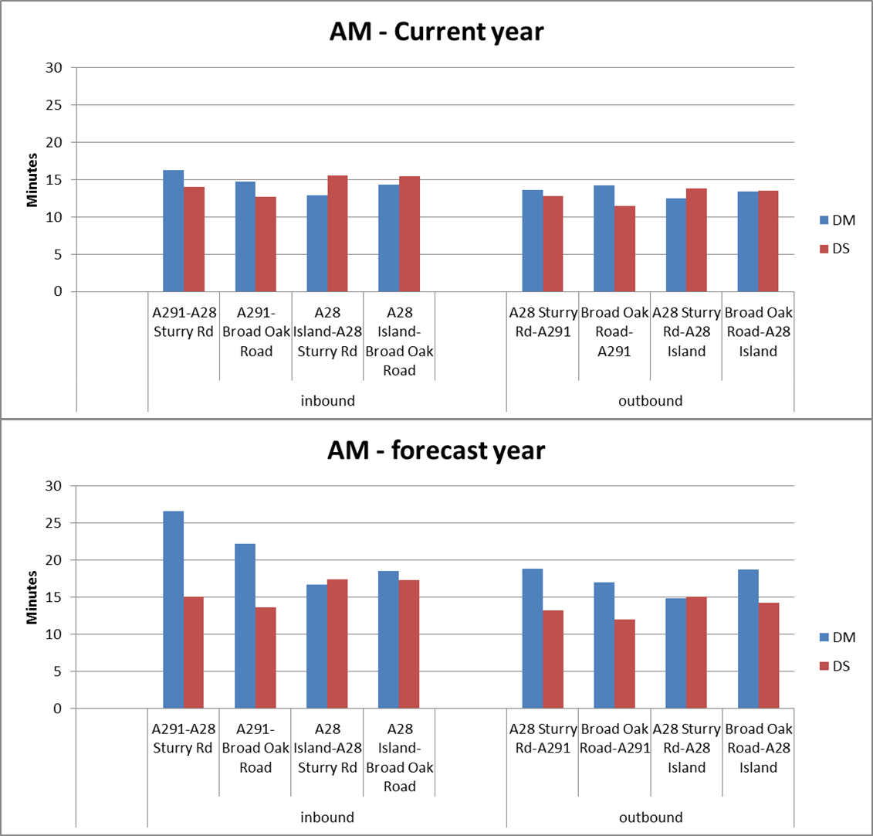

**Figure 4-3: Forecast Journey Times (AM Peak) with/without Sturry Link Rd**

#### Sturry – A28/A91 Junction

### Further outputs have been derived from the wider VISSIM assessment in order to provide an indication of the current and forecast (with and without the Sturry Link Rd) level of congestion and delay at the A28/A291 junction in Sturry.

| All Movements | 2015 Base | Forecast Do Minimum | Forecast Do Something |
| --- | --- | --- | --- |
| Vehicles | 1741 | 2070 | 1841 |
| Average Delay (secs) | 56 | tbc | 32 |
| Total Vehicle Delay (veh mins) | 1637 | tbc | 979 |
| Ave Q (metres) | 72 | 205 | 105 |

#### Table 5: A28/A291 Junction – VISSIM Output Summary (AM Peak)

### The above metrics indicate that the level of traffic through the junction will increase in the forecast scenarios, although more significantly in the Do Minimum (without Sturry Link Rd) scenario.

### When comparing the delays at the junction between the 2015 Base and forecast Do Something (with Sturry Link Rd) scenario, despite an increase in traffic, the forecast average and total delays at the junction are anticipated to decrease. This decrease suggests that the existing junction arrangement currently operates over capacity with significant delays.

### A comparison between the forecast Do Minimum and Do Something scenarios shows that the implementation of the Sturry Link Rd would significantly decrease the average queue length observed at the junction. This further indicates that the existing junction arrangement would come under increasing pressure in terms of congestion if the proposed mitigation scheme was not provided.

#### Herne Village

### The mini-roundabout in Herne allows traffic from Broomfield to the east to join with the A291 mainline traffic from Herne Bay, and the A299 Thanet Way, to Canterbury. This junction contributes to the capacity constraints of the network through Herne.

### **Table 6** below provides a summary of the ARCADY assessments undertaken at the junction to represent the baseline and 3 forecast scenarios for both the AM and PM peak periods.

| Arm | 2015 Base | | HBGC only | | HBGC & Strode Farm only | | All Sites | |
| --- | --- | --- | --- | --- | --- | --- | --- | --- |
| **Max Q** | **RFC** | **Max Q** | **RFC** | **Max Q** | **RFC** | **Max Q** | **RFC** |
| AM Peak | | | | | | | | |
| School Ln | 2 | 0.68 | 3 | 0.76 | 8 | 0.91 | 87 | 1.39 |
| A291 (S) | 1 | 0.57 | 2 | 0.62 | 3 | 0.71 | 8 | 0.90 |
| A291 (N) | 2 | 0.62 | 2 | 0.67 | 3 | 0.76 | 21 | 1.00 |
| PM Peak | | | | | | | | |
| School Ln | 1 | 0.4 | 1 | 0.45 | 1 | 0.54 | 3 | 0.76 |
| A291 (S) | 3 | 0.75 | 4 | 0.81 | 9 | 0.92 | 91 | 1.20 |
| A291 (N) | 2 | 0.70 | 3 | 0.76 | 6 | 0.87 | 59 | 1.13 |

#### Table 6: Herne Mini-roundabout – Capacity Assessment Summary

### The addition of flows related to the ‘all sites’ scenario would have a severe impact on the junction with significant increases in queuing and delay.

# Conclusions

### The A28 and A291 corridors have a complicated network with a variety of highway layout issues, especially a level crossing near the priority junction of the A28/A291. Irregular driver behaviour and junction operation exists due to the network.

### Rat-running is present through Broad Oak to avoid Sturry, using less appropriate roads. This has relieved some of the pressure of the current situation; but should not be actively encouraged as higher than average accident rates have occurred on the alternative route.

### The ‘mainline’ A28 inbound has sustained queuing, particularly during the AM peak period.

### Despite a broadly functioning network at present, there is a concern over resilience; particularly with increased traffic flows. In particular, the capacity at the Sturry level crossing is close to being met and will be exceeded with the addition of traffic associated with strategic development sites.

### In addition to the proposed strategic sites, other smaller sites will also add to existing traffic levels.

### A road casualty reduction strategy should be considered for the corridor; particularly on the A291 section of the route.

### The addition of traffic from all of the strategic sites will have a significant and severe impact on the study corridor both at link and junction level. Mitigation is required to enable the growth set out in the emerging Local Plan.

### Highway improvements are necessary to accommodate the Local Plan aspirations for the north-east quadrant of the district. The proposed Herne Relief Rd and Sturry link Rd are acknowledged as part of the solution; however, further mitigation may also be required at the A28/Sweechgate junction.