Canterbury District
Local Plan

Potential Main Modifications
At 28th April 2016



Potential Main Modifications at 28th April 2016

This document contains a set of potential Main Modifications (as at 28 April 2016), which the Planning Inspector has asked us to provide to him by 29 April 2016.

The proposed changes have been made in order that the Plan reflects changes in national legislation and guidance, such as the National Planning Policy Framework; requirements set out by statutory bodies; and changes in circumstances since the Plan was submitted including new information provided with planning applications;. These changes respond to the Inspector points raised at Stage 1 of the Examination, and are made in order to ensure that the Local Plan is sound and legally compliant.

All Policy/ Paragraph or Figure numbers are taken from the Publication Draft Local Plan (June 2014).

The potential Main Modifications are listed in the order they appear in the Plan.

Modifications are defined as “Main” where they usually involve a change to a policy or other text, which would impact upon the implementation of policy.

The modifications are expressed in the conventional form of strikethrough for deletions and underlining for additions.

Note:
……… - means that further text sits before or after the proposed amendment
CCC - stands for Canterbury City Council

After the hearings have concluded, the Inspector will decide on the main modifications that he considers necessary for the plan to be sound or legally compliant. This may involve some further modifications to those in this schedule or changes to the wording of those proposed by the Council. The final schedule of main modifications will be subject to public consultation and the comments received taken into account by the Inspector in his final report on the Local Plan.

Note: Minor changes that ensure the text in the Local Plan is as up to date as possible, for example updates to document names and publication dates etc are known as “Additional Modifications” and these are not presented within this document, as they do not relate to the soundness of the plan. A schedule of “Additional Modifications” will be prepared separately following the close of the Examination hearings, and subject to approval, it is anticipated that these will also be subject to public consultation.

Reference | Page |  |  | Policy/  Paragraph | Main Modification | Why change is necessary?
Introduction

MM0.1 | 10 |  |  | Key Diagram | Insert Key Diagram into Introduction section  (to follow) | National Planning Policy Framework  Stage 1 Examination
Chapter 1: Strategy

MM1.1 | 11 |  |  | Plan objectives | To protect and enhance the built and natural environment | National Planning Policy Framework  Natural England
MM1.2 | 22 |  |  | SP1 | Delete paragraph 3  Where the Council considers that a proposal would directly undermine the strategy for sustainable development set out in this plan, such proposals will not be approved. | National Planning Policy Framework
MM1.3 | 23 |  |  | SP2 | Amend table as set out below | National Planning Policy Framework  Stage 1 Examination  Reflect Canterbury Retail and Leisure Study (June 2015) (CDLP 6.3)
Policy SP2 Development Requirements

Land is allocated to meet the identified development requirements and guidelines, as set out below.

Development  type | 2011-16 |  | 2016-21 | 2021-26 | 2026-31 |  | Total  (2011–31)
Housing (units)* | 3,000  2,500 |  | 4,200  4,500 | 4,200  4,500 | 4,200  4,500 |  | 15,600  16,000
Employment  land  (B1, B2 and  B8) (sqm) | 25,000 |  | 25,000 | 23,775 | 23,000 |  | 96,775
Other employment uses |  |  |  | To be provided as part of identified employment sites
Retail  provision |  | Area |  | Convenience |  | Comparison
 |  | Canterbury ** |  | 0 sqm |  | 50,000 sqm
 |  | Herne Bay *** |  | 0 sqm |  | 0 sqm
 |  | Whitstable |  |  |  | 3,250 sqm
Retail ***

Comparison Goods  Canterbury** | 0 sqm |  | 8,564 sqm | 11,360 sqm | 13,876 sqm |  | 33,800 sqm
Convenience Goods | 0 sqm |  | 0 sqm | 266 sqm | 2,342 sqm |  | 2,608 sqm

*This is a broad phasing, and a detailed trajectory is set out in Appendix 2 3. The mix of housing types and tenures will be expected to meet the proportions set out in the Council’s Housing Strategy
**After completion of outstanding permissions
***On completion on Central Development Area
** This relates to Canterbury District, not just the City of Canterbury.
*** The City Council will review the retail capacity of the District approximately every 5 years and any future studies within the plan period will become a material planning consideration.

MM1.4 | 24 |  |  | SP3,  Site 1, South Canterbury | Amend table – Other  Local community “hub”; land for two primary schools (each of no less than 2.05ha) and contributions to primary and secondary school education; doctor’s surgery; health care provision; extended park & ride at Dover Road; land reserved for potential relocation of Kent & Canterbury Hospital, if required; 70ha 30ha of new public open space, including allotments; 20ha and new woodland planting | Kent County Council, Education  Canterbury and Coastal Clinical Commissioning Group  Open space and woodland planting amended In line with revised draft Open Space Strategy, which is to be adopted following adoption of Local Plan
MM1.5 | 25 |  |  | SP3,  Site 2  Land at  Sturry/  Broad Oak | Amend table – Other  Other Community facilities to be determined in conjunction with parish council; contribution to land for primary school (no less than 2.05ha) and contributions to primary and secondary school education; health care provision; protection and management of all remaining ancient woodland; provision of new open space; public gardens; parkland and playing fields | Kent County Council, Education  Canterbury and Coastal Clinical Commissioning Group
MM1.6 | 25 |  |  | SP3,  Site 3  Hillborough site, Herne Bay | Amend table – Other  doctor’s surgery; Health care provision; community facilities; land for primary school (no less than 2.05ha) and contributions to primary and secondary school education | Kent County Council, Education  Canterbury and Coastal Clinical Commissioning Group
MM1.7 | 25 |  |  | SP3,  Site3  Hillborough site, Herne Bay | Amend table – Infrastructure  New link to Thanet Way via Altira Park and limited access to Sweechbridge Road; provision of new west-facing on-slip to Thanet Way at the Heart-in-Hand junction; measures to discourage additional traffic using Heart-in-Hand road; proportionate contribution (to be agreed) towards the provision of Herne Relief route and new Sturry crossing. | To comply with CIL regulations
MM1.8 | 25 |  |  | SP3,  Site3  Hillborough site, Herne Bay | Amend Proposals Map (Inset 3, Herne Bay)  Amend boundary to include small additional areas to the north, east and west of the site | Site Developer
MM1.9 | 26 |  |  | SP3,  Site 4  Herne Bay Golf Course | Amend table – Other  8ha of sports & leisure facilities, including cricket, football, hockey, tennis and open space; 1.25ha set-aside for Herne Bay High School; doctor’s surgery; health care provision; care home; contributions to primary and secondary school education | Kent County Council, Education  Canterbury and Coastal Clinical Commissioning Group
MM1.10 | 26 |  |  | SP3,  Site 4  Herne Bay Golf Course | Amend table – Infrastructure  Proportionate contribution (to be agreed) towards the provision of Herne Relief Road route and new Sturry Crossing; new footpath/cycle path to be provided in conjunction with site 5 (Strode Farm, Herne Bay) to link sites 4 and 5 | To comply with CIL regulations
MM1.11 | 26 |  |  | SP3,  Site 5  Strode Farm,  Herne Bay | Amend table - Other  Community facilities, including new parish hall and local needs housing; land for primary school (no less than 2.05ha) and contributions to primary and secondary school education; health care provision | Kent County Council, Education  Canterbury and Coastal Clinical Commissioning Group
MM1.12 | 26 |  |  | SP3,  Site 5  Strode Farm,  Herne Bay | Amend table – Infrastructure  Facilitate and contribute to the provision of the Herne Relief Road, as indicated on the proposals map Provision of new relief route for Herne, as indicated on the proposals map; proportionate contribution (to be agreed) towards the provision of new Sturry Crossing; new footpath/cycle path to be provided in conjunction with site 4 (Herne Bay Golf Course) to link sites 4 and 5 | To comply with CIL regulations  To provide clarity
MM1.13 | 26 |  |  | SP3,  Site 6,  Land at Greenhill, Herne Bay | Amend table – Infrastructure  Proportionate contribution (to be agreed) towards the provision of new relief route for Herne Relief Road and new Sturry Crossing. | To comply with CIL regulations
MM1.14 | 26 |  |  | SP3,  Site 6,  Land at Greenhill, Herne Bay | Amend table – Other  Community facilities to be determined; recreation & leisure facilities; new allotment provision; provision of 720sqm of land for the expansion of the existing primary school from 1 form entry to provide 2 form entry and contributions to primary and secondary school education; health care provision | Kent County Council, Education  Canterbury and Coastal Clinical Commissioning Group
MM1.15 | 27 |  |  | SP3,  Site 7,  Thanet Way, Whitstable | Amend table – Other  Extension of Duncan Down Country Park;  additional public open space, including allotments; provision of a bus route | Planning Application
MM1.16 | 27 |  |  | SP3,  Site 7,  Thanet Way, Whitstable | Amend Proposals Map (Inset 5, Whitstable)  Amend boundary to include small area to the north-east of site | Planning Application
MM1.17 | 27 |  |  | SP3,  Site 8,  Land North of Hersden | Amend table – Housing  5 800 dwellings | Stage 1 Examination
MM1.18 | 27 |  |  | SP3,  Site 8,  Land North of Hersden | Amend text - Other  New community building; play areas and allotments; multi-use games area; Provision of 0.6695ha of land for expansion of existing primary school from 1 form entry to provide a 2 form entry and provision of the main school vehicular access through Site 8; contributions to primary and secondary school education; health care provision | Kent County Council, Education  Canterbury and Coastal Clinical Commissioning Group
MM1.19 | 27 |  |  | SP3,  Site 8,  Land North of Hersden | Amend Proposals Map (Inset 1, Canterbury)  Amend boundary to follow field boundary to the north of the site and to include the track and Joiners Farm (small area within site that was excluded in Publication Draft June 2014) | Site developer has provided updated information
MM1.20 | 28 |  |  | SP3,  Site 9,  Land at Howe Barracks, Canterbury | Amend Proposals Map (Inset 1, Canterbury)  Amend boundary of Strategic Site Allocation in line with Planning Application | Planning Application
MM1.21 | 28 |  |  | SP3,  Site 10,  Land at Kent & Canterbury Hospital, Ridlands Farm and Langton Field, Canterbury | Amend table – Housing  Remove Kent and Canterbury Hospital part of site  Amend as below | Stage 1 Examination  Proposed Amendments November 2015  Approved by CCC November 2015
SP3,  Site 10,  Land at Kent & Canterbury Hospital, Ridlands Farm and Langton Field, Canterbury | Housing | 810 310 dwellings
 | Other | Provision of public open space within the site including play areas; multi-use games area; contributions to primary and secondary school education; community and local facilities to be determined; health care provision
 | Infrastructure | Provision of fast bus link route from the South Canterbury site to South Canterbury Road  (and subject to acceptable proposals for the relocation of the existing Hospital to the South Canterbury site)

MM1.22 | 28 |  |  | SP3,  Site 10,  Land at Kent & Canterbury Hospital, Ridlands Farm and Langton Field, Canterbury | Amend Proposals Map (Inset 1, Canterbury)  Amend boundary to exclude Kent and Canterbury Hospital part of strategic site allocation | Stage 1 Examination  Proposed Amendments November 2015  Approved by CCC November 2015
MM1.23 | 28 |  |  | SP3,  Site 11,  Land at and adjacent Cockering Farm, Thanington | Insert new proposed strategic site allocation site – see below | Stage 1 Examination  Proposed Amendments November 2015  Approved by CCC November 2015  Note: CCC have amended the boundary slightly from that shown in Proposed Amendments November 2015 to remove the small part of garden area at Milton Manor Farm, which was included on the submitted plan by the site promoter in error.  Kent County Council, Education  Canterbury and Coastal Clinical Commissioning Group
SITE 11 | DEVELOPMENT | AMOUNT/TYPE
Land at and adjacent Cockering Farm, Thanington | Housing | 1,150 dwellings
 | Employment space | 1.5ha
 | Other | Provision of public open space within the site; Allotments; land for Primary School (no less than 2.05ha) and contributions to primary and secondary school education; Community and local facilities; Play areas; Multi-use games area; health care provision, new additional woodland planting to enhance the Larkey Valley Local Nature Reserve
 | Infrastructure | New A2 off slip at Wincheap and associated highway improvements at the junction with Ten Perch Road and extended westbound slip road off the A2; Improved/ new road link to Cockering Road; Bus and footpath/cyclepath links; Contribution to expansion of Wincheap Park and Ride; provision of Wincheap Relief Road and highway improvements at Wincheap Green roundabout

MM1.24 | 28 |  |  | SP3,  Site 11  Land at and adjacent to Cockering Farm, Thanington | Update Proposals Map (Inset 1, Canterbury)  Include new proposed strategic site allocation, Land at and adjacent to Cockering Farm, Thanington | Stage 1 Examination  Proposed Amendments November 2015  Approved by CCC November 2015
MM1.25 | 28 |  |  | SP3,  Site 12,  Land South of Ridgeway (John Wilson Business Park), Whitstable | Insert new proposed strategic site allocation – see below | Stage 1 Examination  Proposed Amendments November 2015  Approved by CCC November 2015  Kent County Council, Education  Canterbury and Coastal Clinical Commissioning Group
SITE 12 | DEVELOPMENT | AMOUNT/TYPE
Land South of Ridgeway (John Wilson Business Park), Whitstable | Housing | 300 dwellings
 | Employment space | 1ha
 | Other | Land for Primary School (no less than 2.05ha) and contributions to primary and secondary school education; Local facilities; Improved public open space, including play area and multi-use games area; health care provision
 | Infrastructure | Highway improvements to roundabout at junction of A2990 Thanet Way and Reeves Way, Whitstable

MM1.26 | 28 |  |  | SP3,  Site 12,  Land South of  Ridgeway (John Wilson Business Park), Whitstable | Update Proposals Map (Inset 5, Whitstable)  Include new strategic site allocation Land South of Ridgeway | Stage 1 Examination  Proposed Amendments November 2015  Approved by CCC November 2015
MM1.27 | 28 |  |  | SP3 | Amend text  Detailed development briefs shall be prepared for these sites prior to the granting of planning permission, setting out the detailed requirements for the site; The developer of these sites shall prepare a masterplan, having regard to the Statement of Community Involvement, to accompany a planning application for planning permission. The masterplan shall include the detailed requirements for the site; the anticipated phasing of development, including the and physical and social infrastructure through the plan period; and design and other planning requirements for the site, reflecting “garden city” principles (Appendix 52). Development proposals submitted for these sites shall be in accordance with the total requirements of this policy. and the development brief.  Development proposals shall include a schedule for delivery of the total requirements for the site, and shall include an appropriate mechanism to ensure delivery in a timely and co-ordinated manner. Development should and also meet the requirements of other policies in this Local Plan; the provisions of any supplementary planning documents and any other relevant and any other relevant guidance prepared by the Council.  Development proposals for these sites that do not meet these criteria shall will not be permitted. | Stage 1 Examination  National Planning Policy Framework
MM1.28 | 30 |  |  | SP4 | Amend text  The urban areas of Canterbury, Herne Bay and Whitstable will continue to be the principal focus for development, with a particular focus at Canterbury, together with development at some of the rural service centres and local centres. Policy SP3 identifies the key sites for mixed-use development. Development at these sites will be subject to development briefs or masterplans, setting out the amounts and types of development and their phasing, along with any infrastructure requirements.  In addition to the development allocations set out in this plan:  1. In the urban areas of Canterbury, Herne Bay and Whitstable, new housing development will be supported on suitable sites, where this would be acceptable in terms of environmental, transport and other planning factors, and would not result in the loss of sites identified for business and other specific uses;  2. Small-scale pProvision of new housing that is of a size, design, scale, character and location appropriate to the character and built form of the rural service centres of Sturry and the local centres of Barham, Blean, Bridge, Chartham (including Shalmsford Street), Hersden and Littlebourne and Sturry will be supported provided that such proposals are not in conflict with other local plan policies relating to transport, environmental and flood zone protection and design, and those of the Kent Downs AONB Management Plan, where applicable;  3. In the identified villages of Adisham, Bekesbourne, Bossingham, Broad Oak, Hoath, Kingston, Petham, Rough Common, Tyler Hill, Upstreet, and Wickhambreaux, priority will be given to protecting the rural character of the district and minor infill development (or development to meet an identified local need for affordable housing) of an amount appropriate to the size of the settlement, in a location appropriate to the form of the settlement and of a design and scale that respects and enhances the character of the village;  will be restricted to minor development or infill, or that which is needed to meet an identified local need for affordable housing only;  4. Development At the identified hamlets of Chartham Hatch, Chislet, Bishopsbourne, Fordwich, Harbledown, Ickham, Lower Hardres, Patrixbourne, Stodmarsh, Upper Harbledown, Upper Hardres, Waltham, Westbere, Womenswold, Woolage Green, and Woolage Village development will be permitted will be limited to only that which specifically meets an identified local need; and  5. In the open countryside, development will be permitted normally be limited to that if required for agriculture and forestry purposes (see Policy EMP13). | Stage 1 Examination  National Planning Policy Framework
MM1.29 | 32 |  |  | 1.71 | Amend text  The City Council will expect all the allocated strategic sites to include reasonable and proportionate provision for new green infrastructure, and to meet the requirements of the Habitat Regulations for alternative open space to protect international wildlife sites. to meet the recreational needs of the local residents, deliver sustainable development and support health and wellbeing. | Natural England
MM1.30 | 32 |  |  | SP5 1. | Amend text  Provide measures to protect and enhance biodiversity and meet ensure that the requirements of the habitats regulations are met, and | Natural England
MM1.31 | 32 |  |  | SP5 | Amend text  5. Conserve and enhance the Kent Downs AONB, as guided by the Kent Downs Management Plan (as revised). | Stage 1 Examination  AONB
MM1.32 | 34 |  |  | 1.80 | Amend text  Habitat Regulations matters and mitigation measures. Strategic Access Management and Monitoring (SAMM) Mitigation Measures to address in-combination recreational impacts on the coastal SPA, and Ramsar sites  The City Council has taken into account the findings of its Sustainability Appraisal and Habitat Regulations Assessment work and the advice of Natural England, and has agreed a mitigation strategyies with Natural England to deal with any potential likely significant effect of resulting from new development in the District, from in particular recreational disturbance on the coastal SPA’s and RAMSAR’s resulting from the strategic sites allocated under SP3. The City Council has also begun undertaken a series of visitor surveys to establish “zones of influence” for the sensitive coastal areas relative to the main areas of settlement, to be reviewed if monitoring indicates a need. | In line with current SAMMs
MM1.33 | 34 |  |  | 1.81 | Amend text  The Mitigation strategies will be developed and implemented for the two coastal sites – Thanet Coast and Sandwich Bay SPA / Ramsar and the Swale SPA / Ramsar . for the strategic sites in the draft Plan They are likely to comprises the following measures:  (1) Wardening of the sensitive international wildlife sites, together with increased signage and education, to be funded by new development sites in perpetuity, in accordance with guidance to be prepared by the City Council;  (2) Ongoing monitoring and surveys of sensitive sites across the District, particularly in relation to visitors and bird numbers, to be funded via the wardening programme (the results of the monitoring will be used to review the ongoing delivery of the mitigation);  (3) Consideration of any other measures shown to be as required or appropriate to mitigate recreational impacts of development, for example:, where shown to be appropriate, provision of alternative natural green space could form part of the mitigation measures for the Swale SPA, (for the Swale SPA there is the potential need for SANGs to be provided on some strategic sites in addition to the access management measures identified).access management;  4) The provision of open space on strategic development sites, as set out in the Council’s Development Contributions SPD, including new habitat areas, which contribute to habitat networks, provide alternative informal recreational opportunities (thereby contributing to quality of life, health benefits, potentially reducing pressure on the more sensitive designated sites and contributing to biodiversity gain), and to seek to create new links to the non-designated countryside. The Green Infrastructure Strategy will provide further guidance. | In line with current SAMMs
MM1.34 | 35 |  |  | 1.82 | Amend text  A dDetailed strategies setting out necessary contributions to an in-perpetuity funds and required detailed mitigation measures is are being prepared will be available, and contributions will need to be made in accordance with that those strategies. As all Housing sites and other new development proposals in the district within the identified zone of influences, that are likely to have result in significant recreational effects alone or in-combination on the international coastal wildlife sites, it is anticipated that contributions will take the form of a flat-rate tariff to address all the measures across the district. will be expected to contribute to a tariff to deliver the measures required to mitigate their effects. | In line with current SAMMs
MM1.35 | 35 |  |  | 1.83 | Amend text  The City Council will also continue to work with the other north Kent and east Kent authorities to ensure that there is a joint approach to the consideration of cross-boundary effects, implementation of mitigation and monitoring strategies, and to the long-term development and management of green infrastructure in the area to provide sustainable recreational areas for residents and, where shown to be appropriate, provision of alternative natural green spaces.. Part of the contribution to wardening and other measures will be towards the funding of the North Kent marshes management arrangements | In line with current SAMMs
MM1.36 | 35 |  |  | 1.84 | Amend text  On this basis, Natural England and the City Council are of the view that an Appropriate Assessment of the draft Canterbury District Local Plan under the Habitat Regulations is not required. Development that contributes to the appropriate SAMM or other approved strategic measures will mitigate its impact and will not require Appropriate Assessment for recreational effects on that SPA or Ramsar. | Natural England
MM1.37 | 35 |  |  | 1.85 | Amend text  However, there may be Other development proposals may arise during the lifetime of the Plan, which might may have a likely significant effect on the international wildlife sites within or adjacent to the district and thesey proposals will also need to be assessed under the Habitats Regulations in line with Policy LB5 subject to the same provisions. The following Policy is therefore applicable to all the allocated sites (particularly the strategic sites) in the Plan. It should be noted that the current mitigation measures outlined in the coastal SAMMs have been designed to mitigate recreational impacts from the housing numbers proposed in the Local Plan. Any significant changes in housing numbers would require the reassessment of these measures and their ability to mitigate further impacts and may require additional measures. Policy LB5 is also applicable to all new development proposals. | Natural England
MM1.38 | 36 |  |  | SP7 | Amend text and District Proposal Map, Insets 3, 4, 5 & 6 to include SAMMS Zones of Influence within the Canterbury District.  No development will be permitted, which may have an adverse effect on the integrity of an the coastal sites being the Thanet Coast and Sandwich Bay SAC, SPA and Ramsar Site and Swale SPA and Ramsar, alone, or in combination with other plans or projects, through an increase in recreational disturbance on the over-wintering bird populations for which these sites are designated. and where it cannot be demonstrated that there would be no adverse effect on the integrity of the sites. As such, the strategic development sites identified in the Plan and any other developments within the identified zone of influence, which would lead to an increase in recreational disturbance, are would therefore be required to fund, in-perpetuity, the following mitigation measures access management and monitoring measures to mitigate these impacts, including:  (1) Wardening of sensitive international wildlife sites the coastal SPA and Ramsar sites, signage and interpretation , and increased education, to be funded by the development in perpetuity; and,  (2) Ongoing monitoring and surveys of the sensitive sites in the district to, particularly with regard to visitors and bird numbers, which will be linked to funded via the wardening programmes; and,  (3) Consideration of Any other measures as shown to be required or appropriate to mitigate the effects of development; for example, where shown to be appropriate, provision of alternative natural green space could form part of the mitigation measures for the Swale SPA). access management;  (4) The provision of open space on new sites, as set out in the Council’s Development Contributions SPD.  (4) Contributions will be made in accordance with the guidance prepared by the City Council. Any tariff will comprise a one off payment incorporating a levy for annual expenditure to operate the mitigation strategy and a portion for capital investment to fund wardening and mitigation measures in-perpetuity. | Natural England
Chapter 2: Housing Development

MM2.1 | 41 |  |  | 2.17 | Amend text  The NPPF states that local planning authorities should set out the strategic priorities for the area in the Local Plan. This should include strategic policies to deliver housing and economic development requirements. The City Council therefore, appointed Nathaniel Lichfield and Partners (NLP) to undertake a development requirements study for the District, which was published in January 2012. In 2015, NLP updated the evidence on housing needs contained within the Strategic Housing Market Assessment (2009) and the development requirements study (2012). This housing needs review provided evidence on the objectively assessed housing needs of the District, in line with the NPPF and Planning Practice Guidance. It concluded that the objectively assessed housing need for the District fell within the range 744 to 853 dwellings per annum (dpa). | Stage 1 Examination  Amend text to provide current position
MM2.2 | 41 |  |  | 2.18 | Amend text  The City Council has set the development requirements for the District in line with scenario E of the NLP report which equates to 780 dwellings per annum at 800 dwellings per annum in order to meet the identified objectively assessed housing needs. This gives a 20 year District requirement for 2011-2031 of 15,600 16,000 additional homes units, however, there are some unimplemented sites already in the supply. In addition to the strategic requirement the NPPF states that in order to significantly boost the supply of housing, local planning authorities should identify and update annually, a supply of deliverable sites sufficient to provide 5 years worth of housing against their housing requirements with an additional buffer of 5% to ensure choice and competition in the market. This can be moved forward from later in the plan period. It is also recommended that the buffer be increased to 20% where there is evidence of persistent under delivery. This is not the case in the District over the last 10 years as the annual delivery has been over the former South East Plan annual requirement of 510 pa, 60% of the time and more than doubled the requirement in monitoring year 2007/08 resulting in an overprovision of 1000+ units for the period 2006-11. Therefore as land can be brought forward there is only potentially an issue with the 5 year supply in the final 5 year period (2026-31). Therefore the City Council has applied an additional 5% buffer of 195 units (780pa x 5% x5years). | Stage 1 Examination  Amend text to provide current position
MM2.3 | 42 |  |  | 2.20 | Amend text  The total housing land supply is for the plan period will be made up of a number of elements:  - Completions - the net number of new dwellings created annually is deducted from the District’s requirement which leaves the residual requirement;  - Unidentified sites contribution (windfalls) - this is made up of two elements:  - Unidentified small sites - an estimate of the number of dwellings which will be built on unidentified small sites accommodating fewer than 5 dwellings, based on past trends;  - Unidentified large sites - sites accommodating 5 or more dwellings which are not allocated in the plan.  The City Council makes a windfall allowance of 138 dpa within the plan period for small sites only, based on historic trends. These Windfall sites enter the supply as commitments once they have been granted planning permission. Therefore, they are excluded from the first 3 years of the 5 year supply to avoid double counting with commitments.  ………………… | Stage 1 Examination  Amend text to provide current position
 | 42 |  |  | 2.21 | Amend text  Students have an impact on the privately rented sector supply of housing in Canterbury as set out in paragraph 2.13 and there has been some debate as to whether development of student accommodation can be included in the housing land supply. Government advice as set out in the CLG definition of general housing terms (https://www.gov.uk/definitions-of-general-housing-terms) has stated Government's Planning Practice Guidance sets out that “all student accommodation, whether it consists of communal halls of residence or self-contained dwellings, and whether or not it is on campus, can be included towards the housing provision in local development plans”. However, it notes that Councils should take steps to avoid double-counting. As such the recent approach taken by planning inspectors is that student accommodation can be included in the supply only if it is taken into account in the requirement. The  cCity Council’s approach is to exclude purpose built student accommodation from counting towards the housing requirement, this includes halls of residence or other student accommodation blocks which are purpose built and solely available for student occupation. include in the supply those self-contained units, up to 6 bedrooms, which are either built as flats/apartments and then subsequently let to students or purpose built flats that could be sold on the open market in the future. Halls of residence These will typically comprise units within Use Classes C1 or C2 and are recorded separately by the Council but are not included in the housing supply. Self-contained dwellings, which are built as market housing and subsequently let to student households will be counted towards the housing requirements and included within housing land supply. This is consistent with how the housing needs evidence for the Local Plan has been formed. The City Council will keep this approach under review in light of changing Government guidance. | Stage 1 Examination  Planning Practice Guidance  Amend text to provide current position
MM2.4 | 43 |  |  | 2.22 | Amend text  Housing land supply is continuously monitored and the total land supply is set out annually in the Housing Information Audit (HIA) carried out by the City Council in conjunction with Kent County Council. In order to ensure that there is a controlled delivery of new housing there will need to be regular monitoring. If it becomes apparent that the pace of delivery of new housing is too slow the City Council may have to adjust the phasing to allow those sites that are to be released later in the plan period to come forward earlier. This will be adjusted The City Council will update a housing trajectory, and consider phasing of sites, in consultation with the developers of those sites via the annual phasing questionnaire sent out to developers as part of the annual HIA survey. The resultant 5 year statement will be included in the Council’s Annual Monitoring Report published annuallyin December each year. | Stage 1 Examination
MM2.5 | 43 |  |  | 2.23 | Delete text and table  The City Council has phased the housing land requirement of 15,600 into 5 year bands as set out in Table H1.  Table H1: Phased Housing Land Requirement – Delete Table & para 2.23 | Stage 1 Examination  Amend to provide current position
MM2.6 | 43 |  |  | 2.24 / Table H2 | Amend text and table  In order to meet theis housing requirement the City Council has made a number of strategic allocations which are set out below.  Table H21: Strategic Allocations  Canterbury Sites  Land at South Canterbury 4,000  Ridlands Farm and Langton Field / Hospital site 810 310  Howe Barracks 400 500  Land at and adjacent Cockering Farm, Thanington 1,150  Herne Bay Sites  Strode Farm, Herne Bay 800  Land at Greenhill, Herne Bay 300  Land at Herne Bay Golf Club, Herne Bay 600 572  Land at Hillborough, Herne Bay 1,300  Whitstable Sites  North of Thanet Way, Whitstable 400  Land South of Ridgeway (John Wilson Business Park), Whitstable 300  Rural Sites  Land at Sturry/Broad Oak 1,000  Land North of Hersden 500 800 | Stage 1 Examination  Amend text to provide current position
MM2.7 | 44 |  |  | 2.25 / Table H3 | Amend text and table  Other new housing allocations are set out below and will be subject to an approved development brief or principles setting out the other infrastructure requirements.  Table H32: Other Housing Allocations  St Martin’s Hospital, Canterbury 200  Kingsmead Field, Canterbury 15  Land at Bullockstone Road, Herne Bay 190  Herne Bay Driving Range and Land Adjacent 80  Land at Spires, Bredlands Lane, Hersden 801  Barham Court Farm, Church Lane, Barham 25  Land at Baker's Lane, Chartham 20  Land to rear of 51 Rough Common Road, Rough Common 28  Brickfield Farm, Mill Lane, Bridge 40  Land adjacent to Cranmer and Aspinall Close, Bekesbourne 14 | Stage 1 Examination  National Planning Policy Framework  Amend text to provide current position
MM2.8 | 44 |  |  | 2.28 | Amend text and table  The table below sets out the residual requirement based on the sites included in the Housing Information Audit (HIA) 2013, housing land supply over the plan period 2011-2031 and shows the City Council’s position in meeting thise overall housing requirement. This is drawn from the Housing Land Supply Revised Position report (January 2016) providing a position based on information from the HIA 2015.  Table H34: Housing Land Supply  Housing Land Supply Component No. of Units Residual Requirement  Strategic requirement 2011-2031 15,600 15,600  NPPF 5% buffer (780 x 5%x5years) 195 15,795  Completions 2011/12 624 15,171  Completions 2012/13 524 14,647  Existing unimplemented 2006 local plan allocations (revised) 947 13,700  Existing sites with planning permission in the supply (2011/12 survey) 967 12,733  Small sites contribution 138pa x 18 years remaining 2,484 10,249  New Allocations: Strategic allocations Other site allocations 10,110 531 139 +392 surplus  Housing Land Supply Component No. of Units  Requirement 2011-2031  Local Plan housing requirement (800 dpa) 16,000  Supply 2011-2031  Completions 2011/12 to 2014/15 1,908  Strategic allocations (Table H1) 11,432  Other new allocations (Table H2) 676  Existing unimplemented 2006 Local Plan allocations (as revised) 596  Planning permissions up to 31/03/15 1,213  Windfall allowance of 138 dpa x 13 years (18 remaining years of the plan minus first 3 years) 1,794  Total Supply 17,619  Surplus over plan period (supply minus requirement) +1,619 | Stage 1 Examination  Amend text to provide current position
MM2.9 | 45 |  |  | 2.29 | Amend text  The table above shows that the City Council is planning for the provision of approximately 17,500 new homes providing some headroom and flexibility in meeting the housing requirement of 16,000 new homes. the residual requirement for the period 2011 to 2031 is 15,600. The net contribution from sites with planning permission (up to 31 March 2013) will be 967 units. All Local Plan housing and strategic allocations will contribute another 11,588 units. The small sites windfall contribution is calculated at 2,484 over the remaining 18 year period. Therefore even with the increased requirement to account for the NPPF 5% buffer, the District still has an oversupply of 392 units. It is also necessary for the Council to maintain a five year supply of deliverable housing sites over the period of the Local Plan. Based on the Housing Land Supply Revised Position report (January 2016) and subsequent updates to a small number of sites following the Proposed Amendment Consultation (November 2015), the City Council can demonstrate 5.74 years’ worth of housing supply within the first five year period following adoption of the Local Plan (2015/16-2019/20). The detailed phasing for each of the components making up the housing land supply, as well as a table illustrating the five year housing land supply, is set out in Appendix 23. | Stage 1 Examination  Amend text to provide current position
MM2.10 | 46 |  |  | 2.32 | Amend text  In the past there has been pressure on allocated housing sites for non-residential development including purpose built modular student accommodation. As set out in paragraph 2.21, Canterbury City Council is not counting such purpose built student accommodation This type of housing does not always contribute to the 5 year supply of housing land. Paragraph 2.21 sets out the circumstances when student accommodation can count towards the supply of housing. Although the City Council is very supportive of the development of purpose-built student accommodation as this has the potential to release student occupied family housing onto the general housing market, it will not support this type of development on allocated housing sites aswhere this will erode the identified supply of allocated land for housing. housing land supply. See policy HD7 on student accommodation and paragraphs 2.77 to 2.80 on specialist residential accommodation. | Stage 1 Examination  Amend text to provide current position
MM2.11 | 46 |  |  | HD1 | Amend text  Policy HD1 Housing Allocations  In addition to the sites identified in Policy SP3, tThe City Council will safeguard those sites identified on the proposals map and listed in table H2 and Appendix 23 for housing and for mixed use development where there is an element of residential development.  Development on allocated housing sites for other non-residential uses including purpose-built student accommodation will not normally be permitted.  Allocated housing sites will be safeguarded for housing. Development on allocated housing for other non-housing uses, including purpose-built student accommodation, will only be permitted where it would accord with the other policies of the plan and would not result in the loss of housing capacity on the site.  Land is also identified on the proposals map (Inset 1) at Chaucer Road, Canterbury as an opportunity site in the longer term for new housing during the Local Plan period. | National Planning Policy Framework
MM2.12 | 46 |  |  | 2.36 | Amend text  The mix of tenures, sizes and types of homes provided on any particular development will be required to reflect local needs. This should also encourage social cohesion and the creation of balanced and higher density communities. Different tenures and creative quality design are therefore necessary, in particular in areas of higher density such as town centres and around good public transport interchanges in the urban areas, to provide for the range of accommodation needed and to promote social mix. Home Ownership has become unaffordable to many people in the district and the City Council seeks to encourage the development and delivery of starter homes, as defined by the NPPF. Starter homes on mixed sites will be treated as any other form of affordable housing in that they should represent a mixture of types and sizes of property that is reflective of the overall development. Starter home exception sites are also encouraged where appropriate land is available but the development should reflect the housing needs of the district. In addition, on suitable sites, the City Council will be supportive of provision of self-build plots. | Stage 1 Examination  Text updated to reflect emerging Government policy
MM2.13 | 47 |  |  | 2.40 | Amend text  In 2012 the City Council appointed Adams Integra to undertake an Economic Viability Assessment of the Future Development in the Canterbury District, in particular an assessment of affordable housing viability. This report recommended that given the current economic climate and to maintain the viability of sites, the City Council should consider a 30% affordable housing requirement on sites of 7 or more units across the District. This is a lower percentage than that recommended in the SHMA, however, it now applies a lower threshold of 7 or more units, and therefore recognises the current economic difficulties. The threshold for affordable housing has also been lowered in response to evidence suggesting that in the past the capacity of some sites has been artificially reduced to fall below the affordable housing threshold. The affordable housing requirement will apply to all types of housing developments including sheltered housing schemes. Where proposals are submitted below the 30% affordable requirement threshold, the City Council will require a viability assessment to provide justification. It should be noted that the Government is currently consulting on a new national threshold and the City Council's approach may need to be reviewed in light of this. Canterbury City Council are aware that Government has previously sought to impose a threshold excluding developments of 10 units or fewer from a requirement to contribute to affordable housing provision, albeit this is not currently in place. Any national policy which supersedes the locally applied threshold will be used if, and when, it is implemented and applicable. | Stage 1 Examination  Text updated to reflect emerging Government policy
MM2.14 | 47 |  |  | 2.41 | Amend text  The report also recommended that for sites below 7 units, development will be expected to make either on-site provision or a financial contribution in lieu of on-site provision where there is a viability issue. This will only apply to new additional units, including those in conversions of existing buildings and will not apply to replacements. The City Council’s preference is for on-site provision and a case needs to be made as to why this cannot be achieved. A viability statement may be required and may be assessed by an independent assessor of the Council's choice at the applicant's expense. Where a financial contribution is deemed more appropriate, the City Council will apply the formula set out in paragraph 2.49. As this is a 20 year plan, the City Council will keep all viability issues and the affordable housing percentage under review. | Stage 1 Examination
MM2.15 | 48 |  |  | 2.42 | Amend text  The Adams Integra report suggests a target of affordable housing tenure of 70% rented and 30% suitable intermediate tenure. The City Council will negotiate the exact tenure and type of the units to reflect local needs and the requirements of the Canterbury District Housing Strategy, on each site through pre-application discussions. The addition of starter homes to the affordable housing portfolio and the likelihood of a government set target for Starter Homes, as well as changes to funding arrangements and finances of registered providers, means that in some circumstances, the City Council may have to prioritise delivering the overall target of affordable units, rather that the 70/30 split. | Stage 1 Examination  Text updated to reflect emerging Government policy
MM2.16 | 50 |  |  | 2.49 | Amend text  Calculating Commuted Sums for Affordable Housing  The City Council will prepare guidance or a supplementary planning document setting out how commuted sums will be arrived at.  The City Council will apply the formula set out below for financial contributions.  The financial contribution is arrived at by the following steps:  - Step 1: Open Market Value (OMV) of the housing units on-site (A)  - Step 2: Multiply (A) by the residual land value percentage of 20% (B)  - Step 3: Add 15% of the result of (A) X (B) to reflect site acquisition and servicing costs. This gives the per unit sum.  - Step 4: Apply to the relevant site number and proportion (in this case 30% affordable housing contribution) | To provide clarity
MM2.17 | 50 |  |  | HD2 | Amend text  Policy HD2 Affordable Housing  In order to address the need for affordable housing in the District, tThe City Council will require all types of residential development to make provision for affordable housing. A requirement of seek provision of 30% is to be provided on-site, for schemes of affordable housing on all residential developments consisting of 7 or more units. For schemes of 2 to 6 units either an on-site provision or a financial contribution will be sought using the formula in paragraph 2.49.  The City Council's preferred option is for affordable housing to be provided on-site. Where it can be demonstrated that on-site provision is not suitable, a financial contribution will be sought.  Where the proposed provision of affordable houses is below the requirements set out above, the City Council will require applicants to provide evidence by way of a financial appraisal to justify a reduced provision.  Permission will be refused where the size of the development is artificially reduced to fall below the threshold requiring provision of affordable housing and where the affordable housing element is not comparable in size and design with the rest of the development | National Planning Policy Framework
MM2.18 | 51 |  |  | 2.56 | Amend text  The City Council will make any planning permission subject to a legal agreement to ensure that the affordable homes remain affordable in perpetuity. Only Non-standard shared ownership leases will be accepted that preferably limit ownership to 80% of the total value. Those people who are considered to be a priority for new local needs housing will be chosen in a sequential way. This will be done in conjunction with the Parish Council on the basis of the need within the parish, neighbouring parishes and the wider area. The City Council will support the development of starter homes on rural exception sites where the applicant provides evidence to the satisfaction of the City Council of the localised need for starter homes. Where starter homes are provided on rural exception sites, the City Council will adhere to government guidance as to their status. | Stage 1 Examination  Text updated to reflect emerging Government policy
MM2.19 | 51 |  |  | 2.57 | Amend text  Assuming there are no other overriding planning objections, the City Council may reach agreement with an applicant and grant planning permission for the development on the basis that it is an exception to normal planning policy justified by an identified local need. The planning permission restricts the development of affordable housing, including starter homes where their localised need can be evidenced to the satisfaction of the City Council, which will always be below prevailing market value (in the case of starter homes the City Council will adhere to government guidance on market values) and available only to meet local needs. | Stage 1 Examination  Text updated to reflect emerging Government policy
MM2.20 | 52 |  |  | 2.59 | Amend text  Low cost home ownership, i.e. where the home is sold but an equity share is retained by the developer, may be an alternative to shared ownership. In the case of low cost houses for sale it is important to ensure that the purpose of the scheme is maintained. in perpetuity, and that the dwellings are not sold on by the first occupants at full market value. To do this the occupier should be prevented from being able to own the dwelling outright. This is achieved through shared equity and for this reason the scheme will normally be managed by a Registered Provider. If starter homes are delivered on rural exception sites the City Council will adhere to government guidance on the length of time whereby the home can be sold at full market value and when the occupant could own the dwelling outright. | Stage 1 Examination  Text updated to reflect emerging Government policy
MM2.21 | 53 |  |  | HD3 | Amend policy text  Policy HD3 Rural Exception Sites  The City Council will only permit small scale affordable housing to meet local needs on rural exception sites that is, unallocated land outside the boundary of the urban areas and/or built confines of villages, subject to the following criteria:  a. The applicant and the parish council or local community in conjunction with the City Council, must demonstrate the existence of a local need which cannot be accommodated in any other way, i.e. no other sites are available within the village;  b. The development must be of a scale not in excess of the identified local need;  c. The City Council must be satisfied that the long term occupancy of the dwellings can be controlled to ensure that the housing will continue to be available for a local need at an affordable price in perpetuity and this will be defined by a legal agreement. In instances where starter homes are provided the City Council will adhere to government guidance. Proposals to construct dwellings offering a discounted initial purchase price only will not be acceptable unless they are delivered as a starter home in accordance with government guidance. The City Council will seek to control occupancy through agreements as appropriate to meet local needs;  d. The development must be capable of proper management by a registered provider, village trust, parish council or a similar organisation;  e. There is no conflict with environmental protection policies;  f. Any site must be well related to the village and existing facilities; and  g. Market housing will only be acceptable as an minor element of the scheme in exceptional circumstances, for example, to enable the financial viability of the scheme and or to meet an identified local market need. A financial viability statement will need to be submitted with any application and may be validated by an independent assessor at the expense of the applicant. The market housing element will amount to no more than 30% of the scheme. Any permitted market housing must be comparable in scale and design to the affordable housing element. | Stage 1 Examination  Text updated to reflect emerging Government policy
MM2.22 | 54 |  |  | HD4 | Insert headings and amend text  Policy HD4 New Dwellings in the Countryside  Planning permission for new dwellings in the countryside will only be granted in the following circumstances:  Agricultural Workers Dwelling  a. Where there is an essential need for a rural worker to live permanently at or near their place of work in the countryside, for example, to meet the needs of agriculture or forestry. In such circumstances the City Council will require the applicant to produce an independent report demonstrating the need for the dwelling and the financial viability of the business.  b. Where existing dwellings serving or closely connected with the holding do not provide sufficient accommodation for essential rural workers.  The re-use or enabling development of heritage assets  c. The proposed development would represent the optimal viable use of a heritage asset or would be appropriate enabling development to secure the future of heritage assets; or  d. The development would re-use redundant or disused buildings and lead to an enhancement to the immediate setting.  e. The proposed development complements the existing historic character.  New dwellings in the countryside  ef. The development is of exceptional quality or innovative nature of the design  Where a need is proven, the City Council will normally require the new agricultural dwelling to be sited in association with existing groups of farm buildings. | To provide clarity
MM2.23 | 56 |  |  | HD5 | Amend text  Policy HD5 Conversion of Rural Buildings  Where planning permission is required for the conversion of an existing agricultural or other rural building in the open countryside to a residential use, it will only be granted if the following criteria are satisfied:  a. It has been demonstrated by means of a supporting statement to the satisfaction of the City Council that the building has been continuously actively marketed for 2 a years, for suitable preferred or alternative re-uses, such as business, tourism or community; or  b. The residential conversion is a subordinate part of a scheme for a business, tourism or community re-use, which will have a positive benefit on the local economy and community; or  c. The residential conversion meets an identified local housing need; and  d. The form bulk and design of the building is sympathetic to the rural surroundings and it respects local styles and materials; and  e. The building is capable of conversion without major reconstruction or extension and any alterations can be achieved without a detrimental impact on its character and appearance; and  f. The building is capable of conversion and reuse without requiring substantial additional outbuildings or a significant change in the setting of the building; and  g. There is no overriding conflict with other policies in the Local Plan; and  h. An ecological survey, in line with Policy LB9 will be required if the building is likely to contain protected species and appropriate mitigation measures may be required. | To provide clarity and consistency
MM2.24 | 57 |  |  | 2.75 | Amend text  The wording “exceptionally high” is used in policy HD6 to allow for flexibility for particular local circumstances where the impact of additional HMOs would be particularly acute. The Housing in Multiple Occupation (HMO) Article 4 Direction came into effect on the 25th of February 2016. This means that planning permission is required for changes of use from residential (C3) to small HMO (C4) uses, in the aforementioned wards. This covers the wards (or parts of wards) Barton; Blean Forest; Chartham and Stone Street; Northgate; St Stephens; Sturry; Westgate and Wincheap. A plan showing the area can be found in Appendix 4. The City Council will keep this issue under review to see if there are other areas which need to be subject to this policy and the Article 4 Direction. Any future changes will be subject to public consultation. In order To address these three issues – housing need; community cohesion and residential amenity – the Council considers that the proportion of HMOs in any given area in a 100m radius should comprise of no more than 10% of the total number of properties. The Council believes that Policy HD6 set out below is a reasonable response to the issues.  For the purposes of policy HD6, the designated area includes the area within the urban boundary of Canterbury and the wards of Sturry North, Sturry South, Barton, Wincheap and Blean Forest. It alsoincludes the parish of Harbledown and that part of the Lower Hardres Parish north of the A2.  A plan showing the area can be found in Appendix 3. | To reflect updated position re- HMO Article 4 Direction
MM2.25 | 58 |  |  | 2.76 | Delete text  An Article 4 Direction, similar to that consulted on in 2011, will need to be put in place, and the Council is intending to do towards the end of the Local Plan process. | To reflect updated position re- HMO Article 4 Direction
MM2.26 | 58 |  |  | HD6 | Amend text  Policy HD6 Housing in Multiple Occupation (HMO)  In order to maintain an appropriate housing mix within the designated area, and to safeguard the character of local communities, the proportion of HMOs should not exceed 10% of the total number of dwellings within a 100m radius of any application property. The City Council will not permit changes of use to HMOs, or extensions to existing HMOs, where that proportion would be exceeded. However, in areas where there is already an exceptionally high proportion of HMOs, for example, in any particular block of properties, consideration will be given to permitting further conversions.  In all cases where planning permission is sought for the conversion of residential (C3) to small HMO (C4) uses in the Housing in Multiple Occupation (HMO) Article 4 Direction area or where extensions to existing HMOs are proposed, regard will also be had to the following factors:  a. whether the proposals would lead to a level of car-parking that would exceed the capacity of the street;  b. whether the proposals could provide acceptable arrangements for bin storage and other shared facilities; and  c. whether the design of any extension would be appropriate in terms of the property itself or the character of the area. | To reflect updated position re- HMO Article 4 Direction
MM2.27 | 59 |  |  | 2.80 | Amend text  However, new student accommodation should not be built at the expense of general housing as the City Council must address the need for new family and affordable housing as identified in the Housing Strategy and Corporate Plan. Proposals for purpose built student accommodation in the City often compete for the same sites as general housing, but will not be counted towards the housing land supply within the City Council’s monitoring as set out in paragraph 2.21. In order to protect the delivery and supply of sites for general housing, proposals for purpose built student accommodation on sites allocated for general housing in this plan, will not be generally acceptable (see Policy HD1). Any new proposals for student accommodation will also need to satisfy the criteria in the HMO policy HD6 and meet nationally described space standards. | Amend text to provide clarity  Nationally Described Space Standards
MM2.28 | 60 |  |  | HD7 | Amend text  Policy HD7 Purpose Built Student Accommodation  All future increases in academic or administrative floorspace resulting in increased student numbers by the universities, must be matched by a corresponding increase in purpose-built student accommodation, preferably located on an existing campus.  Proposals for purpose-built managed student accommodation will only be granted if:  - It is the acceptable redevelopment of a non-residential site, where there is no longer a proven need for the existing use;  - The site is not already allocated for general housing;  - The proposal would not lead to a concentration of students in an otherwise residential area and therefore conflict with the purpose of HMO policy HD6;  ………………… | Amend text to provide clarity
MM2.29 | 62 |  |  | 2.87 | Amend text  With an ageing population there is a need for flexibility in new residential accommodation and the Council is seeking to achieve 20% of housing to be built to Part M4(2) of the Building Regulations (see Policy DBE8). to lifetimes homes standard (policy DBE7).  ……………… | Building Regulations
MM2.30 | 63 |  |  | 2.90 | Amend text  The guidance states that local planning authorities should use a robust evidence base to establish accommodation needs to inform local plans. As a result the City Council is working in partnership with the other East Kent local authorities of Thanet, Dover and Shepway on a review of the Gypsy and Traveller Accommodation Assessment (2007). This will provide a robust evidence base on existing provision and future demand for sites. This section will be updated once the GTAA review is completed. It is the Council’s intention to produce a separate development plan document on this issue following the completion of this study.  The City Council, which in partnership with the other East Kent authorities of Thanet, Dover and Shepway commissioned the East Kent Gypsy and Traveller Accommodation Assessment report in 2014. This was carried out by the University of Salford and published in April 2014. Unfortunately, the timing of this study has meant that its findings cannot be included within the Local Plan. It is the City Council’s intention to produce a separate DPD on gypsy and traveller accommodation and to start this process an initial call for sites was carried out in April/May 2015. The next stage will be to assess the suitability of sites that may come forward and produce a planning document containing allocations for consultation by early 2017 with submission for examination in mid-late 2017. | Amend text to provide current situation
MM2.31 | 63 |  |  | 2.91 | Amend text  There is only one permanent gypsy site in the District at Vauxhall Road, Canterbury which is run by Kent County Council. In addition there are a number of private single family gypsy and traveller sites around the District. This reflects the historical trend of a preference for single family sites compared to formal Council run sites.  Therefore in advance of the preparation of a separate the allocations document or a development plan document, the City Council will apply the criteria based policy HD10. To aid the appropriate selection of sites, advice from the planning department should be sought early in the process, preferably before the purchase of a site or land. In general, sensitive locations such as designated nature conservation sites or sensitive landscape areas must be avoided and preference will be given to sites located in or near existing settlements. Any planning permission will normally have permitted development rights removed. | Amend text to provide clarity
MM2.32 |  |  |  | HD10 | Amend text  Policy HD10  h. Proposals should incorporate a landscape strategy and/or an environmental management plan where appropriate. | To provide clarity
MM2.33 |  |  |  | Appendix 2 | Becomes Appendix 3 and amend tables to update to latest position | In line with January 2016 Housing Land Supply Revised Position/latest position
Chapter 3: Economic Development

MM3.1 |  | 71 |  | 3.36 | Area Site Floorspace  Canterbury Land at Barton Farm Land at Cockering Farm, Thanington 70,000 sqm 4,000 sqm  Whitstable Land south of Ridgeway 3,500 sqm  Herne Bay Land at Strode Farm 15,000 sqm  Land at, and extension of, Altira Business Park 33,000 sqm  Total 118,000 125,500 sqm | Proposed Amendments November 2015  Approved by CCC November 2015
MM3.2 |  | 72 |  | EMP1 | Amend table  The following sites are identified and protected for business purposes, under use classes B1 and B8 (except where otherwise specified):  Area Site Site Area  Canterbury Innovation Centre, University of Kent* 3.45ha  Broad Oak Road/ Vauxhall Road 1.4 1.6ha  Land at Sturry Road** 2.2ha  Canterbury West Station*** 0.4ha  Office Connection site, St. Andrews Close 0.10 0.2ha  Herne Bay Eddington Lane (3 sites) 7.9ha  Altira Park 7 10ha  Metric Site 0.2 0.5ha  Whitstable Land at Wraik Hill 3.4ha  Land at Joseph Wilson Business Park 2.5ha  Rural areas Canterbury Business Park (Highland Court) 13ha  On these sites, a small proportion of non-Class B uses will be permitted, provided need is proven and the majority of the site is still utilised for Class B1 and B8 uses. Not more than 10% of completed floorspace on each site. Business Non Class B1 and B8 uses that are provided for elsewhere in the Pplan of and which could compromise the primary business use of these sites (e.g.: retail; residential homes) will not normally be permitted.  *Class B1 only  **Allocated for Use Classes B1 (business), B8 (storage & distribution), D1 (non-residential institutions) and D2 (assembly and leisure) and certain “sui generis” uses, such as car showrooms, where the anticipated nature and level of traffic generation would not undermine the wider transport objectives in this area. Subject to the same caveat, a mix of these uses or an element of A3/A4 uses might also be acceptable  *** Any development of the City Council’s site at Canterbury West shall incorporate replacement car parking. | National Planning Policy Framework  Stage 1 of Examination  To reflect current situation.
MM3.3 |  | 75 |  | 3.46 | Since May 2013, the conversion of office space to residential use has been “permitted development” and the conversion of storage or distribution centre to residential use is permitted development until April 2018. The Council recognises that this limits the effectiveness in the short-term of Policy EMP4, which will in relation not apply to conversion to residential use in many instances. However, it remains the Council’s preferred approach, supported by the conclusions of the Development Requirements Study and the Employment Land Review, and will be applied to other proposals not covered by policies in the plan or the GDPO. This policy would also apply if an article 4 direction was to be applied to any of the employment areas within Canterbury District. If the temporary permitted development rights are discontinued, this Policy will be applied to all applications within the areas identified on the proposals maps. residential uses as well. | General Permitted Development Order
MM3.4 |  | 76 |  | EMP4 | Amend text in (a) and (c)  ………  (a) will only not permit the loss of existing or allocated employment sites, as identified on the Proposals Map, except where:  ...........  (c) will not normally permit the loss change of use of office accommodation in the district to other uses, except in the following circumstances:  …………. | National Planning Policy Framework
MM3.5 |  | 82 |  | EMP12 | Amend text  Subject Excluding to the development allocations set out in this Plan, the City Council will seek to protect best and most versatile farmland for the longer term. Where development of non-allocated agricultural land is demonstrated to be necessary to meet a housing, business or community need, planning consent will normally only be granted on best and most versatile land if a suitable site on poorer quality or previously developed land cannot be identified. | To provide further clarity
MM3.6 |  | 84 |  | 3.76 | Amend text  In The Town and Country Planning (General Permitted Development) (England) Order 2015, the Government made (April 2014) has recently published (April 2014) changes to permitted development rights for the change of use of some rural buildings to business and other uses for a short period. Beyond the scope of those proposalsthe permitted development rights, the City Council will apply the following policy. | General Permitted Development Order
MM3.7 |  | 87 |  | EMP15 | Amend text  a) Development is of an appropriate scale, design and intensity withfor its surroundings;  b) There is no detrimental impact on landscape interests, protected species, sites or features of nature conservation interest such as SSSI, SPA, SAC, RAMSAR, LWS or RIGS, the AONB, or on sites of archaeological or historical importance; | Amend text to provide clarity
Chapter 4: Town Centres and Leisure

MM4.1 | 91 |  |  | TCL1 | Insert New Policy  Policy TCL1: Retail Hierarchy  Development should take place at a scale appropriate to the size and function of the centre within which it is to be located. To guide this approach a Retail Hierarchy has been defined and is set out below.  Retail Hierarchy  City /Sub-Regional Centre* Canterbury  District Centres Whitstable Herne Bay  Local Centres Wincheap, (A28) Canterbury** St. Dunstans, Canterbury Tankerton Road, Tankerton Herne Bay Road / St Johns Road, Swalecliffe Sea Street, Herne Bay Canterbury Road, Herne Bay Reculver Road, Beltinge Faversham Road, Seasalter  Larger Villages Barham Blean Bridge Chartham Sturry Littlebourne  *Retail Nodes identified on the Proposals Maps are included within this category  **The Local Centre of Wincheap refers to the range of retail and other services located along the A28, it excludes the Wincheap Industrial Estate which is subject to Policy TCL7 | Stage 1 Examination
MM4.2 | 91 |  |  | TCL1 | Amend and re-order text  Policy TCL12: Town Centres  Within the designated town centres, the City Council will seek to maintain and enhance their fundamental retail role and character, avoiding the over-concentration of non-retail uses.  However, planning permission will be granted for development of a range of town centres uses that add where they respond to changing need and /or contribute to the vitality and viability of the town centre. including the experience economy, except where the proposed development is in conflict with other policies or other environmental objectives.  Development proposals within town centres should be of an appropriate scale in accordance with its function and position in the retail hierarchy.  The City Council shall adhere to the most up to date General Permitted Development Order. | National Planning Policy Framework  General Permitted Development Order
MM4.3 | 93 |  |  | TCL2 | Amend text  Policy TCL23: Primary Shopping Frontages  Within the Primary Shopping Frontages are designated at Canterbury, Herne Bay and Whitstable as shown on the Proposals Map.  The Council will strongly encourage proposals that promote A1 uses which strengthen the retail function as well as appearance and character of the Primary Shopping Frontages.  The change of use of ground floor premises from Use Class A1 (shops) to other uses will only be permitted where:  - It can be shown that the premises is no longer needed for A1 use and the retention of A1 use at the premises have been fully explored, without success, by way of active marketing at a reasonable rate for a period of at least 12 months in Canterbury or at least 6 months in Herne Bay and Whitstable; and  - The proposed change of use does not have an unacceptable impact on the retail function of the frontage, on the attractiveness, or on the vitality and viability of the primary shopping frontage, including or on pedestrian circulation. to nearby streets.  Alternatively, aAn exception may be made where the proposal would clearly be beneficial to the vitality and viability of the primary retail function of the frontage.  - The proposal adheres to the most up to date General Permitted Development Order. | National Planning Policy Framework  General Permitted Development Order
MM4.4 | 94 |  |  | TCL3 | Amend text  Policy TCL34: Mixed Secondary Shopping Frontages  Mixed Secondary Shopping Frontages are designated at Canterbury, Herne Bay and Whitstable as shown on the Proposals Map.  The Council will strongly encourage proposals that promote a mix of A1 - A5 uses and that maintain active Secondary Shopping Frontages.  Changes of use of ground floor premises in these areas between the A Use Classes will be permitted where the proposed use:  - Retains an active shop front and maintains or enhances the vitality, attractiveness and viability of the shopping area;  - Is complementary to the shopping function of the area and provides a direct service to the public; and  - Does not result in an over concentration of such similar uses in the area.  Change of use to residential or other non-retail uses will not normally be permitted.  - Shall adhere to the most up to date General Permitted Development Order. | National Planning Policy Framework  General Permitted Development Order
MM4.5 | 96 |  |  | TCL5 | Amend text  Policy TLC56: Local Centres  The Council will protect and improve the provision of retail uses and other uses that meet local needs in the designated local centres and the Canterbury City areas of Wincheap, and St Dunstans. Planning permission will only be granted for a  change of use from a retail shop or other community use if:  - The proposed use does not threaten the vitality and viability of the local centre;  - The proposed use is not detrimental to residential amenity;  - The proposed use does not jeopardise the balance and variety of services available in the local centre to meet the needs of the local community;  - There is evidence to demonstrate that there is no demand for the continued use of the premises for retail or community uses; and  - The use is no longer viable and the property has been actively marketed at a reasonable rate for a period of at least 12 months.  - The proposal adheres to the most up to date General Permitted Development Order.  Proposals for new shopping or community provision within or adjacent to local centres will be permitted where the proposals meet a local need, widen the choice, quality or range of shopping or community facilities, and are of a scale appropriate to the function of that particular centre.  The Council will strongly encourage proposals that promote a mix of A1 - A5 uses in its Local Centres that meet retail needs of the local community. | National Planning Policy Framework  General Permitted Development Order
MM4.6 | 99 |  |  | TCL6 | Amend text  Policy TCL67: Main Town Centre Uses  Planning permission for main town centre uses outside the defined town centre boundary, or Primary Shopping Area/Frontage in the case of retail uses, will not be granted unless where the applicant has successfully demonstrated:  - That there are no other more suitably located and available sites nearer to the town centre or Primary Shopping Area for A1 retail uses, using a sequential approach to site identification;  - Flexibility in terms of format and scale;  - The site is accessible and convenient to a range of transport modes other than the car, including good local public transport services and walking and cycling; and  - The proposed development does not have a significant detrimental effect on the highway network in terms of congestion, road safety and pollution.  When assessing applications for retail, leisure and office development outside town centres, and with a floorspace that meets or exceeds 920 2,500m², the Council will also require an impact assessment which will include an assessment of:  - The impact of the development on existing, committed and planned public and private investment (including regeneration schemes) in a centre or centres in the catchment area of the proposal;  - The impact of the proposal on town centre vitality and viability, including local consumer choice and trade in the town centre and wider area; and  - Effect on the vitality and viability of other town centres and identified local centres within the catchment area of the proposal.  Development that gives rise to significant adverse impacts will be refused. | National Planning Policy Framework
MM4.7 | 101 |  |  | TCL7 | Amend text  Policy TCL78: Wincheap Retail Area  The Wincheap Retail Area, as shown on the Proposals Map, will be developed as a satellite retail area of Canterbury City Centre, focused on a complementary mix of comparison retail, and leisure; and business use provision. The Council will facilitate the implementation of a comprehensive mixed-use redevelopment. Any scheme development proposal will be required to:  - Be consistent with any Development Brief produced by the Council and be in accordance with the total requirements of this Policy; and  - substantially a Accommodate up to 33,800 sq m the of large format comparison retail and leisure floorspace identified by the Wincheap Retail Development Brief Canterbury Sequential Assessment and Wincheap Capacity Study 2016 during the plan period and phased in accordance with the Development Requirements in Policy SP2; and  - fForm an effective, functional and complementary satellite centre of Canterbury City centre that complies with TCL6; and  - Identify potential relocation sites for existing businesses that cannot be accommodated within the new development proposals;  - pProvide improved, attractive and convenient pedestrian links with Canterbury city centre: and;  - cContribute towards a package of transport improvements as set out in the Wincheap Traffic Management Scheme (Policy T11).  Redevelopment of any discrete part of the Wincheap Retail Area must not impede the successful implementation of the any wider-scale comprehensive retail and leisure-led redevelopment scheme and must also contribute financially to the overall delivery of transport and pedestrian infrastructure as indicated in the Development Brief the Wincheap Traffic Management Scheme (Policy T11).  The location and design of any new residential development identified as essential to viability of the scheme must be compatible with the primary retail, and leisure; and business function of the site. | Stage 1 Examination  To reflect current situation and Duty to Cooperate
MM4.8 | 103 |  |  | TCL9 | Amend text  Policy TCL910: Environment Public Realm Improvement Areas  The Council will identify Environmental Public Realm Improvement Areas within the Canterbury District. Within these areas the Council will seek environmental improvements that benefit physical and visual connections and enhance the environment through the use of, landscape and surface treatments, street furniture and signage.  Opportunities for the integration of high quality public art should be pursued, and treatment of the public realm should be informed by the heritage values of the place, where appropriate. | To provide clarity - acronym EIA is potentially confusing as EIA is used to refer to Environmental Impact Assessments
MM4.9 | 105 |  |  | TCL10 | Amend text  Policy TCL1011: Mixed Use Development  Within (and around) the town centre, new large developments and development within commercial frontages should incorporate a mix of uses (including residential and / or office uses on upper floors where practicable), which will make a more efficient use of land and add to the vitality of the area. Within the Primary Shopping Frontages, a mixed use retail development shall not result in the overall loss of A1 retail floorspace at ground floor level.  In addition to new sites coming forward in town centres, the following sites are allocated for mixed use development with an indication of the types of uses that would be appropriate as part of the development.  Canterbury  - White Horse Lane: retail, residential, community uses;  - Roger Britton Carpets, 190 Wincheap: retail and residential;  - Kingsmead Depot: retail, leisure and business and residential;  - Peugeot Garage: student housing, office/commercial, leisure and education.  Whitstable  - The Warehouse, Sea Street: residential or offices or hotel, with public open space;  - Whitstable Harbour: fishing, industrial, office / business, leisure and parking.  Herne Bay  - The Central Development Area: community, health, residential; retail, office and leisure  - Stagecoach Bus Depot: galleries, restaurants and cafes with residential on upper floors  - Beach Street: retail and residential  Development of those sites listed above will need to conform to the associated adopted Development Briefs or agreed development principles. shall take into account any relevant adopted masterplans, development briefs, principles or guidance. | Factual update - Herne Bay sites added for consistency
Chapter 5: Transport Infrastructure

MM5.1 | 117 |  |  | 5.29 | Amend text  ……. Cycle parking will be provided in all new developments as per the local standards set out in Appendix 5 of the Canterbury District Local Plan the Kent Medway Structure Plan Supplementary Planning Guidance 4 (SPG4) and Code for Sustainable Homes Technical Guide. ………. | Stage 1 Examination  Ministerial Statement 25.3.15
MM5.2 | 121 |  |  | T8 | Amend criteria text (d)  The Council will require any future proposals for a park and ride at Whitstable to meet the criteria as set out below :  - Minimise the visual impact in respect of the location, layout and design of the development;  - Ensure that the development will not have a significant adverse effect on the amenity of local residents;  - Development which would materially harm scientific or nature conservation interests, either directly, indirectly or cumulatively is mitigated and any impacts can be adequately avoided, mitigated or compensated ;  - Any proposals will be expected to meet the aims of design policies DBE3 and DBE13. | Natural England
MM5.3 | 121 |  |  | 5.46 | Amend text  Kent County Council will apply Kent County Council’s residential parking standard IGN3 or any subsequent guidance. For all other developments the City Council will apply SPG4 and the Code for Sustainable Homes Technical Guidance, convenient, secure, covered and where possible complemented by showering and changing facilities for cyclists. Government Policy no longer requires local authorities to set maximum parking standards. Instead, local authorities are encouraged to develop locally appropriate standards taking into account factors such as the availability of public transport and local car ownership levels. The local parking standards are set out in Appendix 5 of this Local Plan. | National Planning Policy Framework  Ministerial Statement 25.3.15  Stage 1 Examination
MM5.4 | 121 |  |  | T9 | Amend text T9  The City Council will apply Kent County Council’s residential parking standard IGN3 or any subsequent guidance. For all other developments The City Council will apply the local parking standards as set out in Appendix 5 of this Local Plan SPG4 or subsequent guidance. Cycle parking, where provided, will also be as per the local standards as set out in Appendix 5 SPG4 and the Code for Sustainable Homes Technical Guide convenient, secure, covered and where possible complemented by showering and changing facilities. | National Planning Policy Framework  Ministerial Statement 25.3.15  Stage 1 Examination
MM5.5 | 123 |  |  | 5.50 | Amend text  The Local Plan has identified a strategic development site at South Canterbury. This is for a mixed use development including housing, a community hub, play areas, green spaces, two primary schools, a doctor’s surgery, and commercial, an extended park and ride and the potential relocation of the hospital | To reflect current situation
MM5.6 | 124 |  |  | 5.54 | Amend text  ….. Any further significant development in this area will be required to improve and mitigate the effects of this additional traffic by providing New development sites allocated in Herne Bay, Sturry, Broad Oak and Hersden will be required to fund a Sturry Relief Road that avoids the level crossing by providing with a new road bridge, including a bus lane over the railway line. ………. | To reflect current situation
MM5.7 | 125 |  |  | Policy T15 | Amend text  The Council will seek to implement a local distributor A road between linking Chaucer Road and the A257 as identified on the proposals map (Barracks Link, Inset 1), funded by the will be provided as part of the development of the Howe Barracks Strategic Site ……… | To reflect current situation/planning application
Chapter 6: Tourism and Visitor Economy

MM6.1 | 132 |  |  | Paragraph  6.22 | Amend text  Although cultural activity and development is predominately clustered around our town centres, the Council will work with developers to provide cultural interventions and benefits through the application of the Council’s Public Art Policy. through Developer Contributions. Other Funding may also be available through the Community Infrastructure Levy (CIL) and other sources, such as from arts bodies, and charitable trusts or donations | National Planning Policy Framework
MM6.2 | 133 |  |  | TV1 | Amend 2nd paragraph of Policy  All large development proposals should seek to promote include public art as part of the overall design strategy. directly in the design of new developments and through the payment of a financial contribution secured through a section 106 agreement or another suitable mechanism such as CIL. | National Planning Policy Framework
MM6.3 | 136 |  |  | 6.40 | Amend text  Development and renewal would be subject to other policies in the plan including those relating to flooding, landscape, and design and nature conservation. | Environment Agency
MM6.4 | 137 |  |  | TV4 | Amend 1st paragraph  The Council will grant planning permission for new touring and static caravan tourist sites within the District or the refurbishment and expansion of existing sites provided that the proposals meet the aims of the relevant flooding, design, and landscape and biodiversity policies. | Environment Agency
MM6.5 | 137 |  |  | 6.44 | Amend text  Evidence at South East regional level indicates that there is a shortfall of Marina provision along the North Kent coast between Ramsgate harbour and facilities around the Medway estuary. However, there would appear not to be a requirement to make provision for a Marina within the Canterbury District during the plan period. given the fact that there are already firm proposals for Queenborough and Rushmede and Sheerness. There are long term proposals for further provision at Sheerness and these would could provide the additional berths required along the North Kent coast during the plan period. If, however, proposals are received for further provision within the Whitstable and Herne Bay areas they would be considered against Policy TV5. | To reflect current situation
Chapter 7: Climate Change, Flooding, Coastal Change and Water Resources

MM7.1 | 145 |  |  | 7.7 | Amend text  Renewable Energy for Kent', a study prepared for KCC in 2011Kent County Council in 2012, updates existing renewable energy studies for Kent to identify resource potential for renewable energy. It also sets a target for Kent to commit to a reduction in greenhouse gas emissions of 34% by 2020 and 60% by 2030. In the Canterbury District the study identifies the there is a theoretical potential for commercial wind energy (although there are numerous physical and non-physical constraints, including the AONB), a significant biomass resource (the Blean and other managed woodlands), potential opportunities for district heating networks and significant potential for improvements to existing buildings. There is, of course, a significant gap between the physically accessible resource and what is viable and practically deliverable. |  | Update in line with Renewable Energy for Kent, 2012
MM7.2 | 146 |  |  | CC1 | Amend policy text  Policy CC1 Renewable and Low Carbon Energy Production Development  Proposals for the utilisation, distribution and development of renewable and low-carbon sources of energy, including freestanding installations, will be encouraged in appropriate locations. In considering such proposals, the Council will give significant weight to their environmental, community and economic benefits, alongside consideration of public health and safety and impacts on biodiversity, air quality, landscape character, the historic environment, residential amenity of the surrounding area and the protection of the best and most versatile agricultural land. Specific considerations are outlined in Policy DBE2.  Permission will only be granted for large scale or commercial renewable and low carbon energy installations and associated equipment and buildings if there are commitments to ensure their removal after the use has ceased and land restored to its previous use and, where relevant, productive condition |  | National Planning Policy Framework  Clarity and accuracy
MM7.3 | 147 |  |  | 7.13 | It may not be possible for new development to achieve zero carbon by energy efficiency measures and carbon compliance alone and the developer will need to look to Allowable Solutions. From 2016 (and specified further as part of the preparation of a Sustainable Construction and Renewable Energy SPD), the Council will accept contributions to a carbon offsetting fund to enable investment in high quality low and zero carbon community projects, which could include programmes to improve the energy efficiency of the existing housing stock. The City Council will focus on Energy Efficiency and Carbon Compliance, adopting the Government's agreed national standards for Energy Efficiency and Carbon Compliance, and permitting the use of Allowable Solutions to meet the zero carbon target. |  | Up-date in line with current procedure
MM7.4 | 147 |  |  | 7.15 | Amend text  An Energy Statement should may need to be submitted as part of the ‘Sustainability Statement’ required to accompany planning applications by policy DBE1 DBE6 and supporting paragraphs. As part of its Sustainable Construction and Renewable Energy SPD and Community Infrastructure Levy, the Council will establish a Community Renewable Energy Fund to administer and account for carbon credits and other funds generated through Allowable Solutions. |  | 2010 to 2015 government policy: building regulation, Up-date in line with current procedure
MM7.5 | 148 |  |  | CC2 | Amend policy text  Development in the Canterbury District should include proportionate measures to reduce carbon dioxide and greenhouse gas emissions (as outlined table D1 and Policy DBE1).from energy use. in accordance with the following energy hierarchy:  - Fabric Energy efficiency;  - Carbon Compliance: (a) Incorporating renewable energy; (b) Incorporating Low Carbon Sources;  - Allowable Solutions  Where available and feasible, new development will be expected to connect to existing Combined Heat and Power (CHP) distribution networks. The use of on site CHP will be encouraged.  Where it is not feasible or viable to achieve the goal of zero carbon from energy efficiency and carbon compliance measures, the council will coordinate and accept contributions towards Allowable Solutions to enable investment in carbon reduction elsewhere in the district - The Community Renewable Energy Fund.  The Council's Sustainable Construction and Renewable Energy Supplementary Planning Document will provide further guidance.  As well as incorporating measures to reduce carbon emissions development proposals shall show how they have taken account of landform, layout, building orientation, massing and landscaping to minimise energy consumption. |  | 2010 to 2015 government policy: building regulation  National Planning Policy Framework  and current government guidance
MM7.6 | 149 |  |  | CC3 | Amend policy text  Policy CC3 Local Renewable and Low Carbon Energy Production Schemes Combined Heat and Power  Within the Strategic Sites (as shown on the Proposals Map) and other development over 200 units or substantial commercial developments, the development will be required to should provide site wide local renewable or low carbon energy generation schemes, such as Combined Heat and Power (CHP) or connect to an existing CHP distribution network.  An exception will only be made where it is If a local renewable/low carbon scheme is not proposed it will need to be demonstrated that the provision would not be viable or feasible, or it can be demonstrated that an alternative carbon reduction strategy would be more appropriate. |  | National Planning Policy Framework  National Planning Practice Guidance
MM7.7 | 152 |  |  | CC4 | Amend policy text  All d Development proposals within Flood Zones 2 and 3 and sites larger than 1 ha in Flood Zone 1 the areas at risk of flooding or increased surface water run-off shall be subject to a Flood Risk Assessment and/or Drainage Impact Assessment, where relevant. This assessment shall be in accordance with the Council’s Drainage Impact Guidance Note and Strategic Flood Risk Assessment, including the requirement for a contribution towards any necessary new flood defence or mitigation measures. This assessment should include the risk of flooding from surface water, groundwater and ordinary watercourses. Where there is evidence that water from these sources ponds or flows over the proposed site the assessment should state how this will be managed and what the impact on neighbouring sites will be.  Measures identified to mitigate effects shall be installed and maintained at the developers’ own expense or put into a management company to ensure their long term retention, maintenance and management. Other flood resilient and/or resistant measures may also be required, and their provision will be informed by the findings of a submitted Flood Risk Assessment and/or Drainage Impact Assessment (where relevant). |  | Environment Agency  Kent County Council
MM7.8 | 154 |  |  | CC5 | Amend policy text  On sites that have not been previously developed within the Environment Agency’s Zones 2 and 3, no new development will only be permitted if it can be unless an exceptional justification can be demonstrated through that it satisfies the requirements of the Sequential Test and, where required, the Exception Test. Extensions to existing property and change of use must meet the requirements of flood risk assessments. |  | National Planning Policy Framework
MM7.9 | 154 |  |  | 7.43 | Amend text  Amend text and delete the Overtopping Zone at Admiralty Walk, Whitstable from Inset Map 5  There are two areas is an area at Seasalter that are is liable to overtopping from the sea. The areas area at Faversham Road and at Admiralty Walk are is classified as hazardous, as buildings and property can be damaged by wave action. Development will not normally be permitted. Policy CC7 refers to overtopping zones which are shown on the District Proposals Map. |  | To reflect recent changes
MM7.10 | 154 |  |  | CC7 | Amend policy text  Within the overtopping hazard zones as shown on the District Proposals Map and Inset Map 5 (see also all Insets 6), no and development will not normally be permitted. |  | To reflect recent changes
MM7.11 | 156 |  |  | 7.52 | Amend text  As the natural river catchment is ultimately the sink for urban runoff it is vital that stormwater discharges are managed effectively both in terms of quantity and quality. A highly effective way of doing this is through the use of Sustainable Drainage Systems (SuDS). The utilisation of SuDS has the potential to reduce the risk of pollution. The “first flush” of runoff contains the initial flush of pollutants that has built-up on surfaces during the preceding dry period. Interception of small rainfall events, i.e. rainfall events less than or equal to 5mm, would mimic greenfield runoff characteristics and reduce the pollutant loading to downstream systems by retaining this volume within the site. SuDS are designed to reduce the potential of flooding on new and existing urban developments, often working by ensuring that water can soak away into the underlying soil or holding water temporarily. By doing this the amount of water entering drains or the river can be reduced or delayed, thereby reducing the likelihood of flooding. |  | Accuracy update from KCC in line with Drainage and Planning Policy Statement
MM7.12 | 157 |  |  | 7.53 | Amend text  As more development takes place and the amount of impermeable surfaces increase, the use of SuDS, including soakaways, swales, rain gardens and porous/permeable surfaces, has an important role to play in allowing stormwater to enter the ground directly and not to place unrealistic loads on the downstream water network. The drainage system must account for likely impacts of climate change and changes in impermeable area over the design life of the development. Utilisation of SuDS provides greater flexibility to accommodate changes. As well as providing other benefits such as mitigation of heat island effect and enhancing biodiversity. Green roofs can also have the advantage of slowing down runoff from roofs and also provideing a useful refuge for wildlife. |  | Accuracy update from KCC in line with Drainage and Planning Policy Statement
MM7.13 | 157 |  |  | 7.55 | Amend text  The Flood and Water Management Act 2010 requires new developments and redevelopments to have drainage plans for surface runoff approved by the Lead Local Flood Authority which is Kent County Council. The Local Flood Authority (Kent County Council) is responsible for adopting and maintaining new SuDS that serve more than one property and have been constructed as approved and function as designed. “National Standards for sustainable drainage systems” (designing, construction, operating and maintaining drainage for surface runoff) were published in 2011 The National Planning Practice Guidance recommends that sustainable drainage systems should be provided unless demonstrated to be inappropriate. The Non-statutory technical standards for sustainable drainage systems were produced in 2015 to provide guidance on the design, construction , operation and maintenance of sustainable drainage systems. . These National Standards set out what to design and construct in order to gain approval from the lead Local Flood Authority and for operating and maintaining SuDS which the Local Flood Authority adopts. The documents sets out a hierarchy of destinations for surface water runoff.: discharge to the ground, followed by a surface water body, surface water sewer, followed by combined sewer. Most relevant to SuDS, surface water runoff must be discharged to the ground. |  | Accuracy update from KCC in line with Drainage and Planning Policy Statement
MM7.14 | 157 |  |  | 7.56 | Amend text  Kent County Council is the Lead Local Flood Authority within Kent and, as such, is the statutory consultee with respect to surface water on major developments. Development proposals must be accompanied by sufficient information to support the developers drainage strategy. This information may include ground investigation, surveys and design calculations.  Kent County Council have produced a ‘Local flood risk management strategy’ in June 2013 in addition to this they have produced a Drainage and Planning Policy Statement in June 2015. These documents set out a countywide framework for managing the risk of local flooding and provide guidance on the requirements, design considerations and consulting on drainage and local flood risk. These should be referred to by developers prior to development proposals being drawn up. Pre-application advice prior to commencing design is encouraged. On major and strategic development sites consideration should be given to surface water strategically, as part of the scheme development and masterplanning process, which should detail how this infrastructure will be delivered over the life time of the development and different building phases to ensure that schemes are delivered as proposed and to manage ongoing and future flood risk. On-going maintenance of SuDs will need to be undertaken by either an adopting authority or by an appropriate management agent, this information should be included with any planning application.  To ensure the potential for SuDS is maximised on site and any delays in approval are avoided, pre-application discussions between developers, planners, highways authorities and the SAB (SuDS Approval Body) should be arranged from the earliest stages of site design. There will be two types of SuDS approval, a free standing application for permitted development and a combined application where planning permission is required. The detailed implementation of the Act, including phasing options, needs to be confirmed through secondary legislation, expected in 2014. |  | Accuracy update from KCC in line with Drainage and Planning Policy Statement and current procedures.
MM7.15 | 158 |  |  | CC11 | Amend policy text  Planning decisions Proposed development shallshould utilise Sustainable Drainage Systems (SuDS) unless there are practical reasons for not doing so. All developments should aim to achieve as close as possible to the City Council’s stipulated greenfield runoff rates, mimic natural flows and drainage pathways and ensure that surface water run-off is managed as close to its source as possible using the following hierarchy:  - a. Discharge into the ground.  - b. Discharge to a surface water body.  - c. Discharge to a surface water sewer, highway drain, or another drainage system.  - d. Discharge to a combined sewer where there are absolutely no other options, and only where agreed in advance with the relevant sewage undertaker.  Any drainage scheme must manage all sources of surface water, including exceedance flows and surface flows from offsite, provide for emergency ingress and egress and ensure adequate drainage connectivity. It will not be acceptable for surface water runoff to enter the foul water system.  SuDS or other appropriate measures should:  - Maintain public safety;  - Provide sufficient attenuation to surface water flows as appropriate;  - Ensure that there is adequate treatment of surface water flows, such that there is no diminution in quality of any receiving watercourse;  - Ensure protection of groundwater; and  - Provide or enhance wetland habitat and biodiversity where possible.  On major and strategic developments it should be shown how this infrastructure will be delivered over the different building phases to ensure that schemes are delivered as envisaged and that ongoing and future flood risk is managed.  Approval for of the design and long term management and maintenance of SuDS will be required prior to the development commencing. being permitted. |  | Update to accord with current government, Kent County Council and CCC guidance and practices
MM7.16 | 159 |  |  | CC12 | Amend policy text  The City Council will require that new development incorporates well designed mitigation measures to ensure that the water environment does not deteriorate, both during construction and during the lifetime of the development. Furthermore, the City Council will seek to ensure that every opportunity is taken to enhance existing aquatic environments and ecosystems. This will include the restoration of natural river features (including riverbanks) and removal of barriers to fish passage when appropriate opportunities arise.  Any new development should not must not place further pressure on the environment and compromise Water Framework Directive objectives. |  | Stage 1 Examination
MM7.17 | 160 |  |  | 7.63 | Amend text  New development in the Canterbury District must recognise the issue of water stress. There is a need for ongoing liaison between planners, water companies and the Environment Agency in order to ensure that the scale and distribution of housing and future demand is understood, planned for, and associated infrastructure is funded for in the long-term. The City Council will seek to ensure that new development incorporates meets a number of design measures that will contribute to demand management at new developments. The main water efficiency measures are as follows:  - Water consumption within the home is one of the five compulsory aspects to address to achieve the Council’s minimum standard of Level 4 of the Code for Sustainable Homes (Policy DBE1).  - Policy CC11 requires new development to utilise Sustainable Urban Drainage |  | Update due to the Ministerial statement 25.3.15, National Planning Practice Guidance and changes to the building regulations and for clarity  2010 to 2015 government policy: building regulation, Appendix 5: technical housing standards review
MM7.18 | 161 |  |  | CC13 | Amend policy text  The City Council will ensure that development is phased using appropriate time scales for the construction of any necessary water and/or wastewater infrastructure associated with development proposals. The City Council will consult in detail with water companies and the Environment Agency to ensure the need for new water services infrastructure is understood and planned for.  Development should minimise water use as far as practicable by incorporating appropriate water efficiency and water recycling measures. In new homes, the City Council will seek a required level of 105 110 litres maximum daily allowable usage per person in accordance Regulation 36(2)(b) of the with Building Regulations 2010 (as amended) Level 4 of the Code for Sustainable Homes. |  | Update due to the Ministerial statement 25.3.15 and changes to the building regulations.  2010 to 2015 government policy: building regulation, Appendix 5: technical housing standards review
Chapter 8: Design and the Built Environment

MM8.1 | 164 |  |  | 8.5 | Amend text  In planning for the achievement of high quality and inclusive design, developers should have regard to national good practice such as that set out in By Design – Urban design in the planning system: towards better practice; By Design – better places to live; Safer Places – the Planning System and Crime Prevention; and Planning and Access for Disabled People: A Good Practice Guide. In addition developers should refer to The Kent Design Guide (December 2005) which is a companion document to the design principles discussed in this Local Plan. Canterbury City Council has adopted ‘Kent Design’ as a Supplementary Planning Document (SPD). In addition guidance on Archaeology, Conservation and Heritage, Shopfronts and Shopfront Security, and Outdoor Lighting have also been produced and adopted. A number of site specific development briefs and detailed guidance documents are already available from the City Council, (including development briefs, conservation area appraisals, landscape appraisals and area based design guidance). Masterplans, dDevelopment briefs and/or design codes may be produced to help explain the local context and what is required from a development. This guidance may be prepared by the City Council or by developers to help inform well designed developments. The use of skilled designers and design review will be promoted to help deliver the City Council’s vision for the District. Pre-application discussions on proposed developments will be encouraged to help inform the design process. These documents and processes are intended to assist the local planning authority in making decisions and help people who are applying for planning permission. By providing this This guidance and advice, the City Council will helps ensure that good quality development is achieved. |  | Stage 1 Examination  To provide clarity
MM8.2 | 164 |  |  | 8.6 | Amend text  Sustainable development can be defined as “development that meets the needs of the present without compromising the ability of those in the future to meet their own needs” (the Bruntland definition from ‘Our Common Future, the United Nations World Commission on Environment and Development, 1987). The guiding principle is enshrined in the National Planning Policy Frameworks presumption in favour of sustainable development. The Government’s five guiding principles of sustainable development are: “living within the planet’s environmental limits; ensuring a strong, healthy and just society; achieving a sustainable economy; promoting good governance; and using sound science responsibly”. |  | National Planning Policy Framework
MM8.3 | 164 |  |  | 8.7 | Amend text  Land is a finite resource, and it is an objective of the City Council to make more efficient use of previously developed, derelict or underused land. Developments should conserve natural resources, be energy efficient and minimise pollution. In 2010 energy use in domestic buildings (heating, air conditioning, ventilation, lighting, appliances etc) accounted for 2743% of the UK's total energy consumption. The City Council will encourage developments that incorporates best practice initiatives that aim to reduce this level of energy consumption, such as: the Code for Sustainable Homes (2006) with the accompanying Technical Guidance (updated on a six monthly basis); Passivhaus; and the recommendations from the Building Research Establishment (BRE). The City Council will produce a Sustainable Construction and Renewable Energy Supplementary Planning Document that will provide further advice, in due course |  | 2010 to 2015 government policy: building regulation  National Planning Policy Framework  National Planning Practice Guidance  UK greenhouse gas emissions statistics 2015
MM8.4 | 165 |  |  | 8.8 | Delete text  The Code for Sustainable Homes (CSH) is a national standard designed to improve the sustainability of new homes. It is voluntary for private house builders but all publicly funded houses have had to be constructed to code Level 3 since 2008. The CSH measures the sustainability of a house against nine categories and a code level is awarded on the basis of how many mandatory minimum standards have been achieved. The code uses a star rating system to communicate the overall performance of the house (one star = Code Level One). The statutory means of achieving zero carbon homes is being progressed through the Building Regulations rather than through the CSH. By 2013 the Building Regulations will require an energy saving standard equivalent to CSH Code Level 4. In 2008, the Government published 'Lifetime Homes, Lifetime Neighbourhoods: A National Strategy for Housing in an Ageing Society'. This set out the need to build more flexible and inclusive housing in order to meet the future requirements of our ageing population. To encourage the development of more Lifetime Homes the Government incorporated the standard into the Code for Sustainable Homes, and all housing built to Level Six of the code must comply with the Lifetime Homes Standard. Homes built to lower levels of the code can also obtain an additional four credits if they satisfy the Lifetime Homes criteria. |  | Ministerial statement 25.3.15  2010 to 2015 government policy: building regulation
MM8.5 | 165 |  |  | 8.9 | Amend text  Passivhaus standards focus on building fabric and performance with the aim of reducing energy consumption. Typically a Passivhaus should result in an energy rating equivalent to level 5 or 6 of the Code for Sustainable Homes. The Code for Sustainable Homes and the BRE Environmental Assessment Method (BREEAM) standards are overarching sustainability assessment ratings which address a large number of environmental issues. The construction and occupation of buildings are major consumers of resources and can produce large quantities of waste and carbon emissions. In terms of embodied energy there is nothing more sustainable than an existing building and the possibilities of sensitively altering or retro-fitting buildings to bring them up to modern standards should always be considered before demolition and re-building is proposed. The City Council will generally encourage and support proposals to improve the energy efficiency onof existing buildings. |  | Ministerial Statement 25.3.15  2010 to 2015 government policy: building regulation
MM8.6 | 166 |  |  | DBE1 | Amend policy text  All development should respond to the objectives of sustainable development and reflect the need to safeguard and improve the quality of life for residents, conserve resources such as energy, reduce/minimise waste and protect and enhance the environment.  The City Council will therefore require development schemes to incorporate sustainable design and construction measures and must satisfy the criteria set out below:  - Schemes must take account of tThe checklist in table D1 should be used to and demonstrate how sustainable construction and design principles have been incorporated into development into their proposals;.  - Sustainability statements will be required for all applications for major development, and all the strategic sites identified in policy SP3. They should demonstrate how the proposal has responded to the objectives of sustainable development and taken into account the checklist in table D1.  - The City Council will expect energy statements to be submitted for major development¹ planning applications and for all strategic sites listed in policy SP3.  b. New build housing should be constructed to meet the Code for Sustainable Homes level 4 and should be compliant with the current building regulation standards which currently aims to have zero-regulated CO_{²} emissions from the regulated use of energy for all new build houses from 2016;  c. d. Non-residential developments should at least meet a ‘very good' BREEAM rating from 2012 and provide evidence as to why an ‘excellent’ rating from 2015can not be achieved;  d. e. New developments will also need to be resilient to climate change. through the inclusion of a Appropriate climate change adaptation measures, These could include flood resilient measures, solar shading and drought resistant planting, limiting water runoff, reducing water consumption and reducing air pollution.  f. Development proposals will need to show how measures outlined in any sustainable design guidance or SPD adopted by the City Council have been incorporated.  Foot note: As defined in Article 2 of the Town and Country Planning (development Management Procedure) (England) Order 2015 (no.595) or any later amendment |  | 2010 to 2015 government policy: building regulation  National Planning Policy Framework  National Planning Practice Guidance  Town and Country Planning (development Management Procedure) (England) Order 2015
MM8.7 | 166/167 |  |  | 8.10 | Amend text  When justifying a proposed sustainable design in a design and access statement, the following points in Table D1 concerning sustainability should be considered.  …  Energy - Renewable energy - Home user guide and energy monitoring - Reduce energy demand eg through high levels of insulation - Energy use and pollution – cooling, heat generation, pollution air noise and light - The source of energy used and metering - Preferential use of low carbon energy sources and evidence that onsite renewable energy generation has been explored. - Avoiding or minimising any emissions or discharges - Including energy reduction measures from the early design conception stage - Production of energy statements for strategic and major developments, which should include: - A description of the overall energy strategy for the site - A calculation of baseline energy demand and emissions - An assessment of the feasibility of the available renewable and low carbon technologies - A calculation of the potential contribution of each technology to site energy savings and emissions reductions - Approximate costs of each feasible technology, to inform discussion about viability - Other potential impacts of renewable and low carbon energy technologies selected - Long term management of energy supply on the site  Water  - Sustainable urban drainage  - Efficient water use and re-use of water e.g G grey water recycling systems  - Surface water  - Permeable surfaces  - Flooding and drainage – avoidance / reduction / mitigation  Ecology and Landscape - Biodiversity – protection creation and enhancement - Integrated landscape structure and open space system including shelter belts linked where possible to the surrounding landscape - Conservation and retention of high quality natural features (trees, hedgerows, watercourses, water bodies etc.) and the contribution made to increasing and enhancing biodiversity. - Biodiversity – impact loss of habitat, trees, features - Use of land form and landscaping to minimise energy consumption.  Transport  - Transport: Major developments - Ttraffic Aassessment; Small developments – transport statement  Health and Wellbeing - Inclusive design and accessibility - Adaptable buildings - Lifetime homes - Provision of public and private outdoor space - Appropriate landscaping - Passive surveillance |  | National Planning Policy Framework and National Planning Practice Guidance Ministerial Statement 25.3.15
MM8.8 | 168/174 |  |  | 8.10a / 8.31 | Amend text  Relocate paragraph 8.31 to under table D1  Including information about the sustainability principles incorporated in the development can be a useful method of clarifying the ways in which the objectives of sustainable development have been incorporated. Where appropriate A sustainability statement should provide information on the subjects contained within the sustainability checklist in Table D1. This statement could be included in the design and access statement. The sustainability statement is an important means by which applicants should demonstrate design quality. For major developments (as defined in the General Development Procedure Order 1995 or subsequent amendments), and on strategic sites, a sustainability statement should form a separate document that focuses in detail on measures taken to reduce environmental impact and enhance social and economic benefits. An energy statement may also be required as part of this process. |  | National Planning Policy Framework and National Planning Practice Guidance  The Town and Country Planning (Development Management Procedure) Order 2015 (GDPO)  Changes to DBE1  Ministerial statement 25.3.15
MM8.9 | 168 |  |  | 8.13 | Amend text  For the installation of renewable energy (micro-generation) equipment applicants may need to apply for both planning permission (and listed building consent if relevant) and Building Regulations approval. Permitted development rights allowing householders to install specified types of micro-generation equipment without applying for planning permission, in certain circumstances. , were introduced on 1 December 2011. If a proposal is not ‘permitted development’ then a planning or listed building consent application will need to be submitted to the City Council before work can begin. If the proposal relates to a listed building, or is within a conservation area or in the Kent Downs Area of Outstanding Natural Beauty (AONB), the controls over permitted development are slightly more restrictive. |  | 2010 to 2015 government policy: building regulation including the Ministerial statement 25.3.15  National Planning Policy Framework  National Planning Practice Guidance  Town and Country Planning (Development Management Procedure) (England) Order 2015
MM8.10 | 169 |  |  | 8.14 | Delete paragraph  Renewable technologies are easiest to fit in a new build as part of an integrated design. However, they can be retrofitted to existing buildings depending on their location and orientation. It is nearly always cheaper to save a kWh of electricity than to produce one. Therefore, the most important starting point is to reduce energy demand in the building. |  | National Planning Policy Framework and National Planning Practice Guidance Ministerial statement 25.3.15
MM8.11 | 169 |  |  | DBE2 | Amend policy text  In determining applications for the development of renewable or micro-generation equipment installations, the City Council will expect applicants to:  - Avoid any significant adverse impacts (visual, aural, olfactorynoise, odour and amenity impacts) or cumulative impact where appropriate;  - Have given weight to the environmental, social and economic benefits  - Have minimised the visual impacts by providing the optimum in respect of the layout and design of the development including screening;  - Ensure that the development will not have a significant adverse effect on the amenity of localneighbouring residents;  - Ensure that the installation would not have an adverse cumulative impact on the environment by reason of proximity to other existing or proposed renewable energy developments.  - Show there is no adverse impact on heritage assets;  - Demonstrate that there is no significant impact on the landscape setting, habitats, biodiversity, wildlife or designations such as the AONB, AHLV, Ramsar, SACs or SPAs;  - Ensure protection of the best and most versatile agricultural land unless it is demonstrated that it is necessary and no alternative poor quality land is available. |  | Natural England  National Planning Policy Framework and National Planning Policy Guidance  To provide clarity
MM8.12 | 170 |  |  | 8.17 | Amend text  The aim of the City Council is to ensure that all new development in the Canterbury District achieves the highest standards of design. The Strategic Site Allocations, in particular shall reflect “garden city” principles, as set out in Appendix 2 . Quality design has a key role to play in shaping and enhancing the District, as well as repairing the damage done by inappropriate development in the past. Developments should aim to create distinctive, linked, sustainable places that support community cohesion. The appearance of a proposed development and its relationship to its surroundings are material considerations in determining planning applications and appeals. Such considerations relate both to the design of buildings and to urban design. Successful streets, spaces, villages, towns and cities tend to have common characteristics which serve to remind us what should be sought to create a successful place. Those characteristics can be related to the following themes:  - Townscape and character: a place with its own identity.  - Space and enclosure: a place where public and private space is clearly distinguished.  - Quality of the public realm: a place with attractive, useful and successful outdoor areas.  - Ease of movement: a place that is safe and easy to get to and move about in.  - Legibility: a place that has a clear image and is easy to understand.  - Adaptability and resilience: a place that can change easily.  - Diversity: a place with variety and choice.  - Heritage: history and the historic uses of a place. |  | Kent County Council  Consistency with strategic policies
MM8.13 | 172 / 173 |  |  | DBE3 / DBE4 | Combine policies DBE3 and DBE4 and renumber  The distinctive character, diversity and quality of the Canterbury District will be promoted, protected and enhanced through high quality, sustainable inclusive, design, which, reinforces and positively contributes to its local context creating attractive, inspiring and safe places.  Proposals for development, which are of a high quality design, will be granted planning permission having regard to the following considerations:  - The character, setting and context of the site and the way the development is integrated into the landscape;  - The conservation, integration, extension, connection and management of existing natural and historic features including trees and hedgerows, pathways and boundaries to strengthen local distinctiveness, character, habitats and biodiversity;  - The visual impact including the impact on local townscape character and landscape and the skyline;  - The form and density of the development including: the efficient use of land, layout, landscape, density and mix, building heights, scale, massing, materials, finishing and architectural details including proposed lighting schemes;  - The provision of visually interesting frontages at street level;  - The privacy and amenity of neighbouring buildings and future occupiers (including overshadowing, outlook and sunlight);  - The provision of appropriate hard and soft landscaping;  - The impact of polluting elements, such as noise, dust, odour, light, and vibration and air pollution from the development or neighbouring uses including polluting elements; such as noise, air, and light;  - The provision of appropriate amenity and open space;  - The safe movement of pedestrians, cyclists and cars within and around the proposed development;  - The aAccessibility of: buildings and places should meet the highest standards of access and inclusion;  - Parking arrangements conforming to the latest adopted vehicle parking standards;  - That tThe proposed development does not have a detrimental effect on the highway network in terms of congestion, road safety and air quality; and  - The compatibility of the proposed development with other adjacent uses. |  | National Planning Policy Framework and  National Planning Practice Guidance  Kent County Council  Southern Water  Natural England
MM8.14 | 173  183 |  |  | Para 8.24a, b, c  Para 8.51, 8.52 and 8.53 | Relocate paragraphs 8.51-8.53 after Paragraph 8.24 and amend as outlined  Residential Intensification  8.51  There are a number of pressures that affect the character and distinctiveness of the residential areas in the Canterbury District. Recent Government policy has encouraged the development of housing on previously developed land (brownfield land). There are fewer homes being built than new households that are being formed each year and consequently there is a housing shortage. Part of this demand is being met by infilling and intensification of existing housing developments. Selling off part of a large garden for development, for example, is a way in which building land can be made available. although this is now not included in the Government’s definition of previously developed land.  8.52  However, local character and distinctiveness are crucial elements in the choice of location of home ownership. Piecemeal and incremental changes can adversely affect this character. Change is of course inevitable and it is necessary to allow people to adapt to their changing circumstances. Decisions on what is appropriate should be informed by an analysis of the character of the locality and the value placed on that area by the local community. The City Council has produced guidance on residential intensification (April 2008) and development proposals should have regard to this guidance.  8.53  The issues that these areas are facing include:  - Intensification of use – demolition and redevelopment of original houses;  - Scale and appearance of new infill development not in keeping with context;  - Loss of building line, street pattern and roofscape;  - Side extensions that tend to create a terraced effect in the street;  - Acquisition of rear gardens for backland development;  - Tandem development proposals;  - Cumulative changes damaging character;  - Loss of planting and specimen trees;  - Oversized and overbearing redevelopment proposals for apartments/flats with parking areas dominant;  - Demand for on street parking;  - Front gardens surfaced to provide off street parking |  | Text is more relevant to DBE3 as proposed to be amended  Update in line with current CCC procedures and the National Planning Policy Guidance.
MM8.15 | 173 |  |  | DBE4 | Delete and incorporate with Policy DBE3 |  | To provide clarity  National Planning Policy Framework
MM8.16 | 173 |  |  | title | Amend title  Design and Access Statements, Masterplans, Development Briefs and Design Codes Sustainability Statements |  | Stage 1 Examination  To provide clarity
MM8.17 | 173 |  |  | 8.26 | Amend text  Design and access statements will be required for development on strategic sites, major developments⁽⁵⁾ and for developments in designated areas such as World Heritage Sites or Conservation Areas, where the proposed development consists of one or more dwellings or a building or buildings with a floorspace of 100sqm or more; and applications for listed building consent. Planning application design and access statements can also be appropriate for small, low key development proposals, as they still can have an impact on the community. In such cases, only a brief statement explaining the design approach is likely to be necessary. Applicants shall will be tasked with demonstrateing how their applications conform to the good design principles discussed above. The Kent Design Guide is a good resource for advice on the design process. In addition the City Council has published a number of conservation area appraisals which provide a useful source of information on the local context for proposals within conservation areas.  Update note : as defined by Article 2 of the Town and Country Planning (Development Management Procedure (England)) Order 2015 … |  | Clarity  Town and Country Planning (Development Management Procedure (England)) Order 2015  GDPO 2015
MM8.18 | 174 |  |  | 8.27 | Amend text  On occasions when Where village design statements, masterplans, development briefs or design codes/guides have been prepared, or and adopted as a material consideration, or as a supplementary planning document by the City Council, these will form the background design guidance for assessing new development proposals and will be a material consideration when determining planning applications. |  | Clarity – also reflects current procedures
MM8.19 | 174 |  |  | 8.28 | Delete paragraph |  | Town and Country Planning (Development Management Procedure (England)) Order 2015  GDPO 2015
MM8.20 | 174 |  |  | 8.29 | Delete paragraph |  | Town and Country Planning (Development Management Procedure (England)) Order 2015  GDPO 2015
MM8.21 | 174 |  |  | 8.30 | Amend text  Development briefs for specific sites or areas will, in certain cases, have been adopted, following a period of public consultation. Where design statements, masterplans, development briefs or design codes/guides the development brief is are not prepared by the City Council, the landowner or developer is advised to seek guidance on its content because different types of site (large town centre sites and small rural infill sites) are likely to require different approaches. In general, they the development brief should set out the key constraints and contextual characteristics of the site, and establish design parameters for the proposed development. These might include infrastructure needs, opportunities for external spaces and other environmental enhancements. |  | Stage 1 Examination  To provide clarity
MM8.22 | 174 |  |  | 8.31 | Delete paragraph (relocate paragraph 8.31 to under table D1) |  | National Planning Policy Framework and National Planning Practice Guidance  GDPO 2015  Changes to DBE1  Ministerial statement 25.3.15
MM8.23 | 175 |  |  | DBE5 | Delete Policy DBE5 |  | National Planning Policy Framework  Town and Country Planning (Development Management Procedure (England)) Order 2015  GDPO 2015  Ministerial Statement 25.3.15
MM8.24 | 175 |  |  | 8.33 | Delete paragraph |  | 2010 to 2015 government policy: building regulation including the Ministerial statement 25.3.15
MM8.25 | 175 |  |  | Table D2 | Delete table and incorporate a summary of the information in table D1 as outlined above. |  | 2010 to 2015 government policy: building regulation including the Ministerial statement 25.3.15
MM8.26 | 176 |  |  | DBE6 | Delete Policy and incorporate in Policy DBE1 |  | 2010 to 2015 government policy: building regulation including the Ministerial statement 25.3.15
MM8.27 | 176 |  |  | 8.34 | Amend text  Any proposal for large scale development should seek to provide a clear and coherent design framework layout that incorporates the design objectives of Policy DBE3 and any approved masterplan, design code or development brief or other guidance and provides a higher quality development in the surrounding area |  | Stage 1 Examination  To provide clarity
MM8.28 | 177 |  |  | 8.35 | Amend text  Applications for subsequent stages and/or revisions to stages that have already received planning permission will only be considered favourably if they are consistent with the overall principles of the development and any approved masterplan, design code, dDevelopment Bbrief or other guidance. |  | Stage 1 Examination  To provide clarity
MM8.29 | 179/184-185 |  |  | Para 8.44a, b, c, e, f  Para 8.54-8.60 | Relocate paragraphs 8.54-8.60 above Para 8.44 and amend text  Residential Design  8.54  Site layout and the orientation of development should follow the character of the area, particularly when infilling or adding onto well-established residential areas where houses fronting the road with an established building line are the norm. If a new cul-de-sac is to be created the houses at the entrance should front the main road in order to retain the appearance of the street frontage. New housing developments should work to develop coherent building lines and plots boundaries and layouts. Possible development plots should be of a similar size to those prevailing in the adjoining area – i.e. wide enough to locate the building(s) with adequate separation between them. The depth of frontage (i.e. front garden) should be maintained especially where front gardens contribute to the character of the area. Where depths of frontages vary greatly the minimum depth of frontage should be an average size and not be reduced to the shallowest plot. Examples of suitable plot layouts and other guidance can be found in the Council’s Residential Intensification Design Guide (2008) Kent Design Guide.  8.55  New dwellings should be sited to prevent any direct overlooking of habitable rooms of existing neighbouring houses. New dwellings should be positioned away from common boundaries to ensure that windows do not overlook principal elevations and that daylight and sunlight are not adversely affected. Proposals should retain important trees, hedgerows and landscape features and should not disturb wildlife corridors. Large gardens that make a significant contribution to the character of the area and its biodiversity should not be lost retained and created where possible.  8.56  New development proposals within an established residential area will be when considered acceptable in principle if they will need to fit in with existing built form in terms of density, appearance, proportion, scale, and massing. New housing development on greenfield or large brownfield sites should tie in with the adjoining areas and develop a coherent built form and character in its own right. Proposals to develop at a scale and massing that are considered to be out of character with the adjoining area, and would harm the surrounding context will be resisted. Backland development will only be allowed where it does not affect the amenities of surrounding properties. The new development should avoid the overlooking of existing private amenity space.  8.57  The height form and footprint of the proposed building, particularly in respect of infill developments, and the width of building plots and any proposed infill dwelling should be similar to that prevailing along the road frontage. There should be adequate side boundary separation of buildings in the street frontage; appropriate separation will be required between houses depending on the location’s streetscape. Sufficient parking shall be provided on site. A limited amount of parking can be provided to the front of the house in the garden if the space is well landscaped and designed in such a way that the hard surfacing does not dominate and cover the whole of the front garden. The drainage of such hard surfaced areas should be via a sustainable drainage system where appropriate. Vehicular access points should be designed in accordance with the standards set out in Kent Design.  8.58  The loss of healthy mature areas of established planting, including trees and hedgerows, which have a general amenity value, will be resisted where it is considered that these form an intrinsic part of the area’s character and appeal.  8.59  All dwellings designed as family houses should provide private garden space suitable for family needs. Shared open spaces for flats and elderly people’s accommodation may be acceptable. The over development of individual plots will be resisted.  8.60  Apartment designs and developments of flats will be resisted in locations where they are considered to be out of scale and context with the surrounding area. They will also be resisted where the site’s location is considered to be unsustainable in terms of convenient, easy and safe pedestrian links to local facilities and public transport links. Intensive housing or apartment developments should be avoided unless they are of an appropriate scale. Where buildings are being converted into apartments the footprint of the new building should be is similar to that of the existing dwelling. |  | Clarity in light of changes to DBE3
MM8.30 | 179 |  |  | 8.44 | Amend text  Residential Space Standards  … The value of such properties can also decline resulting in a lack of care of maintenance and neglect. Surrounding properties and the wider area can also be adversely affected. The December 2015 report from RIBA ‘Space Standards for Homes’ highlights the need for big enough homes and shows that in areas such as London and the Southeast where space standards have been required or promoted, house sizes have remained acceptable although have still reduced noticeably over the last 4 years. |  | 2010 to 2015 government policy: building regulation including the Ministerial statement 25.3.15  Technical housing standards – nationally described space standard.
MM8.31 | 179 |  |  | 8.46 | Amend text  In order to address the concerns over inadequate dwelling size in new housing the Government’s space standards have been prepared will be used. … |  | 2010 to 2015 government policy: building regulation including the Ministerial statement 25.3.15  Technical housing standards – nationally described space standard
MM8.32 | 179 |  |  | DBE7 | Amend policy text  All new housing proposals should have an acceptable standard of accommodation in terms of internal layout, room sizes and amenity space. Residential accommodation should will be required to meet the minimum space standards set out in the Department for Communities and Local Government’s Technical housing standards – nationally described space standard.table D3. In addition developments should provide:  - Storage space and space for refuse and recycling  - Facilities for covered cycle parking  - Outdoor space for private and/or communal use  The City Council will expect at least 20% of all residential developments to be built to Lifetime Home Standards spread equally between all tenure groups. |  | 2010 to 2015 government policy: building regulation including the Ministerial statement 25.3.15  Technical housing standards – nationally described space standard
MM8.33 | 179 |  |  | 8.47 | Amend text  To achieve a good standard of homes that are flexible and adaptable they must be built to at least the Department for Communities and Local Government’s nationally described space standards the minimum internal space standards set out in Table D3. These standards are considered to be the minimum acceptable and the City Council would expect to see a range of homes in excess of these minimum sizes. The usability of a home is not solely dependent on its size but also on whether it can be organised to meet the needs of the residents. People appreciate larger living space and the number of rooms provided. Providing a large internal floor area will, however, not compensate for a poorly designed internal layout, badly proportioned spaces and awkward door swings. Rooms should be of sufficient size to allow them to function in relation to their proposed use. Where multi-functional rooms are proposed they should allow for future sub-division. Living rooms should have a width greater than 3.3 metres. Bedrooms should have a minimum floor area of 7m² for a single bedroom and 12m² for a double/twin bedroom (ensuite showers/bathrooms do not count towards this minimum). Single bedrooms should be at least 2m wide, double bedrooms at least 2.6m wide and all bedrooms should be at least 3m in length. Additional guidance concerning internal space standards is available from the Lifetimes Homes Standard. |  | 2010 to 2015 government policy: building regulation including the Ministerial statement 25.3.15  Technical housing standards – nationally described space standard
MM8.34 | 180 |  |  | Table D3 | Delete table D3 |  | 2010 to 2015 government policy: building regulation including the Ministerial statement 25.3.15  Technical housing standards – nationally described space standard
MM8.35 | 181 |  |  | 8.48 | Delete paragraph 8.48 and incorporate some of the text in a new paragraph 8.50a |  | 2010 to 2015 government policy: building regulation including the Ministerial statement 25.3.15  Building Regulations changes
MM8.36 | 181 |  |  | 8.49 | Amend text  The City Council instructed Adams Integra as part of their Economic Viability Assessment, to appraise the impact of a 20% requirement for all housing developments to be built to lifetime homes standard the space standards as part of their wider viability assessment. They concluded advised that it would not have a significant negative impact on scheme viability and therefore the City Council will expect 20% of all resdiental developments to be built to lifetime Home Standards, as set out in policy DBE7. |  | 2010 to 2015 government policy: building regulation including the Ministerial statement 25.3.15  Technical housing standards – nationally described space standard  Building Regulations changes
MM8.37 | 181 |  |  | 8.50 | Amend text  … An inclusive environment will be easily used by as many people as possible without separation, special treatment or undue effort and will be adaptable over time to meet changing needs. It is important to ensure that full access is integrated into all design features rather than being seen as an add-on or just for disabled people. …  Inclusive flexible design should future proof development to ensure that it is accessible to the widest sections of the population. The principles above provide an important starting point for addressing inclusive design in the built environment. They should be used in assessing planning applications and in drawing up any masterplans, development briefs and design codes area planning frameworks, as well as in the scoping of highways and traffic management schemes. |  | National Planning Policy Framework
MM8.38 | 182/180 |  |  | 8.50a  8.48 | Amend text  The lifetime Homes Standard was established in the 1990’s to incorporate a set of principles that should be implicit in good housing design. In this context Good housing design should maximise utility, independence and quality of life without compromising on the aesthetics or cost effectiveness of design. It should seek to provide flexible accommodation that meets the changing needs of households over time. It is therefore an expression of Inclusive design as it is that which has the ability to meet the requirements of a wide range of households such as families with pushchairs, wheelchair users, the elderly and people with disabilities. |  | 2010 to 2015 government policy: building regulation including the Ministerial Statement 25.3.15  Building Regulations changes
MM8.39 | 182/181 |  |  | 8.50b  8.49 | Insert a new paragraph along the line of paragraph 8.49  The City Council instructed Adams Integra as part of their Economic Viability Assessment, to appraise the impact of a 20% requirement for all housing developments to be built to lifetime homes standards. They concluded that it would not have a significant negative impact on scheme viability and therefore the City Council will expect 20% of all residential developments to be built to the Requirement M4(2) of the Building Regulations 2010 (as amended) accessible and adaptable dwellings, as set out in Policy DBE8. |  | National Planning Policy Framework  2010 to 2015 government policy: building regulation including the Ministerial statement 25.3.15  Building Regulations changes
MM8.40 | 182 |  |  | Policy DBE8 | Amend text  The City Council will require developments to meet the highest standards of accessibility and inclusion. Developers should ensure that developments:  - Can be used and accessed safely and easily by all;  - Are convenient, welcoming and enjoyable to use independently without special treatment;  - Are flexible and responsive so that people can use them in different ways;  - Are realistic and recognise that one solution may not work for all.  - Can be adapted to the changing needs of users and environmental conditions.  The City Council will expect 20% of homes on major developments and strategic sites to meet the accessibility and adaptable dwellings Regulation M4(2) of the Building Regulations (as amended). |  | National Planning Policy Framework  2010 to 2015 government policy: building regulation including the Ministerial statement 25.3.15  Building Regulations changes
MM8.41 | 183 |  |  | 8.51-8.53 | Relocate paragraphs 8.51-8.53 after Paragraph 8.24 |  | Clarity in light of changes to DBE3  Update in line with current CCC procedures and the National Planning Policy Guidance
MM8.42 | 183 |  |  | Policy DBE9 | Delete |  | Is dealt with in policy DBE3 in line with NPPF and NPPG
MM8.43 | 184-185 |  |  | 8.54-8.60 | Relocate paragraphs 8.54-8.60 above Para 8.44 |  | Clarity in light of changes to DBE3
MM8.44 | 188 |  |  | DBE10 | Amend text  The City Council will permit alterations and extensions to buildings which:  - Are compatible with the character of the original building in terms of design, layout, size, bulk, mass, height, choice of materials and position;  - Will not result in unacceptable loss of privacy, overshadowing or overbearing to neighbouring properties;  - Will not create unacceptable overlooking or overshadowing to neighbouring properties; and  - Are not detrimental to the amenity and character of the locality and streetscape.  Particular attention will be paid to ensuring that such new development or works to listed buildings and non-listed buildings in conservation areas do not damage their special architectural character. |  | Clarity
MM8.45 | 188 |  |  | 8.74 | Amend text  Landscape design should be seen as the total design of outside space from the very first layout design stage where built development and open space is broadly zoned, to the detailed design of hard surfaces, road layout, lighting, street furniture, enclosing walls, fences and other structures, building scale, density and style, as well as planting design including using drought resistant planting where possible. Landscape design should take its cue from the existing landscape context. |  | Kent County Council
MM8.46 | 191 |  |  | DBE12 | Amend policy text  In order to ensure that functional, visually successful public open space is created with a strong sense of place as part of new development, the City Council will expect developments to incorporate the following:-  - The retention and incorporation of public rights of way and the creation of a connected open space and pedestrian/cyclist circulation system related, where appropriate, to a landscape framework having regard to safety and security;  - The maximising of opportunitiesy for all areas of the public realm to be subject to natural surveillance;  - The incorporation of landscape design to the frontage of development sites, particularly where they border principal roads;  - In order to improve the physical environment of the public realm the City Council will expect the promotion of public art, subject to appropriate consultative and planning considerations. Where new development changes or creates new public places, the City Council will expect encourage the provision of public art to be included as part of the proposal.  - Create opportunities for wildlife habitats and corridors where appropriate.  - Demonstrate how the management and maintenance of public open space will be continued long term. |  | CPRE  Natural England  Update with respect to current CCC procedures
Chapter 9: Historic Environment

MM9.1 | 200 |  |  | HE1 | Amend policy text  The City Council will support proposals which protect, conserve and, where appropriate, enhance the historic environment and the contribution it makes to local distinctiveness and sense of place. Proposals that make sensitive use of historic assets through regeneration and reuse, particularly where these bring redundant or under-used buildings and areas into an appropriate use, will be encouraged.  Development must conserve and where appropriate enhance, or reveal, the significance of heritage assets and their settings. Development will not be permitted where it is likely to cause harm to the significance of heritage assets or their setting unless it is necessary to achieve substantial public benefit that would outweigh the harm or loss.  Any development affecting directly, or the setting of, a listed or locally listed building, Conservation Area, Scheduled Ancient Monument, registered park or garden, historic landscape, or archaeological site will be required to submit a Heritage Statement with any Planning Application. The statement will need to outline and provide evidence as to the significance of the heritage asset including its setting, the likely impact of the development upon it and be proportional to the importance of the said heritage asset.  Should permission be granted for the removal of part or all of a heritage asset the City Council will not permit the removal or demolition of the heritage asset until it is proven that the approved replacement development will proceed. |  | National Planning Policy Guidance  Kent County Council
MM9.2 | 213 |  |  | 9.55 | Amend text  The Council will resist the demolition of heritage assets which contribute to the character and appearance of conservation areas should be retained. When Planning Permission for demolition of a heritage asset is applied for the Council will refuse consent unless it can be applicants should demonstrated that:  - the demolition is necessary in order to deliver substantial public benefits; or  - the nature of the heritage asset affected prevents all reasonable uses for the site; and  - no viable use for the asset can be found in the medium term that will enable conservation; and  - conservation through grant funding is not possible; and  - the harm or loss of the heritage asset is outweighed by the benefits of bringing the site back into use. |  | National Planning Policy Framework
Chapter 10: Landscape and Biodiversity

MM10.1 | 227 |  |  | LB1 para 2 | Amend text  High priority will be given to conservation and enhancement of natural beauty in the Kent Downs Area of Outstanding Natural Beauty (AONB) and planning decisions should have regard to its setting. Major developments and pProposals which conflict with the objective to conserve and enhance the AONB, or that endanger tranquillity, will not be permitted except in exceptional circumstances where it is demonstrated to be in the public interest, the need is shown and detrimental effects are moderated or mitigated.  In considering proposals for development within the AONB, the emphasis should be on small-scale proposals that are sustainably and appropriately located and designed to enhance the character of the AONB. The City Council will grant proposals which support the economy and social well-being of the AONB and its communities, including affordable housing schemes, provided that they do not conflict with the aim of conserving and enhancing natural beauty by addressing location, scale, form, high quality design, materials and mitigation and conform with have regard to the advice set out in the Kent Downs AONB Management Plan, and its supporting guidance.  Proposals will be encouraged where they serve to facilitate the delivery of the statutory Kent Downs AONB Management Plan and are desirable for the understanding and enjoyment of the area. |  | National Planning Policy Framework and Guidance  AONB Unit
MM10.2 | 229 |  |  | LB2 | Amend text  …  Within these areas, development will be considered in relation to the extent to which its location, scale, design and materials would protect the local landscape character and enhance the future appearance of the designated landscape and its heritage and nature conservation interest. Only development proposals that which run contrary to support the landscape character (including settlement character), or have no impact directly upon historic setting, archaeological or nature conservation interests, where relevant, will not be permitted.  … |  | National Planning Policy Framework
MM10.3 | 231 |  |  | LB4 | Amend text  Proposals for development, and associated land use change or land management, must demonstrate that they are informed by, and are sympathetic to, the landscape character of the locality. In considering development proposals, the City Council will take every opportunity to reinforce, restore, conserve or improve, as appropriate, the landscape character of the area in which development is proposed.  Development will only be permitted if the following criteria can beare satisfied:  - Development would be appropriate to the economic and social wellbeing of the area;  - The site selection can be adequately justified, with the siting of development minimising the impact;  - Development would safeguard or strengthen tranquillity, features and patterns that contribute to the landscape character and local distinctiveness of the area;  - The scale, design, materials and landscaping measures are appropriate and would lead to an enhancement of the character of the landscape; and  - Development will promote maintenance, enhancement, and restoration of biodiversity as appropriate in accordance with policy LB9.  All development must take into account the sensitivity of the particular landscape to accommodate change. Development, or associated land use change or land management, which would significantly adversely affect the landscape character of an area, will not normally be allowed. The development should take into account appropriately address the findings of the Canterbury Landscape Character and Biodiversity Appraisal condition and sensitivity guidelines of the particular landscape policy for the character areas affected. |  | National Planning Policy Framework
MM10.4 | 232 |  |  | 10.22 | Amend text  However, sites designated in the District for their international, national and local importance, however, form a critical part of the District’s strategy for habitat and species protection and as such, wherever possible, should be protected, buffered and linked to form a network of habitats. together. |  | Natural England
MM10.5 | 232 |  |  | 10.25 | Amend text  Other sites within a 15km radius of which lie close to the Canterbury District include:  • Dover to Kingsdown Cliffs SAC;  • Folkestone to Etchinghill Escarpment SAC;  • Lydden and Temple Ewell Downs SAC;  • Margate and Long Sands SAC;  • Parkgate Down SAC;  • Medway Estuary and Marshes SPA/Ramsar;  • Outer Thames Estuary SPA;  • Thanet Coast SAC;  - Sandwich Bay SAC  • North East Kent European Marine Site;  • The Swale SPA/Ramsar;  • Swale and Medway European Marine site;  • Wye and Crundale Downs SAC. |  | Natural England  Habitats Regulation Assessment
MM10.6 | 233 |  |  | 10.30 | Amend text  If there is a risk of a significant effect of a plan or a project on one of these internationally designated sites that cannot be mitigated for or avoided, development proposals will require an Appropriate Assessment under the Habitats Regulations 2010 (as amended), to determine whether or not they would have an adverse effect on the integrity of the site either alone or in-combination. Under European legislation, the City Council as a competent authority has a duty to exercise its functions to ensure that these sites are maintained in a favourable condition. The Conservation Objectives for each European site provide a helpful reference when assessing what, if any, potential impacts a plan or project may have and what mitigation may be effective. |  | Natural England  Habitat Regulations and National Planning Policy Guidance  (changes associated with changes to LB5)
MM10.7 | 233 |  |  | LB5 | Amend text  Sites of international nature conservation importance must receive the highest levels of protection. No development will be permitted which may have an adverse effect impact on the integrity of an SAC, SPA or Ramsar site, alone or in combination with other plans or projects, as it would not be in accordance with the Habitat Regulations 2010 (as amended) and the aims and objectives of this Local Plan. Where a likely significant effect of a plan or projects’ effects on European sites a SAC, SPA or Ramsar site, alone or in-combination, cannot be excluded screened out during Habitat Regulations Assessment as not likely to be significant Screening, an Appropriate Assessment in line with the Habitats Regulations Directive and associated regulations will be required.  Any development (plan or project) considered likely to have a significant effect on a SAC, SPA or Ramsar site will need early consultation with Canterbury City Council and any other appropriate Statutory Consultee or authority as to the likely impacts and to identify appropriate mitigation as necessary. Where mitigation measures are agreed by the City Council, the development will be required to fund and/or implement such mitigation measures as agreed. Any residual impacts may still require in-combination assessment.  In the event that the City Council is unable to conclude that there will be no adverse effect on the integrity of any European internationally designated site, the plan, or project will be refused unless the tests of no alternative sites and the imperative reasons of overriding public interests in accordance with regulation 62 of the Habitats Regulations 2010 (as amended) are proven. |  | Natural England  Habitat Regulations  National Planning Policy Guidance
MM10.8 | 234 |  |  | 10.35 | Amend text  To date, Advice from Natural England is that the planned quantum of housing in the Canterbury and Thanet Districts is likely to result in an significant effect on the bird interest (over-wintering Turnstones) of the Thanet Coast and Sandwich Bay SPA and Ramsar site from increased recreational disturbance associated with new housing. They have advised that Aa ‘zone of influence’ is has been identified to establish which future housing sites are most likely to contribute to this recreational impact. Access management, awareness raising and education delivered through a wardening scheme have been identified as appropriate mitigation to reduce impacts on Turnstones during their over wintering period (Oct- End March)8 months) with further monitoring to ensure that these measures are effective. Given the level of housing coming forward these measures are may be required in-perpetuity, unless further evidence suggests proves otherwise or other mitigation can be shown to reduce the impact on the site from future housing. For example the provision of green infrastructure may well have a role in reducing the pressure on sensitive coastal sites, and if this can be evidenced such an approach could be used to mitigate for this recreational pressure. |  | Natural England  To bring in line with HRA appropriate assessment study in topic paper (CDLP 10.4)
MM10.9 | 235 |  |  | 10.37 | Amend text  The Blean Complex Special Area of Conservation SAC - The main interest feature of this site is the oak hornbeam forest. Lack of coppice management and deterioration in air quality are considered to be the main vulnerabilities for this important woodland. The Council is currently considering (as part of its Habitat Regulations Screening) whether the local plan proposals are likely to have a significant negative effect on the Blean SAC. Proximity of roads to sensitive habitat and any physical barriers between the road and the habitat that filter air pollution are key issues. The probable impact of predicted Annual Average Daily Traffic (AADT) along the Blean Road (A290) (which is within 200m of the SAC) resulting from housing allocations in the Local Plan has been calculated using the approach set out in the Design Manual for Road and Bridges. This result concluded that there was unlikely to be a significant impact on the Blean SAC resulting from air pollution from increased housing, in particular nitrogen deposition. In particular However, it is important that there are no further decreases in air quality or other impacts to the detriment of sensitive parts of the site. Proximity to roads of sensitive habitat, and any barriers to air pollution are key issues under consideration. Recreation levels at the Blean SAC will need to be monitored, but it is not currently a particular concern, due to the current access management and educational programme on this site. The City Council will work with the managers (RSPB, KWT) of the site to understand any potential impacts from future developments. |  | Natural England  To bring in line with HRA appropriate assessment study in topic paper (CDLP 10.4)
MM10.10 | 235 |  |  | 10.39 | Amend text  The City Council will produce a Strategic Access, Mitigation and Monitoring Plans for the two European coastal SPAs/Ramsars designated sites in the Canterbury District, that will be applied to development within the identified zones of influence of those Natura 2000 sites to ensure that no adverse effect will result from recreational disturbance from development proposed under the Plan. This will include tariff setting and essential mitigation to be agreed with Natural England and other appropriate authorities. This is to ensure in-combination effects are considered and development is made fairly charged responsible for mitigation costs. |  | Natural England  In line with current situation
MM10.11 | 236 |  |  | LB6 | Amend text  Planning permission will not normally be granted for development which would materially harm the scientific or nature conservation interest, either directly, indirectly or cumulatively, of sites designated as a site of Special Scientific Interest (SSSI), or National Nature Reserve (NNR) and Marine Conservation Zones (MCZ) for their nature conservation, geological, or geomorphological value. Support will be given for enhancement. |  | Natural England
MM10.12 | 239 |  |  | LB8 | Amend policy text  New development will need to show how it will:  - avoid the fragmentation of existing habitats and support the creation of coherent ecological networks through both urban and rural areas; and  - retain, protect and enhance notable ecological features of conservation value such as ancient woodland, neutral grassland, hedgerows, trees, wetlands, river corridors and other water bodies, and habitats that offer breeding or feeding sites of local importance to populations of protected or targeted species. Only lighting that has been sensitively designed to minimise disturbance to protected species and their food sources (e.g. low level, directed, warm, tinted lighting) will be permitted.  - protect opportunities for improving connectivity of habitats in strategically important Biodiversity Opportunity Areas.  Strategic opportunities for biodiversity improvement will be actively pursued within the Biodiversity Opportunity Areas. Development which significantly damages opportunities for improving connectivity of habitats in these strategically important areas will be refused. |  | National Planning Policy Guidance
MM10.13 | 244 |  |  | Policy LB9 | Amend text  All development should avoid a net loss of biodiversity/nature conservation value and actively pursue opportunities to achieve a net gain, particularly where:  - There are wildlife habitats/species identified as Species or Habitats of Principal Importance;  - There are habitats/species that are protected under wildlife legislation;  - The site forms a link between or buffer to designated wildlife sites.  This will be secured by:  - Ensuring that development site evaluation is undertaken to establish the nature conservation value of the proposed development sites. Developers will be expected to carry out appropriate ecological survey/s and present outline proposals for mitigation and enhancement prior to the determination of a planning application. Planning permission will only be granted where the City Council is satisfied that the avoidance and mitigation measures proposed can give an effective means to conserve and enhance and represent an appropriate response to the habitat or species interest of the site. Where on-site mitigation is not possible, as a last resort, compensatory adequate compensatory habitat enhancement, creation schemes or other measures will be required to ensure that the impacts of the development on valued natural features and wildlife have been offset to their fullest practical extent.  - In some cases, where wildlife impacts are significant, it may be necessary to find an alternative location for the development if a suitable alternative location cannot be found the application may be refused. For European protected species, planning permission will only be granted where the three tests set out in the Habitats Regulations are satisfied.  - b. Delivering positive opportunities for habitat restoration and creation through the development process: identifying, safeguarding and managing existing and potential land (or landscape features of major importance for wild flora and fauna) for nature conservation as part of development proposals, particularly where a connected series of sites can be achieved.  Development which may harm (either directly or indirectly) Habitats or Species of Principal Importance will only be permitted if:  - c. there are no reasonable alternatives and there are clear demonstrable social or economic benefits of the development which clearly outweigh the need to safeguard the site or species; and  - d. adequate mitigation, and compensation and enhancement measures are provided when damage to biodiversity interests are unavoidable.  - The long term security of the mitigation area is secured to ensure the site is protected against future development.  - The long term management of the habitats and funding for its implementation are provided by the applicant to ensure the habitats or populations of species are conserved and enhanced in the long term.  Any mitigation measures must be within the control of the developer. The developer must take responsibility for ensuring mitigation measures are fully implemented. |  | Natural England
MM10.14 | 246 |  |  | Policy LB10 | Amend policy text  New development should incorporate trees, in areas of appropriate landscape character, to help restore…  … , an area’s amenity or the movement of wildlife, unless:  - The need for, and benefits of, the development in that location clearly out-weigh the loss; and,  - Adequate mitigation and compensation measures can be agreed with the City Council and are fully implemented by the developer. |  | National Planning Policy Framework
MM10.15 | 247 |  |  | LB11 | Amend policy text  The City Council will refuse proposals for development that would result in the loss, deterioration or damage to the character or integrity of the Blean Complex or which would will prevent important opportunities for biodiversity improvement within the identified Biodiversity Improvement Areas. |  | National Planning Policy Framework
MM10.16 | 249 |  |  | LB13 | Amend policy text  Development shall show how tThe environment within river corridors and river catchments, including the landscape, water environment and wildlife habitats, will be conserved and enhanced.  Supply of water, treatment and disposal of waste water and flood risk management should be shown to be sustainable and deliver environmental benefits, within the water environment. |  | National Planning Policy Framework
Chapter 11: Open Space

MM11.1 | 266 |  |  | Policy OS9 | Update proposals map (Inset 3-Herne Bay)  Change Protection of Existing Open Space designation boundary at The Links, Herne Bay |  | Planning application granted on part of site
MM11.2 | 266 |  |  | Policy OS9 | Amend proposals map (Inset 1- Canterbury)  Add new Protection of Existing Open Space policy designation (OS9) at Howe Barracks to semi-natural parkland area to the North West of the site, to the allotment area, north of the gymnasium, and to the play areas (two small areas to the east).  Reduce the size of the Protection of Existing Open Space policy designation (OS9) covering the playing fields area to the south of the site to include just the playing field, south of the gymnasium. |  | Stage 1 Examination  Planning Application
MM11.3 | 266 |  |  | Policy OS9 | Amend Boundary  Update proposals map (Inset 5, Whitstable)  Add new Protection of Existing Open Space area at Site 7, Thanet Way, Whitstable |  | Planning application
MM11.4 | 266 |  |  | Policy OS9 | Amend proposals map (Inset 1- Canterbury City centre)  Add in additional site at Folly Farm, Canterbury as Protection of Existing Open Space designation |  | Planning application
MM11.5 | 266 |  |  | Policy OS9 | Update proposals map (Inset 2- Canterbury City centre)  Add in additional site at Bingley Island, Canterbury as Protection of Existing Open Space designation |  | In line with CCC Riverside Strategy
MM11.6 | 268 |  |  | 11.69 | Amend text and delete table  Local Quantity Open Space Provision Standards for new residential development open space typology requirements per 1000 new residents are as follows : set out in the Council’s Open Space Strategy as revised.  Parks 0.3 ha  Green corridors 0.3 ha  Sports fields 0.87 ha  Amenity green space 1.3 -1.7 ha  Play areas 0.3 ha  Semi natural 4.0 ha  Allotments 15 plots per 1,000 – 1.56msq per person |  | In line with revised draft Open Space Strategy, which is to be adopted following adoption of Local Plan
MM11.7 | 268 |  |  | 11.72 | Amend text  Where it is inappropriate to provide open space within a development, the developer will be required to make a financial contribution for “off site” provision in accordance with specified rates to the Council’s open space provision as set out in paragraph 11.69 the Council’s Open Space Strategy as revised. These were established in the Council’s Open Space Strategy following public consultation. |  | In line with revised draft Open Space Strategy, which is to be adopted following adoption of Local Plan
MM11.8 | 270 |  |  | Policy OS12 | Amend criteria (b)  Existing open space is protected and improved as part of these networks, which where possible, should extend through major new development sites and connect directly with community facilities, employment areas and transport hubs in order to deliver sustainable development and support the health and well being of residents. |  | Natural England
MM11.9 | 270 |  |  | Paragraph 11.78 | Amend text  There are also a number of open space allocations in Canterbury associated with this strategy and these are shown on the Proposals Map (Inset Insets 1 & 2) they are as follows:  - Fransican Franciscan Gardens/Binnewith Island  - Nursery Garden, Stour Street (south east of St Peter’s Grove)  - St Peter’s Lane  - North Lane car park  - Land at St Radigand’s Street  - Tannery Park  - Kingsbrook Park |  | In line with CCC Riverside Strategy and Typo
MM11.10 | 270 |  |  | Policy OS13 | Update proposals map (Inset 2- Canterbury City Centre)  Add in additional site as Open Space allocation at Tannery Park, Canterbury |  | In line with Riverside Strategy
MM11.11 | 270 |  |  | Policy OS13 | Update proposals map (Inset 2- Canterbury City Centre)  Add in additional site as Open Space allocation at Kingsbrook Park, Canterbury |  | In line with Riverside Strategy
Chapter 12: Quality of Life

MM12.1 | 281 |  |  | Paragraph 12.41 | Amend Text  ….. Policy QL9 promotes and safeguards an area at the Kent & Canterbury Hospital’s for future health care development strategic role for the district and wider area and Policy SP3 is proposing to relocate the hospital to a new site as part of the strategic site at South Canterbury. Policy SP3 reserves land at Site 1 for the potential relocation of the Kent & Canterbury Hospital, if required in the future. |  | To reflect the current situation
MM12.2 | 281 |  |  | Policy QL9 | Amend policy text  Land is allocated at Kent & Canterbury Hospital as shown on the Proposals Map (Inset 1) for health–related development. until such a time that the hospital relocation has taken place. |  | To reflect the current situation
MM12.3 | 283 |  |  | Policy QL11 | Update text  Development that could directly or indirectly result in material additional air pollutants and worsening levels of air quality within the area surrounding the development site will not be permitted unless acceptable measures have been taken as part of the proposal. An air quality assessment will be required if the proposal is likely to have a significant impact on air quality. |  | To reflect the current situation
MM12.4 | 285 |  |  | Policy QL13 | Delete Policy  Policy QL13 Waste Management and Recycling  Any major proposals for waste disposal, waste incineration, energy generation from waste or other waste – related proposals, will need to address the following issues:  - The need for proposal;  - Consideration of alternative sites;  - Air quality and impact on public health ;  - Impact on the landscape and visual amenity;  - Geology, hydrology and ground conditions;  - Ecology and nature conservation interests;  - Noise impact;  - Archaeology;  - Traffic generation and alternative methods of transportation of waste by means other than by road;  - Impact on residential amenity;  Lifetime of the scheme and any subsequent restoration of the site. |  | Policy no longer required due to the imminent adoption of the Kent Minerals and Waste Local Plan (expected July 2016)
Appendices

Appendix 1 Indicative layouts for Strategic Development Sites

MM App1.1 |  | App 1 | Indicative Layouts for Strategic Development Sites |  | New indicative layout for Land at Greenhill, Herne Bay  (to follow) |  | For consistency
MM App1.2 |  | App1 | Indicative Layouts for Strategic Development Sites |  | New indicative layout for Land at Howe Barracks, Canterbury  (to follow) |  | For consistency
MM App1.3 |  | App1 | Indicative Layouts for Strategic Development Sites |  | New indicative layout for Land at Ridlands Farm and Langton Field, Canterbury  (to follow) |  | For consistency
MM App1.4 |  | App1 | Indicative Layouts for Strategic Development Sites |  | New indicative layout for Site 11, Land at and adjacent to Cockering Farm, Thanington, Canterbury |  | For consistency
MM App1.5 |  | App 1 | Indicative Layouts for Strategic Development Sites |  | New indicative layout for Site 12, Land South of Ridgeway (John Wilson Business Park), Whitstable |  | For consistency
Appendix 2 Garden City Principles

MM App2.1 |  | App 2 | Garden City Principles |  | Insert a new appendix 2 and re number all following appendices  Garden City Principles |  | Stage 1 Examination
Appendix 3 Schedule of Housing Allocations and Permissions

MM App3.1 |  | App 2 3 | Schedule of Housing Allocations and Permissions |  | Delete the whole appendix and replace with new appendix,  rename as Appendix 3 |  | Amend in line with January 2016 Housing paper and subsequent updates in relation to a small number of sites following the Proposed Amendments consultation November 2015
MM App3.2 |  | App 2 3 | Delete from previous Appendix 2 -  Schedule of Housing Allocations and Permissions |  | Proposed deletion of Housing Allocation at 181 Sea Street, Herne Bay (14 Dwellings) |  | Amend in line with January 2016 Housing paper and subsequent updates in relation to a small number of sites following the Proposed Amendments consultation November 2015
MM App3.3 |  | App 2 3 | Delete from previous Appendix 2 -  Schedule of Housing Allocations and Permissions |  | Proposed deletion of part of Housing Allocation at Land adjacent to Canterbury West Station (20 Dwellings) |  | Amend in line with January 2016 Housing paper and subsequent updates in relation to a small number of sites following the Proposed Amendments consultation November 2015
MM App3.4 |  | App 2 3 | Delete from previous Appendix 2 -  Schedule of Housing Allocations and Permissions |  | Proposed deletion of Housing Allocation at Corner of Canterbury Rd/Victoria Rd, Herne Bay (5 Dwellings) |  | Amend in line with January 2016 Housing paper and subsequent updates in relation to a small number of sites following the Proposed Amendments consultation November 2015
MM App3.5 |  | App 2 3 | Delete from previous Appendix 2 -  Schedule of Housing Allocations and Permissions |  | Proposed deletion of Housing Allocation at Builders Yard r/o 3 Belmont Rd, Whitstable (23 Dwellings) |  | Amend in line with January 2016 Housing paper and subsequent updates in relation to a small number of sites following the Proposed Amendments consultation November 2015
MM App3.6 |  | App 2 3 | Delete from previous Appendix 2 -  Schedule of Housing Allocations and Permissions |  | Proposed deletion of Housing Allocation at Beresford Rd North and South, Whitstable (20 Dwellings) |  | Amend in line with January 2016 Housing paper and subsequent updates in relation to a small number of sites following the Proposed Amendments consultation November 2015
MM App3.7 |  | App 2 3 | Delete from previous Appendix 2 -  Schedule of Housing Allocations and Permissions |  | Proposed deletion of Housing Allocation at Land adjacent 15 Hamilton Rd, Whitstable (10 Dwellings) |  | Amend in line with January 2016 Housing paper and subsequent updates in relation to a small number of sites following the Proposed Amendments consultation November 2015
MM App3.8 |  | App 2 3 | Delete from previous Appendix 2 -  Schedule of Housing Allocations and Permissions |  | Proposed deletion of Housing Allocation at 37 Essex Street, Whitstable (7 Dwellings) |  | Amend in line with January 2016 Housing paper and subsequent updates in relation to a small number of sites following the Proposed Amendments consultation November 2015
MM App3.9 |  | App 2 3 | Delete from previous Appendix 2 -  Schedule of Housing Allocations and Permissions |  | Proposed deletion of Housing Allocation at land adjacent to 100 Albert Street, Whitstable (11 Dwellings) |  | Amend in line with January 2016 Housing paper and subsequent updates in relation to a small number of sites following the Proposed Amendments consultation November 2015
Appendix 4 Housing in Multiple Occupation - Article 4 Direction Area

Appendix 4 Schedule of Employment Sites Appendix

MM App4.1 |  | App 4 |  |  | Delete the whole appendix |  | Duplication/The table in App 4 is at EMP1, page 72 (with some proposed modifications)
MM App4.2 |  | App 3 4 | Housing in Multiple Occupation |  | Amend map title and rename as Appendix 4  Housing in Multiple Occupation -Possible Article 4 Direction Area |  | To reflect current position – Article 4 Direction Area which came into force on 25 February 2016
Appendix 5 Canterbury City Council Local Parking Standards

MM App5.1 |  | App 5 | Canterbury City Council Local Parking Standards |  | Insert a new appendix  Canterbury City Council Local Parking Standards |  | Stage 1 of Examination

Proposed Changes to the Proposals Maps

The Ordnance Survey mapping included within this publication is provided by Canterbury City Council under licence from the Ordnance Survey in order to fulfil its public function to act as a planning authority. Persons viewing this mapping should contact Ordnance Survey copyright for advice where they wish to licence Ordnance Survey map data for their own use.

The following pages set out the City Council’s proposed amendments to the Proposals Maps of the Publication Draft, June 2014.
For ease of reference, where amendments are being proposed to sites which appear on the Proposals Maps of the Publication Draft (June 2014), the June 2014 site extract is re-produced at the top of the page, with the proposed amendment (April 2016) shown at the bottom of the page.
Also for ease of reference the number of dwellings proposed/removed is shown in brackets for each site.
Proposed Amendments to Strategic Site Allocation boundaries (Policy SP3)
Map Inset 3, Herne Bay (Publication Draft June 2014)
Strategic Site Allocation 3: Land at Hillborough, Herne Bay (1,300 Dwellings)

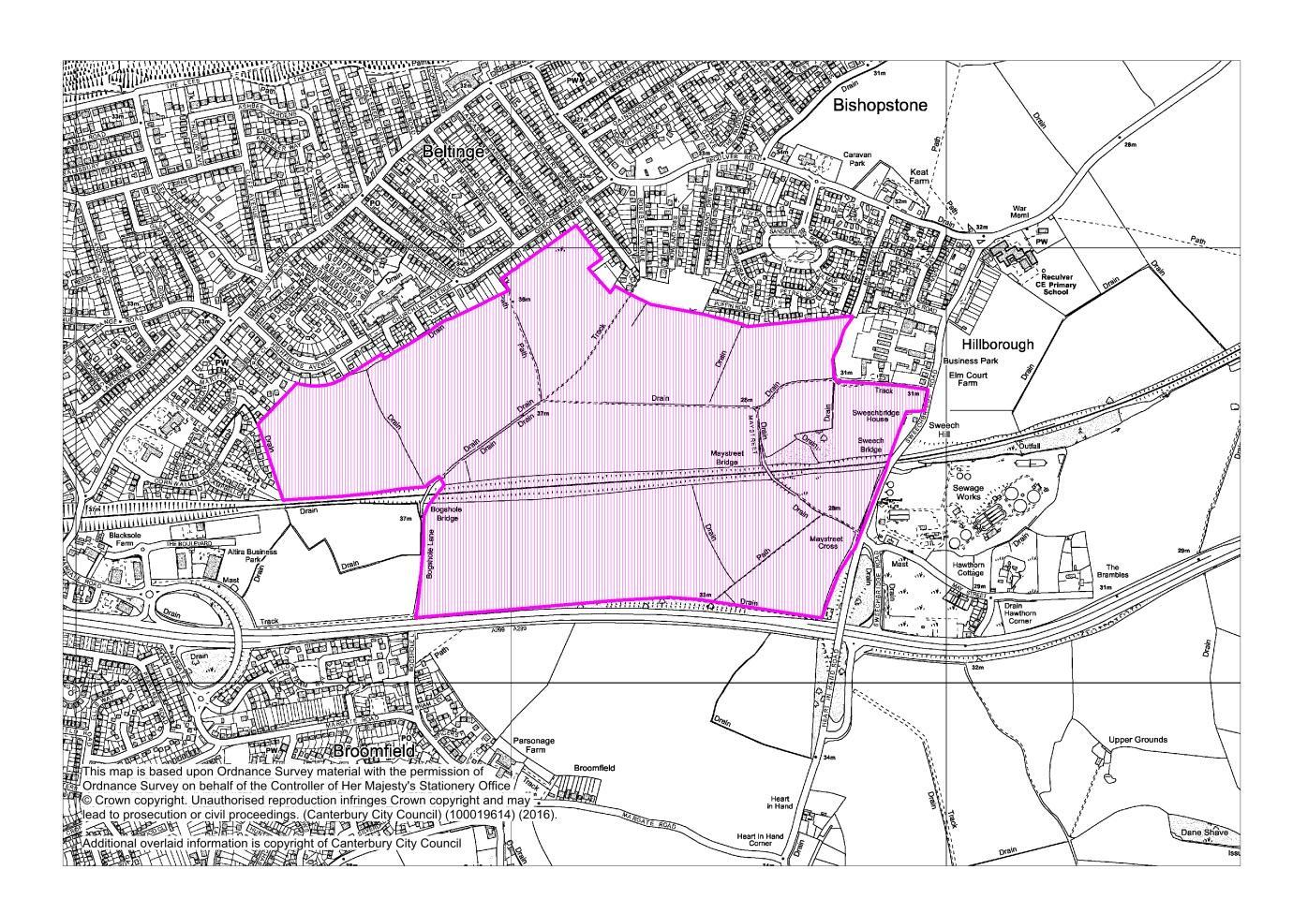
MM1.8 Map Inset 3, Herne Bay (Proposed Modification April 2016)
Proposed amendment to the boundary of Strategic Site Allocation 3: Land at Hillborough, Herne Bay
(1,300 Dwellings)

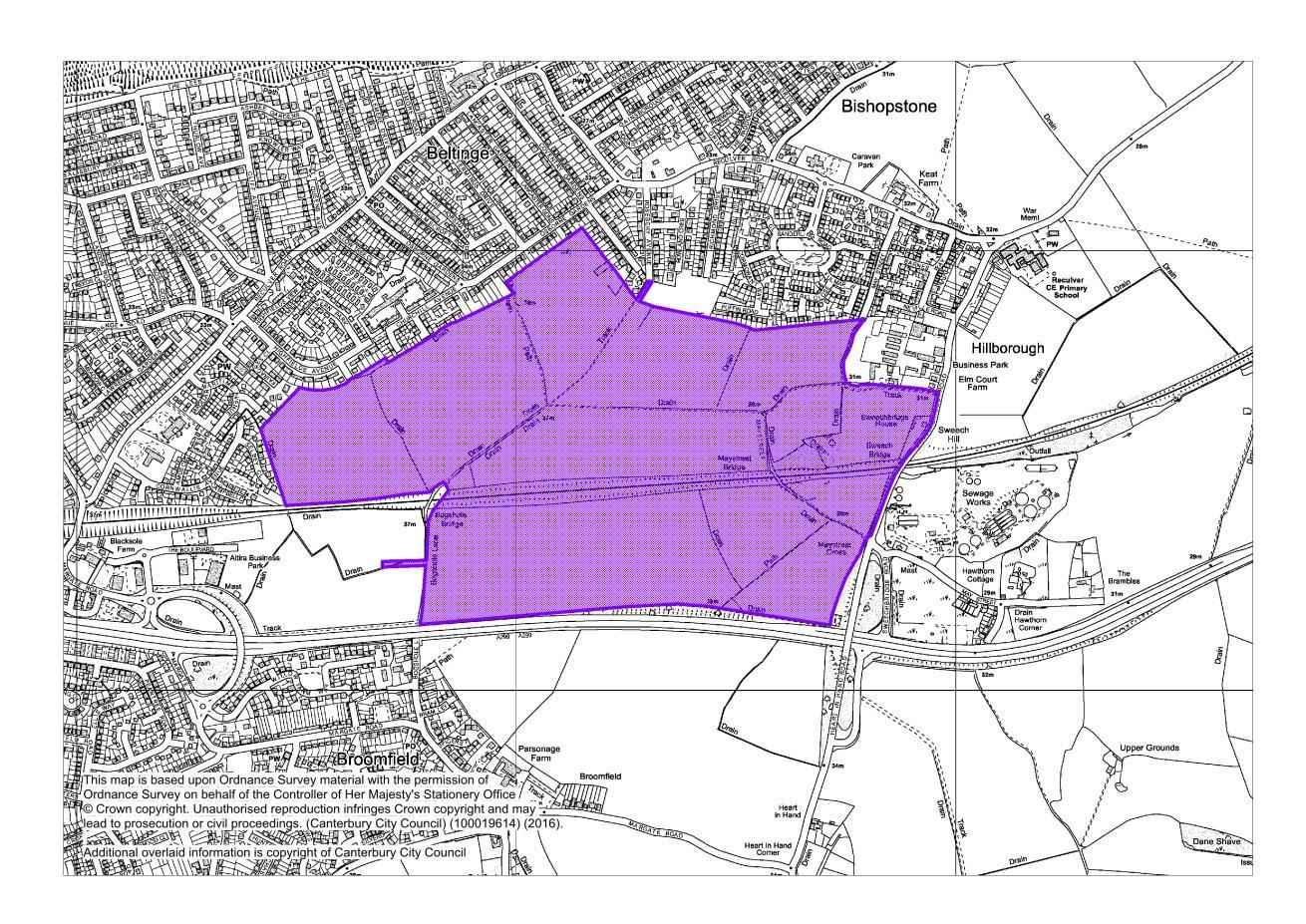

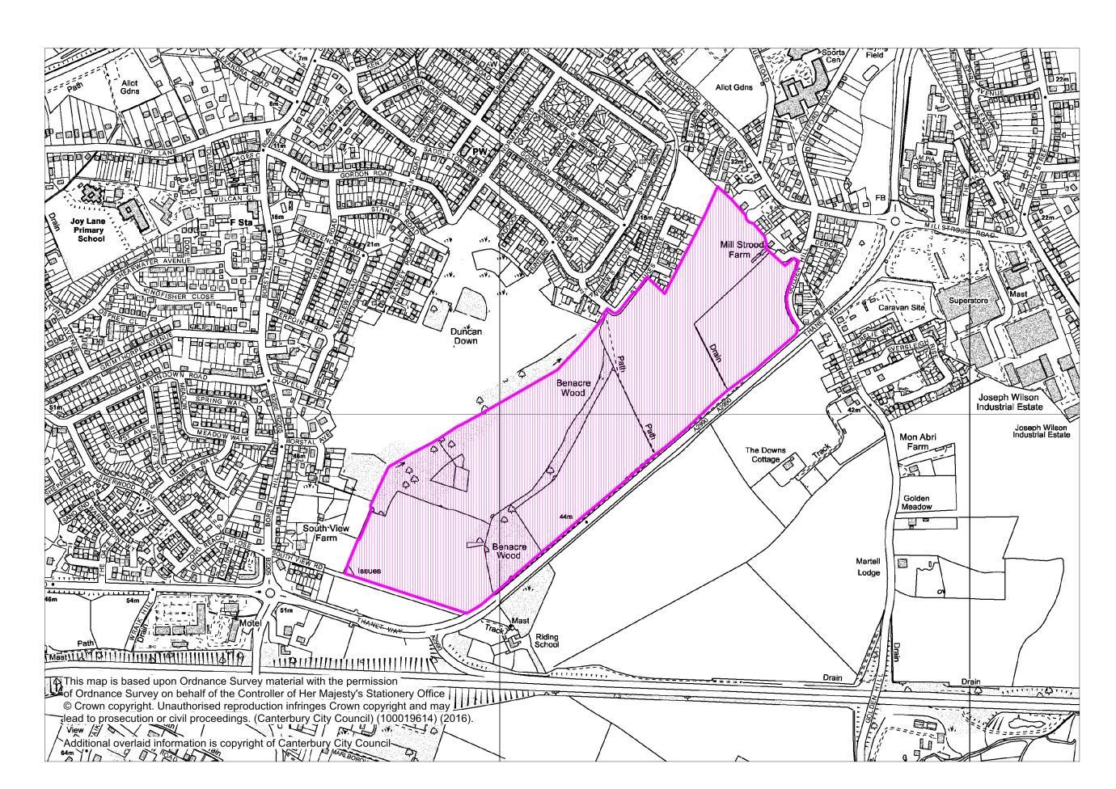
Map Inset 5, Whitstable (Publication Draft June 2014)
Strategic Site Allocation 7: Land at Thanet Way, Whitstable (400 Dwellings)
MM1.16 Map Inset 5, Whitstable (Proposed Modification April 2016)
Proposed amendment to the boundary of Strategic Site Allocation 7: Land at Thanet Way, Whitstable (400 Dwellings)

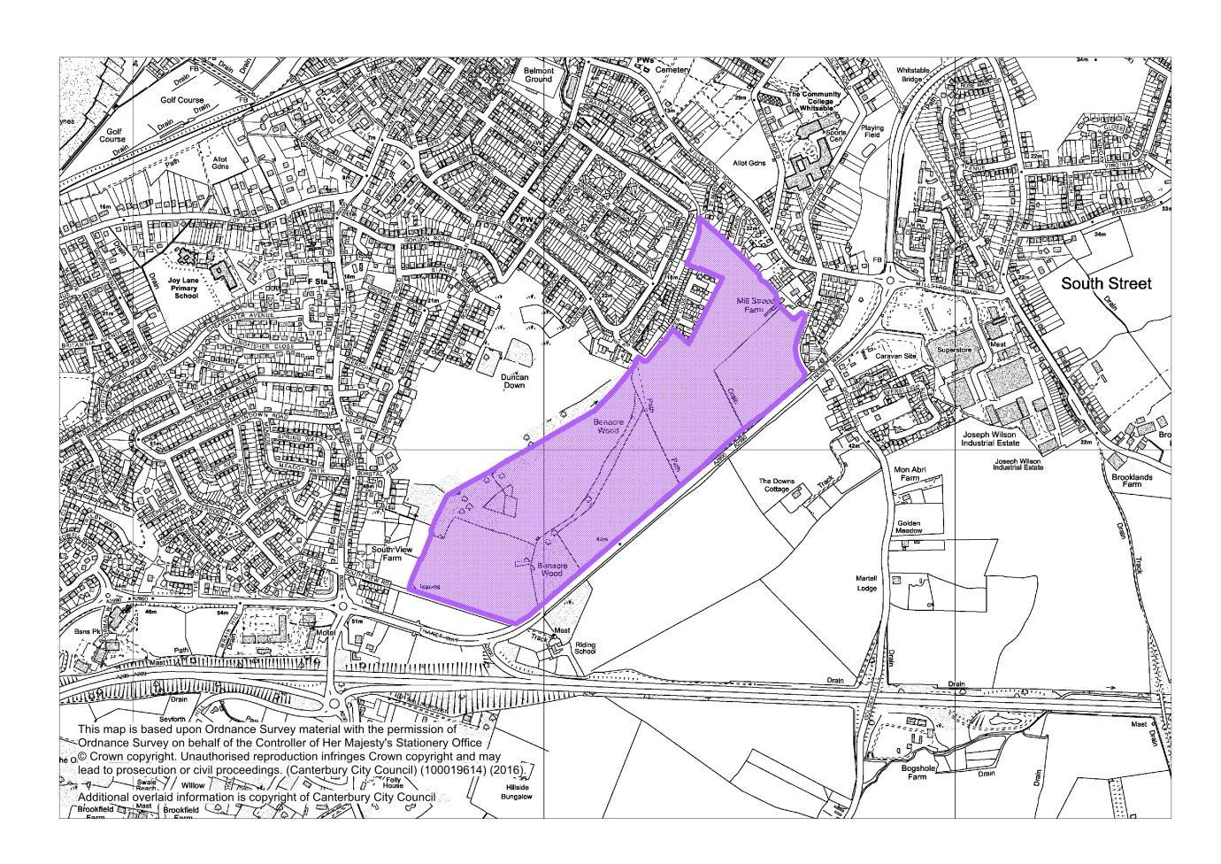

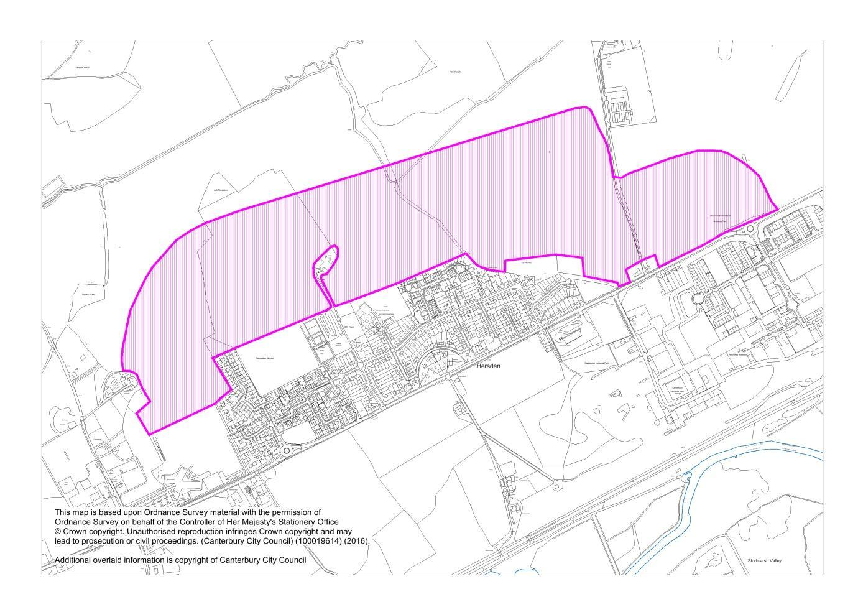
District Proposal Map (Publication Draft June 2014)
Strategic Site Allocation 8: Land North of Hersden (500 Dwellings)

MM1.19 District Proposal Map (Proposed Modification April 2016)
Proposed amendment to the boundary of Strategic Site Allocation 8: Land North of Hersden (800 Dwellings)

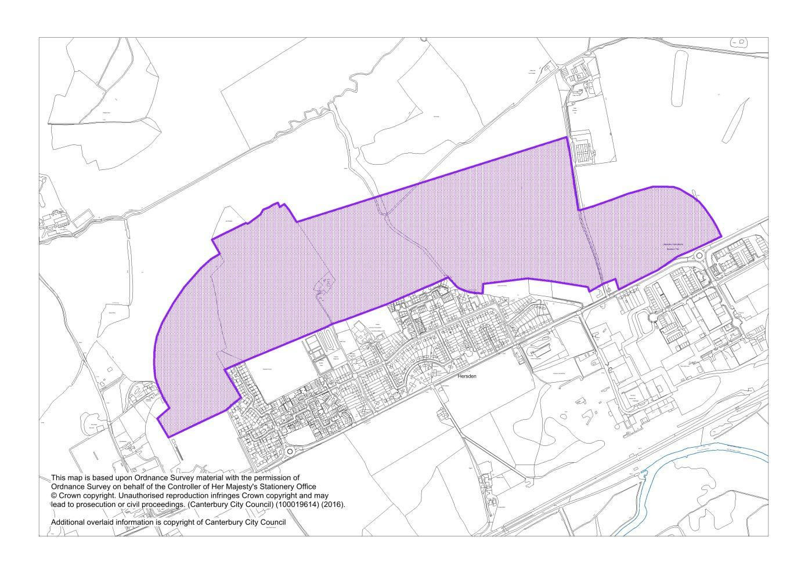

District Proposal Map (Publication Draft June 2014)
Strategic Site Allocation 9: Land at Howe Barracks, Canterbury (400 Dwellings)

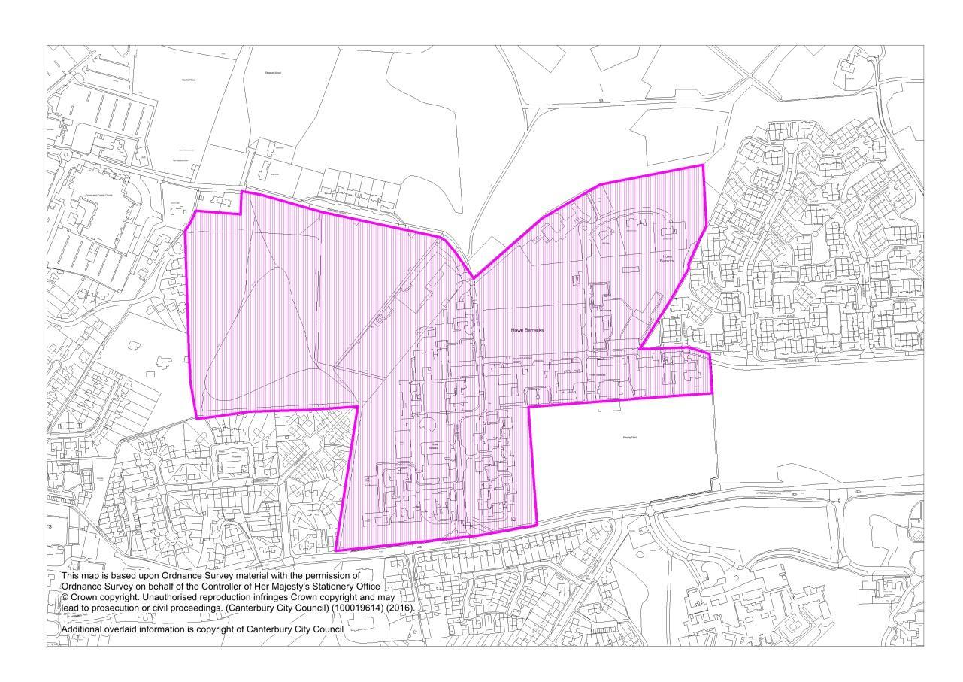
MM1.20 District Proposal Map (Proposed Modification April 2016)
Proposed amendment to the boundary of Strategic Site Allocation 9: Land at Howe Barracks, Canterbury (500 Dwellings)

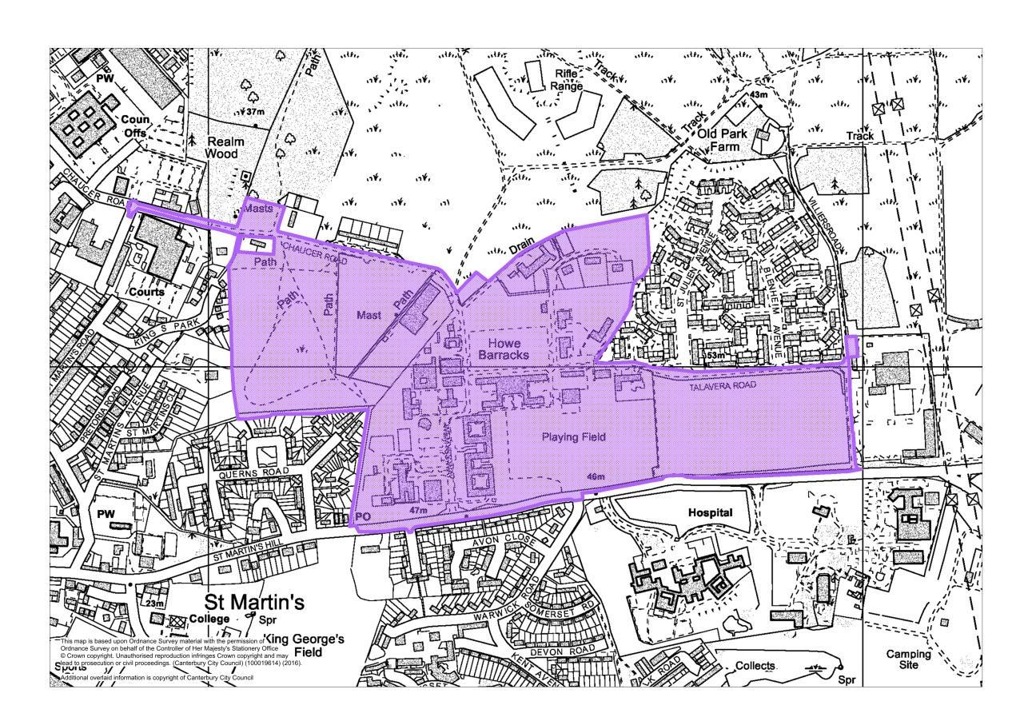

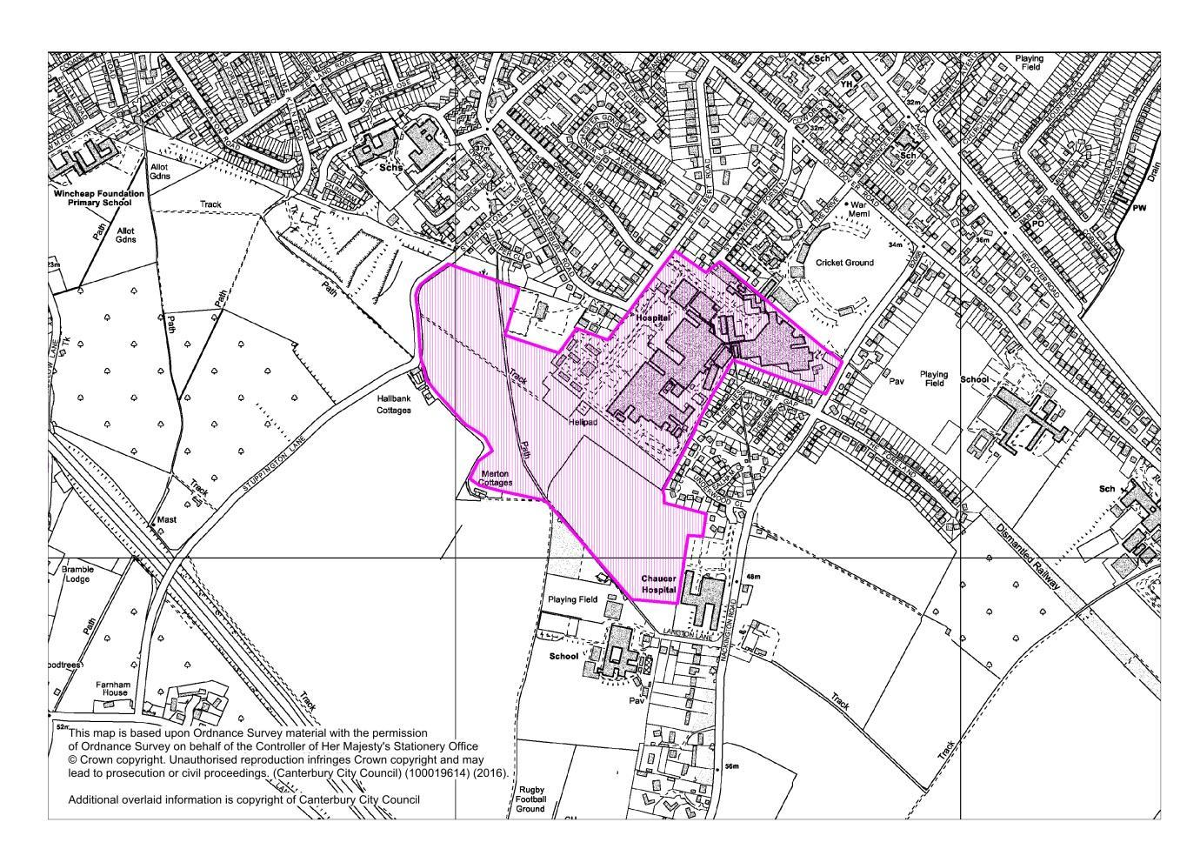
Map Inset 1, Canterbury (Publication Draft June 2014)
Strategic Site Allocation 10: Land at the Kent & Canterbury Hospital, Ridlands Farm and Langton Field, Canterbury (810 Dwellings)
MM1.22 Map Inset 1, Canterbury (Proposed Modification April 2016)
Proposed amendment to the boundary of Strategic Site Allocation 10: Land at Ridlands Farm and Langton Field, Canterbury (310 Dwellings)

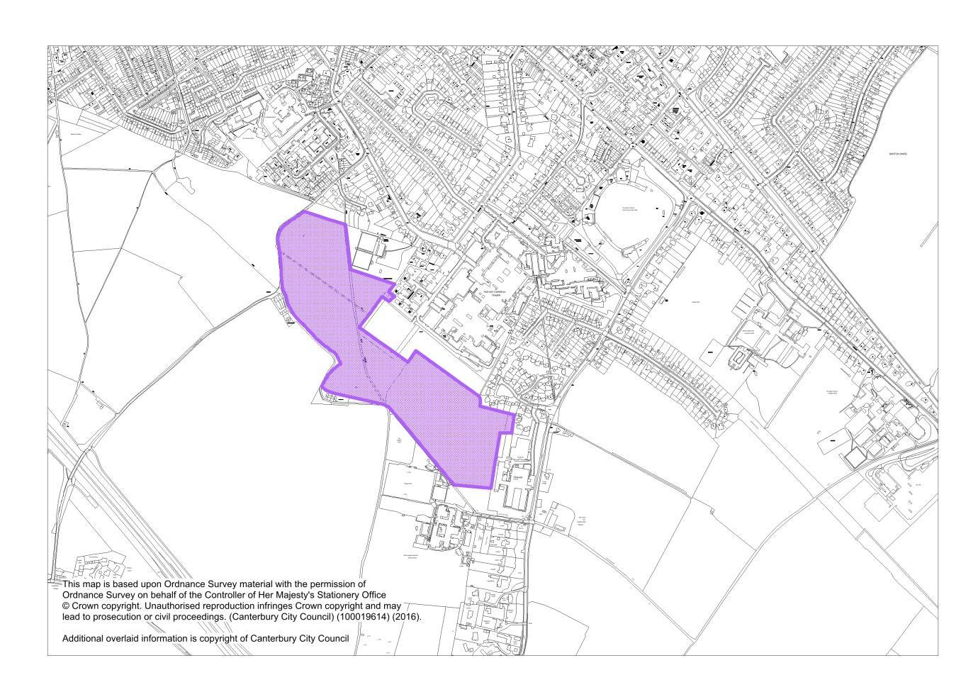

Proposed New Strategic Site Allocations (Policy SP3)
MM1.24 Map Inset 1, Canterbury, (Proposed Modification April 2016)
Proposed New Strategic Site Allocation 11: Land at and adjacent to Cockering Farm, Thanington (1150 Dwellings)

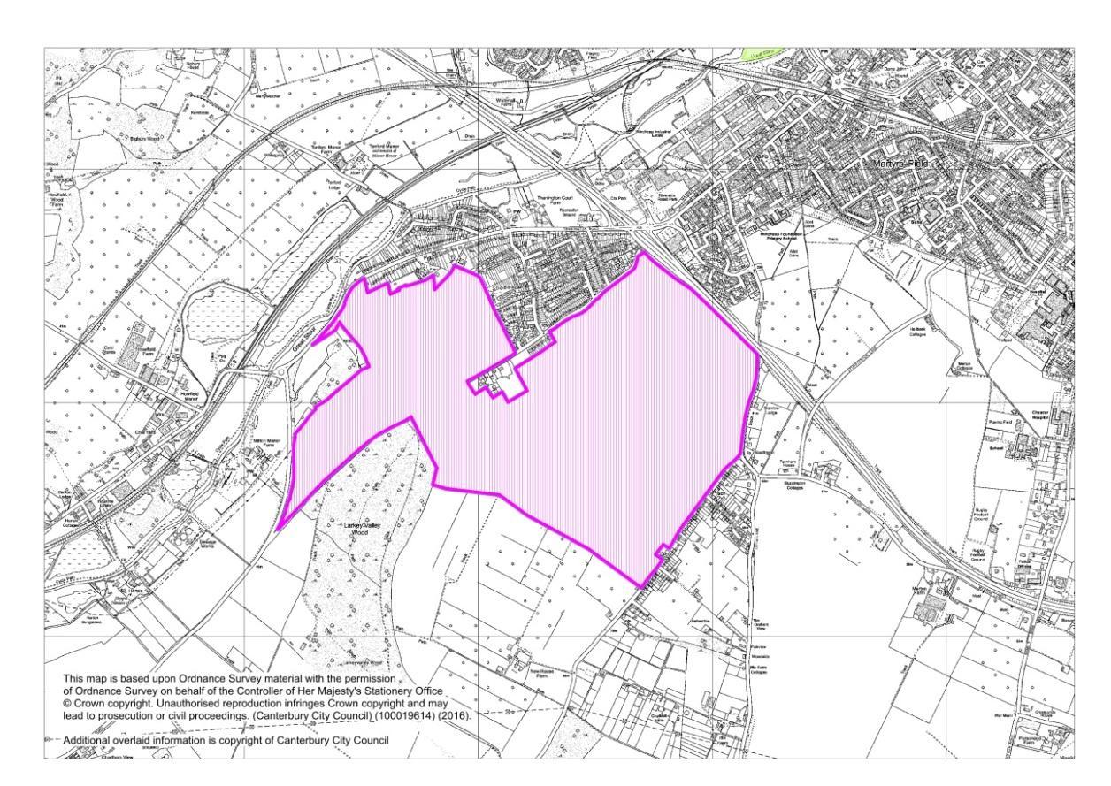
MM1.26 Map Inset 5, Whitstable (Proposed Modification April 2016)
Proposed New Strategic Site Allocation 12: Land South of Ridgeway (John Wilson Business Park), Whitstable (300 Dwellings)

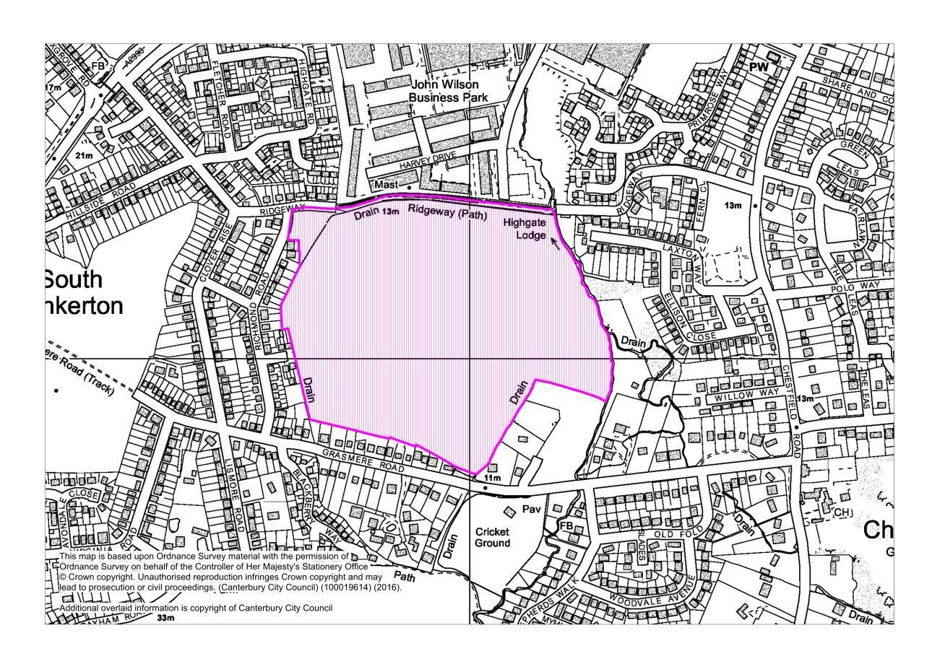

Proposed Amendment to Housing Allocation (Policy HD1)
Map Inset 1, Canterbury (Publication Draft June 2014)
Housing Allocation: Land rear of 51 Rough Common Road, Rough Common, Canterbury
(16 Dwellings)

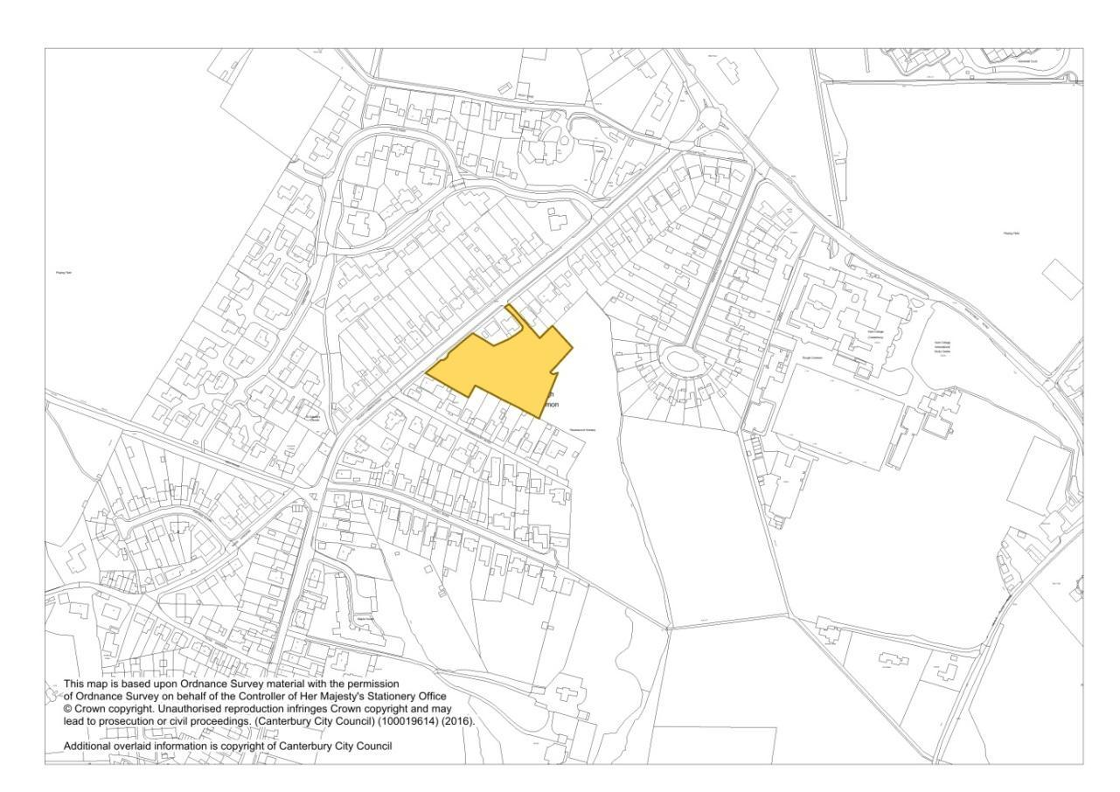
MM2.7 Map Inset 1, Canterbury (Proposed Modification April 2016)
Proposed Extension to the existing Housing Allocation: Land rear of 51 Rough Common Road, Rough Common, Canterbury (28 Dwellings)

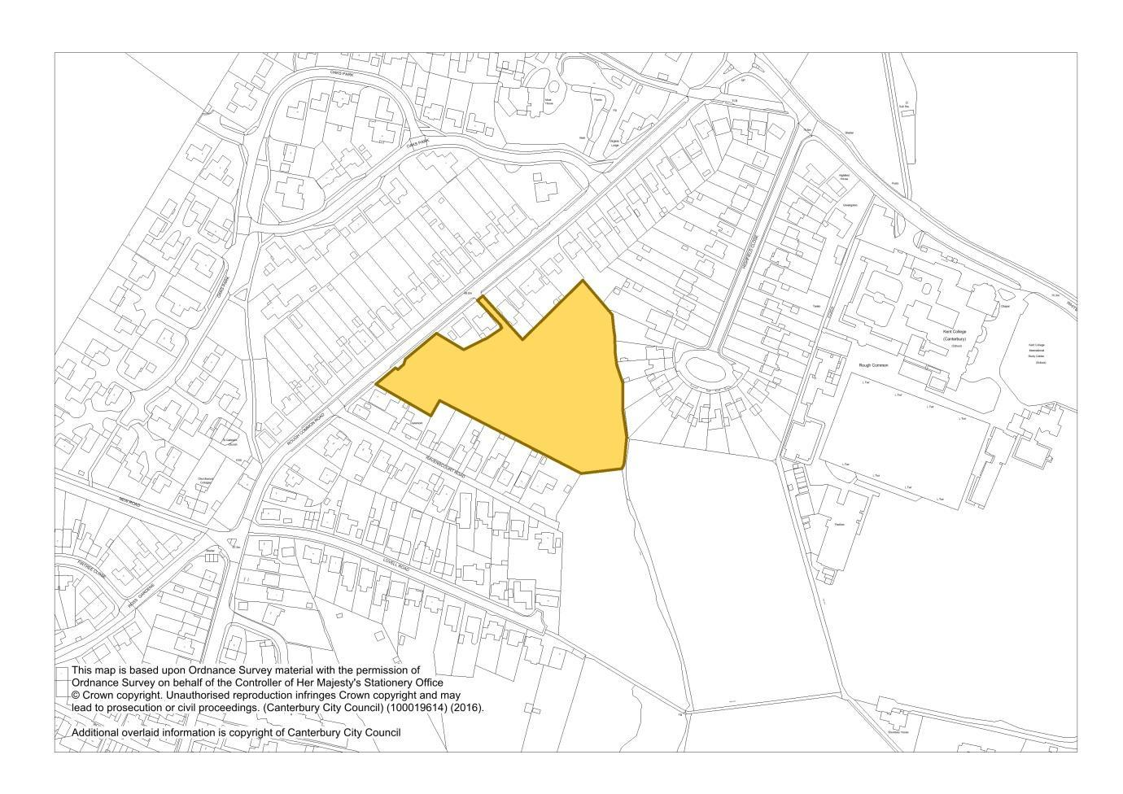

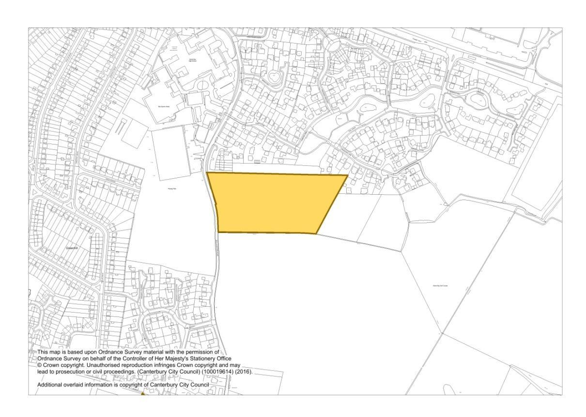
Proposed New Housing Allocations (Policy HD1)
MM2.7 Map Inset 3, Herne Bay (Proposed Modification April 2016)
Proposed New Housing Allocation: Herne Bay Driving Range and Land Adjacent
(80 Dwellings)
MM2.7 District Proposal Map (Proposed Modification April 2016)
Proposed New Housing Allocation: Brickfield Farm, Mill Lane, Bridge (40 Dwellings)

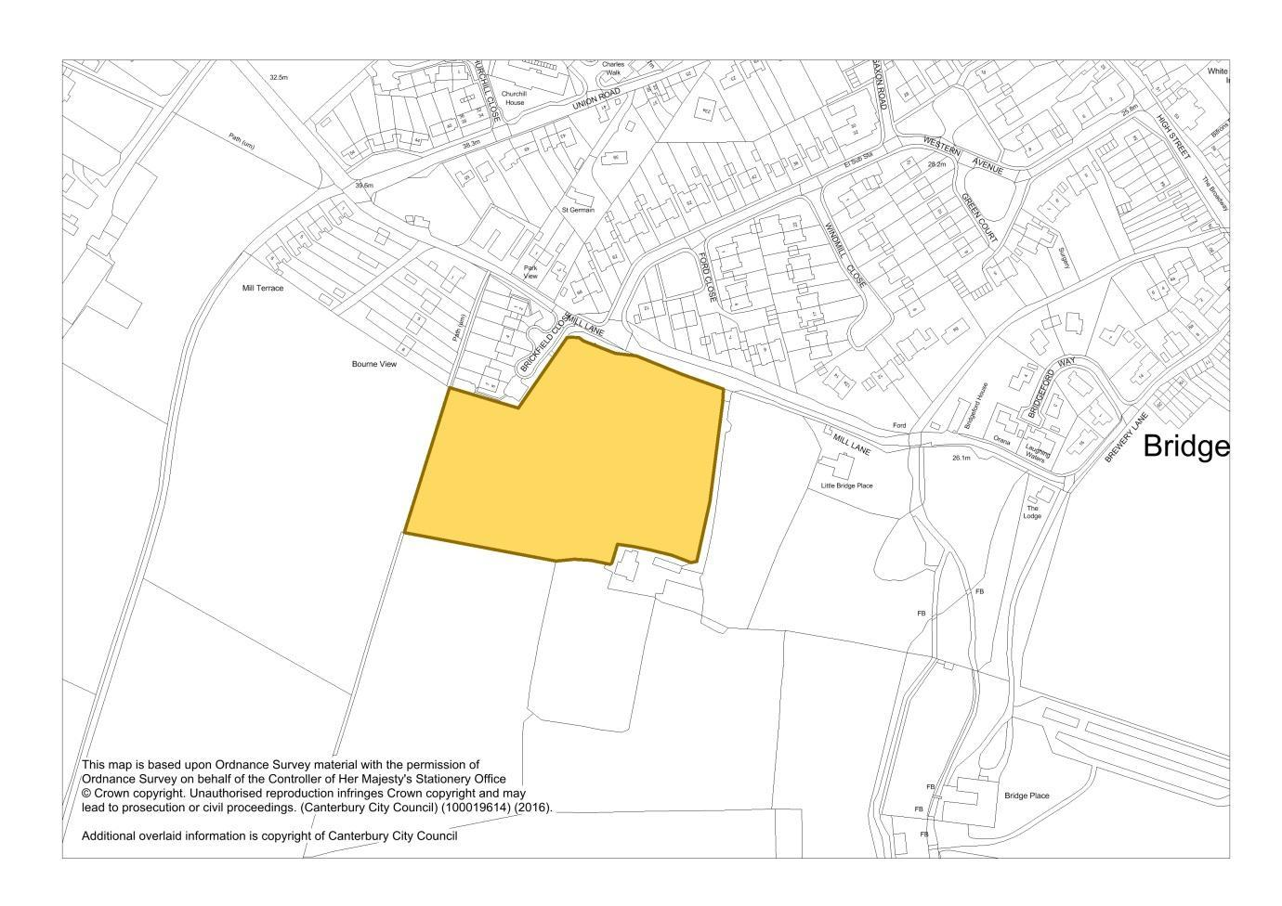

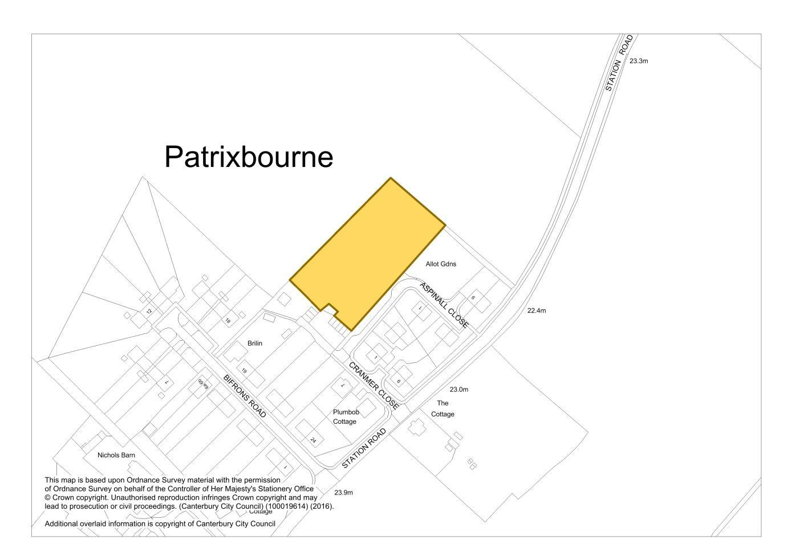
MM2.7 District Proposal Map (Proposed Modification April 2016)
Proposed New Housing Allocation: Land adjacent Cranmer and Aspinall Close, Bekesbourne,
(14 Dwellings)

Proposed Housing Allocations to be deleted from Publication Draft June 2014

MM App3.2 Map Inset 3, Herne Bay (Publication Draft June 2014)
Proposed deletion of Housing Allocation at 181 Sea Street, Herne Bay (14 Dwellings)

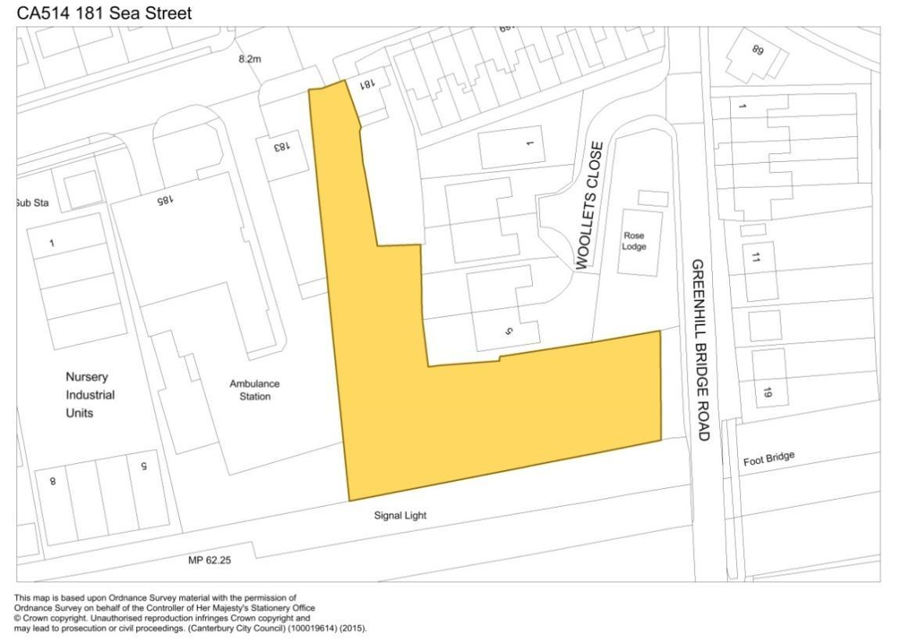
MM App3.3 Map Inset 1, Canterbury (Publication Draft June 2014)
Proposed deletion of part of Housing Allocation at Land adjacent to Canterbury West Station
(20 Dwellings)

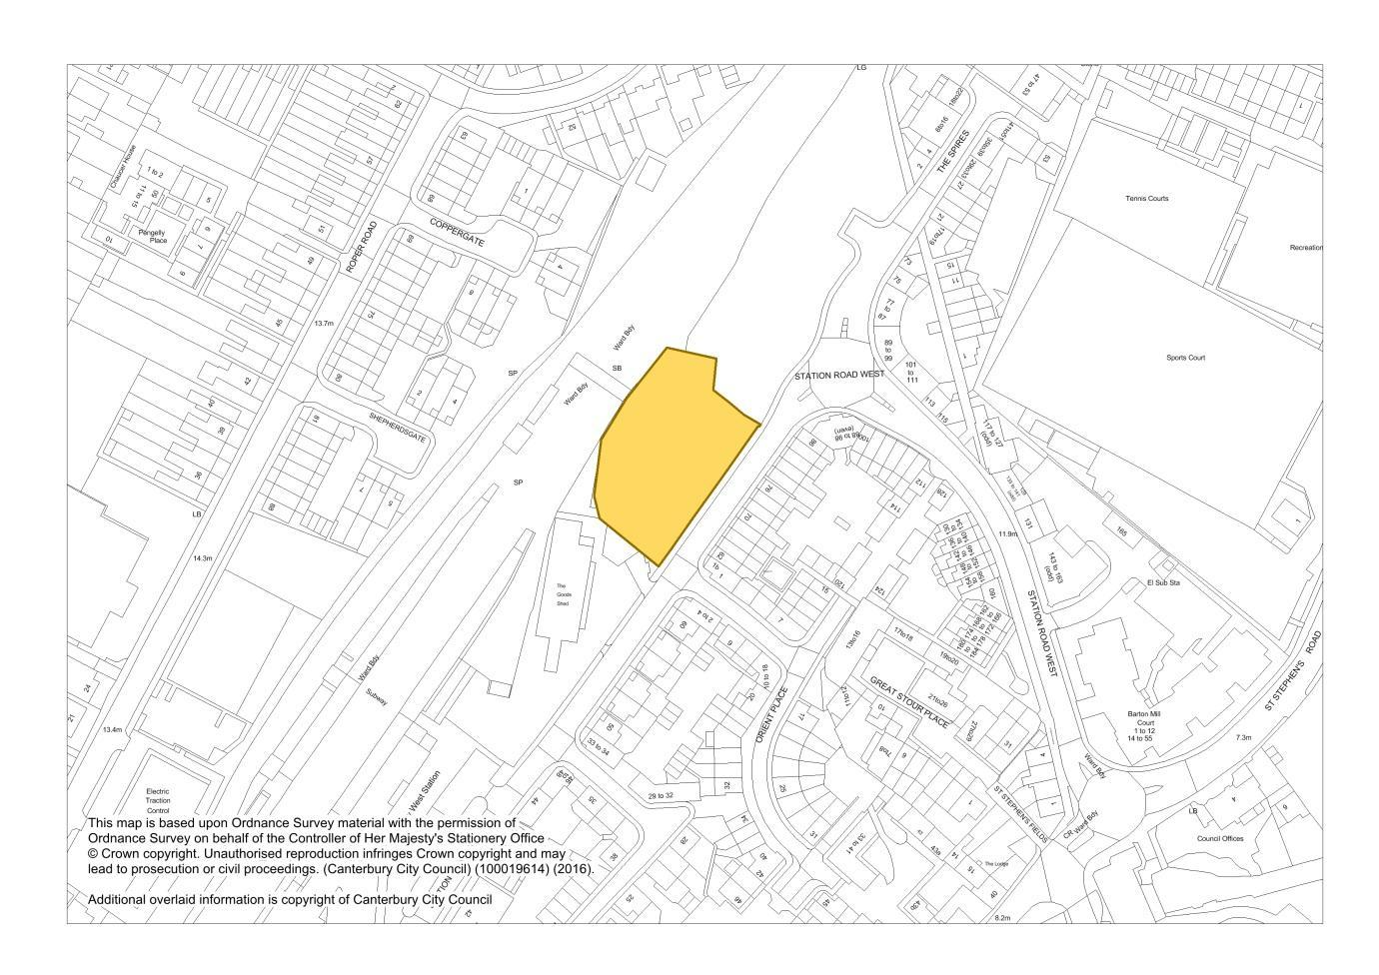

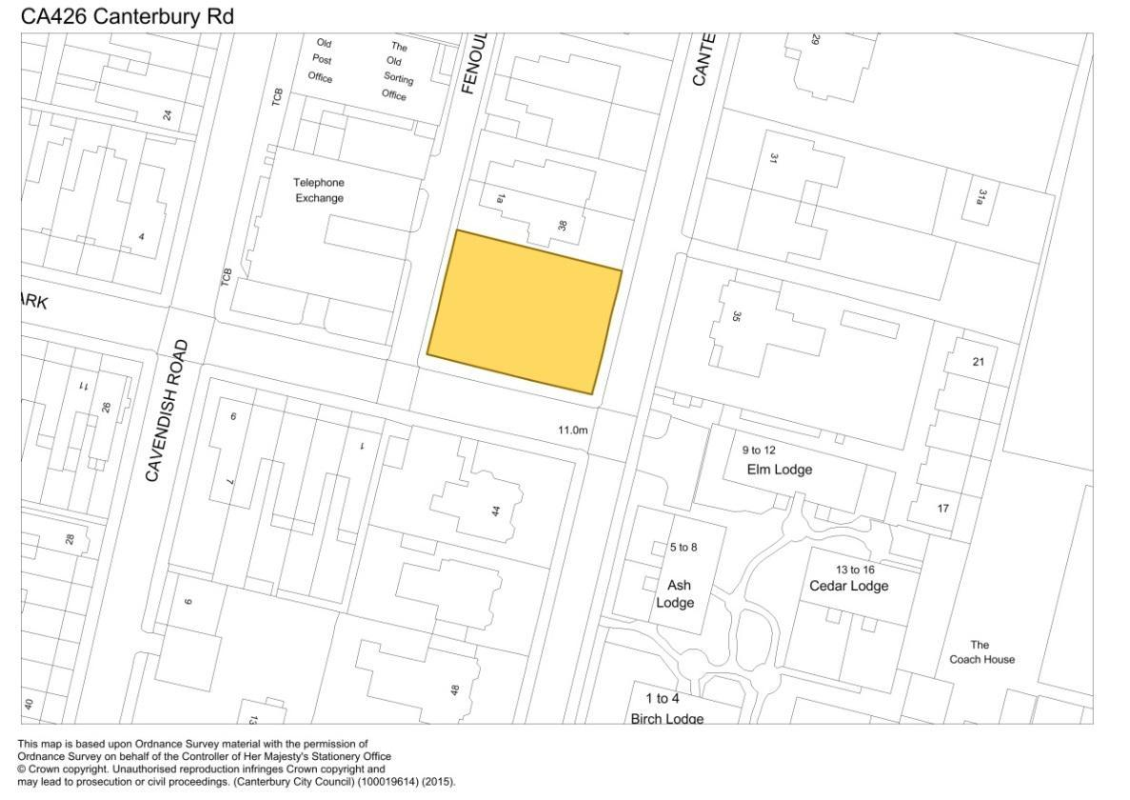
MM App3.4 Map Inset 4, Herne Bay Town Centre (Publication Draft June 2014)
Proposed deletion of Housing Allocation at Corner of Canterbury Rd/Victoria Rd, Herne Bay
(5 Dwellings)
MM App3.5 Map Inset 6, Whitstable Town Centre (Publication Draft June 2014)
Proposed deletion of Housing Allocation at Builders Yard r/o 3 Belmont Rd, Whitstable
(23 Dwellings)

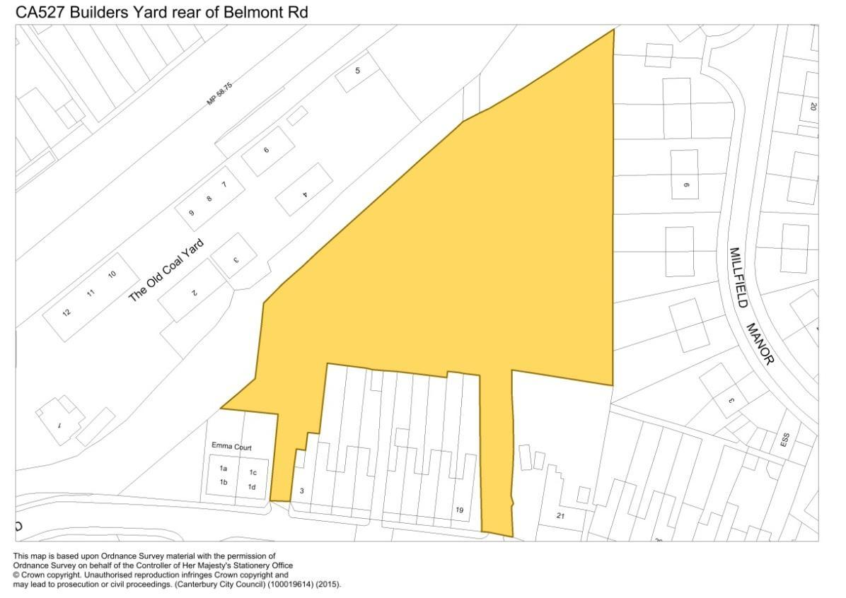

MM App3.6 Map Inset 6, Whitstable Town Centre (Publication Draft June 2014)
Proposed deletion of Housing Allocation at Beresford Road North and South, Whitstable
(20 Dwellings)

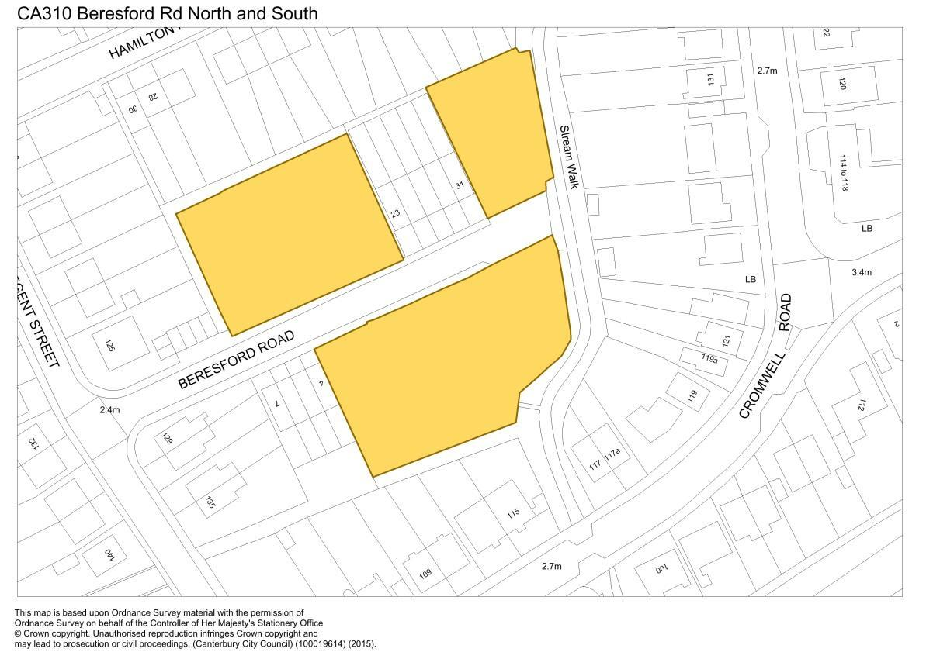
MM App3.7 Map Inset 6, Whitstable Town Centre (Publication Draft June 2014)
Proposed deletion of Housing Allocation at Land adjacent 15 Hamilton Rd, Whitstable
(10 Dwellings)

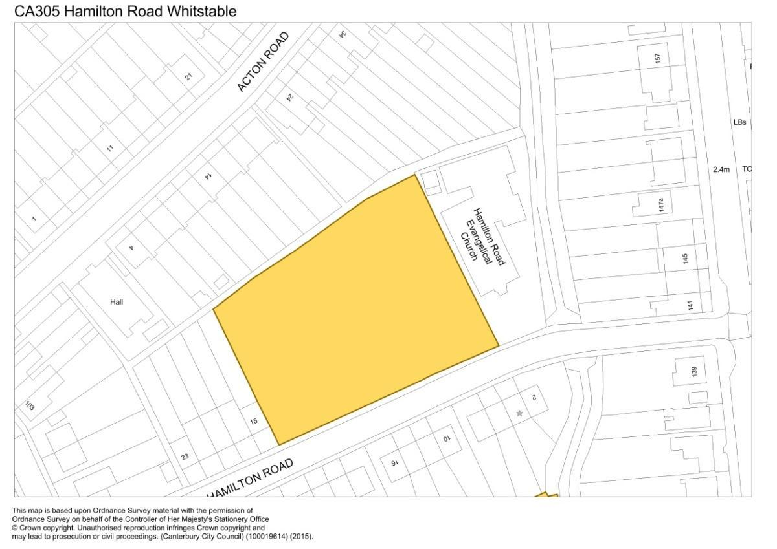

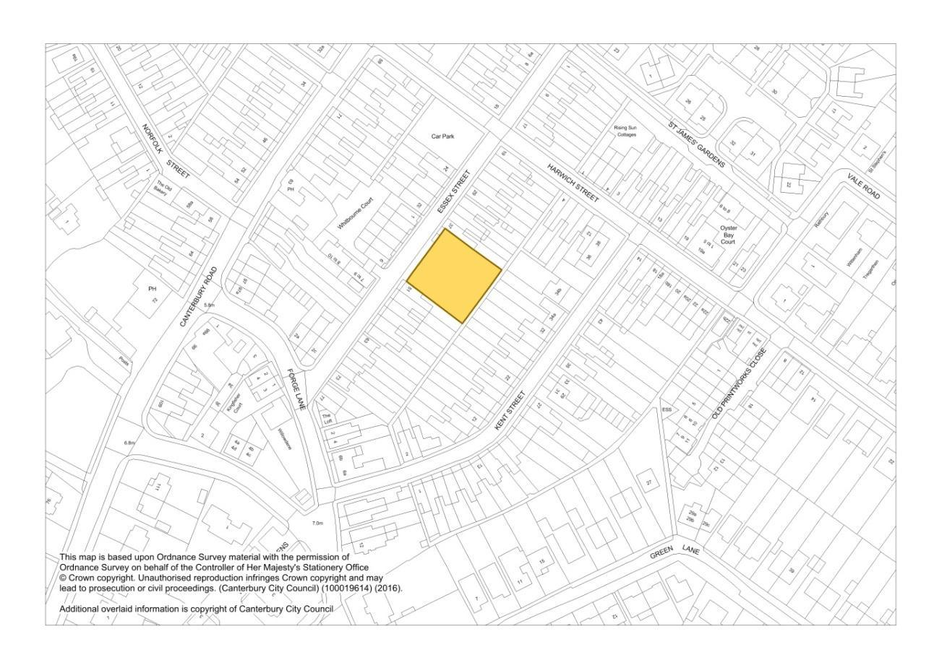
MM App3.9 Map Inset 6, Whitstable Town Centre (Publication Draft June 2014)
Proposed deletion of Housing Allocation at Land adjacent to 100 Albert Street, Whitstable
(11 Dwellings)
MMApp3.8 Map Inset 6, Whitstable Town Centre (Publication Draft June 2014)
Proposed deletion of Housing Allocation at 37 Essex Street, Whitstable (7 Dwellings)

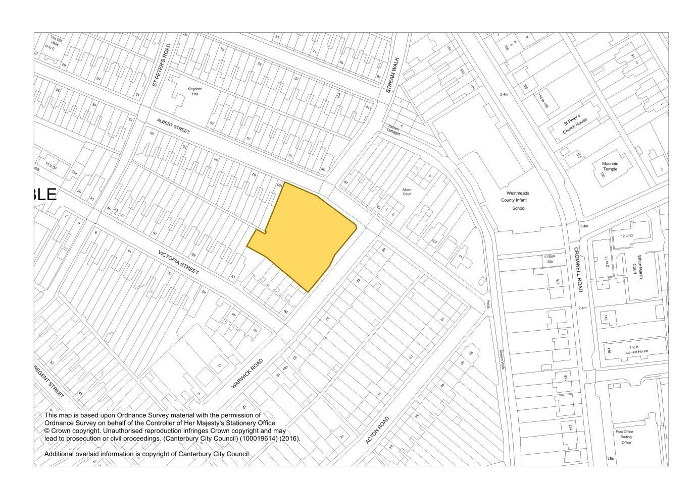

MM11.1 Map Inset 3, Herne Bay (Proposed Modification April 2016)
Proposed amendment to boundary of Protection of Existing Open Space at The Links, Herne Bay
Protection of Existing Open Space (Policy 0S9)

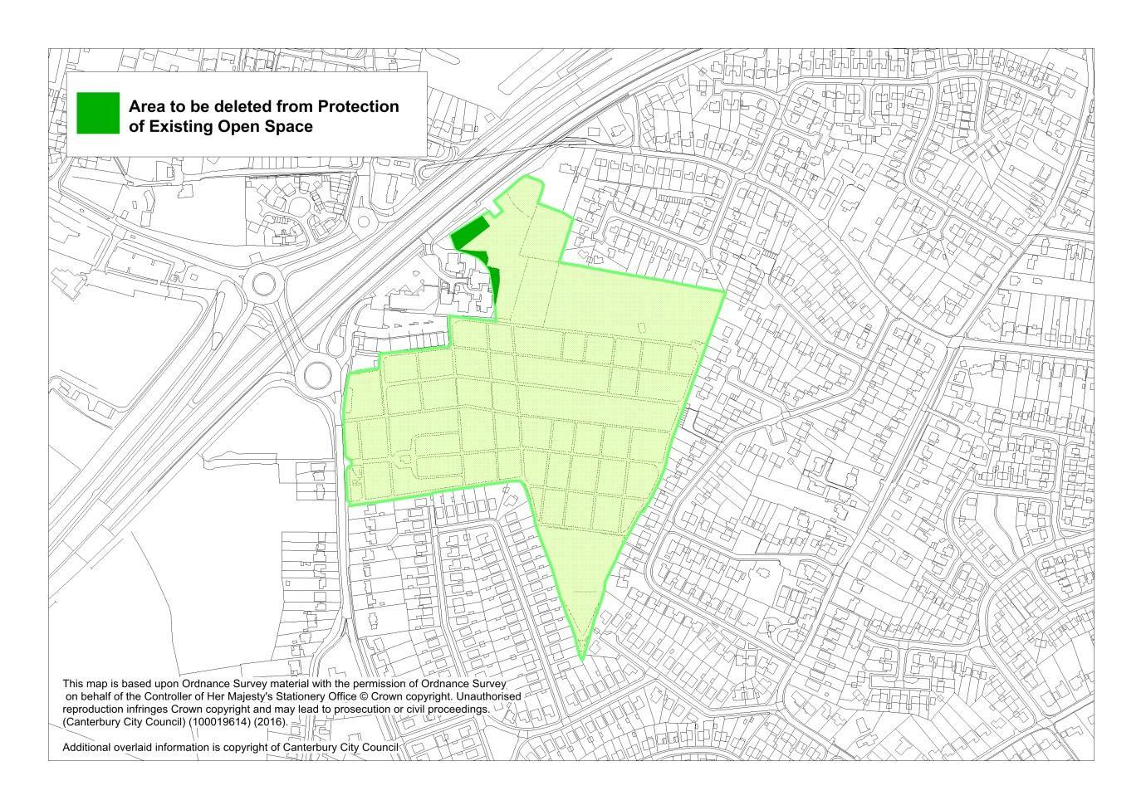
MM11.2 Map Inset 1, Canterbury (Proposed Modification April 2016)
Proposed New and Proposed amended boundary of Protection of Existing Open Space at Howe Barracks, Littlebourne Road, Canterbury

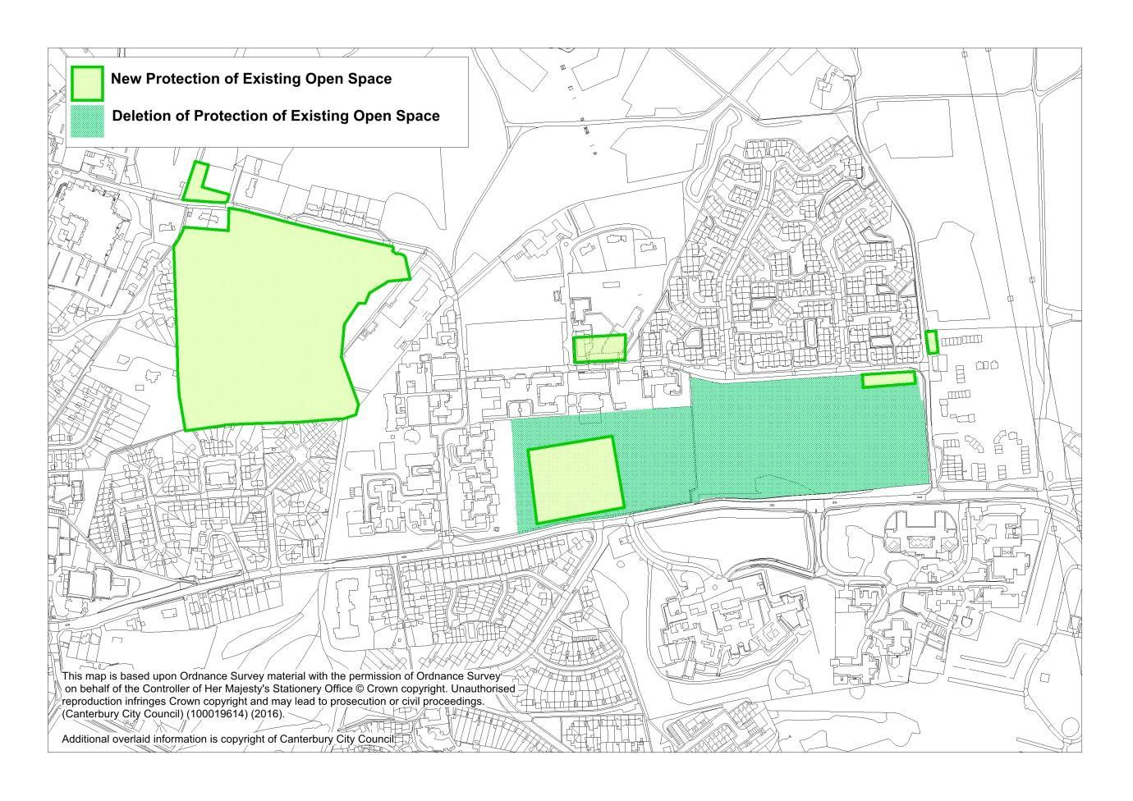

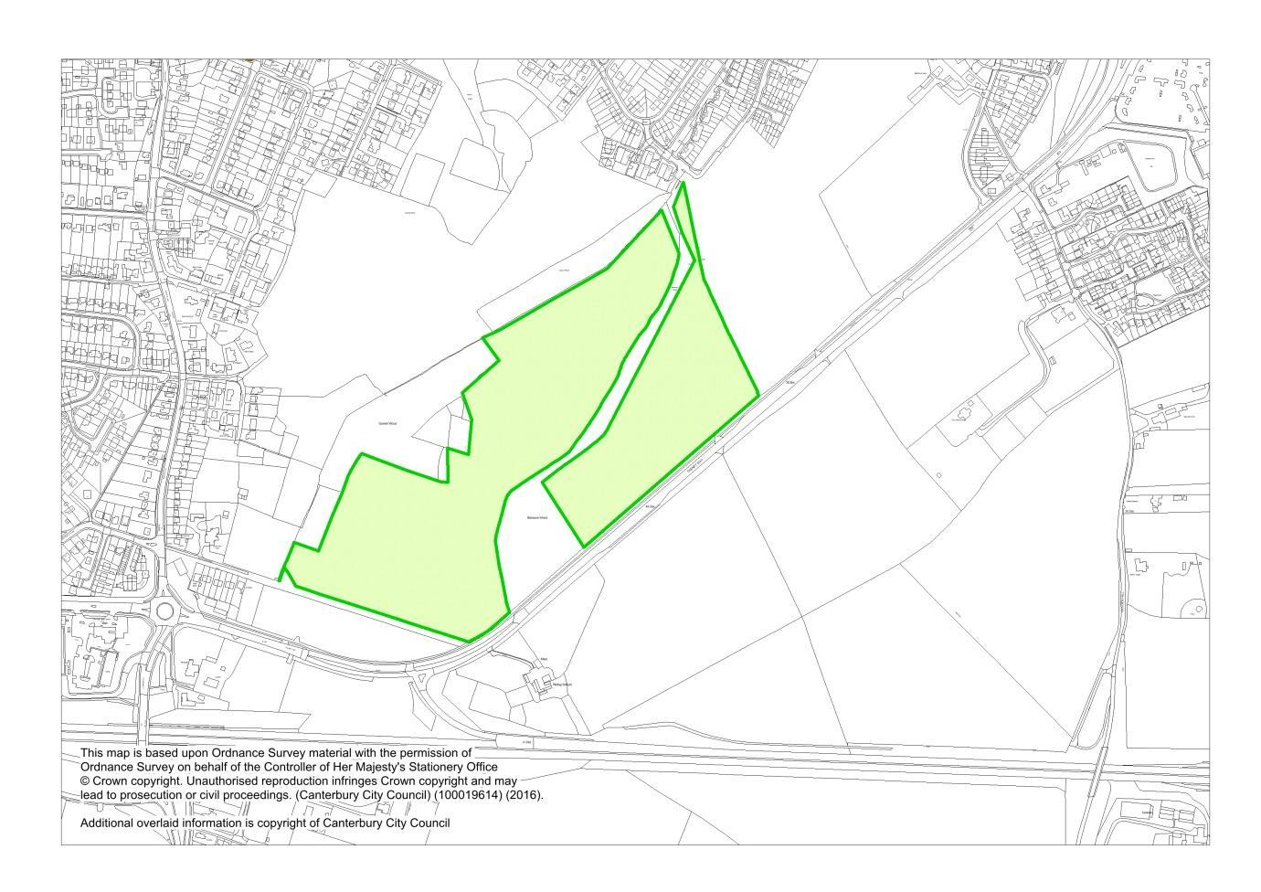
MM11.3 Map Inset 5, Whitstable (Proposed Modifications April 2016)
Proposed new Protection of Existing Open Space extension to Duncan Down Village Green, Whitstable

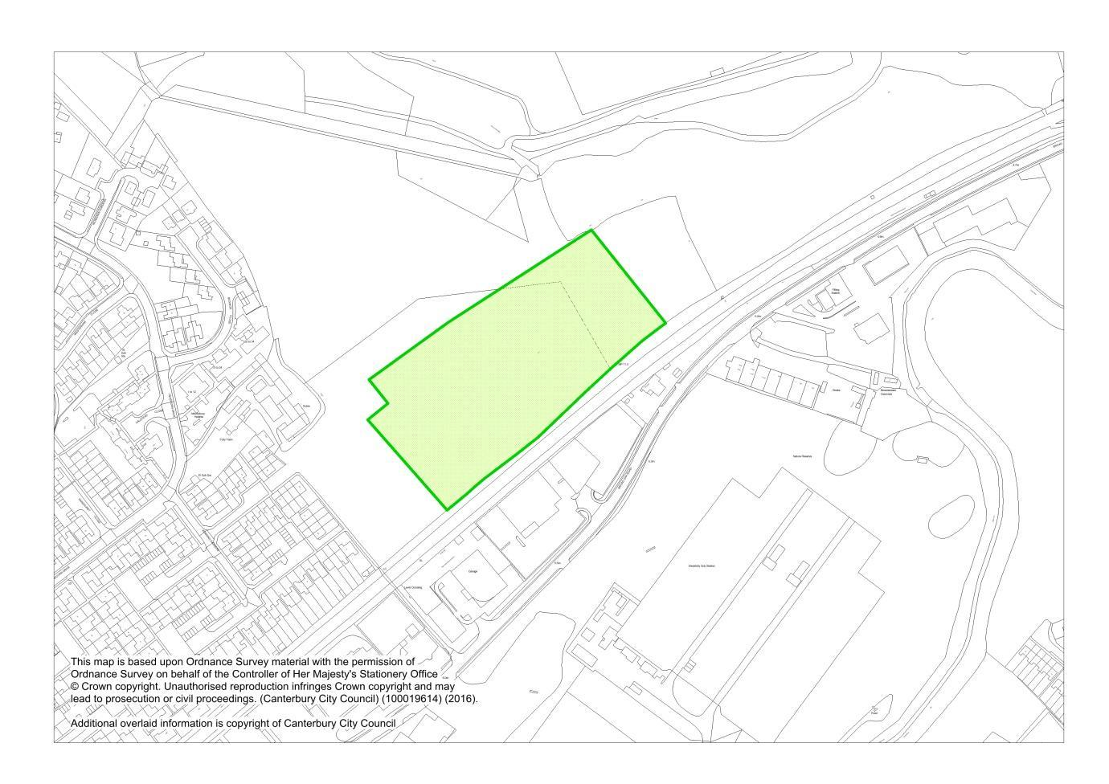
MM11.4 Map Inset 1, Canterbury (Proposed Modifications April 2016)
Proposed new Protection of Existing Open Space at Folly Farm, Canterbury

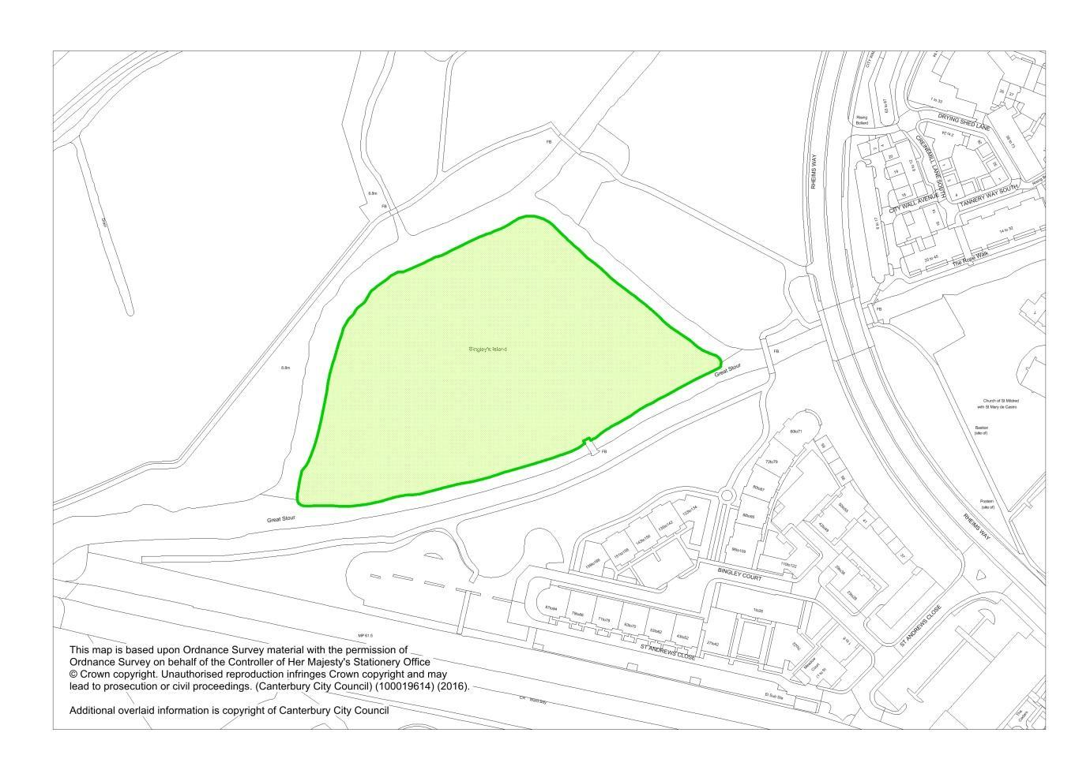
MM11.5 Map Inset 1, Canterbury (Proposed Modification April 2016)
Proposed new Protection of Existing Open Space at Bingley’s Island, Canterbury

Proposed new Open Space (Policy OS13)
MM11.10 Map Inset 2, Canterbury City Centre (Proposed Modification April 2016)
Proposed new Open Space at Tannery Park, Canterbury

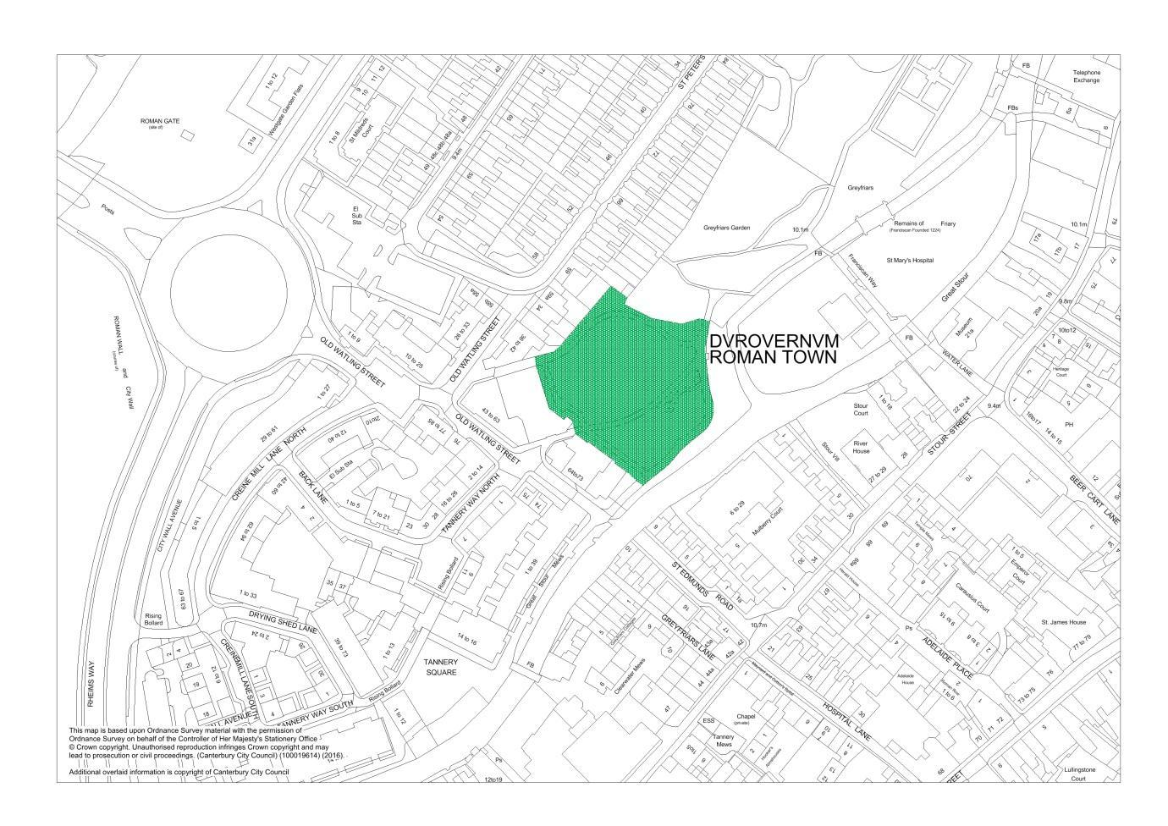

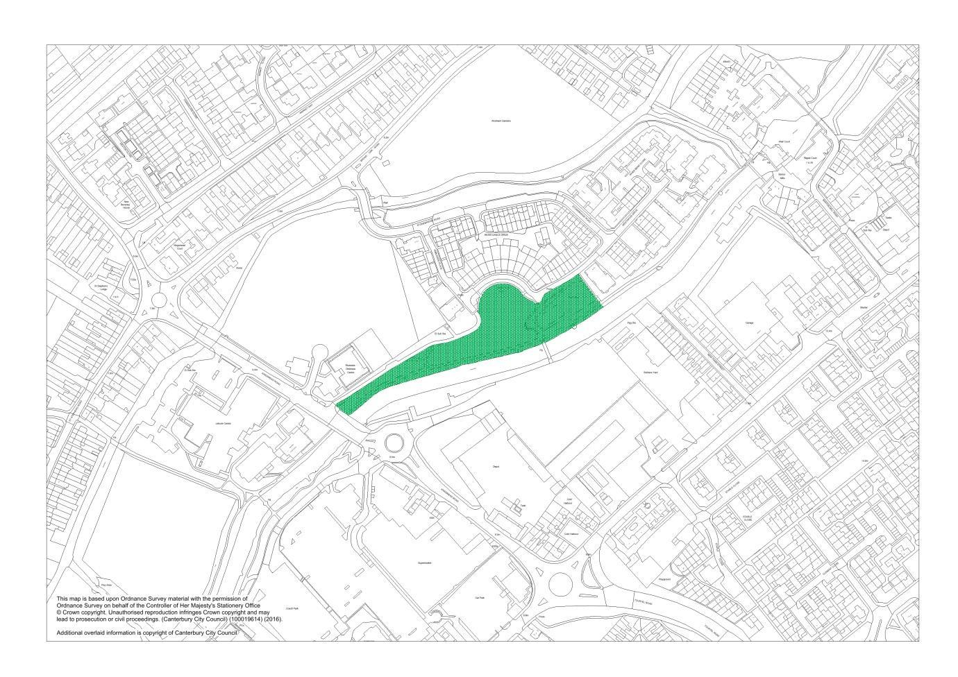
MM11.11 Map Inset 1, Canterbury (Proposed Modification April 2016)
Proposed new Open Space at Kingsbrook Park, Canterbury
Amendment to Overtopping Hazard Zone (Policy CC7)
MM7.9 Map Inset 5, Whitstable (Publication Draft June 2014)
Proposed deletion of area of Overtopping Zone at Admiralty Walk, Whitstable

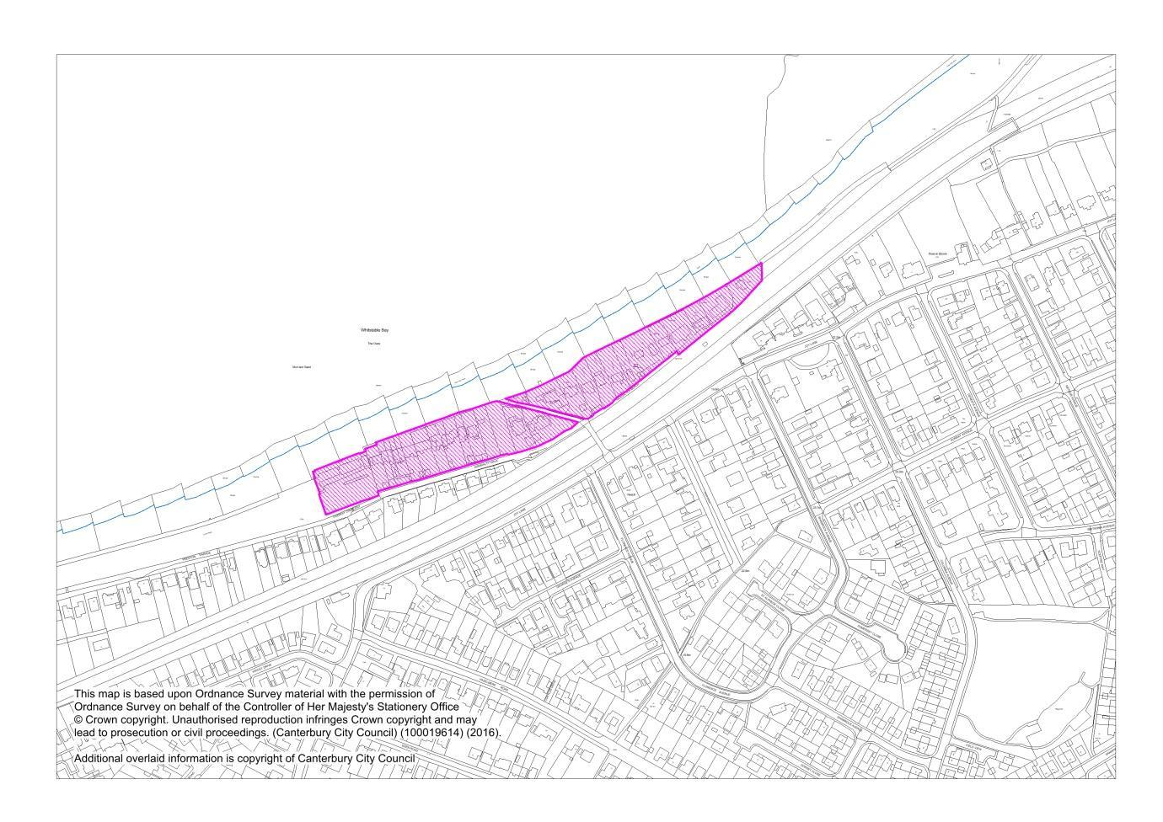

New SAMMS Zones of Influence within the Canterbury District
MM1.38 District Proposal Map, Insets 3, 4, 5 & 6 (Proposed Modification April 2016)
New SAMMS Zones of Influence within the Canterbury District

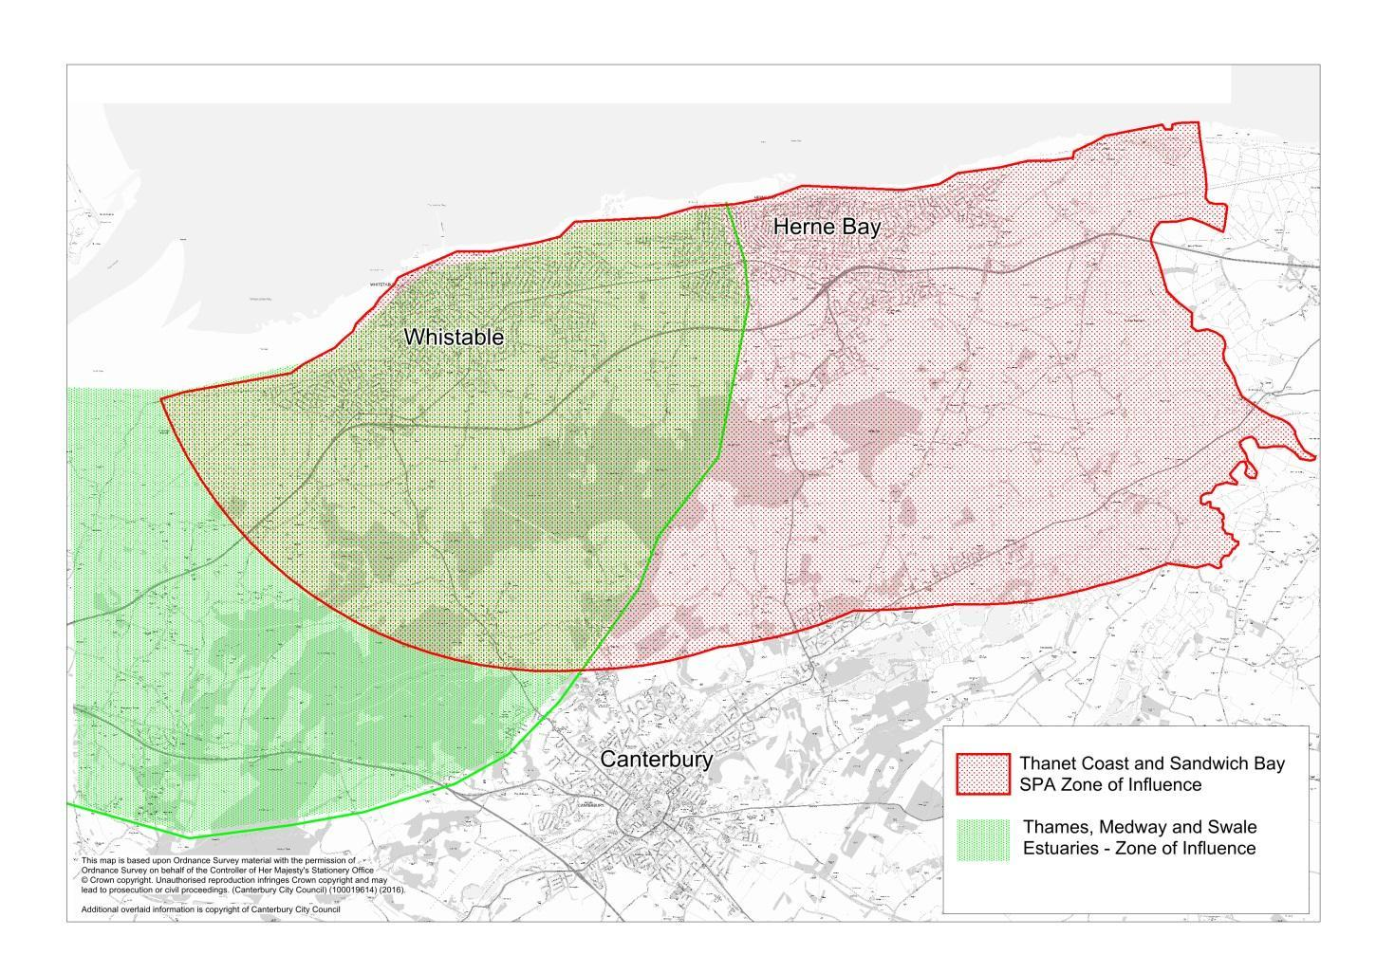

Appendix 1

Site Allocations Location Map

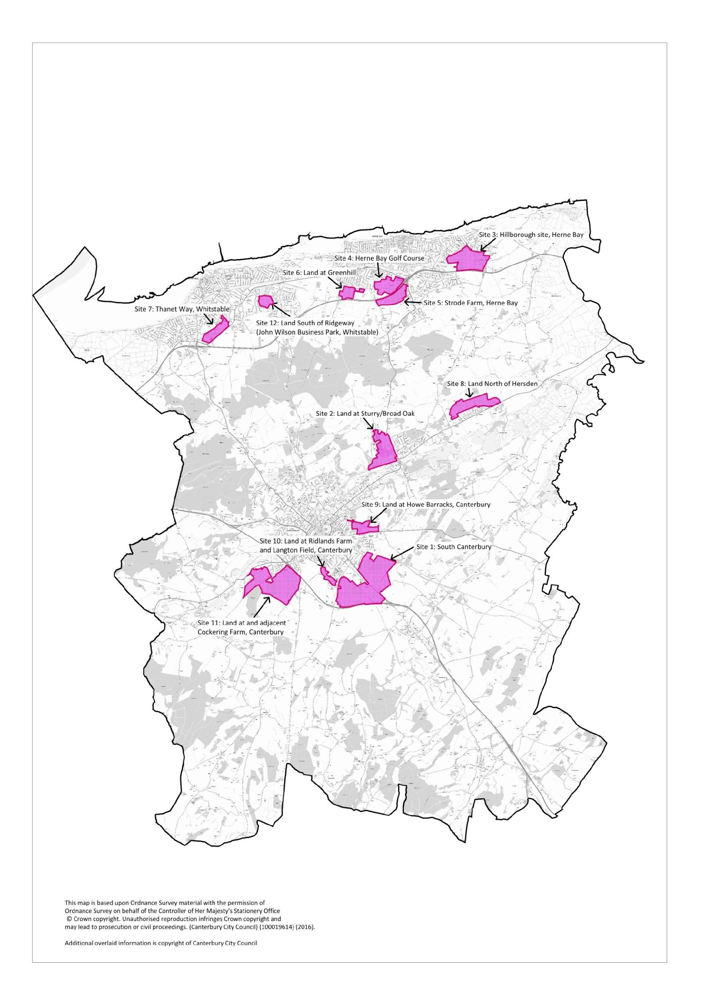
Appendix 1: Site Allocations Location Map
Appendix 2

Garden City Principles

Garden City Principles

- Mixed-tenure homes and housing types that are genuinely affordable for everyone.

- A wide range of employment opportunities including local jobs within easy commuting distance of homes.

- Well-designed quality homes with gardens, combining the best of town and country to create healthy communities including opportunities to grow food.

- Development that enhances the natural environment, providing public open space and a comprehensive green infrastructure network and net biodiversity gains and energy-positive technology to ensure climate resilience.

- Strong cultural, recreational and shopping facilities in walkable, vibrant, sociable neighbourhoods.

- Integrated and accessible transport systems, with walking, cycling and public transport designed to be the most attractive forms of local transport.

Appendix 3

Schedule of Housing Allocations and Permissions
Summary Table of Housing Land Supply

Components of Housing Land Supply | 2015-16 | 2016-17 | 2017-18 | 2018-19 | 2019-20 | 2020-21 | 2021-22 | 2022-23 | 2023-24 | 2024-25 | 2025-26 | 2026-27 | 2027-28 | 2028-29 | 2029-30 | 2030-31 | Total No. of units
Strategic Sites and Other Housing Allocations (inc PA) | 0 | 135 | 775 | 1322 | 1374 | 1375 | 1295 | 1250 | 1181 | 871 | 745 | 510 | 375 | 300 | 300 | 300 | 12108
Existing Allocations from 2006 | 0 | 20 | 103 | 76 | 99 | 0 | 40 | 40 | 189 | 5 | 0 | 0 | 0 | 0 | 0 | 24 | 596
Planning Permissions HIA 2015 | 182 | 247 | 270 | 274 | 153 | 30 | 30 | 27 |  |  |  |  |  |  |  |  | 1213
Small Site Windfall Calculation |  |  |  | 138 | 138 | 138 | 138 | 138 | 138 | 138 | 138 | 138 | 138 | 138 | 138 | 138 | 1794
Total | 182 | 402 | 1148 | 1810 | 1764 | 1543 | 1503 | 1455 | 1508 | 1014 | 883 | 648 | 513 | 438 | 438 | 462 | 15711

Strategic Allocations
Site name | 2015-16 | 2016-17 | 2017-18 | 2018-19 | 2019-20 | 2020-21 | 2021-22 | 2022-23 | 2023-24 | 2024-25 | 2025-26 | 2026-27 | 2027-28 | 2028-29 | 2029-30 | 2030-31 | Total No. of units
Site 1 Land at South Canterbury | 0 | 0 | 100 | 300 | 300 | 300 | 300 | 300 | 300 | 300 | 300 | 300 | 300 | 300 | 300 | 300 | 4000
Site 2 Land At Sturry/Broad Oak |  | 0 | 60 | 140 | 150 | 150 | 150 | 150 | 150 | 50 |  |  |  |  |  |  | 1000
Site 3A Land at Hillborough, Herne Bay | 0 | 0 | 50 | 85 | 95 | 95 | 100 | 100 | 100 | 100 | 100 | 100 | 75 |  |  |  | 1000
Site 3 B Hillborough A E Estates |  |  | 40 | 60 | 70 | 70 | 60 |  |  |  |  |  |  |  |  |  | 300
Site 4 Land at Herne Bay Golf Course, Herne Bay |  | 30 | 80 | 80 | 80 | 80 | 100 | 20 | 51 | 51 |  |  |  |  |  |  | 572
Site 5 Land at Strode Farm, Herne Bay |  |  | 80 | 80 | 80 | 80 | 80 | 80 | 80 | 80 | 80 | 80 |  |  |  |  | 800
Site 6 Land at Greenhill, Herne Bay |  |  | 50 | 50 | 50 | 50 | 50 | 50 |  |  |  |  |  |  |  |  | 300
Site 7 North of Thanet Way, Whitstable |  | 20 | 95 | 95 | 95 | 95 |  |  |  |  |  |  |  |  |  |  | 400
Site 8 Land North of Hersden |  |  | 20 | 70 | 75 | 75 | 75 | 120 | 120 | 120 | 125 |  |  |  |  |  | 800
Site 9 Land at Howe Barracks, Canterbury |  | 0 | 60 | 90 | 100 | 100 | 100 | 50 |  |  |  |  |  |  |  |  | 500
Site 10 Land at Ridlands Farm /Hospital site, Cant |  |  |  | 50 | 50 | 50 | 50 | 50 | 60 |  |  |  |  |  |  |  | 310
Site 11 A Land at Cockering Farm, Thanington |  |  |  | 50 | 90 | 90 | 90 | 100 | 100 | 100 | 100 | 30 |  |  |  |  | 750
Site 11 B Cockering Road Thanington |  |  |  |  | 50 | 90 | 90 | 90 | 80 |  |  |  |  |  |  |  | 400
Site 12 Land South of Ridgeway (Grasmere pasture) Chestfield |  |  |  | 30 | 50 | 50 | 50 | 50 | 50 | 20 |  |  |  |  |  |  | 300

Other Housing Allocations
Site name | 2015-16 | 2016-17 | 2017-18 | 2018-19 | 2019-20 | 2020-21 | 2021-22 | 2022-23 | 2023-24 | 2024-25 | 2025-26 | 2026-27 | 2027-28 | 2028-29 | 2029-30 | 2030-31 | Total No. of units
St Martin's Hospital, Canterbury |  |  | 100 | 100 | 0 | 0 |  |  |  |  |  |  |  |  |  |  | 200
Land at Bullockstone Road, Herne Bay | 0 |  |  |  |  |  |  | 50 | 50 | 50 | 40 |  |  |  |  |  | 190
Spires, Land at Bredlands Lane, Sturry |  | 40 | 40 |  |  |  |  |  |  |  |  |  |  |  |  |  | 80
Barham Court Farm, Barham | 0 | 25 |  |  |  |  |  |  |  |  |  |  |  |  |  |  | 25
Land at Baker's Lane, Chartham | 0 | 20 |  |  |  |  |  |  |  |  |  |  |  |  |  |  | 20
Kingsmead Field |  |  |  | 15 |  |  |  |  |  |  |  |  |  |  |  |  | 15
HB Golf Driving range Greenhill (SHLAA 12) |  |  |  |  |  |  |  | 20 | 20 |  |  |  |  |  |  |  | 40
Land adjacent to Herne Bay Golf Driving range Greenhill (SHLAA 199) |  |  |  |  |  |  |  | 20 | 20 |  |  |  |  |  |  |  | 40
Land at Brickfield Farm, Mill Lane, Bridge (SHLAA 186) |  |  |  | 20 | 20 |  |  |  |  |  |  |  |  |  |  |  | 40
Land adjacent to Cranmer and Aspinall Close, Bekesbourne (SHLAA 171) |  |  |  | 7 | 7 |  |  |  |  |  |  |  |  |  |  |  | 14
Land to rear of 51 Rough Common Road, Rough Common adj to existing allocation (SHLAA 78)* |  |  |  |  | 12 |  |  |  |  |  |  |  |  |  |  |  | 12

Local Plan Allocations carried forward from District Local Plan (2006)
Site name | 2015-16 | 2016-17 | 2017-18 | 2018-19 | 2019-20 | 2020-21 | 2021-22 | 2022-23 | 2023-24 | 2024-25 | 2025-26 | 2026-27 | 2027-28 | 2028-29 | 2029-30 | 2030-31 | Total No. of units
Canterbury
CA481 Adj Canterbury West Station, Canterbury |  |  |  |  |  |  |  |  | 20 |  |  |  |  |  |  |  | 20
CA480 Kingsmead depot, Canterbury |  |  |  | 20 | 20 |  |  |  |  |  |  |  |  |  |  |  | 40
CA282 St Johns Lane Employment Exch, Canterbury |  |  |  |  |  |  |  |  |  |  |  |  |  |  |  | 24 | 24
CA482 Canterbury East Station (North Side) Car Park |  |  | 24 |  |  |  |  |  |  |  |  |  |  |  |  |  | 24
CA278 Northgate Car Park, Canterbury |  |  |  |  |  |  |  |  | 21 |  |  |  |  |  |  |  | 21
CA507 Castle Street Car Park, Canterbury |  |  |  |  |  |  |  |  | 54 |  |  |  |  |  |  |  | 54
CA503 BT Car Park, Upper Chantry Lane, Canterbury |  |  |  | 20 |  |  |  |  |  |  |  |  |  |  |  |  | 20
CA477 Holmans Meadow Car Park, Canterbury |  |  |  |  |  |  |  |  | 20 |  |  |  |  |  |  |  | 20
CA043B Rosemary Lane Car Park, Canterbury |  |  |  |  | 20 |  |  |  |  |  |  |  |  |  |  |  | 20
CA554 8-12 Pilgrims Way, Canterbury |  |  | 20 |  |  |  |  |  |  |  |  |  |  |  |  |  | 20
CA488 Land East of White Horse Lane, Canterbury |  |  |  |  | 10 |  |  |  |  |  |  |  |  |  |  |  | 10
CA347 Ivy Lane North, Canterbury |  |  |  |  | 10 |  |  |  |  |  |  |  |  |  |  |  | 10
CA500 Sea Cadets Centre, Canterbury |  |  | 3 |  |  |  |  |  |  |  |  |  |  |  |  |  | 3
CA281 Hawks Lane, Canterbury |  |  |  |  | 9 |  |  |  |  |  |  |  |  |  |  |  | 9
CA047 St Radigund's Place, Canterbury |  |  |  |  |  |  |  |  | 7 |  |  |  |  |  |  |  | 7
CA479 Car Park adj Registry Office, Canterbury |  |  | 5 |  |  |  |  |  |  |  |  |  |  |  |  |  | 5
CA286 St John's Lane Car Park, Canterbury |  |  |  |  |  |  |  |  |  | 5 |  |  |  |  |  |  | 5
Herne Bay
CA340 Garage Site, Kings Road, Herne Bay |  |  |  |  |  |  |  |  | 43 |  |  |  |  |  |  |  | 43
CA491 Herne Bay Station, Land at |  |  | 35 |  |  |  |  |  |  |  |  |  |  |  |  |  | 35
HB1 Central Development Area (Herne Bay Area Action Plan), Herne Bay |  |  |  |  |  |  | 40 | 40 |  |  |  |  |  |  |  |  | 80
HB2 Beach Street (Herne Bay Area Action Plan), Herne Bay |  |  |  | 20 |  |  |  |  |  |  |  |  |  |  |  |  | 20
CA375/HB3 Herne Bay Bus Depot, Herne Bay |  |  |  |  | 30 |  |  |  |  |  |  |  |  |  |  |  | 30
Whitstable
CA530 Ladysmith Grove (UCS Site W17), Land at |  | 15 | 16 |  |  |  |  |  |  |  |  |  |  |  |  |  | 31
CA524 Tankerton Rd car park & (garage - CA/03/0364), Whitstable |  |  |  |  |  |  |  |  | 17 |  |  |  |  |  |  |  | 17
CA308 124 & adjoining Middle Wall, Whitstable |  |  |  |  |  |  |  |  | 7 |  |  |  |  |  |  |  | 7
CA309 Sea Street (Green's Warehouse), Whitstable |  | 5 |  |  |  |  |  |  |  |  |  |  |  |  |  |  | 5
Rural
CA559 Rough Common Rd, Rough Common |  |  |  | 16 |  |  |  |  |  |  |  |  |  |  |  |  | 16

Schedule of Planning Permissions (HIA 2015)
Application No | Address | Address | Locality | 2015-16 | 2016-17 | 2017-18 | 2018-19 | 2019-20 | 5 year Total | 2020-21 | 2021-22 | 2022-23
CA0400497 | St Mildreds Tannery |  | Canterbury | 5 | 14 |  |  |  | 19
CA0701471 | Former Huyck Factory Site Millstrood Road |  | Whitstable | 15 | 17 |  |  |  | 32
CA0701658 | 1 Blackburn Road |  | Herne Bay |  |  | 1 |  |  | 1
CA0801124 | 25 Broomfield Road Land Adjoining |  | Herne |  |  | 1 |  |  | 1
CA0900444 | Whitstable Post Office | Gladstone Road | Whitstable |  |  |  | 12 |  | 12
CA0900999 | Herne Bay Methodist Church | High Street | Herne Bay | 9 |  |  |  |  | 9
CA0901580 | 25 Island Road | Upstreet | Chislet |  | 5 | 5 |  |  | 10
CA0901692 | The Forge | The Street | Ickham |  | 1 |  |  |  | 1
CA0901713 | Barton Yard At Junction Of Diamond Road And Westmeads Road |  | Whitstable | 14 |  |  |  |  | 14
CA0901760 | Land Rear Of 121 - 125 Sturry Road |  | Canterbury | 8 |  |  |  |  | 8
CA0901882 | 153 Ashford Road |  | Thanington | 4 |  |  |  |  | 4
CA1000503 | Land West Of Mill Lane & North Of A299 Thanet Way |  | Herne Bay | 2 |  |  |  |  | 2
CA1000713 | 53 Joy Lane |  | Whitstable |  |  | 0 |  |  | 0
CA1001228 | Land Rear Of 12 Gorse Lane |  | Herne |  |  | 1 |  |  | 1
CA1001299 | Sweech Farm | Herne Bay Road | Broad Oak |  |  |  | 2 | 2 | 4
CA1001301 | 66 Eddington Lane |  | Herne Bay |  |  | 2 | 2 |  | 4
CA1001360 | 33a Borstal Hill |  | Whitstable |  |  |  | 3 |  | 3
CA1001644 | Chestfield Farm | The Drove | Chestfield |  |  | 2 | 2 |  | 4
CA1001662 | 56-58 Central Parade |  | Herne Bay |  |  |  | 5 | 5 | 10
CA1100590 | 7-16 Stour Street |  | Canterbury |  |  |  | 6 | 6 | 12
CA1100660 | Bigbury Gap Site | Land Betweeen Bigbury House, Bigbury Cottage & Bigbury | Chartham Hatch |  |  |  | 1 |  | 1
CA1100747 | 55 Millstrood Road |  | Whitstable |  |  | 2 | 4 |  | 6
CA1100945 | Cornerstone Maypole Lane | Hoath | Hoath |  | 0 |  |  |  | 0
CA1101128 | Freshfields Westcourt Lane | Woolage Green | Womenswold |  | 1 |  |  |  | 1
CA1101190 | 156 Tankerton Road | Tankerton | Whitstable |  |  | 6 |  |  | 6
CA1101610 | 23 Stanley Road |  | Herne Bay |  |  | 1 |  |  | 1
CA1101627 | 57 Grand Drive |  | Herne Bay |  |  | 2 |  |  | 2
CA1101727 | 10 Longport |  | Canterbury |  |  |  | 7 |  | 7
CA1101879 | 2 Sturry Hill |  | Sturry | 4 | 8 |  |  |  | 12
CA1101885 | The Thatched House | Gravel Castle Road | Barham |  | 0 |  |  |  | 0
CA1101902 | 2-4 St John's Road | Swalecliffe | Whitstable |  |  |  | 3 | 6 | 9
CA1102032 | Land Adjacent To | 40 Park View, | Sturry | 1 |  |  |  |  | 1
CA1102145 | Land Adjacent To 6 The Avenue | Hersden | Sturry |  |  | 1 |  |  | 1
CA1102170 | Land Adjacent To No 1 Clare Road |  | Whitstable |  | 1 |  |  |  | 1
CA1200019 | The Old Malt House | Malthouse Road | Canterbury |  |  | 7 | 7 |  | 14
CA1200022 | Downland Cycles Ltd | Malthouse Road | Canterbury |  |  |  | 5 |  | 5
CA1200087 | 62 Sturry Hill |  | Sturry |  | 1 | 1 |  |  | 2
CA1200136 | 15 The Friars |  | Canterbury | -1 |  |  |  |  | -1
CA1200140 | Ridgeway Farm Bungalow | Ridgeway Road | Herne |  | 0 |  |  |  | 0
CA1200161 | Tankerton Evangelical Church, | 154 Northwood Road | Whitstable |  |  | 5 | 6 |  | 11
CA1200213 | 66-68 Shalmsford Street |  | Chartham | 1 |  |  |  |  | 1
CA1200256 | Land Adjacent To 10 Cogans Terrace |  | Canterbury | 1 |  |  |  |  | 1
CA1200559 | The Old Farm House | The Drive | Chestfield |  |  | 1 |  |  | 1
CA1200621 | Almonry House | Monastery Street | Canterbury |  | 2 |  |  |  | 2
CA1200678 | 38b St Dunstan's Street |  | Canterbury | 1 |  |  |  |  | 1
CA1200689 | 64 High Street |  | Whitstable |  | 1 |  |  |  | 1
CA1200690 | 64 Mortimer Street |  | Herne Bay |  | 2 |  |  |  | 2
CA1200720 | 65-65a London Road |  | Canterbury | 12 |  |  |  |  | 12
CA1200731 | Land At Junction Of Farleigh Rd Broad Oak Rd |  | Canterbury | 2 |  |  |  |  | 2
CA1200741 | 2 Chapel Street |  | Herne Bay |  |  | 1 |  |  | 1
CA1200810 | 7 Sea View Road |  | Herne Bay | 0 |  |  |  |  | 0
CA1200814 | Land To The Rear Of Ivydene Montpellier Avenue |  | Whitstable |  |  | 1 |  |  | 1
CA1200831 | 34 St Anne's Road | Tankerton | Whitstable |  |  | 2 |  |  | 2
CA1200915 | Land Adjacent To | 38 Whitstable Road | Canterbury |  |  | 3 |  |  | 3
CA1200927 | Land Adjacent To | 31 Ulcombe Gardens And Rear Of 32 Ulcombe Gardens | Canterbury |  | 2 |  |  |  | 2
CA1200932 | Coach House | 55 London Road | Canterbury |  |  | 2 |  |  | 2
CA1201137 | Bridge Methodist Chapel | Patrixbourne Road | Bridge | 1 |  |  |  |  | 1
CA1201138 | The Coach House | Denne Hill Farm | Womenswold | 1 |  |  |  |  | 1
CA1201153 | Land To Rear Of | 137 Canterbury Road | Herne Bay |  |  | 1 |  |  | 1
CA1201169 | Folly Farm | Headcorn Drive | Canterbury |  |  | 4 |  |  | 4
CA1201173 | The Old Jolly Sailor | 142 Joy Lane | Whitstable | 1 |  |  |  |  | 1
CA1201208 | 53 Dargate Road | Yorkletts | Whitstable |  |  | 1 |  |  | 1
CA1201405 | Land Rear Of Homeside Farmhouse | The Street | Bossingham Upper Hard |  |  | 1 |  |  | 1
CA1201458 | 126 And Garages To Rear Of 128 Tankerton Road |  | Whitstable | 8 | 5 |  |  |  | 13
CA1201532 | 21-23 Whitstable Road |  | Canterbury |  | 1 |  |  |  | 1
CA1201608 | 38 Island Road | Sturry Road | Sturry |  | 5 |  |  |  | 5
CA1201615 | 140 Cromwell Road |  | Whitstable |  | 1 |  |  |  | 1
CA1201693 | 5 High Street |  | Whitstable |  | 2 | 5 |  |  | 7
CA1201698 | Land At Sea Farm And Croft Farm | Dargate Road | Yorkletts |  | 2 | 3 |  |  | 5
CA1201715 | Land At Farleigh Road |  | Canterbury |  | 0 | 0 |  |  | 0
CA1201722 | North Barn | Home Farm House | Marshside |  | 1 |  |  |  | 1
CA1201775 | National House | 65 High Street | Herne Bay |  | 6 |  |  |  | 6
CA1201818 | Neville House | 90-91 Northgate | Canterbury | 4 | 3 |  |  |  | 7
CA1201865 | Beltinge Lodge | Hillborough Road | Herne Bay |  | 1 |  |  |  | 1
CA1202029 | The Local Ph | Cockering Road | Chartham |  |  | 2 |  |  | 2
CA1202037 | 35 Island Road |  | Sturry |  |  | 2 |  |  | 2
CA1202061 | Denge Wood Farm | Flaxland Lane | Garlinge Green, Petham | 0 |  |  |  |  | 0
CA1202062 | Land Adjacent To | 74 Wincheap | Canterbury |  |  | 3 |  |  | 3
CA1202086 | 120 Blean Common |  | Blean | 1 |  |  |  |  | 1
CA1202104 | 74 The Broadway |  | Herne Bay |  | 0 |  |  |  | 0
CA1202108 | Land Rear Of | 36 St Martin's Road | Canterbury |  |  | 1 |  |  | 1
CA1202135 | Woodlands | Fox's Cross Hill | Yorkletts |  | 0 |  |  |  | 0
CA1202145 | 23 St George's Avenue |  | Herne Bay |  |  | 1 |  |  | 1
CA1202220 | Land Adjacent To | 133 Reculver Road | Herne Bay |  |  |  | 1 |  | 1
CA1202243 | 38 Western Esplanade |  | Herne Bay |  | 0 |  |  |  | 0
CA1300002 | Land Adjacent To No 11 Lismore Road |  | Whitstable | 1 |  |  |  |  | 1
CA1300031 | Former Wyevale Garden Centre | London Road | Upper Harbledown |  | 5 | 7 | 7 |  | 19
CA1300058 | 44 Honey Hill |  | Blean |  | -1 |  |  |  | -1
CA1300098 | 32 High Street |  | Herne Bay |  |  | 4 | 4 |  | 8
CA1300153 | Jersey Dairy Farm | 80 Mill Lane | Herne | 3 | 2 |  |  |  | 5
CA1300195 | Herne Bay Court | Canterbury Road | Herne Bay |  |  | 10 | 30 | 30 | 70 | 30 | 30 | 27
CA1300299 | 61 Lansdown Road |  | Canterbury |  | 1 |  |  |  | 1
CA1300301 | 2 Beer Cart Lane & 70 Stour Street |  | Canterbury |  | 7 | 7 |  |  | 14
CA1300421 | 3 Argyle Road |  | Whitstable |  |  | 1 |  |  | 1
CA1300432 | Land Adjacent To | 64 Warwick Road | Canterbury |  |  | 8 |  |  | 8
CA1300439 | 55 Millstrood Road |  | Whitstable |  | 1 |  |  |  | 1
CA1300484 | 80 Herne Avenue |  | Herne Bay | 1 |  |  |  |  | 1
CA1300576 | Horton Chapel | Cockering Road | Chartham | 1 |  |  |  |  | 1
CA1300600 | 102 New Dover Road |  | Canterbury |  |  | -1 |  |  | -1
CA1300606 | 8 High Street |  | Canterbury |  |  | 4 |  |  | 4
CA1300694 | Barham Methodist Chapel | Derringstone Hill | Barham |  | 1 |  |  |  | 1
CA1300764 | Folly Farm | Headcorn Drive | Canterbury |  |  | 1 |  |  | 1
CA1300773 | Sea Pinks | Sunray Avenue | Whitstable | 1 |  |  |  |  | 1
CA1300787 | 37 Vauxhall Avenue |  | Herne Bay |  |  | 0 |  |  | 0
CA1300791 | Bees End | Chapel Lane | Broad Oak |  | 1 |  |  |  | 1
CA1300833 | 226a And 226b | Tankerton Road | Whitstable |  |  | 2 | 3 |  | 5
CA1300853 | Former Oil Depot | Union Road | Bridge |  | 2 | 2 |  |  | 4
CA1300868 | 190 Wincheap |  | Canterbury |  |  |  | 5 | 5 | 10
CA1301015 | 69-71 High Street |  | Whitstable |  | 1 |  |  |  | 1
CA1301033 | Land Off Cranmer Close, Station Road |  | Bekesbourne |  |  | 1 |  |  | 1
CA1301110 | Braymor House, | Queens Avenue | Canterbury |  |  | 1 |  |  | 1
CA1301132 | Port & Starboard House | 26 & 26a Admiralty Walk | Whitstable |  | -1 |  |  |  | -1
CA1301192 | 54 Sea View Road |  | Herne Bay |  |  | 2 |  |  | 2
CA1301205 | 10 Upper Bridge Street |  | Canterbury |  | 8 |  |  |  | 8
CA1301210 | 114a High Street |  | Herne Bay | 1 |  |  |  |  | 1
CA1301220 | Broadway Green Farm | Broadway | Petham |  |  | 1 |  |  | 1
CA1301223 | Land At Bakers Lane |  | Chartham |  |  | 1 |  |  | 1
CA1301266 | St John Ambulance | St Marys Court, Church Lane | Canterbury |  |  | 5 | 5 |  | 10
CA1301269 | The Marlowe Centre | St Peter's Lane | Canterbury | 6 | 5 |  |  |  | 11
CA1301335 | Old Oast House | Hollow Lane | Canterbury |  |  | 2 |  |  | 2
CA1301336 | Land At Woodside House | London Road | Harbledown |  |  | 1 |  |  | 1
CA1401386 | Land Between The Sycamore And Chequer Tree Close | Island Road | Hersden |  | 5 | 5 |  |  | 10
CA1301391 | Sparrow Court | Gravel Castle Road | Barham | 0 |  |  |  |  | 0
CA1301413 | 16 Dover Street |  | Canterbury |  | 1 |  |  |  | 1
CA1301491 | 12 Lower Chantry Lane |  | Canterbury |  |  | 7 | 15 | 10 | 32
CA1301521 | Downland Cycles Ltd | Malthouse Road | Canterbury |  |  | 7 | 7 |  | 14
CA1301525 | Springfield Nurseries | Bekesbourne Lane | Bekesbourne | 0 |  |  |  |  | 0
CA1301582 | 115 High Street |  | Herne Bay |  |  | 2 |  |  | 2
CA1301617 | Land At Calcott Hall | Calcott Hill | Sturry |  | 1 | 2 |  |  | 3
CA1301700 | Land Adjacent To Rosary Farmhouse | Church Road | Hoath |  |  | 1 |  |  | 1
CA1301717 | 62 Burgate |  | Canterbury |  | 1 |  |  |  | 1
CA1301718 | Land And Garages At 41 Shalmsford Street |  | Chartham |  | 1 |  |  |  | 1
CA1301727 | 15 Albion Place |  | Canterbury |  | 1 |  |  |  | 1
CA1301729 | Dempseys Removals | Diamond Road | Whitstable | 22 |  |  |  |  | 22
CA1301862 | 6 Teynham Road |  | Whitstable |  | 1 |  |  |  | 1
CA1301863 | 68 Old Dover Road |  | Canterbury |  |  |  |  | 5 | 5
CA1301865 | 73 Sweechgate |  | Broad Oak |  |  | 2 |  |  | 2
CA1301875 | Oriel Lodge | 3 Queens Avenue | Canterbury |  |  | 1 |  |  | 1
CA1301876 | 19 South Canterbury Road |  | Canterbury |  |  | 1 |  |  | 1
CA1301886 | 6 Dargate Road | Yorkletts | Whitstable |  |  | 0 |  |  | 0
CA1301945 | Unit 3 Towergate House | Chaucer Business Park | Wraik Hill |  |  | 5 | 10 |  | 15
CA1301949 | Land Adjoining 5 And 6 Thornden Wood Road |  | Herne Bay |  |  | 2 | 2 |  | 4
CA1302036 | 32 Jubilee Road |  | Littlebourne |  | 2 |  |  |  | 2
CA1302053 | Units 1, 2 3 Hoath Farm | Bekesbourne Lane | Canterbury | 1 |  |  |  |  | 1
CA1302094 | St Andrews House | Station Road East | Canterbury |  |  |  | 10 | 15 | 25
CA1302111 | 7 Vinten Close |  | Herne |  | 1 |  |  |  | 1
CA1302177 | Buckholt Barn | Anvil Green Road | Waltham |  | 1 |  |  |  | 1
CA1302197 | Ford Manor Farm Oast | Ford Hill | Hoath |  | 1 |  |  |  | 1
CA1302201 | 1-6 Manwood Hospital | St. Stephens Green | Canterbury |  | 4 |  |  |  | 4
CA1302245 | Land Adjacent To Southern Water Pump House | Nethergong Hill | Chislet |  |  | 1 |  |  | 1
CA1302269 | Sturry Fire Station | High Street | Sturry |  |  |  | 7 |  | 7
CA1302308 | 130-132 Tankerton Road |  | Tankerton |  | 3 |  |  |  | 3
CA1302353 | Units 7 Hoath Farm | Bekesbourne Lane | Canterbury | 1 |  |  |  |  | 1
CA1302377 | The Loft, Little Bursted Farm | Lynsore Bottom | Upper Hard |  | 0 |  |  |  | 0
CA1peter | Land At Gordon Road | Wincheap | Canterbury |  |  | 7 | 7 |  | 14
CA1302396 | Beechmount | Conyngham Lane | Bridge |  | 0 |  |  |  | 0
CA1302403 | 47 Castle Street |  | Canterbury |  | 0 |  |  |  | 0
CA1400001 | 108 High Street |  | Herne Bay |  |  | 6 |  |  | 6
CA1400032 | The Coach House | 7 Mill Road | Sturry |  |  | 3 |  |  | 3
CA1400091 | 57 New Dover Road |  | Canterbury | -1 |  |  |  |  | -1
CA1400172 | Land Adjacent To 36 Bellevue Road |  | Whitstable |  | 2 |  |  |  | 2
CA1400276 | 26 Daytona Way |  | Studd Hill | 1 |  |  |  |  | 1
CA1400304 | 10 Station Road West |  | Canterbury | 1 |  |  |  |  | 1
CA1400311 | 32 Oxford Street |  | Whitstable |  |  | 1 |  |  | 1
CA1400319 | 212 Tankerton Road |  | Whitstable |  | 1 |  |  |  | 1
CA1400322 | 85 High Street |  | Herne Bay |  |  | 1 |  |  | 1
CA1400327 | Land Adjoining 54 Mill Lane |  | Harbledown |  |  | 1 |  |  | 1
CA1400346 | 26 Golden Hill |  | Whitstable |  |  | 1 |  |  | 1
CA1400349 | Anester Cottage | London Road | Harbledown | 1 |  |  |  |  | 1
CA1400479 | St Joseph’s Hall | River View | Sturry | 3 |  |  |  |  | 3
CA1400480 | Land Adjacent To 7 West Cliff Gardens |  | Herne Bay | 1 |  |  |  |  | 1
CA1400499 | Land Adjacent To 21 Pretoria Road |  | Canterbury |  |  | 1 |  |  | 1
CA1400549 | 93 Osborne Gardens |  |  | 2 | 0 |  |  |  | 2
CA1400550 | Blackman House | 6a St Peter's Lane | Canterbury |  |  | 1 |  |  | 1
CA1400580 | Land Adjacent To 49 Queensbridge Drive |  | Herne Bay | 1 |  |  |  |  | 1
CA1400604 | Barretts | Pound Lane | Canterbury |  |  | 1 | 10 |  | 11
CA1400621 | Deeson's, | 25-27 Sun Street | Canterbury |  | -1 |  |  |  | -1
CA1400654 | Roseacre | Trenley Drive | Canterbury | 0 |  |  |  |  | 0
CA1400682 | Land Rear Of 43 Old Dover Road |  | Canterbury |  |  | 1 |  |  | 1
CA1400716 | Lesser Knowlesthorpe | Barton Mill Road | Canterbury | 9 |  |  |  |  | 9
CA1400747 | The Treasury | The Street | Ickham |  |  | 1 |  |  | 1
CA1400765 | Marsh House | St Peter's Road | Whitstable |  |  | 3 |  |  | 3
CA1400861 | Duckpitts Farm | Wingham Road | Bramling Ickham | 1 |  |  |  |  | 1
CA1400933 | Artichoak Cottage | Island Road | Upstreet |  | -1 |  |  |  | -1
CA1400994LB | Flat 12/13 Chantry Hall | Dane John | Canterbury | 2 |  |  |  |  | 2
CA1400999 | 87 High Street |  | Herne Bay |  |  | 1 |  |  | 1
CA1401001 | 127 Spring Lane |  | Canterbury | 1 |  |  |  |  | 1
CA1401020 | Ibis Rising | Worcester Lane | Canterbury | 0 |  |  |  |  | 0
CA1401025 | 54 Northgate |  | Canterbury | 2 |  |  |  |  | 2
CA1401028 | 15 William Street |  | Herne Bay |  |  | -1 |  |  | -1
CA1401066 | 56-58 Bentley Avenue |  | Herne Bay |  |  | 1 |  |  | 1
CA1401091 | Mount Charles House, 5 Mount Charles Walk | Union Road | Bridge |  | 1 |  |  |  | 1
CA1401094 | Northgate House | 115-120 Northgate | Canterbury |  |  |  | 10 | 14 | 24
CA1401110 | Hickling | Manwood Avenue | Canterbury | 1 |  |  |  |  | 1
CA1401113 | St Aubins | 60 Sturry Hill | Sturry |  |  | 1 |  |  | 1
CA1401125 | 159 Ashford Road |  | Thanington |  |  | 2 |  |  | 2
CA1401129 | Land Rear Of Hollydene | Staines Hill | Sturry |  |  | 1 |  |  | 1
CA1401165 | 103b Tankerton Road |  | Tankerton |  |  | 1 |  |  | 1
CA1401173 | 40 Railway Avenue |  | Whitstable |  |  | 1 |  |  | 1
CA1401200 | 62 And 64 Blean Common |  | Blean | -1 |  |  |  |  | -1
CA1401207 | Four Seasons | Bigbury Road | Chartham Hatch |  |  | 1 |  |  | 1
CA1401219 | 6-9 Larkey View, |  | Chartham Hatch |  |  | 2 |  |  | 2
CA1401333 | 2 Becketts Wood | Upstreet | Chislet |  |  |  | 1 |  | 1
CA1401347 | The Retreat And Beach Cottage | Seasalter Beach | Whitstable |  |  | -2 |  |  | -2
CA1401357 | 7 Busheyfields Road | Herne | Herne | 0 |  |  |  |  | 0
CA1401422 | Telephone Engineering Centre | Littlebourne Road | Canterbury | 16 | 53 | 20 | 4 |  | 93
CA1401493 | 103 St John's Road |  | Swalecliffe |  |  | 1 |  |  | 1
CA1401495 | 103 St John's Road |  | Swalecliffe |  |  | 2 |  |  | 2
CA1401501 | Little Well Farm | Fleets Lane | Tyler Hill |  |  | 1 |  |  | 1
CA1401502 | First Floor And Second Floor Flat | 114 Whitstable Road | Canterbury | 1 |  |  |  |  | 1
CA1401503 | Land At Farleigh Road |  | Canterbury |  | 12 |  |  |  | 12
CA1401506 | 11 Admiralty Walk |  | Whitstable |  | 0 |  |  |  | 0
CA1401527 | Land Adjacent To The Royal Oak | Hatch Lane | Chartham |  | 1 | 1 |  |  | 2
CA1401551 | Land At 7 Valkyrie Avenue |  | Whitstable |  |  | 1 |  |  | 1
CA1401569 | 8 Admiralty Walk |  | Seasalter | 1 |  |  |  |  | 1
CA1401594 | Land Adjacent 1 Studds Cottages, | Whitstable Road | Herne Bay |  | 1 |  |  |  | 1
CA1401601 | Seacroft | 10a Dargate Road | Yorkletts, |  |  | 1 |  |  | 1
CA1401609 | Rear Of 10 Station Road West |  | Canterbury | 1 |  |  |  |  | 1
CA1401708 | Land Rear Of Elliot Close And East Street, |  | Canterbury |  | 5 | 5 |  |  | 10
CA1401753 | Melbury | Maypole Lane | Hoath |  |  | 1 |  |  | 1
CA1401762 | 11 Richmond Drive |  | Herne Bay | 1 |  |  |  |  | 1
CA1401774 | Land Adjacent To 10 Brabourne Close |  | Canterbury |  | 1 |  |  |  | 1
CA1401861 | Broomfield Orchard | Broomfield Road | Herne |  |  | 0 |  |  | 0
CA1401868 | Herne Bay Musical Theatre Society, | 28 Arkley Road | Herne Bay |  |  |  | 3 |  | 3
CA1401908 | 2 Victoria Road |  | Canterbury |  |  | 1 |  |  | 1
CA1401931 | Land Adjacent To 40 Grasmere Road |  | Whitstabe |  |  | 1 |  |  | 1
CA1401937 | Land Adjoining 140 Cromwell Road |  | Whitstable |  | 1 |  |  |  | 1
CA1401939 | Park End | Station Chine | Herne Bay |  | 1 |  |  |  | 1
CA1401955 | 130 Tankerton Road |  | Tankerton |  |  | 0 |  |  | 0
CA1401969 | 111-113 Carlton Hill |  | Herne Bay |  |  | 2 |  |  | 2
CA1401980 | Peggatty House | 68 Marine Parade | Whitstable |  |  | 1 |  |  | 1
CA1401983 | The Bungalow | North Stream | Marshside |  | 0 |  |  |  | 0
CA1402004 | 77-79 Castle Street |  | Canterbury |  | 2 |  |  |  | 2
CA1402054 | 11-12 Orchard Street |  | Canterbury | -1 |  |  |  |  | -1
CA1402071 | Sydney House | Sydney Road | Whitstable |  |  | 1 |  |  | 1
CA1402072 | Sercos Yard | St Peters Place | Canterbury | 2 | 2 |  |  |  | 4
CA1402075 | Land Adj | 2 Cobblers Bridge Road | Herne Bay |  |  | 1 |  |  | 1
CA1402094 | 47 Old Bridge Road |  | Whitstable |  |  | 2 |  |  | 2
CA1402157 | Longshot | Maypole Lane | Hoath |  |  | 0 |  |  | 0
CA1402202 | 7 Bicknor Close |  | Canterbury |  |  | 1 |  |  | 1
CA1402203 | Hillside Cottage | Wood Hill | Tyler Hill |  |  | 0 |  |  | 0
CA1402205 | Woodways | Clapham Hill | Whitstable |  | 0 |  |  |  | 0
CA1402214 | Methodist Church | Glenbervie Drive | Herne Bay |  |  | 1 |  |  | 1
CA1402235 | Plot At Meadow View | Herne Common | Herne | 1 |  |  |  |  | 1
CA1402238 | Durham House | 69 Canterbury Road | Herne Bay |  |  |  | 9 |  | 9
CA1402244 | Land To The Rear Of | 19 And 21 Chestfield Road | Chestfield |  |  | 1 |  |  | 1
CA1402245 | Westbrook Farmhouse | Sea Street | Herne Bay |  |  |  | 7 |  | 7
CA1402295 | 38 Whitstable Road |  | Canterbury |  |  |  | 4 |  | 4
CA1402299 | 49 Hillman Avenue |  | Herne Bay |  | 0 |  |  |  | 0
CA1402301 | Victoria Lodge, Victoria Mews | Regent Street | Whitstable |  |  | 1 |  |  | 1
CA1402317 | Two Ac | Hard Court Road | Upper Hard |  |  | 1 | 3 |  | 4
CA1402318 | 20 Talbot Avenue |  | Herne Bay | 0 |  |  |  |  | 0
CA1402333 | Rear Of 115 High Street |  | Herne Bay |  | 2 |  |  |  | 2
CA1402382 | 2 The Halt |  | Whitstable |  | 1 |  |  |  | 1
CA1402408 | 57a New Dover Road |  | Canterbury |  | -1 |  |  |  | -1
CA1402428 | 49 Hillman Avenue |  | Studd Hill |  |  | 1 |  |  | 1
CA1402452 | 27-28 Burgate |  | Canterbury |  |  | 2 |  |  | 2
CA1402476 | 51 Wolseley Avenue |  | Studd Hill |  | 0 |  |  |  | 0
CA1402480 | 6 Preston Parade |  | Seasalter |  |  | 1 |  |  | 1
CA1402565 | 16 Grafton Rise |  | Herne Bay |  |  | 1 |  |  | 1
CA1402578 | Land West Of Huntsman And Horn Public House | Margate Road | Broomfield |  | 4 | 4 |  |  | 8
CA1402582 | 66 Poplar Drive |  | Greenhill |  | 1 |  |  |  | 1
CA1402603 | Sunnybank | Iffin Lane | Thanington |  | 0 |  |  |  | 0
CA1402653 | Sydney House | Sydney Road | Whitstable | 1 |  |  |  |  | 1
CA1402679 | Sunnyside | Rayham Road | Whitstable |  |  | 2 |  |  | 2
CA1402696 | 100 Queens Road |  | Whitstable | 0 |  |  |  |  | 0
CA1500008 | Durleigh | 1 The Circus | Herne Bay |  | 1 |  |  |  | 1
CA1500019 | Talltrees | Albion Lane | Herne |  | 1 |  |  |  | 1
CA1500080 | 45 St Peters Street |  | Canterbury |  |  | 2 |  |  | 2
CA1500091 | 61 Wolseley Avenue |  | Herne Bay |  | 0 |  |  |  | 0
CA1500123 | Land At Croft View | Dargate Road | Yorkletts |  |  | 1 |  |  | 1
CA1500153 | 97 Fairview Gardens |  | Sturry |  |  | 1 |  |  | 1
CA1500179 | Land Adjacent, 9 The Fairway |  | Herne Bay | 1 | 1 |  |  |  | 2
CAE0300009 | Blue Anchor Caravan Park (Beach Court) | Faversham Road | Seasalter | 2 | 8 |  |  |  | 10
CA1400801 | 62 London Road |  | Canterbury |  | 1 |  |  |  | 1
CA1401768 | Brook House | Reeves Way | Chestfield |  |  |  | 20 | 27 | 47
CA1402270 | Beckett House | New Dover Road | Canterbury |  |  |  | 25 | 28 | 53
CA1500185 | Holme Lodge Farm | Pean Hill | Blean |  |  | 3 |  |  | 3
CA1402034 | St James House | 77-79 Castle Street | Canterbury |  | 10 |  |  |  | 10
CA1500065 | The Coach House | 7 Mill Road | Sturry |  |  | 3 |  |  | 3
 |  |  | Totals | 182 | 247 | 270 | 274 | 153 | 1126 | 30 | 30 | 27

Appendix 5
Canterbury City Council
Local Parking Standards

Canterbury City Council
Local Parking Standards
The parking standards set out below are based on the Kent vehicle parking standards set out in
KCC Supplementary Planning Guidance 4 (2006) and
KCC Interim Guidance Note 3 (2008)

Land Use Class A1: Shops

Development of retail premises for the sale, display or provision of goods and services
(except hot food) to visiting members of the public. Such development includes:
- grocers, green grocers, butchers, supermarkets, superstores, hypermarkets
- non-food retail warehouses but excluding retail warehouse clubs
- electrical goods and hardware stores
- garden centres/DIY stores
- pet shops/stores
- post offices
- ticket sales or travel agencies
- sale of sandwiches or other cold food for consumption off the premises
- internet (cyber) cafes
- hairdressers/beauty salons
- funeral directors
- hire of domestic or personal goods
- washing or cleaning of clothes/fabrics on the premises

Maximum Goods Vehicle & Car Parking Standards

 | Goods Vehicle Parking | Car Parking
Food retail up to 1,000m² | 1 space per 500m² | 1 space per 18m²
Food retail over 1,000m² | 1 space per 500m² | 1 space per 14m²
Non food retail | 1 space per 500m² | 1 space per 25m²
Parking
Notes:
1.  2.  3. | Car parking provision includes spaces for staff.  For Garden Centres: greenhouses that are used predominantly for growing and are not open to members of the public should not be included as part of the gross floor space for determining the level of car parking provision. Up to 50% of the car parking spaces required can be provided as overflow car parks, which would not have to be constructed to as high a standard as the main car park.  For all large retail establishments the provision for goods vehicles only applies up to  a maximum of 6 spaces. For sites where more provision is required, a minimum of 6 spaces should be provided with the actual number being determined by consideration of the operational requirements and demonstrated through a Transport Assessment.

.
Minimum Cycle Parking Standards

 | Short to medium stay  (collection/ delivery/ shopping) | Medium to long stay  (staff)
Up to 1,000m² | 1 space per 200m² | 1 space per 200m²
Up to 5,000m² | 1 space per 400m² | 1 space per 400m²
Over 5,000m² | Minimum of 12 spaces

Land Use Class A2: Financial and Professional Services

Uses include:
- banks, building societies, bureaux de change
- estate agents
- employment agencies
- solicitors and accountants
- betting offices
- tourist information centres
- travel agencies

Most Class A2 uses are located in town centres where the provision of dedicated on-site car or cycle parking may not be appropriate or possible. Such developments will be assessed on a case by case basis taking into account the public parking provision available.

Maximum Car Parking Standards

 | Car Parking
All developments | 1 space per 20m²

Note
1. | Car parking provision covers spaces for both staff and visitors/ customers.

Minimum Cycle Parking Standards

 | Short to medium stay  (collection/ delivery) | Medium to long stay  (staff)
All developments | 1 space per 1,000m² | 1 space per 200m²
 | Minimum of 2 spaces to be provided

Land Use Class A3: Restaurants and Cafés

Class A3 uses may be located in town centres where the provision of dedicated on-site car or cycle parking may not be appropriate or possible. Such developments will be assessed on a case by case basis taking into account the public parking provision available.

Maximum Goods Vehicle & Car Parking Standards

 | Goods Vehicle Parking | Car Parking
 |  | Employees | Customers
Restaurants and Cafés⁽²⁾ | See note 1 | 1 space per 2 staff | 1 space per 6m²
Transport Cafés⁽³⁾ | 1 lorry space per 5m² | 1 space per 2 staff | 1 space per 15m²

Notes:
1  2.  3. | Adequate facilities should be provided to enable delivery vehicles to park and manoeuvre clear of the highway.  Includes roadside restaurants  Car parking provision for customers should be contained within the allocated space for lorry parking

Minimum Cycle Parking Standards

 | Short to medium stay  (collection/ delivery) | Medium to long stay  (staff)
All developments | 1 space per 10 seats | 1 space per 20 seats
 | Minimum of 2 spaces to be provided

Land Use Class A4: Drinking Establishments

Class A4 uses may be located in town centres where the provision of dedicated on-site car or cycle parking may not be appropriate or possible. Such developments will be assessed on a case by case basis taking into account the public parking provision available.

Maximum Goods Vehicle & Car Parking Standards

 | Goods Vehicle Parking | Car Parking
 |  | Employees | Customers
Public Houses, Licenced Bars and Banqueting Halls⁽²⁾ | See note 1 | 1 space per 2 staff | 1 space per 10m²

Notes:
1  2. | Adequate facilities should be provided to enable delivery vehicles to park and manoeuvre clear of the highway.  Includes bars open to non-residents in hotels and non-diners in restaurants.

Minimum Cycle Parking Standards

 | Short to medium stay  (collection/ delivery) | Medium to long stay  (staff)
All developments | 1 space per 10 seats | 1 space per 20 seats
 | Minimum of 2 spaces to be provided

Land Use Class A5: Hot Food Takeaways

This use class caters specifically for takeaways and fast food premises and are differentiated from A3 uses as they raise different traffic and parking demands

Class A5 uses may be located in town centres where the provision of dedicated on-site car or cycle parking may not be appropriate or possible. Such developments will be assessed on a case by case basis taking into account the public parking provision available.

Maximum Goods Vehicle & Car Parking Standards

 | Goods Vehicle Parking | Car Parking
 |  | Employees | Customers
Takeaways ⁽²⁾ | See note 1 | 1 space per 2 staff | 1 space per 8m²

Notes:
1  2. | Adequate facilities should be provided to enable delivery vehicles to park and manoeuvre clear of the highway.  Includes drive-in or drive- through restaurants. These establishments must also provide sufficient on-site waiting space for vehicles to wait clear of the public highway.

Minimum Cycle Parking Standards

 | Short to medium stay  (collection/ delivery) | Medium to long stay  (staff)
All developments | 1 space per 10 seats | 1 space per 20 seats
 | Minimum of 2 spaces to be provided

Land Use Class B1: Business

This use class includes office development, other than the uses which are set out in use class A2, research and development and light industrial uses which could be carried out in a residential area without detriment to the amenity of the area. Offices will normally have a higher employment density and therefore a higher parking requirement than light industry or research uses. In particular B1 uses outside town centres will normally require a higher parking provision than general industrial uses in use class B2.

The variations in employment density between the use classes incorporated with the B1 use class and the location of the development will mean that there is scope for each case to be assessed individually taking into account the public parking provision available.

Maximum Goods Vehicle & Car Parking Standards

 | Goods Vehicle Parking | Car Parking
Offices up to 500m² | See note 1 | 1 space per 20m²
Offices 500m² to 2,500m² | See note 1 | 1 space per 25m²
Offices over 2,500m² | See note 1 | 1 space per 30m²
High Tech/ Research/ Light Industrial | 1 space per 200m² | 1 space per 35m²

Notes:
1  2. | Adequate facilities should be provided to enable delivery vehicles to park and manoeuvre clear of the highway.  For large developments the provision for goods vehicles applies up to a maximum of 6 spaces. For sites where a greater provision is likely to be required the actual number should be determined through the consideration of operational requirements and demonstrated through a transport assessment.

Minimum Cycle Parking Standards

 | Short to medium stay  (collection/ delivery) | Medium to long stay  (staff)
All developments | 1 space per 1,000m² | 1 space per 200m²
 | Minimum of 2 spaces to be provided

Land Use Class B2: General Industrial

This use class covers development of any size to accommodate industrial processes which do not meet the residential amenity test of use class B1. The standard should be applied with discretion to industrial premises that will demonstrate a high employee density, comparable, for example with B1 High Tech and Research.

Maximum Goods Vehicle & Car Parking Standards

 | Goods Vehicle Parking | Car Parking
Development up to 200m² | See note 1 | 3 spaces
Development over 200m² | 1 space per 200m² | 1 space per 50m²

Notes:
1  2. | Adequate facilities should be provided to enable delivery vehicles to park and manoeuvre clear of the highway.  For large developments the provision for goods vehicles applies up to a maximum of 6 spaces. For sites where a greater provision is likely to be required the actual number should be determined through the consideration of operational requirements and demonstrated through a transport assessment.

Minimum Cycle Parking Standards

 | Short to medium stay  (collection/ delivery) | Medium to long stay  (staff)
All developments | 1 space per 1,000m² | 1 space per 200m²
 | Minimum of 2 spaces to be provided

Land Use Class B8: Storage and Distribution

This use class covers storage and distribution of food and other products and wholesale trade of those products, but excluding retail to the general public or shopping discount clubs which are covered by A1 uses.

The standard should be applied with discretion to industrial premises that will demonstrate a high employee density, for example with sophisticated storage and tracking of high value products. The office component of use class B8 should be assessed as B1 development in addition.

Maximum Goods Vehicle & Car Parking Standards

 | Goods Vehicle Parking | Car Parking
Storage and Distribution | 1 space per 300m² | 1 space per 110m²
Wholesale trade distribution | 1 space per 300m² | 1 space per 35m²

Notes:
1 | Parking provision for associated office space to be determined using the standards set out in Land use class B1.

Minimum Cycle Parking Standards

Medium to long stay
(staff)
All developments |  | 1 space per 200m²
 | Minimum of 2 spaces to be provided

Land Use Class C1: Hotels

This use class covers development providing accommodation for payment (including self -catering accommodation) which cannot be classed as residential and where there is no significant element of care provided. This includes caravan or chalet parks, but not individual premises which are classed under use class C3. Residential hostels are excluded and are considered to be unclassified and dealt with on a case by case basis.
Where hotels are proposed to be located in town centres the provision of dedicated on-site car or cycle parking may not be appropriate or possible. Such developments will be assessed on a case by case basis taking into account the public parking provision available.

The use class includes:
- hotels, motels, boarding and guest houses.
- Holiday/ touring caravan sites and campsites

Maximum Goods Vehicle & Car Parking Standards

 | Goods Vehicle and Coach Parking | Car Parking
 |  | Employees | Guests/ visitors
Hotels, Motels, Boarding and Guest Houses | See notes 1 and 2 | 1 space per 2 staff | 1 space per bedroom  (see note 3)
Other C1 development | See note 1 | 1 space per 2 staff | 1 space per unit/ pitch + 1 space per 3 units of 5 person capacity or greater.

Notes:
1  2.  3. | Adequate facilities should be provided to enable delivery vehicles to park and manoeuvre clear of the highway.  For developments exceeding 20 bedrooms suitable provision should be made for coaches by either:  Facilities to drop off and pick up guests off the public highway or by utilisation of the car parking area, or  Off street coach parking provision of 1 space per 20 bedrooms contained within the allocated space for car parking.  An additional provision should be made where bars and restaurant facilities are open to the general public of one third of the appropriate standard under Class A3.  For bars this equates to 1 space per 12m² and for restaurants 1 space per 15m²

Minimum Cycle Parking Standards

All developments | 1 space per 10 beds, units or pitches.

Land Use Class C2: Residential Institutions

This use class covers development providing residential accommodation which includes an element of care, hospitals and residential accommodation for an educational establishment

Maximum Goods Vehicle & Car Parking Standards

 | Goods Vehicle and Coach Parking | Car Parking
 |  | Employees | Residents/ visitors
Nursing/ Residential care homes | Minimum of 1 space for an ambulance and  See note 1 | 1 space per resident staff + 1 space per 2 other staff | 1 space per 6 beds or residents
Hospitals and  Hospices | See notes 1 and 2 | 1 space per 2 staff | 2 spaces per 3 beds
Residential schools, colleges or training centres | See notes 1 and 3 | 1 space per resident staff + 1 space per 2 other staff | 1 space per 15 students

Notes:
1  2.  3. | Adequate facilities should be provided to enable delivery vehicles to park and manoeuvre clear of the highway.  Sufficient ambulance bays and/or parking should be provided to meet the operational needs of the development. Site specific details should be agreed with the Local Planning Authority  At special schools there is a need to include appropriate additional spaces for ambulances, taxis and coaches.

Minimum Cycle Parking Standards

Hospitals and other residential units offering a level of care | 1 space per 10 beds
Residential schools, colleges or training centres | 1 space per 5 students

Land Use Class C3: Dwellings

This use class covers dwellings for occupation by single persons or families, shared accommodation where up to 6 people live together as a single household, self-contained individual accommodation with a resident warden (sheltered accommodation) and static residential caravan sites.

Car Parking Standards

Location | Town Centre | Edge of Centre | Suburban | Suburban Edge/ Village/ Rural
On–street controls | On street controls preventing long stay parking | On street controls, residents’ scheme or existing saturation  (Note 3) | None, or very limited | None or very limited
Nature of Guidance | Maximum  (Note1) | Maximum | Minimum  (Note 6) | Minimum  (Note 6)
1 and 2 bed flats | 1 space per unit  Controlled  (Note 2) | 1 space per unit  Not allocated | 1 space per unit  Not allocated | 1 space per unit  Not allocated
1 and 2 bed houses | 1 space per unit  Controlled  (Note 2) | 1 space per unit  Allocation possible | 1 space per unit  Allocation possible | 1.5 spaces per unit  Allocation of 1 space per unit possible
3 bed houses | 1 space per unit  Controlled  (Note 2) | 1 space per unit  Allocation possible | 1.5 spaces per unit  Allocation of 1 space per unit possible | 2 independently accessible spaces per unit  Allocation of one or both spaces possible
4+ bed houses | 1 space per unit  Controlled  (Note 2) | 1.5 spaces per unit  Allocation of 1 space per unit possible | 2 independently accessible spaces per unit  Allocation of both spaces possible  (Note 7) | 2 independently accessible spaces per unit  Allocation of both spaces possible  (Note 7)
Are garages acceptable?  (Note 4) | Yes | Yes, but not as a significant proportion of the overall provision | In addition to standards given above | In addition to standards given above
Additional visitor parking  (Note 5) | Public car parks | Communal areas 0.2 per unit max. | On- street areas  0.2 per unit | On- street areas  0.2 per unit

Notes:
1.  2.  3. | Reduced or nil provision is encouraged in support of demand management and efficient use of land.  Parking or garage courts with controlled entry.  .Reduced or nil provision is acceptable in rented properties subject to tenancy controls
4. | Open car port or car barns are acceptable at all locations, subject to good design
5 | Visitor parking may be reduced where the main provision is not allocated. May not be required for flats
6 | A lower provision may be acceptable if vehicular trip rate constraints are to be applied in connection with a binding and enforceable travel plan.
7. | Best provided side by side or in another independently accessible form. Tandem parking arrangements are often under- used.

Minimum Cycle Parking Standards

Individual residential dwellings (1) | 1 space per bedroom
Flats and maisonettes (2) | 1 space per unit
Sheltered accommodation (2) | 1 space per 5 units

Notes:
1 | Cycle parking should normally be provided within the curtilage of the dwelling. Where a garage is provided it should be of a suitable size to accommodate the cycle parking provision.
2 | Cycle parking should be provided as a secure covered communal facility if a suitable individual alternative is not available.

Land Use Class D1: Non Residential Institutions

This use class covers development where there is no residential element, which is not used principally as a place of entertainment but where members of the public have access eg education and health facilities. It includes day centres, adult training centres and other premises for the provision of non-resident social services as well as non-residential schools and colleges. The car parking standards are maxima, and more stringent provision may be appropriate for the allocation of spaces to pupils and students.

Maximum Vehicle Parking Standards

 | Goods Vehicle Parking | Car Parking
 |  | Employees |  | Pupils, visitors, clients
Primary and Secondary Schools | See notes 1, 2, 3 and 6 | 1 space per staff + 10%
Further and Higher Education | See notes 1, 2 and 3 | 1 space per 1 staff |  | 1 space per 7 students
Libraries, art galleries, museums, public exhibition halls | See note 1 | 1 space per 60m²
Places of worship | See note 1 | 1 space per 5 seats
Medical Centres/ Clinics/ Surgeries (including veterinary surgeries) | See notes 1 and 4 | 1 space per 2 staff | 4 spaces per consulting/ treatment room
Nurseries/ Crèches/ Playschools | See notes 1 and 3 | 1 space per 2 staff | 1 space per 4 children
Day care centres | See notes 1 and 5 | 1 space per 2 staff | 1 space per 4 attendees

Notes:
1  2.  3  4  5  6 | Adequate facilities should be provided to enable delivery vehicles to park and manoeuvre clear of the highway.  Provision should be made to accommodate school/ public transport vehicles delivering and picking up children.  Appropriate provision should be made for the setting down and picking up children in a safe environment and in a manner that does not unduly interfere with the operation and use of the public highway.  Provision should be made to accommodate ambulances where appropriate.  Provision within the overall allocation for car parking should be made for mini buses where these are used to transport people to and from day care centres.  At special schools there is a need to include appropriate additional spaces for ambulances, taxis and coaches

Minimum Cycle Parking Standards

Junior Schools | 1 space per 50 pupils
Secondary schools, further and higher education | 1 space per 7 students rising to 1 space per 5 students as demand dictates
Medical centres, surgeries | 1 space per 2 consulting/ treatment rooms
Other non-residential institutions | 1 space per 50 seats or per 100m²

Notes
Cycle parking that is intended for long stay use at schools or for staff at other establishments should be secure and covered.

Land Use Class D2: Assembly and Leisure

This use class covers development of sites for leisure, recreation and entertainment purposes (excluding libraries, art galleries, museums and exhibition halls which are covered by use class D1, and theatres and casinos which are unclassified)

Maximum Vehicle Parking Standards

 | Car Parking
Cinemas, concert halls, conference centres, bingo halls | 1 space per 5 seats
Social Clubs, discos, dance halls, ballrooms | 1 space per 22m²
Multi activity sports and leisure centres, swimming pools, ice rinks, health and fitness centres, gymnasiums | 1 space per 22m² + 1 space per 15 seats if appropriate
Marinas and other boating facilities | 1 space per mooring or berth
Stadia | 1 space per 15 seats or 1 coach space per 300 seats
Bowling greens/ centres/ alleys, snooker halls, tennis/ squash/ badminton clubs | 3 spaces per lane/ court/ table + 1 space per 15 spectators if required
Outdoor sports facilities, playing fields | 1 space per 2 participants + 1 space per 15 spectators
Golf courses and driving ranges | 3 spaces per hole/ bay
Equestrian centres, riding stables | 1 space per stable
Historic house and gardens, country parks | 1 space per 400 visitors per annum  + 1 coach space per 5000 visitors per annum
Theme parks, leisure parks | 1 space per 200 visitors per annum  + 1 coach space per 5000 visitors per annum
Other uses | 1 space per 22m²
Notes:
1 | Adequate facilities should be provided to enable delivery vehicles to park and manoeuvre clear of the highway.

Minimum Cycle Parking Standards

 | Short stay  (visitors, spectators) | Long stay  (staff)
Leisure and entertainment venues | 1 space per 300 seats | 1 space per 300 seats
Sports facilities and venues | 1 space per 10 participants + 10% | 1 space per 10 staff
Notes
Cycle parking that is intended for long stay use should be secure and covered.
Unclassified Land Uses

There are miscellaneous developments that do not fall into any of the main use classes.
Some of these unclassified uses may be located in town centres where the provision of dedicated on-site car or cycle parking may not be appropriate or possible. Such developments will be assessed on a case by case basis taking into account the public parking provision available.

Maximum Vehicle Parking Standards

 | Car Parking
 | Employees | Customers/ visitors
Car sales (including auctions) | 1 space per 2 staff | 1 space per 50m²
Petrol filling stations | 1 space per 20m² (see note 2)
Night clubs/ casinos | 1 space per 22m²
Theatres | 1 space per 5 seats
Retail warehouse clubs | 1 space per 25m² + 1 HGV space per 500m ²
Amusement arcades | 1 space per 22m²
Residential hostels | 1 space per resident staff + 1 space per 2 other staff | 1 space per 6 residents
Vehicle servicing and repair | 1 space per 2 staff | 4 spaces per service bay
Taxi and Vehicle hire, coach and bus depots | 1 space per 2 staff | 1 space per 4 registered vehicles
Open commercial use (eg scrap yards, recycling centres (see note 3) | 1 space per 2 staff | To be assessed individually
Law courts | 1 space per 2 staff | 6 spaces per courtroom
Notes:
1  2.  3. | Adequate facilities should be provided to enable delivery vehicles to park and manoeuvre clear of the highway.  Applies to retail areas only and not to filling station forecourts  Provision for goods vehicle parking to be determined on a site by site basis

Minimum Cycle Parking Standards

Cycle parking will be determined on a site by site basis.

Parking at Railway Stations

Provision for parking at or close to railway stations and integrated with public transport access is considered to be appropriate including at rural stations. Any increase in parking should be part of a package that also seeks to enhance access by bus, cycling and walking so that railway stations can become integrated transport hubs.

Design Guidance

This guidance is provided to ensure that new developments, or extensions to existing developments, incorporate the determined level of vehicular parking in a manner that is safe, easy to use and does not unduly interfere with the operation and use of the public highway.
The aim of this design guidance is to enable a consistent approach to parking provision whilst allowing sufficient flexibility for developers and local authorities to adapt the guidance to local circumstances and individual site constraints.

Garages

Experience has shown that garages provided for individual residential dwellings are unlikely to be used for the parking of a vehicle unless sufficient space is also incorporated within the garage for storage. This may have less relevance for garages that are provided as a communal facility for residential accommodation. However, the needs of the mobility impaired, either as a driver or as a passenger, should also be considered in the design of garages and sufficient space should also be allowed to enable a garage to be used as a secure location for any cycle parking provision.

Taking these factors into account the preferred internal dimensions of a garage that should be considered for residential developments are:

Preferred garage size for a single car | 5.5m length x 3.6m width
Preferred garage size for 2 cars | 5.5m length x 6.0m width
arage Size for Single Car
Where it can be demonstrated that cycle parking is provided elsewhere width of garage can be reduced.

Driveways and Manoeuvring on Site

The provision of driveways for residential dwellings needs to be treated with caution and take into account the principles of Kent Design. Driveways that are provided need to consider:
(a) The impact on the setting of the property
(b) Its relationship to garage provision
(c) The impact of its use on the public highway

Driveways that are provided as an alternative to a garage should have the same dimensions as the preferred size of a car parking bay. This should ensure that vehicles parked on driveways do not cause any obstructions to footways, verges or the carriageway. Where driveways are provided in front of garages these should be of sufficient length to allow a vehicle to be parked whilst the garage doors are opened or closed. Otherwise, during such manoeuvres the vehicle may cause a temporary obstruction of the carriageway or any footway or verge situated between the road and the property.
Where parking or garaging for more than two cars is provided this should not be met by constructing the garage or parking area one vehicle wide by the number of vehicles long. Driveways associated with garages and parking areas for two cars should be double width.

Where developments require access by goods vehicles site layouts should include adequate standing and manoeuvring space for vehicles waiting to unload. This may utilise areas provided for car parking if the peak times for cars and goods vehicles do not coincide. To eliminate reversing movements onto the public highway, space for the manoeuvring of goods vehicles should ideally be provided clear of the highway.

Parking Bay Sizes

The dimensions of a car vary considerably with current vehicles ranging from 2.5m to 5.6m in length and 1.7m to 2.4m in width. The average dimensions of a car based on those currently available on the market is around 4.4m in length and 2.0m in width. Design Bulletin
32 (DB32) sets a minimum parking bay for cars of 4.8m x 2.4m. This would provide approximately 0.2m (8 inches) clearance around an average car. There are circumstances, particularly those involving the loading and unloading of vehicles, when a larger parking bay size than that set out in DB32 would be preferable.

The preferred sizes for parking bays to be provided as part of development proposals are:

 | Length | Width
Powered 2 wheelers (1) | 2.5m | 1.5
Cars (2) | 5.0m | 2.5m
Disabled badge holders | 5.5m | 3.6m
Light goods vehicles | 7.5m | 3.5m
Minibuses (3) | 8.0m | 4.0m
Coaches (3) | 14.0m | 4.0m
Rigid heavy goods vehicles | 12.0m | 3.5m
Articulated heavy goods vehicles | 16.0m | 3.5m
Notes
- A minimum space of 1.0m should be allowed between each motorcycle
- Where car parking spaces are provided parallel to and abutting a carriageway, aisle or drive the preferred bay size should be 6.0 x 2.5m to allow vehicles to manoeuvre into the bay when adjoining bays are occupied. The width of end spaces abutting an enclosed boundary should be increased to 2,7m
- A width of 4.0m is the minimum necessary to allow passengers to embark and disembark safely.

Planning for Pedestrians

The needs of pedestrians should be taken into account when designing the layout of parking areas. This should include both those who have parked within the car park and those who are accessing the development by foot. Pedestrian access both to the development and across a car park should, wherever possible, be provided along the pedestrian desire lines.

Within the car park, provision should be made to allow pedestrians to walk through it easily and safely. The provision of raised footways through the car park and crossing points across main vehicle routes will help to alleviate conflict between pedestrians and vehicles. A typical layout is shown below. Pedestrian routes should also incorporate measures to assist the mobility impaired.

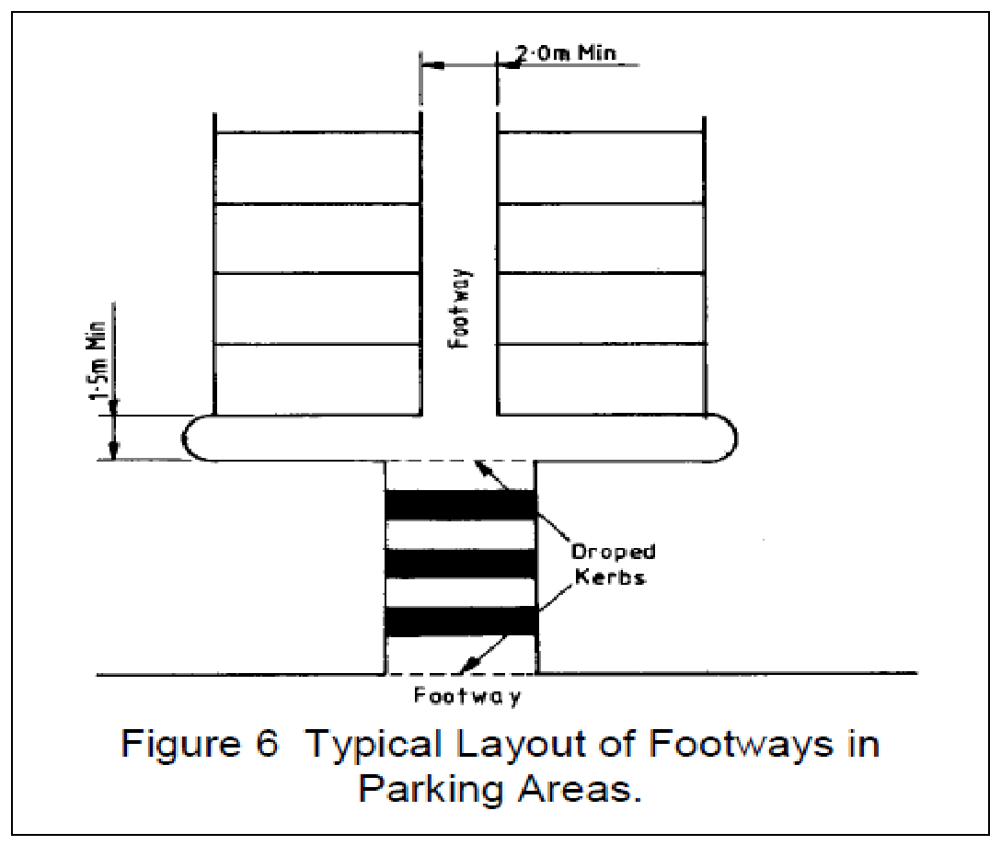
Typical layout of footways in parking areas

Access/Egress to Parking Areas

Access to car parks from the public highway will require the provision of adequate sight lines to ensure that highway safety is not compromised. Suitable provision should also be made to enable pedestrians, especially the mobility impaired, to cross a car park access.

Within the parking area developers will need to provide a balance between the following conflicting requirements:
- Adequate visibility for the safe manoeuvring of vehicles.
- Safety of any pedestrian movements that are likely to occur.
- Landscaping of the parking area
- Personal security issues.
- Efficient operation of the parking area.

When parking is proposed immediately adjacent to the public highway, either at the rear of the footway or carriageway, right angled parking spaces with direct access should not be used, except in the case of private dwellings.

Cycle Parking

The parking needs of cyclists vary depending on the purpose of their trip:
• Collection & Delivery – parking for short stay users needs to be near the entrance to, or inside, the place visited, and may be less secure than long stay provision.
• Shopping –Groups of cycle stands should be located at regular intervals so that the bicycle does not have to be parked more than a short walk from the final destination and ideally should be within sight of the owner.
• Meetings & Appointments – use is often irregular and can be for long periods, up to a whole day. Users favour locations where lighting and surveillance are perceived to be good, usually at or near to main building entrances and preferably covered.
• Workplace – use is generally all day and on a regular basis. Demand is more likely to justify grouping of racks, often within areas where there is controlled access, CCTV monitoring or individual lockers.
• Residential – requires high standards of security and should avoid the need to take bicycles a long way into a building.

In addition to the provision of secure cycle parking, developers will be required to consider the additional needs of cyclists (such as lockers, changing and shower facilities where appropriate), the access to cycle parking and the interaction between cyclists and other highway users.

The location of cycle parking provides a key role in persuading cyclists to use it. Cycle parking that is not convenient to the cyclist’s ultimate destination or where security is perceived to be poor will often stand empty and be subject to vandalism. Depending on the purpose of the trip the following locational requirements should be considered:
- Obvious and well signed
- Near to the entrance of the premises being visited
- Visible and attractive
- Well lit
- An appropriate level of surveillance and security
- Good weather protection
- Off street location with good and safe access, separated from parking vehicles
- Situated close to well used thoroughfares
- Well maintained

Where a development provides more than one access to a building, or group of buildings, it may be preferable to have small groups of cycle parking facilities spread around the development rather than a single central location. The emphasis should be on providing the most convenient locations for the users.

The location of cycle parking facilities should not present a hazard to pedestrians, especially the mobility impaired. There are several measures that can be taken to minimise the conflict between pedestrians and cyclists:
- Tactile surfaces around cycle parking.
- Raised plinths with a feathered edge in contrasting colours to the existing footway.
- Cycle parking placed on the median zone between the carriageway and the footway.
- Hoops to deflect pedestrian flow around cycle stands.
- Providing a tapping rail (with a maximum height above ground of 150mm) so that an empty rack cannot be walked into.
- Incorporating advertising and lighting with stands.

The provision of cycle parking facilities should fully complement cycle access opportunities to the development. This should include appropriate links to any local cycle network that either already exists or is proposed in an adopted local transport strategy.

A variety of devices and systems are currently available to meet the needs of cyclists.
In general the equipment used to provide secure cycle parking should have the following requirements:
- Easy to use.
- Enable bicycles to be supported without being damaged.
- Vandal proof.
- Have a good finish, clean and with no sharp edges.
- Allow use of cyclist’s own locks where appropriate.
- Have the ability to secure the frame and both wheels.
- Allow storage of helmet and other accessories where appropriate.

Wall Loops
These are a simple, cheap and convenient alternative to stands which can be used where there is limited space and a substantial length of wall. A relatively low level of maintenance is generally required. They should be set 700–750mm from the ground, project no more than 50mm from the wall and set at a minimum pitch to park a bicycle every 1800mm. They are not a suitable option for long stay parking.

Sheffield Stands.
These have the virtue of simplicity and value for money and are ideal for short-term parking. They are not always the best option for long stay and/or high-density parking.
Stands with heights over 800mm should be avoided, as they do not support smaller bicycles.
A lower crossbar or panel can be provided to support smaller children’s bicycles.
Stands should be 900–1200mm long to support the bicycle at or near axle centres. Suitable space should be provided between stands to allow cyclists to get alongside the bicycle to lock it.
When considering the location of cycle parking using this type of stand it is important to remember how far the bicycle will extend beyond the stand itself. The angling of stands can reduce their width as an obstacle.

Lockable Cycle Stands
These secure both the frame and wheels of a bike and generally have a lower parking density than Sheffield stands. They offer greater levels of security and can be quicker to use.

Lockers
These combine speed of parking with weather protection and high levels of security. They require the greatest level of management commitment and opportunities for abuse can be greater. The liability for securing contents must be clearly defined. The most widely preferred system is a medium/long term hire regime, which requires an explicit agreement with users. A clearance under the units will help to make the locker unattractive for warehousing or sleeping, assist in cleaning operations and provide ventilation.

Staffed Facilities
There is little potential for such facilities to be commercially viable and they are mainly associated with a bike shop or some other compatible outlet.

Unstaffed Facilities
These are mostly associated with provision for employees although they could potentially also be used at public transport boarding points. They generally consist of secure cages or buildings with access allowed through the use of a key or swipe card. Full enclosure of such facilities will offer better weather protection and it is prudent to limit the number of users of the facility. Where a large number of parking spaces are required then more than one facility should be considered, which could then be sited at more convenient locations within the development compared with a larger centrally located facility.

Parking for the Mobility Impaired

Parking bays for the mobility impaired should be conveniently located and clearly signed. Their location should take into consideration the distances that potential users may be capable of walking to reach the facilities they desire. The generally accepted guidelines of walking distances for different degrees of mobility are:

Visually impaired 150 metres
Wheelchair users 150 metres
Ambulatory impairment without a walking aid 100 metres
Ambulatory impairment with a walking aid 50 metres

Parking bays for the mobility impaired should be designed so that drivers and passengers, either of whom may be impaired, can get in and out of the vehicle easily and safely. They need to be designed to encompass a wide range of mobility impairments. They should also ensure easy access to and from the side and rear of the vehicle and protect the mobility impaired from moving traffic.
Typical layouts of parking bays for the mobility impaired are shown below:

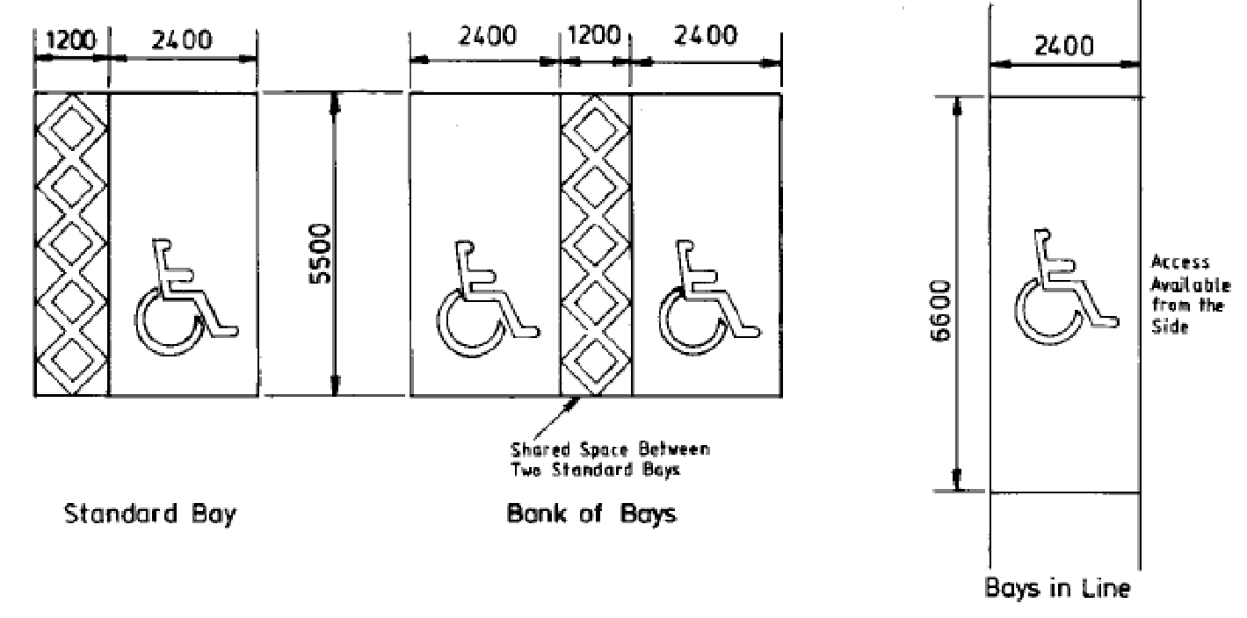

Off-street parking bays that are parallel to the access aisle, making access available from the side, should be at least 6.6m long and 2.4m wide. The additional length will allow access to the rear of the vehicle where wheelchairs are often stored. Access from the side should be unencumbered by street furniture.

Off-street parking bays that are perpendicular to the access aisle should be at least 5.5m long and 2.4m wide with an additional width of at least 1.2m along one side. This should allow sufficient width for wheelchair access between vehicles and enable vehicle doors to be fully opened. Where bays are adjacent to each other the 1.2m access area can be utilised to serve parking bays on either side.

Parking bays for the mobility impaired should be located as near as possible to a suitably designed entrance/exit to the development. Access to and from the parking bays should also be free from steps, obstructions and steep slopes.

The minimum standards for the provision of parking for people with impaired mobility are as follows:

For Employees and Visitors to Business Premises (Land Use Classes A2, B1, B2 & B8)

Car Parks up to 40 spaces |  | 2 designated spaces + 1 space of sufficient  size but not specifically designated.
Car Parks with 40 to 200 spaces |  | 4 designated spaces or 5% of the total  capacity, whichever is greater
Car parks with greater than 200 spaces |  | 6 designated spaces + 2% of the total  capacity
For Shopping, Recreation and Leisure (Land Use Classes A1, A3, A4, A5, C1, D1, D2 &
Unclassified)

Car Parks up to 50 spaces |  | 1 designated space + 2 spaces of sufficient  size but not specifically designated.
Car Parks with 50 to 200 spaces |  | 3 designated spaces or 6% of the total  capacity, whichever is greater
Car parks with greater than 200 spaces |  | 4 designated spaces + 4% of the total  capacity
Notes  1.  2. | The provision of parking spaces for the mobility impaired will be part of the overall level of parking provision for the development as opposed to an additional requirement.  The use of spaces allocated for the mobility impaired should be regularly monitored to ensure that the allocation is correct and that the system is working well.

Any new development which includes off-street parking should have at least one parking space that is either designated for the mobility impaired or, if not specifically designated, is of sufficient size to be used by the mobility impaired. Where provision for the mobility impaired is not to be provided as part of the development the local planning authority may seek a contribution from the developer towards the provision, operation and maintenance of parking bays either on-street or in public off-street car parks.

Motorcycle Parking

Provision should be made for motorcycle parking at all new developments in order to enable the use of this mode of transport. As with cycle parking the level of provision required will vary depending on the purpose of the trip. The availability of secure parking is particularly important in areas where medium to long term parking is anticipated.

Motorcycle parking standards are a separate and additional requirement to the vehicle and cycle parking standards. As a minimum the following standard of provision should be made for motorcyclists within non- residential developments:

Non-residential developments | 1 space + 1 space for every 20 car parking spaces provided

Where communal parking facilities for residential developments are provided the above standards will also apply.
In locating motorcycle parking, sites should be chosen that are well drained, particularly if ground anchors are provided. The surface should, as far as practical, have no, or only a slight, gradient, have a non-slip surface and be firm enough to prevent stands sinking into the ground. Parking areas should only be provided to the rear of footways in exceptional circumstances and under the condition that they would not interfere with pedestrian movements or jeopardise pedestrian safety.

Motorcyclists are prone to the same personal security concerns as other transport users. Hence, good lighting will increase confidence in both personal and vehicle security. Where possible the parking should be located in areas that will regularly be observed and consideration should be given to protecting areas with bollards or some similar restriction to discourage theft.

It is often not possible to pass a lock through a motorcycle frame. Hence any anchor point needs to be at a suitable height for locking the wheel. Two basic types of anchor points can be used to provide secure parking for motorcyclists:

Ground Level – the anchor point remains below the surface, often concealed by a hinged steel plate set flush with the surface. The plate is raised by the user allowing a loop to be lifted up and the users own lock passed through. Consideration should be given to the potential hazard that could be caused as a result of the anchor being left upstanding or jammed in the raised position. Anchor points of this type will require regular maintenance.

Raised – a horizontal bar is provided at a height of approximately 400-600mm above ground. This is generally provided at the edge of the carriageway. It can represent a trip hazard or impediment if installed along the edge of footways. Provision should be integrated with pedestrian railings or protected by means to safeguard pedestrians, particularly those with impaired vision.

As defined in Article 2 of the Town and Country Planning (development Management Procedure) (England) Order 2015 (no.595) or any later amendment.

