Date: 13 July 2016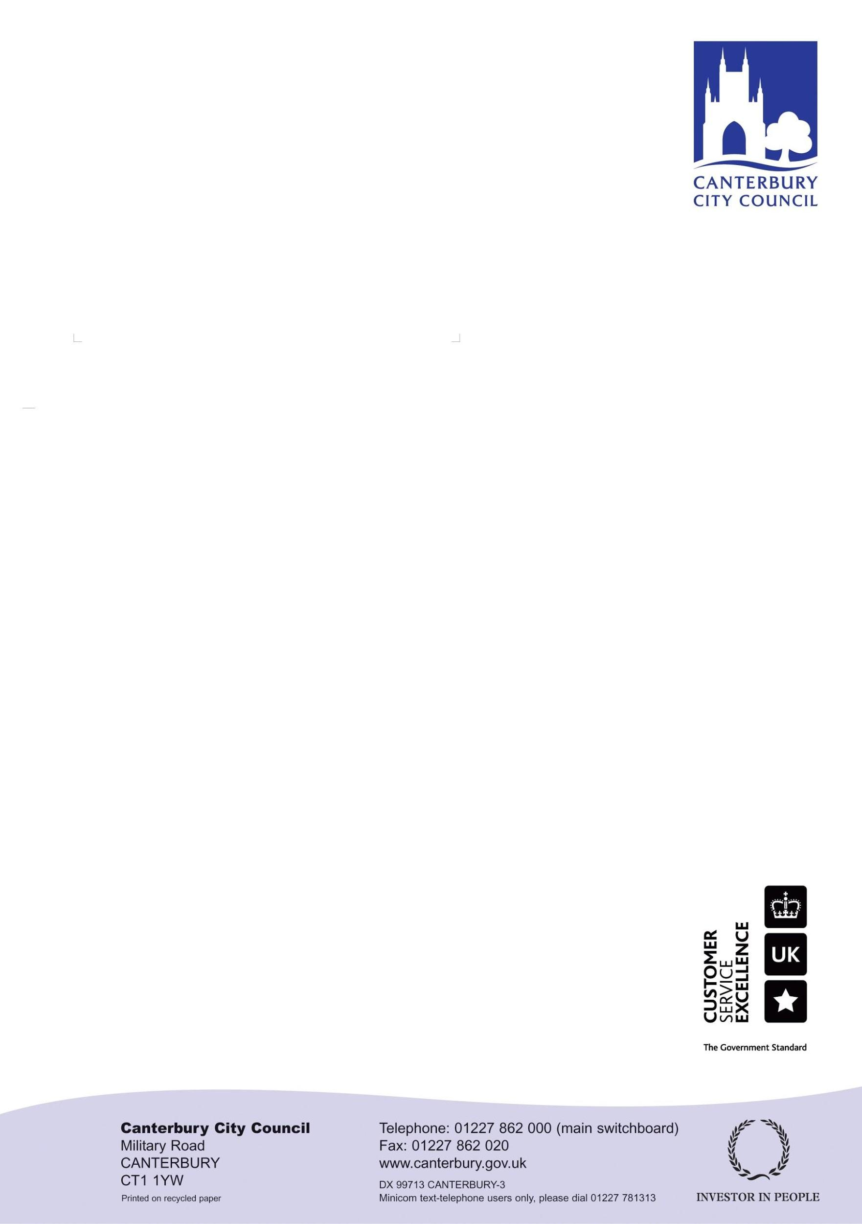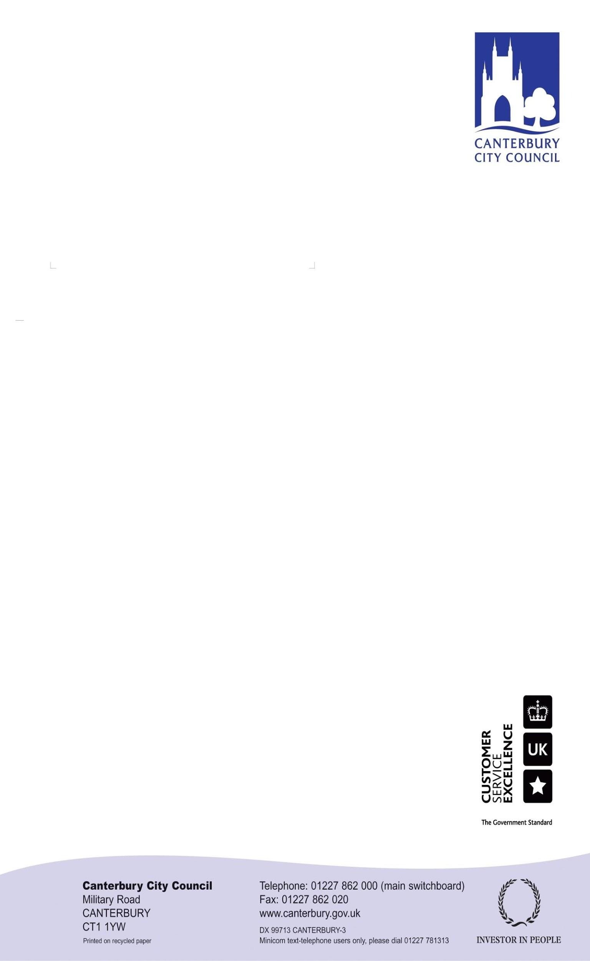

Ask for: **Karen Britton**

Direct dial:01227 **862196**

E-mail: karen.britton@canterbury.gov.uk

Mr M Moore

The Planning Inspectorate

Room 3/13

Temple Quay House

2 The Square

Temple Quay

Bristol

BS1 6PN

Dear Mr Moore

**Response to your letter dated 28 June 2016 re- Potential Main Modifications**

Thank you for your letter of 28 June 2016 highlighting your comments on the Potential Main Modifications document 28 April 2016 (CDLP 16.29.24).

I respond to the specific matters that require a response at this stage and note that some comments relate to matters that will be discussed at the forthcoming hearings and other matters will be addressed through the next iteration of the Main Modifications (those items have been marked * below).

Proposals Map *

Format *

Key Diagram and List of Superseded Policies *

MM1.2 Policy SP1 – The text of the policy could be included instead within the general text or alternatively deleted completely, at your discretion.

MM1.5 – the changes have been made to clarify wording following further information/ communication from KCC Education and the NHS Canterbury and Coastal Commissioning Group on their respective education and health requirements; clarification of the park and ride location and the 70ha figure is based on the CDLP 9.3 Draft Open Space Strategy 2014-19, which sets out revised standards.

MM1.6, MM1.7, MM1.10, MM1.12, MM1.15, MM1.18 –changes have been made to clarify wording following further information and communication from KCC Education and the NHS Canterbury and Coastal Commissioning Group on their respective education and health requirements.

MM1.28 – noted - use revised text.

MM1.34, MM1.36, MM1.39

Policy SP7 and Paragraphs 180-1.85 (MM1.33-1.39) are in accordance with the Conservation of Habitats and Species Regulations 2010 as agreed with Natural England in the Statement of Common Ground dated 12/6/2015.

MM1.0008

Yes, it is split over MM1.30 and MM1.31

MM2.4 – suggest delete the phrase “and consider phasing of sites”.

MM2.13 – the proposed new text inserted (underlined) in the Potential Main Modifications document is proposed to now be removed in the light of the CCC letter of 2 June 2016.

MM5.1, MM5.4 – noted - use revised text.

MM11.1 to MM11.5, MM11.78 to MM11.11 –

A question in the stage 2 Local Plan Examination covers this point (see the Council’s Matter 15 Open Space Statement).

MM11.6, MM11.7 - as above - a question in the stage 2 Local Plan Examination covers this point (see the Council’s Matter 15 Open Space Statement).

Additional Modifications – comments noted.

Yours sincerely

*Karen Britton*

Planning Policy Manager