**Matter 7: Petition**

Devine Homes

380674/380257

**CANTERBURY DISTRICT DRAFT (2014) LOCAL PLAN PUBLIC EXAMINATION**

**Matter 7**: Strategic Sites Allocations

Site 7 Thanet Way, Whitstable

**Submitted Petition Statement**

**On behalf of Devine Homes, Strand, Lucchesi Buchan**

**Prepared and submitted by**

**Courtley Consultants Ltd: July 2015**

**Representations upon the submission by Mr Little of a petition under**

**Matter 7: Strategic Site Allocations- Thanet Way, Whitstable**

**1. Planning Background and Community Engagement**

1.1 The NPPF paragraph 66 states:

**“Applicants will be expected to work closely with those directly affected by their proposals to evolve designs that take account of the views of the community. Proposals that can demonstrate this in developing the design of the new development should be looked on more favourably.”**

1.2. The site known as Thanet Way, Whitstable (Site 7) currently has a registered outline planning application (CA/15/01296). Please see the Statement of Community Involvement (June 2015) submitted as part of this application by Barton Wilmore which has now been submitted to the Examination Evidence Base during the hearing sessions. This statement demonstrates how the owners have consulted with the local community and key stakeholders. In summary, the consultation has included engaging with local councillors, residents, and interested organisations. In addition, discussions have been held with the planning, economic development and infrastructure teams at Canterbury CC and Kent CC.

1.3. This approach is in accordance with NPPF paragraph 155 which states:

**“Early and meaningful engagement and collaboration with neighbourhoods, local organisations and business is essential”**

1.4. The consultation and engagement strategy can be broken down into the following 5 categories:

i. Site promotion through the Local Plan preparation and consultation (2010-2015)

ii. Public involvement through undertaking a public exhibition ;( Sept 2011)

iii. Stakeholder involvement (2010-2015)

iv. Pre-application discussions with CCC (Dec 2014), and

v. Technical pre-application discussions with statutory consultees (2013-2015)

1.5. From the outset, Devine Homes have engaged with local community and action groups, most notably the Friends of Duncan Down. Other groups involved have included the Whitstable Society, Thanet Way Residents Association, Whitstable Umbrella Community Centre, Transition Town, and the Kent Enterprise Trust. The consultation has involved representation of the groups being invited to regular meetings to discuss and engage on issues concerning the development of the scheme, and a public exhibition was held to showcase the initial proposals for the site during the early stages of preparation in 2011. Local residents and organisations have been given genuine opportunities to give their opinion, provide feedback and positively influence the evolution of the scheme. Cumulatively, the respondents have represented a cross section of the local community and are well placed to advise on local interests.

1.6. The consultation exercise has resulted in input from the community and stakeholders, which influenced the design and layout of the scheme.

1.7. The Appendices in the Statement of Community Involvement (SCI) show the evolution of Site 7 through the different engagement stages.

1.8 The extent of the proposed residential development on Site 7 is illustrated in the draft Local Plan as **“Strategic development site Thanet way, Whitstable”** which clearly shows Duncan Down as a Village Green and adjoining land proposed for new open space, existing woodland and landscaping (See Appendix I)

1.8. It is important to state the Local Wildlife Site known as Duncan Down(also registered as 3 Village Greens)does not form any part of Site 7 or the SHLAA Site 001. Although Benacre Wood ( Village Green) does fall within the boundary of Site:7, it has never been put forward in any representation for development and is proposed as part of the *“Extension to Duncan Down country park; additional public open space, including allotments under Policy SP3 Site 7 Thanet Way site, Whitstable.”*

**2. The Petition**

2.1. A petition was submitted Mr Little and accepted by the Planning Inspector at the examination into Matter 7: Strategic Sites Allocation- Thanet Way site, Whitstable on the 22nd July 2015.

2.2 The point was made to the Inspector at the examination that Mr Little (an objector to Site 7 and promoter of an omission site opposite known as Land at 42 Golden Hill, Whitstable: SHLAA 135) had begun a petition against development on Duncan Down since 2013 and had numerous opportunities to submit this petition at any time during the consultation stages of this Local Plan.

2.3 The petition is submitted as four different items, as follows:

A. A5 Leaflet

(i) This leaflet is headed “**SAVE DUNCAN DOWN FROM THE** **BULLDOZER”.** It allows a name and postcode to be put at the top of what appears to be the back page but there is NO facility to date the leaflet and therefore no dates are given. (See Appendix II).

(ii) This leaflet sets out a number of statements on the front of the form, for example:

“**Whitstable needs to protect Duncan Down from Devine Homes**” As explained in paragraph 1.8 Duncan Down does not form any part of Site 7 and is a protected Wildlife Site and Village Green.

**“Canterbury City Council has since moved the Designated Urban Area to include the Downs for DEVELOPMENT”.** Duncan Down does not fall within the Designated Urban Area as defined in the deposit draft Local Plan and is not proposed for development.

**“In 2014 Councillors approve Duncan Down for Building WE ask why.”** The Council clearly have not approved Duncan Down for Building!

On the reverse side of the Leaflet there are **Coloured Pictures:** These pictures are totally misleading as it suggests development taking place on Duncan Down where none exist.

(iii) Also on the reverse side of the Leaflet the “Local Referendum” asks a number of misleading questions regarding the threat to development on Duncan Down. It refers to the SHLAA site 001 and not the more appropriate Site 7 neither of which is identified on a plan or map. It also offers no explanation of what is actually proposed in the submitted draft Local Plan.

(iv) Given the degree of incorrect and misleading information in this leaflet the inevitable response will be obtained i.e. signatures in support of protecting Duncan Down from development which we fully endorse.

(v) This leaflet and its petition should accordingly be given no weight with regard to the allocation of Site 7.

B. Online paper copy.

(i) This is a list of names and postcodes, again lacking dates, on the submitted computerised list. On what appears to be the front page of their online paper copy there is the following preamble:

**“To: Canterbury City Council**

**protect the whole of Duncan Down and create a large wildlife meadow and Country Park; new areas for native trees, planting, recreating the ancient woodlands of Benacre Woods, create a woodland play area, small car park toilets wheel chair and scooter access.**

**There is a huge need for affordable housing in Whitstable. Canterbury councillors have rejected an alternative site that is opposite Duncan Down which would save Duncan Down and build affordable homes”**

(ii) Only around a third of the signatories of this petition had district wide postcodes.

(iii) Site 7: Thanet Way, Whitstable does not impact upon Duncan Down and under Policy SP3 delivers much of what is referred to above. This site is the only one capable of delivering the extension and improvements required to the Local Wildlife Site and village greens including the transfer of ownership of Benacre Wood and the Duncan Down extension to an appropriate body approved by Canterbury CC.

(iv) Site 7 has a 30% affordable housing requirement and Devine Homes have confirmed their commitment in the planning application CA/15/01296 to deliver around 120 affordable dwellings as part of this site’s development.

(v) This online petition should also be given little weight as it is again misleading with regard to the allocation of Site 7.

C. A4 paper format.

(i) The A4 paper petitions states:

**“Save Duncan Down from the Bulldozer and say NO to**

**LUXURY HOUSING DEVELOPMENT**

**We the signatures want to protect the whole of Duncan Down and create a large meadow and Country Park; new areas for native trees planting recreating the ancient woodlands of Benacre Woods, create a woodland play area, small car park, toilets, wheel chair and scooter access.**

**There is a huge need for affordable housing in Whitstable. Canterbury councillors have rejected an alternative site that is opposite Duncan Down which would save Duncan Down and build affordable homes.”**

(ii) This is very similar to the preamble stated on the online paper copy (B referred to above) and so the same comments apply.

(iii) Of all the signatures with appropriate addresses and postcodes, only 25 are dated.

D. A4 paper statement.

Within the petition handed to the Inspector there is a paper copy of what appears to be an undated statement titled **“SAVE DUNCAN DOWN FROM HOUSE BUILDING. HELP OUR CHILDREN AND GRANDCHILDREN. Once it’s under concrete you will never see it again**” (See Appendix III)

A copy of this statement is attached to this representation in Appendix II**.** It is not clear whether this paper statement was shown/given to the signatories but again much of what is in this statement is misleading , especially the intimation that Duncan Down will be “under concrete” by building 300-400 homes.

**3. Conclusion**

3.1 Although there are a large number of signatures on the petitions handed to the Inspector they relate to the protection of Duncan Down and Benacre Wood neither of which are under threat from Site 7. Indeed significant improvements to the Local Wildlife Site, landscape, ecology and access to open space including provision of around 15 hectares of new open space, green infrastructure and multi-use games area will be provided by the proposed development of the Thanet Way site, as well as around 120 affordable homes (30%).

3.2 The Community engagement on this site started at an early stage of the Local Plan process in 2010 and has been on going ever since, contrary to the claims made by Mr Little at the examination.

3.3 It is important to recognise the motivation of this petition not only in its continued reference to land on the opposite side of Thanet Way (SHLAA 135) but by the implied threat by Devine Homes to the loss of Duncan Down and Benacre Wood.

3.4 We would therefore invite you to consider the petition with extreme caution and hence give it limited or little weight in your consideration of the soundness of the allocation of Policy SP3 Site 7: Thanet Way site, Whitstable.

3.5 Policy SP3 Site 7 is a positively prepared, sound and effective housing allocation consistent with National Policy.

**APPENDIX I**

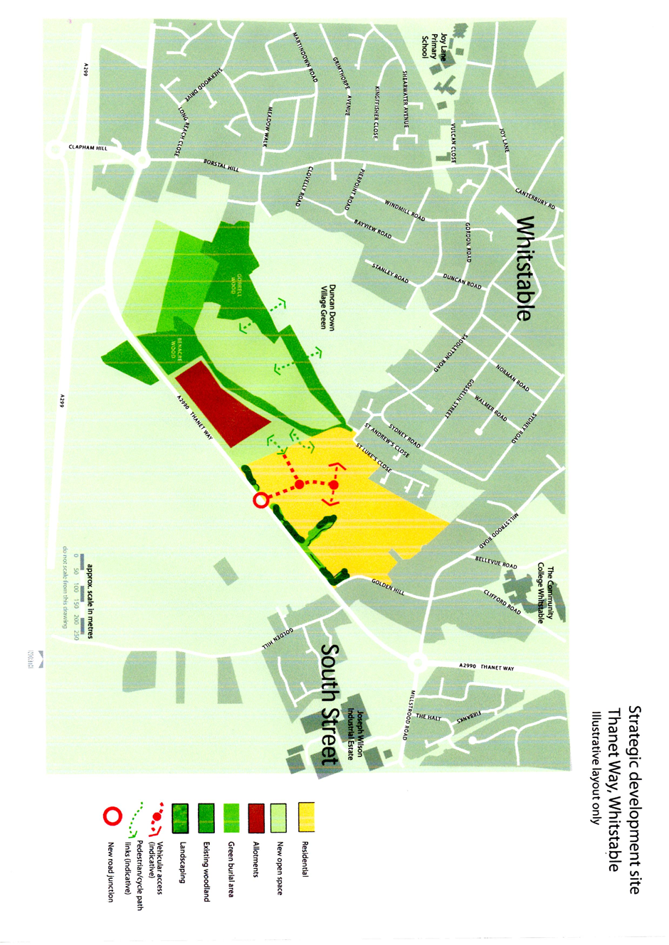

**APPENDIX II**

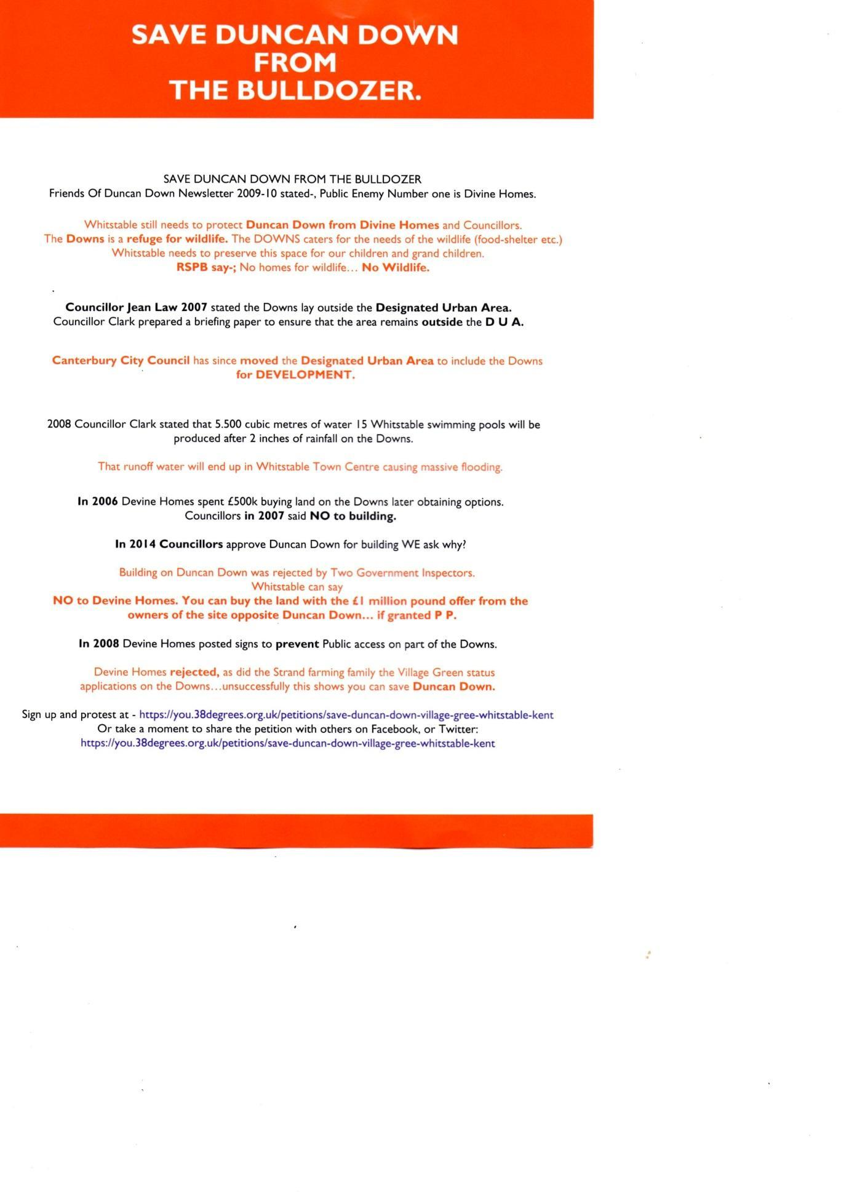

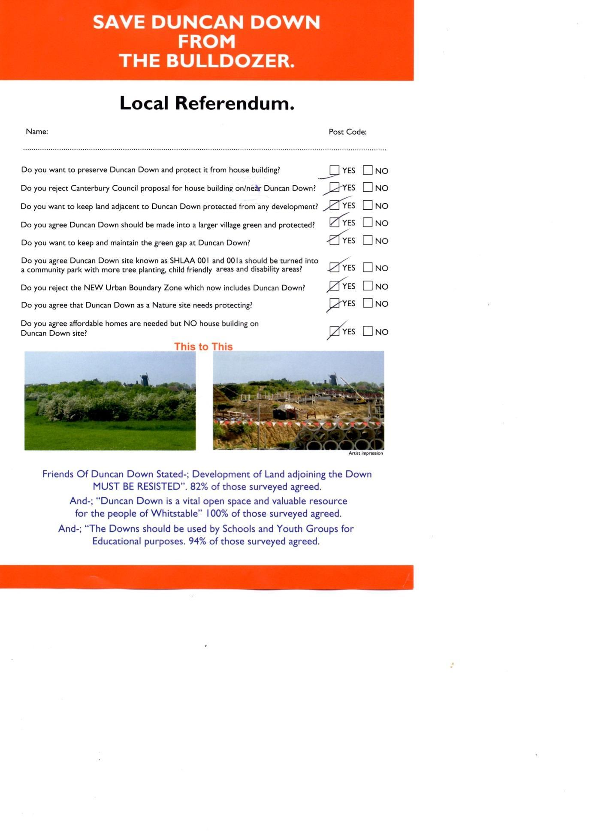

**APPENDIX III**

