**CCC Early Review Note – Household Projections**

# Introduction

* 1. In response to the City Council, the Inspector has requested as follows:

*“The Council has indicated that if necessary any concerns could be addressed through an early review. I should be grateful if they could put forward some appropriate wording in the form of main modifications to the plan for me to consider should I decide to recommend that this is the appropriate outcome.”*

* 1. It is understood the purpose of any review would be to primarily address any perceived deficiency in the proposed housing requirement.
  2. The relevant guidance for reviewing Local Plans is contained within PPG ID:12-008:

*“****How often should a Local Plan be reviewed?***

*To be effective plans need to be kept up-to-date. Policies will age at different rates depending on local circumstances, and the local planning authority should review the relevance of the Local Plan at regular intervals to assess whether some or all of it may need updating. Most Local Plans are likely to require updating in whole or in part at least every five years. Reviews should be proportionate to the issues in hand. Local Plans may be found sound conditional upon a review in whole or in part within five years of the date of adoption.*

*The National Planning Policy Framework makes clear that relevant policies for the supply of housing should not be considered up-to-date if the authority cannot demonstrate a five-year supply of deliverable housing sites. Local planning authorities should also consider whether plan making activity by other authorities has an impact on planning and the Local Plan in their area. For example, a revised Strategic Housing Market Assessment will affect all authorities in that housing market area, and potentially beyond, irrespective of the status or stage of development of particular Local Plans.”*

# Potential Main Modification Wording

* 1. The monitoring and review of the Local Plan is set out in Chapter 1: Strategy at paras 1.86-1.88, and is the best location to insert any potential ‘review’ policy. A form of wording is suggested as follows:

**Plan Monitoring & Review**

1.86 The Council will establish a full monitoring programme and will identify key areas for future monitoring, to seek to ensure that the overall Plan strategy is being delivered. It will also establish monitoring targets. Monitoring is likely to include the following:

* a particular focus on the long–term objective to strengthen and diversify the local economy;
* the delivery of housing (including affordable housing), employment and retail floorspace;
* the delivery of key physical and social infrastructure;
* environmental standards and design quality in new development; and
* condition of environmental resources.

1.87 The Council will undertake monitoring on an annual basis, and the results of this monitoring will be reported via an Annual Monitoring Report.

1.88 To keep policies up-to-date ~~I~~it is the intention to undertake a review of the Local Plan every ~~4-5~~ five years as a matter of course. The Council will also use the monitoring programme to identify whether there are areas where the Local Plan strategy is not being delivered, and needs more immediate review. However, the Council recognises that it is embarking on what will inevitably be a long-term strategy, and it will not undertake short-term formal reviews of the Plan unless it is clear from its monitoring that key elements of the Strategy are not being delivered. ~~The formal proposals for monitoring and review will be provided at submission stage.~~

1.89 In addition to the ongoing monitoring of the delivery of the Plan strategy, there remains some uncertainty over demographic projections that have been issued by Government in the period following formal submission of the Local Plan, and the implications these may have for housing need in Canterbury District and other parts of the Housing Market Area. Following adoption of the Plan, the Council will consider whether the housing requirement in Policy SP2 continues to meet objectively assessed needs across the housing market area, based on up-to-date evidence and cooperation with other local planning authorities within the Housing Market Area. If the Council’s assessment indicates an early partial review of the Plan is necessary, this will commence within two years from the date of adoption of the Plan, and will draw upon an updated evidence base including a new Strategic Housing Market Assessment.

# Example Review Policies/Wording in Other Adopted Local Plans

* 1. By way of reference, below sets out extracts of a range of other ‘review’ mechanisms contained within other adopted Local Plans.

## Milton Keynes Core Strategy (July 2013)

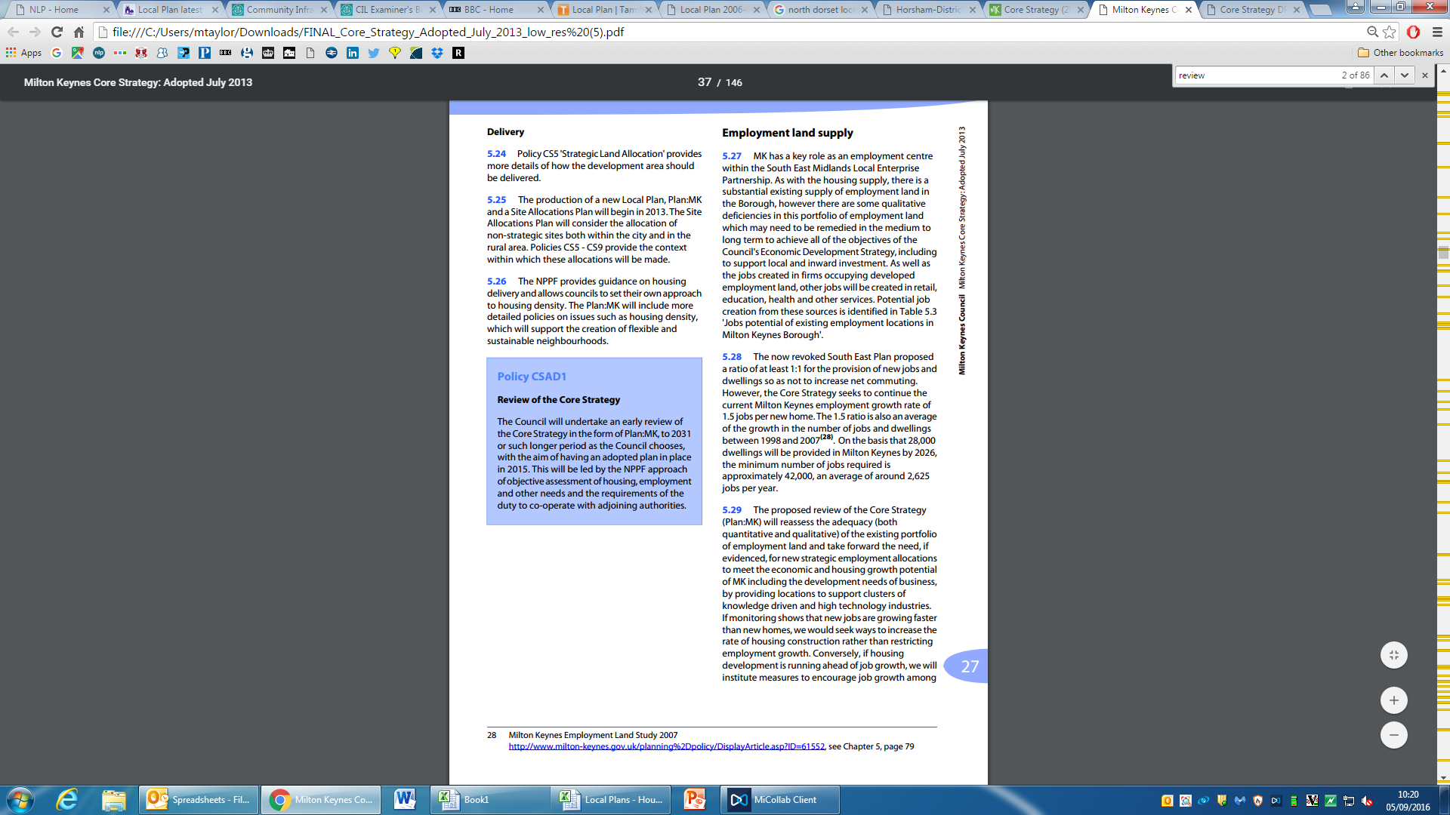

## Horsham Local Plan (Nov 2015)

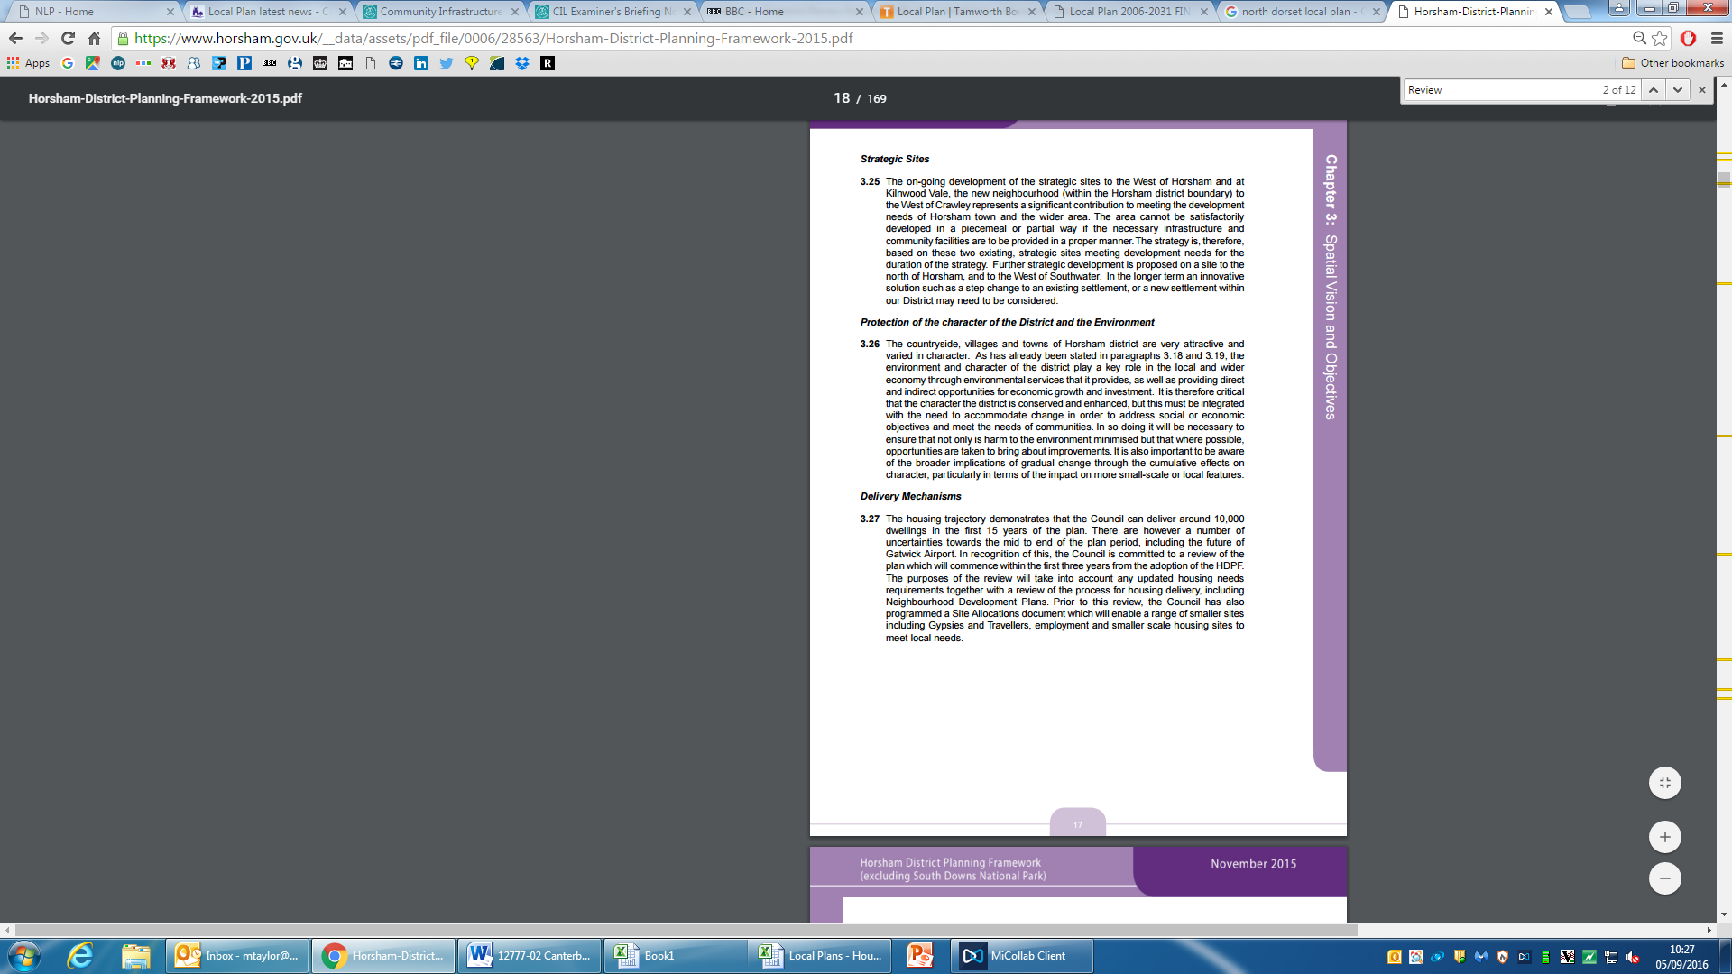

## Tamworth Local Plan (Feb 2016)

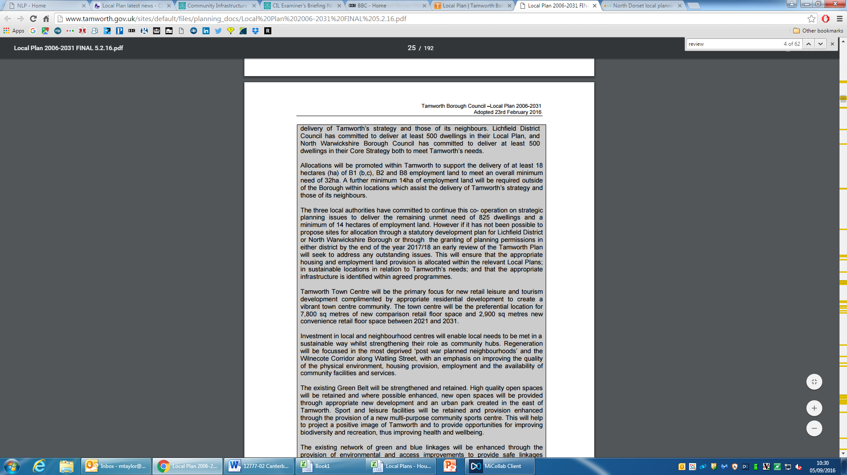

## North Dorset Local Plan (Jan 2016)

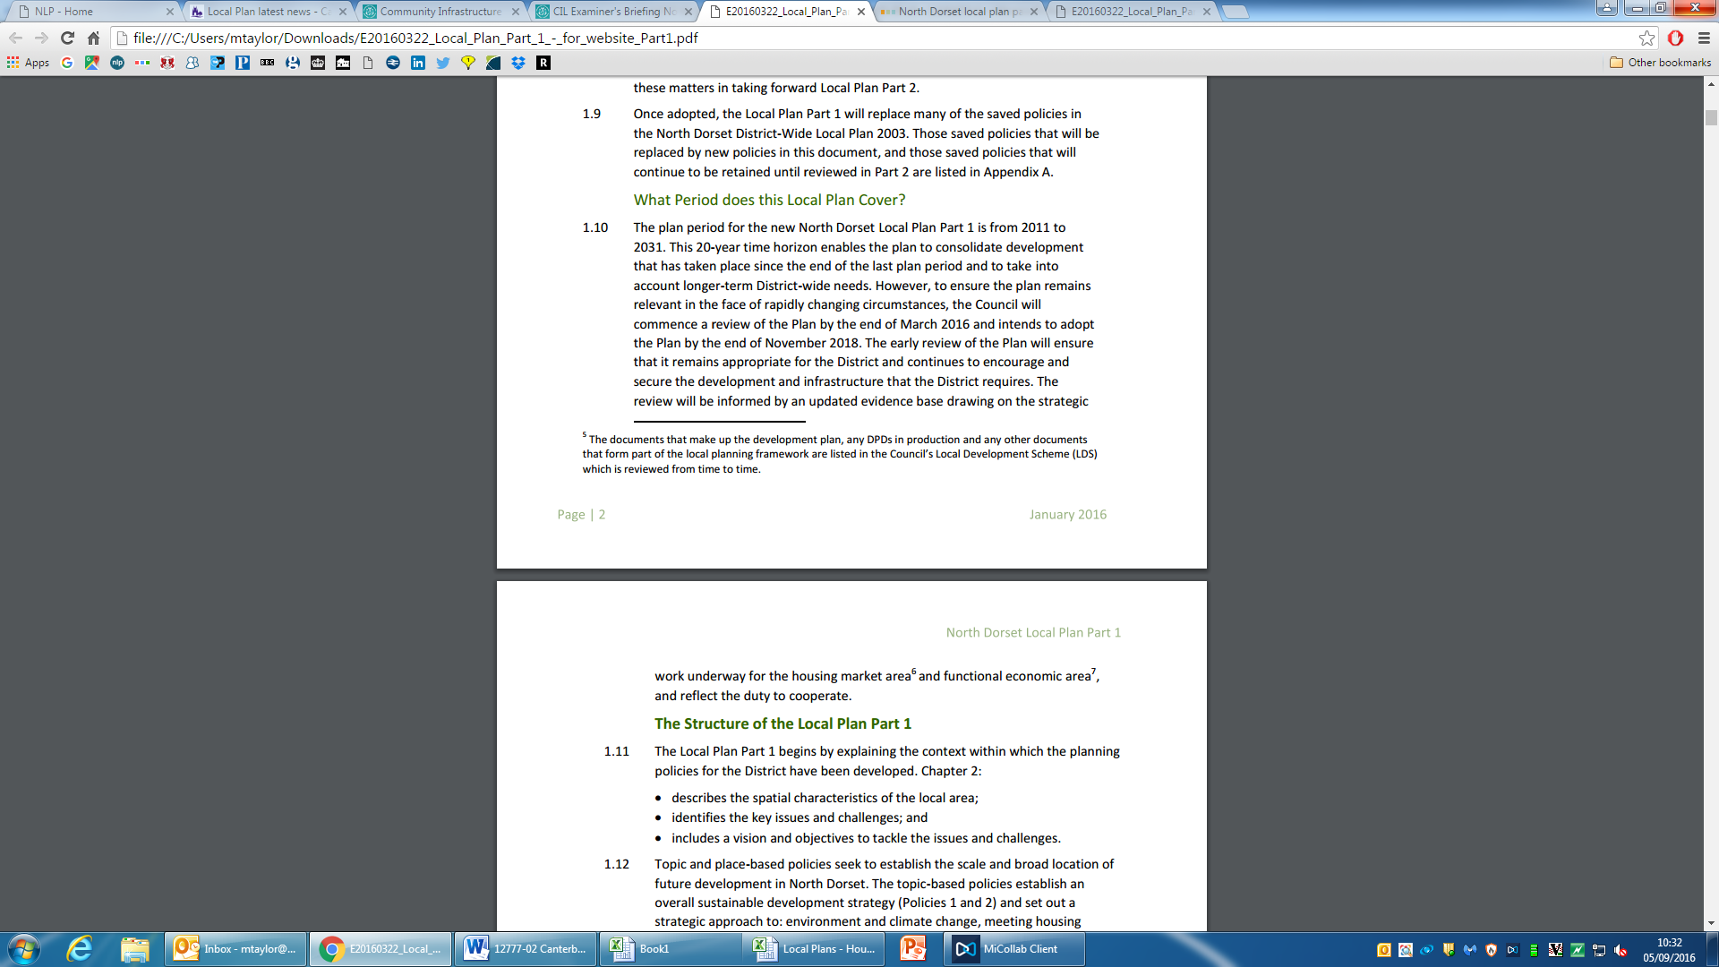

## Stratford-upon-Avon Local Plan (July 2016)

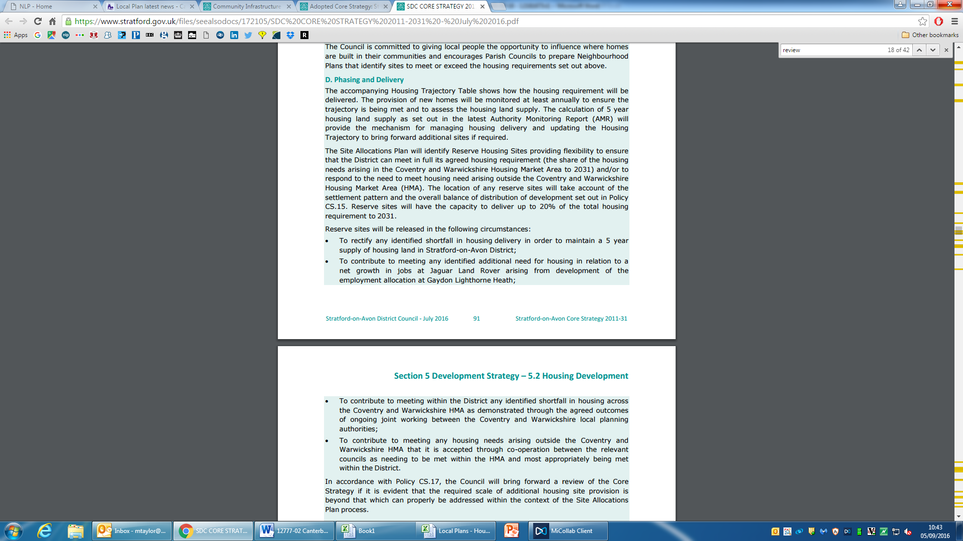

## Chichester Local Plan (July 2015)

