Extract from CANTERBURY DISTRICT LOCAL PLAN 2040 Sustainability Appraisal Report - Draft Canterbury District Local Plan 2040 (Regulation 18):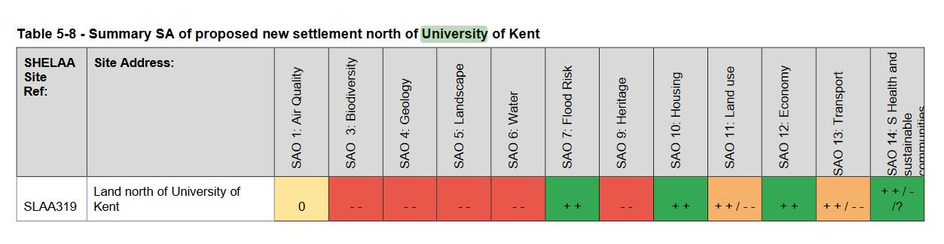

<https://www.theguardian.com/science/article/2024/may/19/andrea-mechelli-urban-mind-green-space-mental-health?CMP=Share_iOSApp_Other&fbclid=IwZXh0bgNhZW0CMTEAAR1r01tGhFenay_L3PzAlXUHl97F-ByzE3VZZXvN9IRmhzyfispUo6XiNEY_aem_ATqpLlLbU0XOD6jPwUuhtgfDhiYmHpf3Q22KbJ7B0ZjGPDAN1s8OLwMUl27DEI02b0JBFmINJMVgBzPnAHHBtPjm>

Part of Kent Wildlife Trust's response to the University's plans to destroy ancient woodland in order to build the Sibson Building: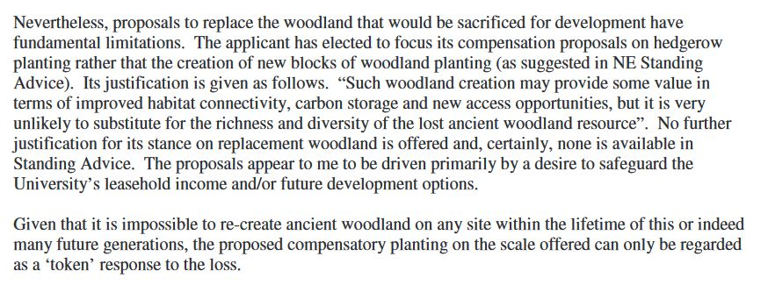

The Blean Wood Research Group (edited by William Holmes and Alexander Wheaten (2002) "The Blean: the woodlands of a Cathedral City", White Horse Press, Chestfield, p. 137

[https://l.facebook.com/l.php?u=https%3A%2F%2Fhackington-pc.gov.uk%2Fwp-content%2Fuploads%2F2024%2F05%2FHackington-Parish-Council-Response-Draft-Local-Plan-2040.pdf%3Ffbclid%3DIwZXh0bgNhZW0CMTAAAR0l4o64zk6aGN1uDqcf8_gBedLpuIj0PAEgZdJUosO_v6hELsib1y-kd0g_aem_ATomROQpKqXdxbHOcqU1M8_XxX-Aah5AzBh4phH2YAUqYoA2hs_yuKlfTeTh0bDCRjbPhyT9vo_D8rcOyMZYgKoL&h=AT1BUxbjL3IQYGiN8XCj-MK4DBTVAN-2rxVtdX5_U3lxvaYOR1lI6JVkiXuOzgkz3dlPl0jr2UtqmM_xd09psZKzImC05NsduEqLJGWqvjcaz6XEcjlj0sN7yQp8Cn6fWw&__tn__=-UK-R&c[0]=AT1eROHDSP4xIPcckOQH9oUPdtEdY6du8ZgeKEKRA4JDT9eOpvnaBJDpkipVHUdKoNsxZGg5GJKRZXqqXd_y65QebvJ4bhACSkAGS3hvH9t8ewmfk_VMyXWfQsAZiJibCdEK5m9pJI4fW-PzDGS9AKL0zPYYDA-SuazchiD5PeyV3_FkeuWwdftO-zzd17LNUkkFnjClJDLRpzg4Lu8w29qfzYKkxIvmjmIRLLrl34XbWUt2](https://l.facebook.com/l.php?u=https%3A%2F%2Fhackington-pc.gov.uk%2Fwp-content%2Fuploads%2F2024%2F05%2FHackington-Parish-Council-Response-Draft-Local-Plan-2040.pdf%3Ffbclid%3DIwZXh0bgNhZW0CMTAAAR0l4o64zk6aGN1uDqcf8_gBedLpuIj0PAEgZdJUosO_v6hELsib1y-kd0g_aem_ATomROQpKqXdxbHOcqU1M8_XxX-Aah5AzBh4phH2YAUqYoA2hs_yuKlfTeTh0bDCRjbPhyT9vo_D8rcOyMZYgKoL&h=AT1BUxbjL3IQYGiN8XCj-MK4DBTVAN-2rxVtdX5_U3lxvaYOR1lI6JVkiXuOzgkz3dlPl0jr2UtqmM_xd09psZKzImC05NsduEqLJGWqvjcaz6XEcjlj0sN7yQp8Cn6fWw&__tn__=-UK-R&c%5b0%5d=AT1eROHDSP4xIPcckOQH9oUPdtEdY6du8ZgeKEKRA4JDT9eOpvnaBJDpkipVHUdKoNsxZGg5GJKRZXqqXd_y65QebvJ4bhACSkAGS3hvH9t8ewmfk_VMyXWfQsAZiJibCdEK5m9pJI4fW-PzDGS9AKL0zPYYDA-SuazchiD5PeyV3_FkeuWwdftO-zzd17LNUkkFnjClJDLRpzg4Lu8w29qfzYKkxIvmjmIRLLrl34XbWUt2)